SEC Form 4

FORM 4

Check this box if no longer subject to Section 16. Form 4 or Form 5 obligations may continue. See Instruction 1(b).

UNITED STATES SECURITIES AND EXCHANGE COMMISSION
Washington, D.C. 20549
 |  | OMB APPROVAL
STATEMENT OF CHANGES IN BENEFICIAL OWNERSHIP
 |  | OMB Number: | 3235-0287
 |  | Estimated average burden
Filed pursuant to Section 16(a) of the Securities Exchange Act of 1934 |  | hours per response: | 0.5
or Section 30(h) of the Investment Company Act of 1940

1. Name and Address of Reporting Person*
Cooper Andrew D

(Last) (First) (Middle)

400 NORTH FIFTH STREET MAIL STATION 8602

(Street)
 | PHOENIX | AZ | 85004
 | (City) | (State) | (Zip)

2. Issuer Name and Ticker or Trading Symbol | 5. Relationship of Reporting Person(s) to Issuer
PINNACLE WEST CAPITAL CORP [ | (Check all applicable)
PNW ] |  | Director | 10% Owner
 | X | Officer (give title | Other (specify
 |  | below) | below)
3. Date of Earliest Transaction (Month/Day/Year) |  | VP & Treasurer
06/29/2020
4. If Amendment, Date of Original Filed (Month/Day/Year) | 6. Individual or Joint/Group Filing (Check Applicable
Line)
X Form filed by One Reporting Person

Form filed by More than One Reporting
Person

Table I - Non-Derivative Securities Acquired, Disposed of, or Beneficially Owned

 | 1. Title of Security (Instr. 3) | 2. Transaction | 2A. Deemed | 3. | 4. Securities Acquired (A) or |  |  | 5. Amount of | 6. Ownership | 7. Nature
 |  | Date | Execution Date, | Transaction | Disposed Of (D) (Instr. 3, 4 and |  |  | Securities | Form: Direct | of Indirect
 |  | (Month/Day/Year) | if any | Code (Instr. | 5) |  |  | Beneficially | (D) or Indirect | Beneficial
 |  |  | (Month/Day/Year) | 8) |  |  |  | Owned Following | (I) (Instr. 4) | Ownership
 |  |  |  |  |  |  |  | Reported |  | (Instr. 4)
 |  |  |  | Code V | Amount | (A) or | Price | Transaction(s)
 |  |  |  |  |  | (D) |  | (Instr. 3 and 4)
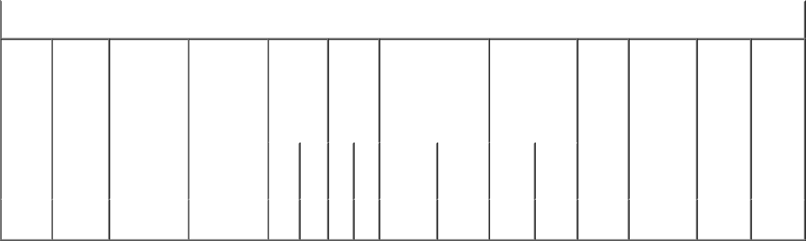

Table II - Derivative Securities Acquired, Disposed of, or Beneficially Owned

(e.g., puts, calls, warrants, options, convertible securities)

1. Title of | 2. | 3. Transaction | 3A. Deemed | 4. | 5. Number | 6. Date Exercisable and |  | 7. Title and |  | 8. Price of | 9. Number of | 10. | 11. Nature
Derivative | Conversion | Date | Execution Date, | Transaction | of | Expiration Date |  | Amount of |  | Derivative | derivative | Ownership | of Indirect
Security | or Exercise | (Month/Day/Year) | if any | Code (Instr. | Derivative | (Month/Day/Year) |  | Securities |  | Security | Securities | Form: | Beneficial
(Instr. 3) | Price of |  | (Month/Day/Year) | 8) | Securities |  |  | Underlying |  | (Instr. 5) | Beneficially | Direct (D) | Ownership
 | Derivative |  |  |  | Acquired |  |  | Derivative Security |  |  | Owned | or Indirect | (Instr. 4)
 | Security |  |  |  | (A) or |  |  | (Instr. 3 and 4) |  |  | Following | (I) (Instr. 4)
 |  |  |  |  | Disposed |  |  |  |  |  | Reported
 |  |  |  |  | of (D) |  |  |  |  |  | Transaction(s)
 |  |  |  |  | (Instr. 3, 4 |  |  |  |  |  | (Instr. 4)
 |  |  |  |  | and 5)
 |  |  |  |  |  |  |  |  | Amount
 |  |  |  |  |  |  |  |  | or
 |  |  |  |  |  |  |  |  | Number
 |  |  |  |  |  | Date | Expiration |  | of
 |  |  |  | Code V | (A) (D) | Exercisable | Date | Title | Shares
Restricted | (1) |  |  |  |  | (2) | (2) | Common | 960 | (1)
Stock |  | 06/29/2020 |  | A | 960 |  |  |  |  |  | 960 | D
 |  |  |  |  |  |  |  | Stock
Units

Explanation of Responses:

- Each Restricted Stock Unit represents a contingent right to receive the economic equivalent of one share of the Company's common stock. The Restricted Stock Units will be settled, at the reporting person's election, in 100% shares of common stock, 50% in common stock and 50% in cash, or 100% in cash.

- The Restricted Stock Units award was granted and was effective on June 29, 2020, and vests in four equal, annual installments beginning on February 19, 2021, and will be settled in four equal, annual installments beginning February 19, 2021.

Remarks:

/s/ Diane Wood, Attorney-in- |  |  | 07/01/2020
Fact
** Signature of Reporting Person |  |  | Date

Reminder: Report on a separate line for each class of securities beneficially owned directly or indirectly.

* If the form is filed by more than one reporting person, see Instruction 4 (b)(v).

- Intentional misstatements or omissions of facts constitute Federal Criminal Violations See 18 U.S.C. 1001 and 15 U.S.C. 78ff(a). Note: File three copies of this Form, one of which must be manually signed. If space is insufficient, see Instruction 6 for procedure.
Persons who respond to the collection of information contained in this form are not required to respond unless the form displays a currently valid OMB Number.

POWER OF ATTORNEY

Know all by these presents, that the undersigned hereby constitutes and appoints each of Diane Wood and Robert E. Smith, or either of them signing singly, and with full power of substitution, the undersigned's true and lawful attorney-in-fact to:

- prepare, execute in the undersigned's name and on the undersigned's behalf, and submit to the U.S. Securities and Exchange Commission (the "SEC") a Form ID, including amendments thereto, and any other documents necessary or appropriate

to obtain codes and passwords enabling the undersigned to make electronic filings with the SEC of reports required by Section 16(a) of the Securities Exchange Act of 1934 or any rule or regulation of the SEC;

- execute for and on behalf of the undersigned, in the undersigned's capacity as an officer and/or director of Pinnacle West Capital Corporation (the "Company"), Forms 3, 4, and 5 in accordance with Section 16(a) of the Securities Exchange Act of 1934 and the rules thereunder;

- do and perform any and all acts for and on behalf of the undersigned which may be necessary or desirable to complete and execute any such Form 3, 4, or 5, complete and execute any amendment or amendments thereto, and timely file such

form with the SEC and any stock exchange or similar authority; and

- take any other action of any type whatsoever in connection with the

foregoing which, in the opinion of such attorney-in-fact, may be of benefit to, in the best interest of, or legally required by, the undersigned, it being understood that the documents executed by such attorney in fact on behalf of the undersigned pursuant to this Power of Attorney shall be in such form and shall contain such terms and conditions as such attorney-in-fact may approve in such attorney-in-fact's discretion.

The undersigned hereby grants to each such attorney-in-fact full power and authority to do and perform any and every act and thing whatsoever requisite, necessary, or proper to be done in the exercise of any of the rights and powers herein granted, as fully to all intents and purposes as the undersigned might or could do if personally present, with full power of substitution or revocation, hereby ratifying and confirming all that such attorney-in-fact, or such attorney-in-fact's substitute or substitutes, shall lawfully do or cause to be done by virtue of this power of attorney and the rights and powers herein granted. The undersigned acknowledges that the foregoing attorneys-in-fact, in serving in such capacity at the request of the undersigned, are not assuming,

nor is the Company assuming, any of the undersigned's responsibilities to comply with Section 16 of the Securities Exchange Act of 1934.

This Power of Attorney shall remain in full force and effect until the undersigned is no longer required to file Forms 3, 4, and 5 with respect to the undersigned's holdings of and transactions in securities issued by the Company, unless earlier revoked by the undersigned in a signed writing delivered to the foregoing attorneys-in-fact.

IN WITNESS WHEREOF, the undersigned has caused this Power of Attorney to be executed as of this 1st day of July, 2020.

/s/ Andrew D. Cooper

Signature

Andrew D. Cooper

Print Name

