SEC Form 4

FORM 4

Check this box if no longer subject to Section 16. Form 4 or Form 5 obligations may continue. See Instruction 1(b).

UNITED STATES SECURITIES AND EXCHANGE COMMISSION
Washington, D.C. 20549
 |  | OMB APPROVAL
STATEMENT OF CHANGES IN BENEFICIAL OWNERSHIP
 |  | OMB Number: | 3235-0287
 |  | Estimated average burden
Filed pursuant to Section 16(a) of the Securities Exchange Act of 1934 |  | hours per response: | 0.5
or Section 30(h) of the Investment Company Act of 1940
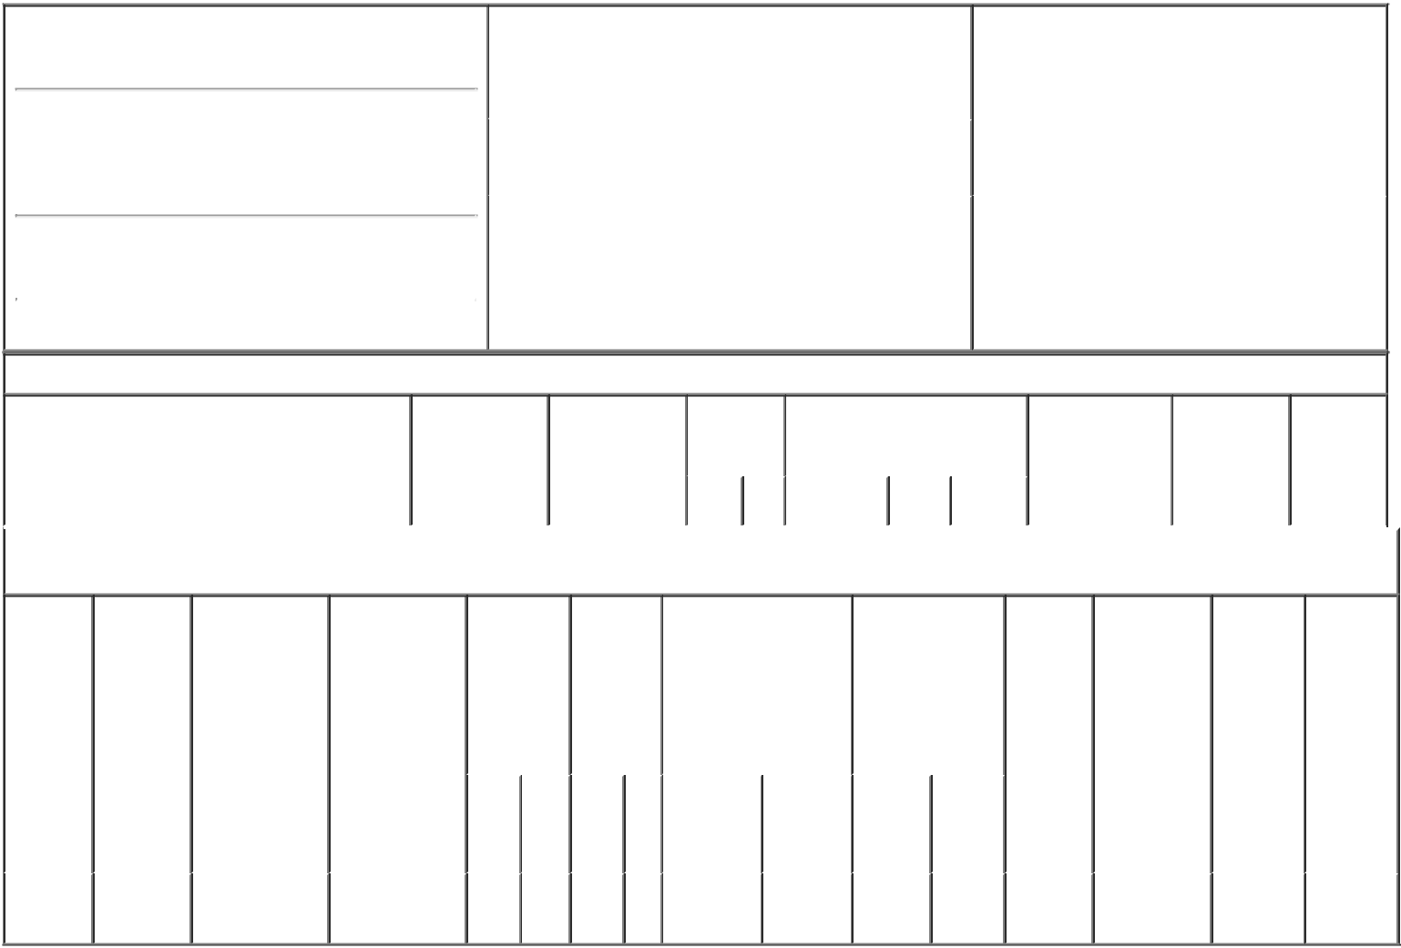

1. Name and Address of Reporting Person*
GULDNER JEFFREY B.

(Last) (First) (Middle)

400 NORTH 5TH STREET

MS 8602

(Street)
 | PHOENIX | AZ | 85004
 | (City) | (State) | (Zip)

2. |  | Issuer Name and Ticker or Trading Symbol |  | 5. Relationship of Reporting Person(s) to Issuer
 | PINNACLE WEST CAPITAL CORP [ PNW ^{(Check all applicable)}
 | ] |  |  | X | Director | 10% Owner
 |  |  |  | X | Officer (give title | Other (specify
 |  |  |  |  | below) | below)
3. |  | Date of Earliest Transaction (Month/Day/Year) |  |  | Chairman, President & CEO
02/18/2020
4. |  | If Amendment, Date of Original Filed (Month/Day/Year) |  | 6. Individual or Joint/Group Filing (Check Applicable
Line)
X Form filed by One Reporting Person

Form filed by More than One Reporting
Person

Table I - Non-Derivative Securities Acquired, Disposed of, or Beneficially Owned

 | 1. Title of Security (Instr. 3) | 2. Transaction | 2A. Deemed | 3. | 4. Securities Acquired (A) or |  |  | 5. Amount of | 6. Ownership | 7. Nature
 |  | Date | Execution Date, | Transaction | Disposed Of (D) (Instr. 3, 4 and |  |  | Securities | Form: Direct | of Indirect
 |  | (Month/Day/Year) | if any | Code (Instr. | 5) |  |  | Beneficially | (D) or Indirect | Beneficial
 |  |  | (Month/Day/Year) | 8) |  |  |  | Owned Following | (I) (Instr. 4) | Ownership
 |  |  |  |  |  |  |  | Reported |  | (Instr. 4)
 |  |  |  | Code V | Amount | (A) or | Price | Transaction(s)
 |  |  |  |  |  | (D) |  | (Instr. 3 and 4)

Table II - Derivative Securities Acquired, Disposed of, or Beneficially Owned

(e.g., puts, calls, warrants, options, convertible securities)

1. Title of | 2. | 3. Transaction | 3A. Deemed | 4. | 5. Number |  | 6. Date Exercisable and |  | 7. Title and |  | 8. Price of | 9. Number of | 10. | 11. Nature
Derivative | Conversion | Date | Execution Date, | Transaction | of |  | Expiration Date |  | Amount of |  | Derivative | derivative | Ownership | of Indirect
Security | or Exercise | (Month/Day/Year) | if any | Code (Instr. | Derivative |  | (Month/Day/Year) |  | Securities |  | Security | Securities | Form: | Beneficial
(Instr. 3) | Price of |  | (Month/Day/Year) | 8) | Securities |  |  |  | Underlying |  | (Instr. 5) | Beneficially | Direct (D) | Ownership
 | Derivative |  |  |  | Acquired |  |  |  | Derivative Security |  |  | Owned | or Indirect | (Instr. 4)
 | Security |  |  |  | (A) or |  |  |  | (Instr. 3 and 4) |  |  | Following | (I) (Instr. 4)
 |  |  |  |  | Disposed |  |  |  |  |  |  | Reported
 |  |  |  |  | of (D) |  |  |  |  |  |  | Transaction(s)
 |  |  |  |  | (Instr. 3, 4 |  |  |  |  |  |  | (Instr. 4)
 |  |  |  |  | and 5)
 |  |  |  |  |  |  |  |  |  | Amount
 |  |  |  |  |  |  |  |  |  | or
 |  |  |  |  |  |  |  |  |  | Number
 |  |  |  |  |  |  | Date | Expiration |  | of
 |  |  |  | Code V | (A) | (D) | Exercisable | Date | Title | Shares
Restricted | (1) |  |  |  |  |  | (2) | (2) | Common | 9,580 | (1)
Stock |  | 02/18/2020 |  | A | 9,580 |  |  |  |  |  |  | 9,580 | D
Units |  |  |  |  |  |  |  |  | Stock

Explanation of Responses:

- Each Restricted Stock Unit represents a contingent right to receive the economic equivalent of one share of the Company's common stock. The Restricted Stock Units will be settled, at the reporting person's election, in 100% shares of common stock, 50% in common stock and 50% in cash, or 100% in cash.

- The Restricted Stock Units award was granted and was effective on February 18, 2020, and vests in four equal, annual installments beginning on February 19, 2021, and will be settled in four equal, annual installments beginning February 19, 2021.

Remarks:

/s/ Diane Wood, Attorney-in- |  |  | 02/20/2020
Fact
** Signature of Reporting Person |  |  | Date

Reminder: Report on a separate line for each class of securities beneficially owned directly or indirectly.

* If the form is filed by more than one reporting person, see Instruction 4 (b)(v).

- Intentional misstatements or omissions of facts constitute Federal Criminal Violations See 18 U.S.C. 1001 and 15 U.S.C. 78ff(a). Note: File three copies of this Form, one of which must be manually signed. If space is insufficient, see Instruction 6 for procedure.
Persons who respond to the collection of information contained in this form are not required to respond unless the form displays a currently valid OMB Number.

