UNITED STATES
SECURITIES AND EXCHANGE COMMISSION
Washington, D.C. 20549

FORM 8-K

CURRENT REPORT
Pursuant to Section 13 or 15(d) of the
Securities Exchange Act of 1934

Date of report (Date of earliest event reported): September 28, 2012

Commission File Number |  | Exact Name of Registrant as Specified in  Charter; State of Incorporation;  Address and Telephone Number |  | IRS Employer  Identification Number
1-8962 |  | Pinnacle West Capital Corporation  (an Arizona corporation)  400 North Fifth Street, P.O. Box 53999  Phoenix, AZ 85072-3999  (602) 250-1000 |  | 86-0512431
1-4473 |  | Arizona Public Service Company  (an Arizona corporation)  400 North Fifth Street, P.O. Box 53999  Phoenix, AZ 85072-3999  (602) 250-1000 |  | 86-0011170

Check the appropriate box below if the Form 8-K filing is intended to simultaneously satisfy the filing obligation of the registrant under any of the following provisions:

o Written communications pursuant to Rule 425 under the Securities Act (17 CFR 230.425)

o Soliciting material pursuant to Rule 14a-12 under the Exchange Act (17 CFR 240.14a-12)

o Pre-commencement communications pursuant to Rule 14d-2(b) under the Exchange Act (17 CFR 240.14d-2(b))

o Pre-commencement communications pursuant to Rule 13e-4(c) under the Exchange Act (17 CFR 240.13e-4(c))

This combined Form 8-K is separately filed or furnished by Pinnacle West Capital Corporation and Arizona Public Service Company. Each registrant is filing or furnishing on its own behalf all of the information contained in this Form 8-K that relates to such registrant and, where required, its subsidiaries. Except as stated in the preceding sentence, neither registrant is filing or furnishing any information that does not relate to such registrant, and therefore makes no representation as to any such information.

Item 7.01 Regulation FD Disclosure.

Investor and Analyst Meeting

Pinnacle West Capital Corporation (Pinnacle West) will be participating in various investor meetings from October 1, 2012 through October 5, 2012 and will be utilizing handouts during those meetings. Copies of the handouts are attached hereto as Exhibit 99.1.

Item 9.01 Financial Statements and Exhibits.

(d) Exhibits

Exhibit  No. |  | Registrant(s) |  | Description
99.1 |  | Pinnacle West  Arizona Public  Service Company |  | Pinnacle West handouts for use at various investor meetings from October 1, 2012 through October 5, 2012.

2

SIGNATURES

Pursuant to the requirements of the Securities Exchange Act of 1934, each registrant has duly caused this report to be signed on its behalf by the undersigned hereunto duly authorized.

 | PINNACLE WEST CAPITAL CORPORATION
 | (Registrant)
Dated: September 28, 2012 | By: | /s/ James R. Hatfield
 | James R. Hatfield
 | Senior Vice President and Chief Financial
 | Officer
 | ARIZONA PUBLIC SERVICE COMPANY
 | (Registrant)
Dated: September 28, 2012 | By: | /s/ James R. Hatfield
 | James R. Hatfield
 | Senior Vice President and Chief Financial
 | Officer

3

Exhibit 99.1

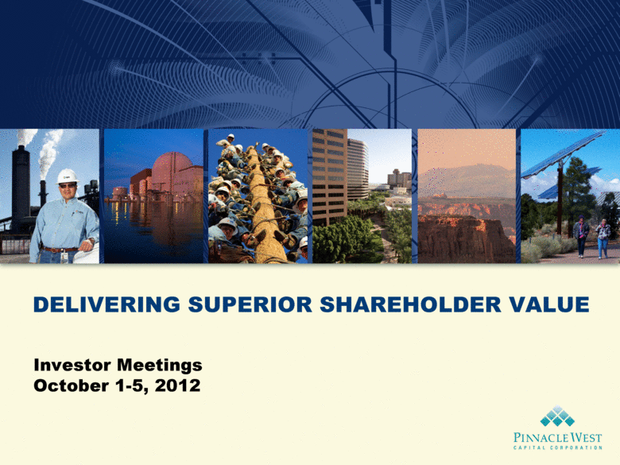 | DELIVERING SUPERIOR SHAREHOLDER VALUE Investor Meetings October 1-5, 2012

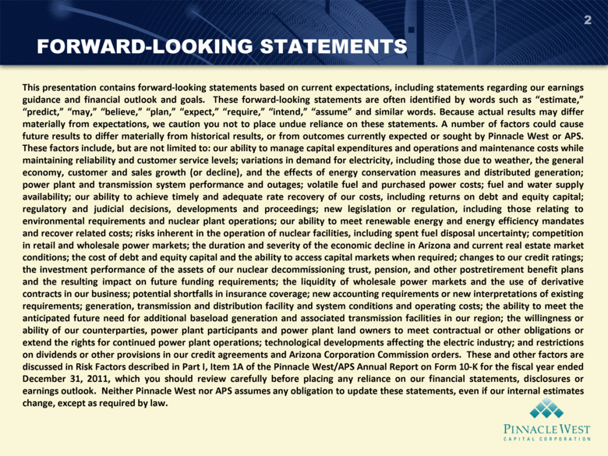 | FORWARD-LOOKING STATEMENTS 2 This presentation contains forward-looking statements based on current expectations, including statements regarding our earnings guidance and financial outlook and goals. These forward-looking statements are often identified by words such as estimate, predict, may, believe, plan, expect, require, intend, assume and similar words. Because actual results may differ materially from expectations, we caution you not to place undue reliance on these statements. A number of factors could cause future results to differ materially from historical results, or from outcomes currently expected or sought by Pinnacle West or APS. These factors include, but are not limited to: our ability to manage capital expenditures and operations and maintenance costs while maintaining reliability and customer service levels; variations in demand for electricity, including those due to weather, the general economy, customer and sales growth (or decline), and the effects of energy conservation measures and distributed generation; power plant and transmission system performance and outages; volatile fuel and purchased power costs; fuel and water supply availability; our ability to achieve timely and adequate rate recovery of our costs, including returns on debt and equity capital; regulatory and judicial decisions, developments and proceedings; new legislation or regulation, including those relating to environmental requirements and nuclear plant operations; our ability to meet renewable energy and energy efficiency mandates and recover related costs; risks inherent in the operation of nuclear facilities, including spent fuel disposal uncertainty; competition in retail and wholesale power markets; the duration and severity of the economic decline in Arizona and current real estate market conditions; the cost of debt and equity capital and the ability to access capital markets when required; changes to our credit ratings; the investment performance of the assets of our nuclear decommissioning trust, pension, and other postretirement benefit plans and the resulting impact on future funding requirements; the liquidity of wholesale power markets and the use of derivative contracts in our business; potential shortfalls in insurance coverage; new accounting requirements or new interpretations of existing requirements; generation, transmission and distribution facility and system conditions and operating costs; the ability to meet the anticipated future need for additional baseload generation and associated transmission facilities in our region; the willingness or ability of our counterparties, power plant participants and power plant land owners to meet contractual or other obligations or extend the rights for continued power plant operations; technological developments affecting the electric industry; and restrictions on dividends or other provisions in our credit agreements and Arizona Corporation Commission orders. These and other factors are discussed in Risk Factors described in Part I, Item 1A of the Pinnacle West/APS Annual Report on Form 10-K for the fiscal year ended December 31, 2011, which you should review carefully before placing any reliance on our financial statements, disclosures or earnings outlook. Neither Pinnacle West nor APS assumes any obligation to update these statements, even if our internal estimates change, except as required by law.

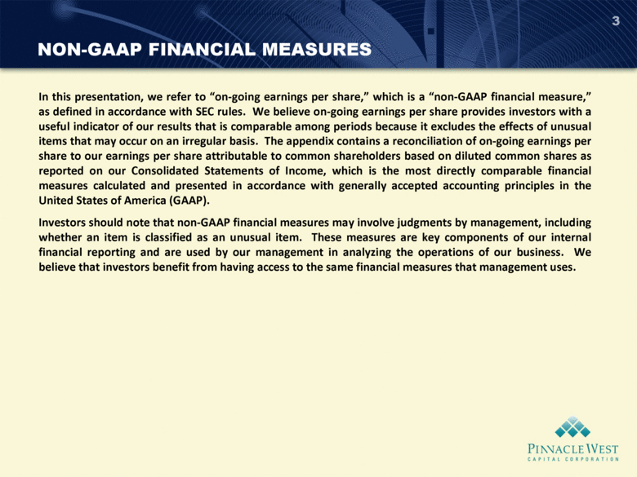 | NON-GAAP FINANCIAL MEASURES 3 In this presentation, we refer to on-going earnings per share, which is a non-GAAP financial measure, as defined in accordance with SEC rules. We believe on-going earnings per share provides investors with a useful indicator of our results that is comparable among periods because it excludes the effects of unusual items that may occur on an irregular basis. The appendix contains a reconciliation of on-going earnings per share to our earnings per share attributable to common shareholders based on diluted common shares as reported on our Consolidated Statements of Income, which is the most directly comparable financial measures calculated and presented in accordance with generally accepted accounting principles in the United States of America (GAAP). Investors should note that non-GAAP financial measures may involve judgments by management, including whether an item is classified as an unusual item. These measures are key components of our internal financial reporting and are used by our management in analyzing the operations of our business. We believe that investors benefit from having access to the same financial measures that management uses.

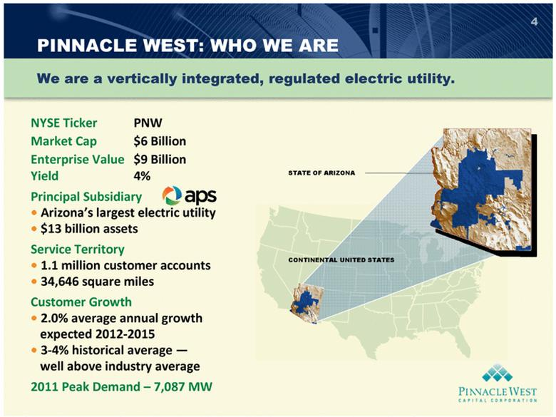 | 4 NYSE Ticker PNW Market Cap $6 Billion Enterprise Value $9 Billion Yield 4% Principal Subsidiary  Arizonas largest electric utility  $13 billion assets Service Territory  1.1 million customer accounts  34,646 square miles Customer Growth  2.0% average annual growth expected 2012-2015  3-4% historical average  well above industry average 2011 Peak Demand  7,087 MW CONTINENTAL UNITED STATES STATE OF ARIZONA PINNACLE WEST: WHO WE ARE We are a vertically integrated, regulated electric utility.

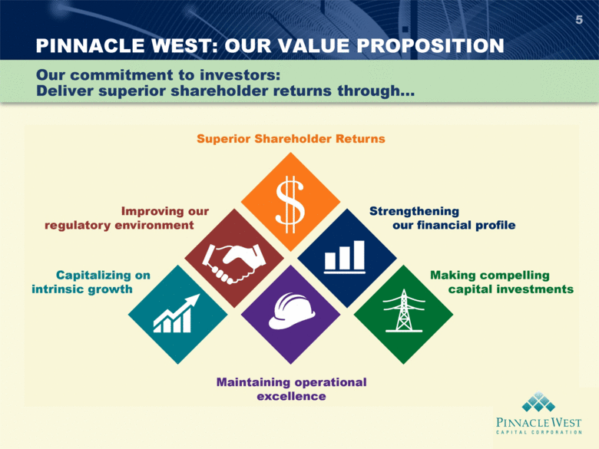 | PINNACLE WEST: OUR VALUE PROPOSITION 5 Our commitment to investors: Deliver superior shareholder returns through

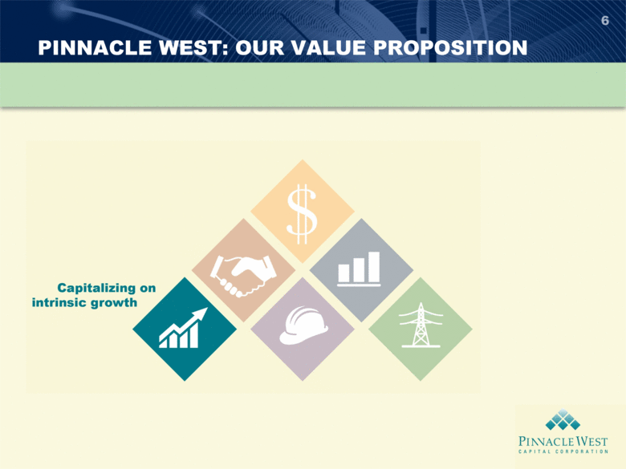 | PINNACLE WEST: OUR VALUE PROPOSITION 6

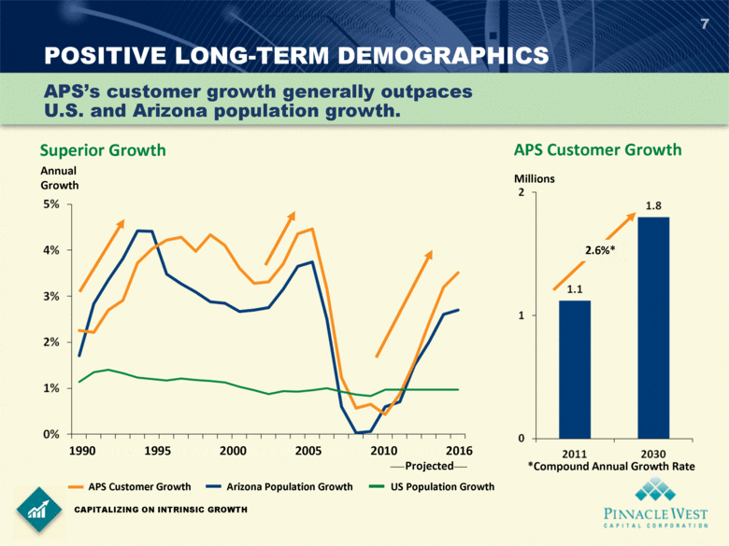 | POSITIVE LONG-TERM DEMOGRAPHICS 7 CAPITALIZING ON INTRINSIC GROWTH Superior Growth APSs customer growth generally outpaces U.S. and Arizona population growth. Annual Growth 1990 1995 2000 2005 2010 2016 Projected APS Customer Growth Arizona Population Growth US Population Growth 2.6%* Millions APS Customer Growth *Compound Annual Growth Rate

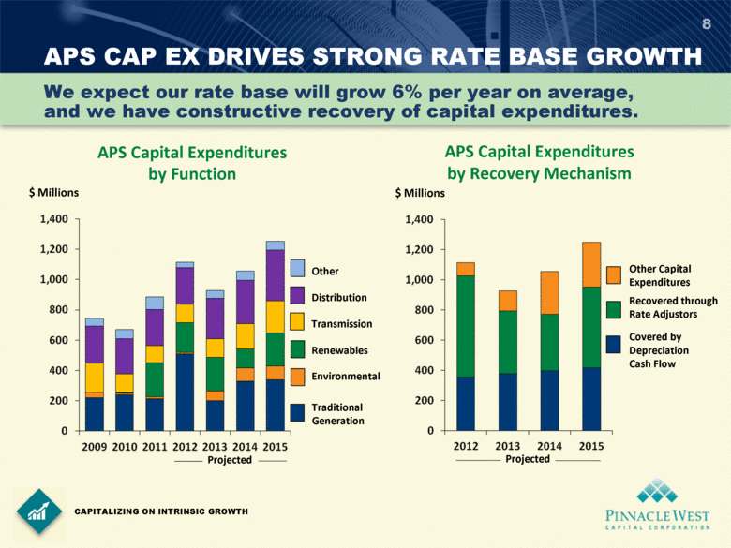 | 8 We expect our rate base will grow 6% per year on average, and we have constructive recovery of capital expenditures. APS CAP EX DRIVES STRONG RATE BASE GROWTH CAPITALIZING ON INTRINSIC GROWTH APS Capital Expenditures by Function $ Millions Projected Other Distribution Transmission Renewables Environmental Traditional Generation $ Millions Other Capital Expenditures Recovered through Rate Adjustors Covered by Depreciation Cash Flow APS Capital Expenditures by Recovery Mechanism Projected

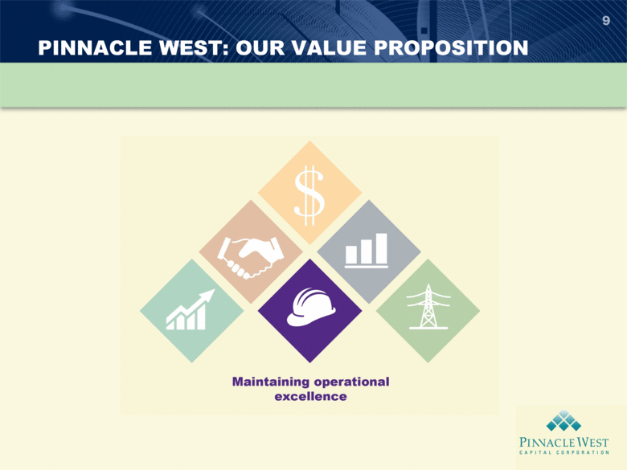 | PINNACLE WEST: OUR VALUE PROPOSITION 9

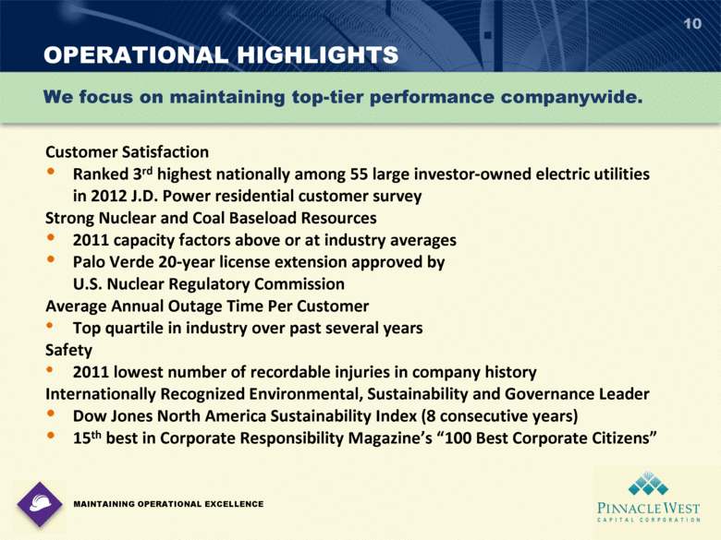 | OPERATIONAL HIGHLIGHTS 10 Customer Satisfaction Ranked 3rd highest nationally among 55 large investor-owned electric utilities in 2012 J.D. Power residential customer survey Strong Nuclear and Coal Baseload Resources 2011 capacity factors above or at industry averages Palo Verde 20-year license extension approved by U.S. Nuclear Regulatory Commission Average Annual Outage Time Per Customer Top quartile in industry over past several years Safety 2011 lowest number of recordable injuries in company history Internationally Recognized Environmental, Sustainability and Governance Leader Dow Jones North America Sustainability Index (8 consecutive years) 15th best in Corporate Responsibility Magazines 100 Best Corporate Citizens We focus on maintaining top-tier performance companywide. MAINTAINING OPERATIONAL EXCELLENCE PINNACLE WEST CAPITAL CORPORATION

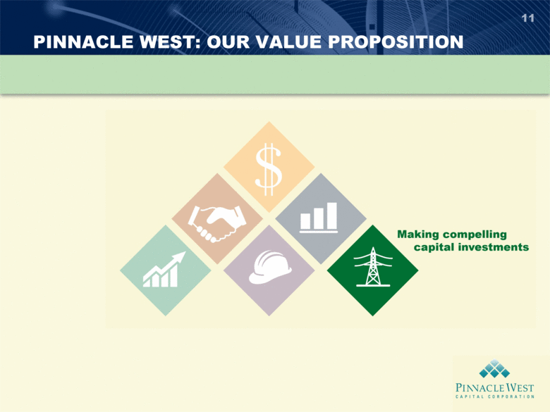 | PINNACLE WEST: OUR VALUE PROPOSITION 11

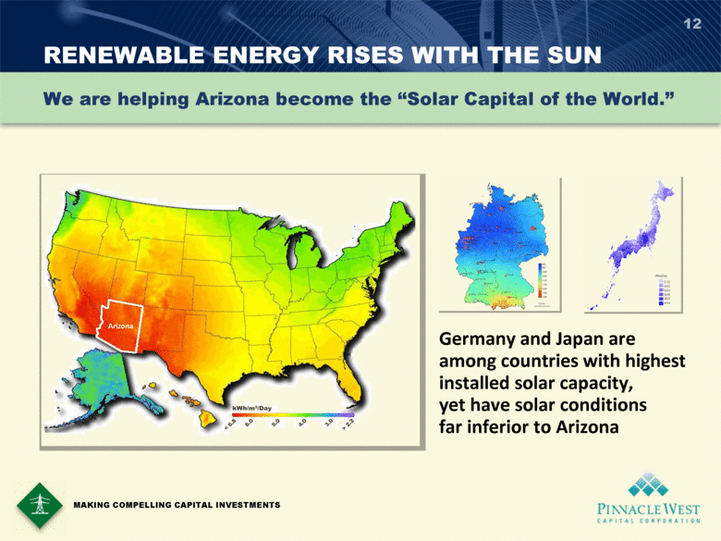 | RENEWABLE ENERGY RISES WITH THE SUN 12 We are helping Arizona become the Solar Capital of the World. Germany and Japan are among countries with highest installed solar capacity, yet have solar conditions far inferior to Arizona MAKING COMPELLING CAPITAL INVESTMENTS Arizona PINNACLE WEST CAPITAL CORPORATION

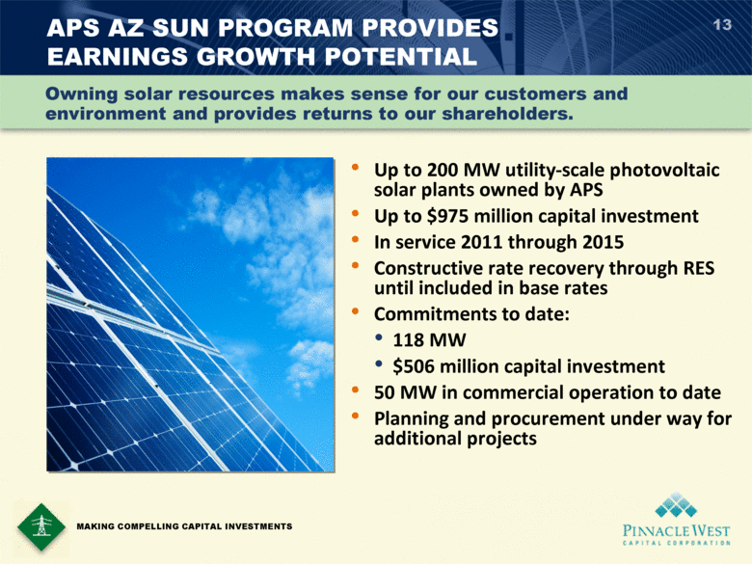 | APS AZ SUN PROGRAM PROVIDES EARNINGS GROWTH POTENTIAL Up to 200 MW utility-scale photovoltaic solar plants owned by APS Up to $975 million capital investment In service 2011 through 2015 Constructive rate recovery through RES until included in base rates Commitments to date: 118 MW $506 million capital investment 50 MW in commercial operation to date Planning and procurement under way for additional projects 13 MAKING COMPELLING CAPITAL INVESTMENTS Owning solar resources makes sense for our customers and environment and provides returns to our shareholders.

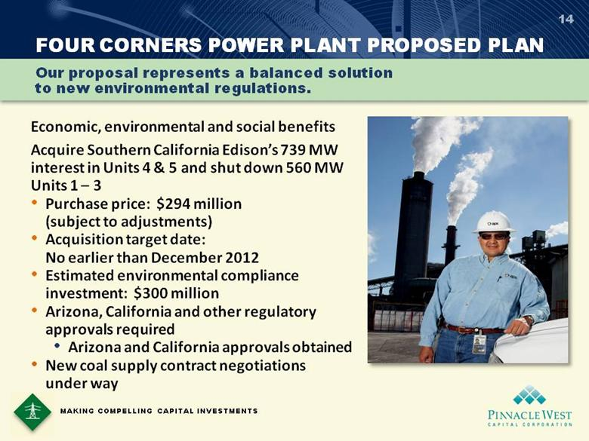 | 14 MAKING COMPELLING CAPITAL INVESTMENTS FOUR CORNERS POWER PLANT PROPOSED PLAN Our proposal represents a balanced solution to new environmental regulations. Economic, environmental and social benefits Acquire Southern California Edisons 739 MW interest in Units 4 & 5 and shut down 560 MW Units 1  3 Purchase price: $294 million (subject to adjustments) Acquisition target date: No earlier than December 2012 Estimated environmental compliance investment: $300 million Arizona, California and other regulatory approvals required Arizona and California approvals obtained New coal supply contract negotiations under way

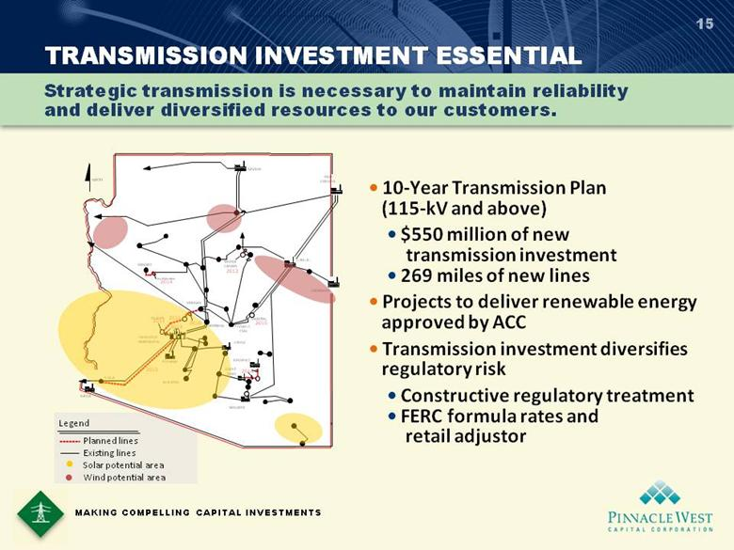 | TRANSMISSION INVESTMENT ESSENTIAL 15  10-Year Transmission Plan (115-kV and above)  $550 million of new transmission investment  269 miles of new lines  Projects to deliver renewable energy approved by ACC  Transmission investment diversifies regulatory risk  Constructive regulatory treatment  FERC formula rates and retail adjustor Strategic transmission is necessary to maintain reliability and deliver diversified resources to our customers. 100 MW 970 MW 1032 MW 350 MW 4300 MW 1005 MW Legend NORTH SAGUARO N . GILA PALO VERDE - HASSAYAMPA YUCCA GILA BEND REDHAWK KYRENE WESTWING BAGDAD 2016 PINNACLE PEAK CHOLLA NAVAJO 2015 CORONADO YOUNGS CANYON 2012 SUNDANCE 2014 FOUR CORNERS DESERT BASIN Line Relocation 2014 Planned lines Existing lines Solar potential area Wind potential area 2013 DELANEY 2013 MAZATZAL 2015 MORGAN 2015 MAKING COMPELLING CAPITAL INVESTMENTS

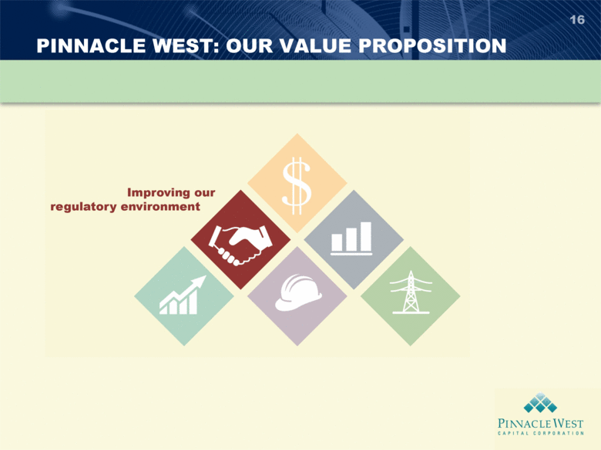 | PINNACLE WEST: OUR VALUE PROPOSITION 16

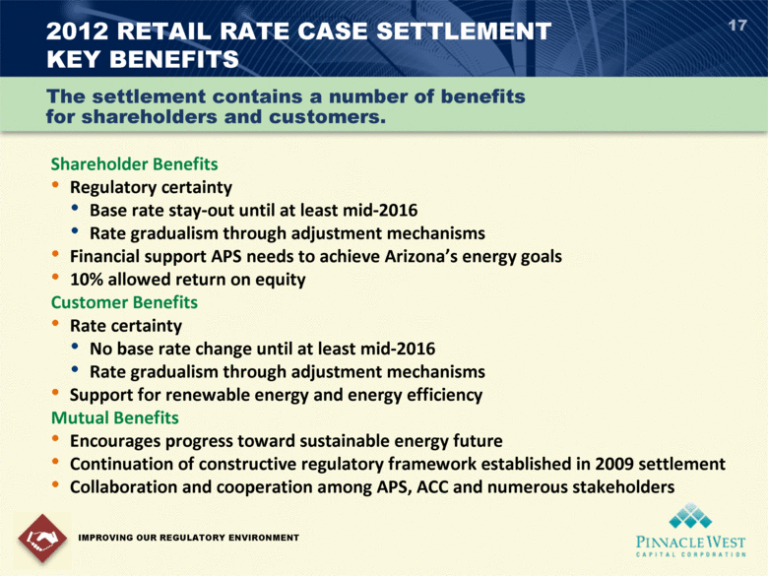 | 2012 RETAIL RATE CASE SETTLEMENT KEY BENEFITS 17 Shareholder Benefits Regulatory certainty Base rate stay-out until at least mid-2016 Rate gradualism through adjustment mechanisms Financial support APS needs to achieve Arizonas energy goals 10% allowed return on equity Customer Benefits Rate certainty No base rate change until at least mid-2016 Rate gradualism through adjustment mechanisms Support for renewable energy and energy efficiency Mutual Benefits Encourages progress toward sustainable energy future Continuation of constructive regulatory framework established in 2009 settlement Collaboration and cooperation among APS, ACC and numerous stakeholders IMPROVING OUR REGULATORY ENVIRONMENT The settlement contains a number of benefits for shareholders and customers.

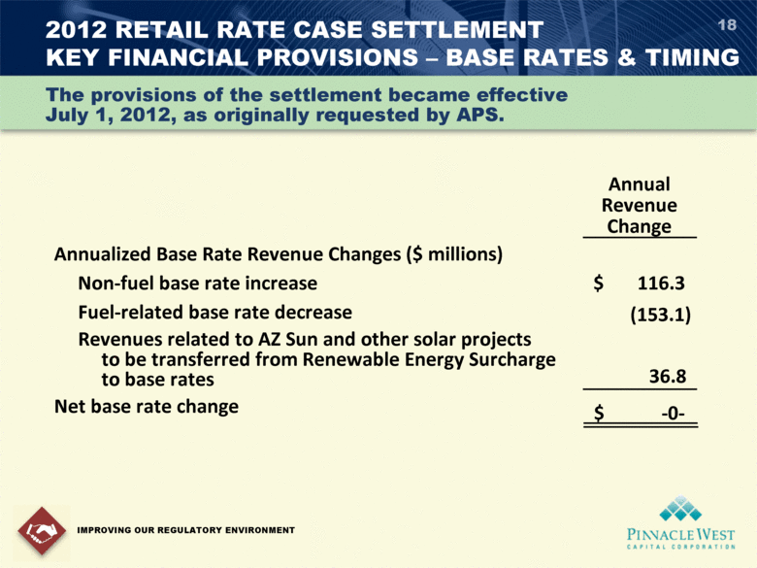 | 2012 RETAIL RATE CASE SETTLEMENT KEY FINANCIAL PROVISIONS  BASE RATES & TIMING 18 The provisions of the settlement became effective July 1, 2012, as originally requested by APS. IMPROVING OUR REGULATORY ENVIRONMENT Annual Revenue Change Annualized Base Rate Revenue Changes ($ millions) Non-fuel base rate increase $ 116.3 Fuel-related base rate decrease (153.1) Revenues related to AZ Sun and other solar projects to be transferred from Renewable Energy Surcharge to base rates 36.8 Net base rate change $ -0-

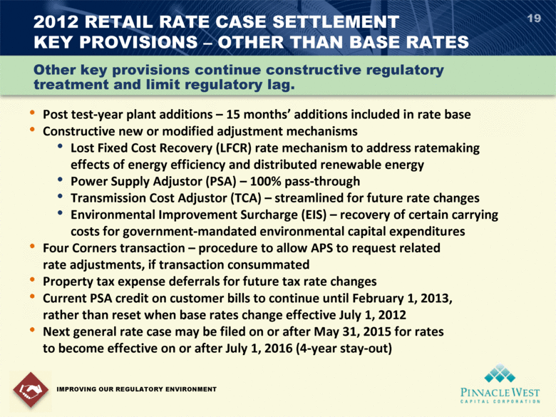 | 2012 RETAIL RATE CASE SETTLEMENT KEY PROVISIONS  OTHER THAN BASE RATES 19 • Post test-year plant additions  15 months additions included in rate base • Constructive new or modified adjustment mechanisms • Lost Fixed Cost Recovery (LFCR) rate mechanism to address ratemaking effects of energy efficiency and distributed renewable energy • Power Supply Adjustor (PSA)  100% pass-through • Transmission Cost Adjustor (TCA)  streamlined for future rate changes • Environmental Improvement Surcharge (EIS)  recovery of certain carrying costs for government-mandated environmental capital expenditures • Four Corners transaction  procedure to allow APS to request related rate adjustments, if transaction consummated • Property tax expense deferrals for future tax rate changes • Current PSA credit on customer bills to continue until February 1, 2013, rather than reset when base rates change effective July 1, 2012 • Next general rate case may be filed on or after May 31, 2015 for rates to become effective on or after July 1, 2016 (4-year stay-out) IMPROVING OUR REGULATORY ENVIRONMENT Other key provisions continue constructive regulatory treatment and limit regulatory lag.

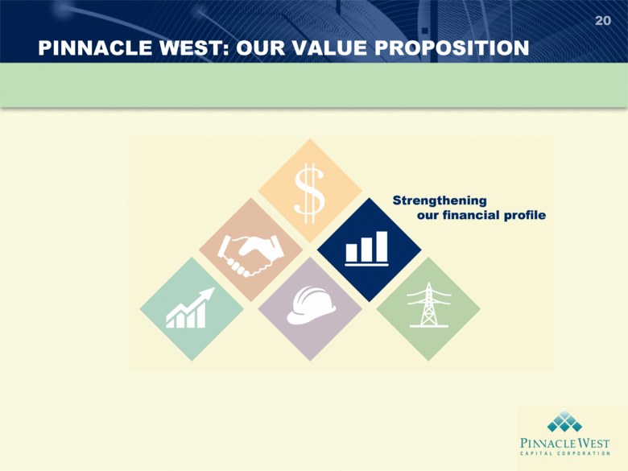 | PINNACLE WEST: OUR VALUE PROPOSITION 20

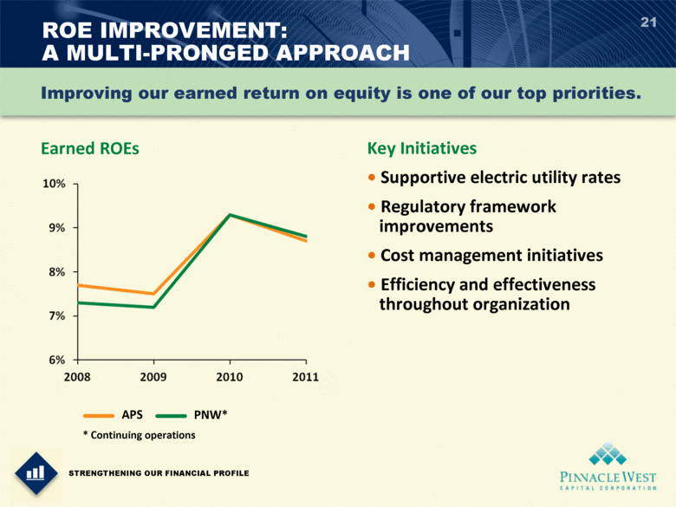 | 21 Improving our earned return on equity is one of our top priorities. Earned ROEs Key Initiatives  Supportive electric utility rates  Regulatory framework improvements  Cost management initiatives  Efficiency and effectiveness throughout organization STRENGTHENING OUR FINANCIAL PROFILE ROE IMPROVEMENT: A MULTI-PRONGED APPROACH * Continuing operations APS PNW*

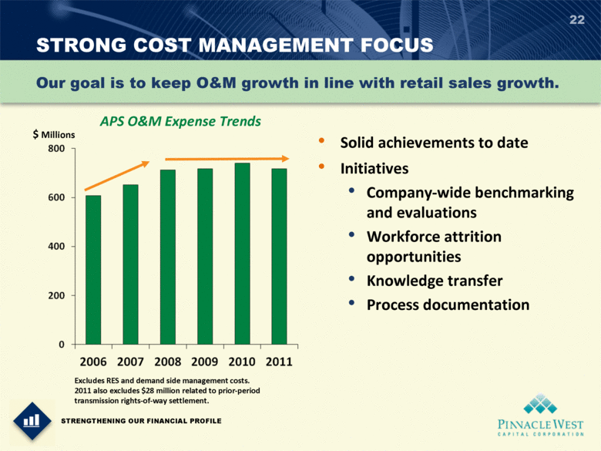 | 22 Our goal is to keep O&M growth in line with retail sales growth. STRENGTHENING OUR FINANCIAL PROFILE STRONG COST MANAGEMENT FOCUS • Solid achievements to date • Initiatives • Company-wide benchmarking and evaluations • Workforce attrition opportunities • Knowledge transfer • Process documentation Excludes RES and demand side management costs. 2011 also excludes $28 million related to prior-period transmission rights-of-way settlement. APS O&M Expense Trends $ Millions

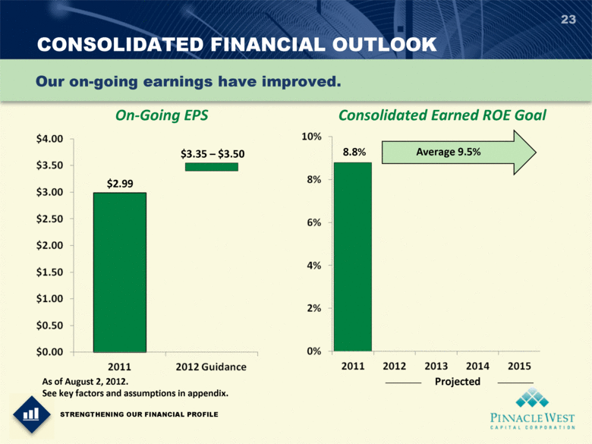 | 23 Our on-going earnings have improved. STRENGTHENING OUR FINANCIAL PROFILE CONSOLIDATED FINANCIAL OUTLOOK On-Going EPS As of August 2, 2012. See key factors and assumptions in appendix. $2.99 $3.35  $3.50 Projected Consolidated Earned ROE Goal 8.8% Average 9.5%

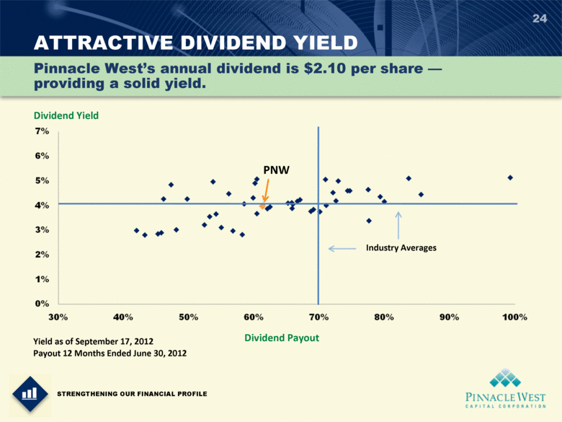 | ATTRACTIVE DIVIDEND YIELD 24 Dividend Yield Dividend Payout Industry Averages PNW Yield as of September 17, 2012 Payout 12 Months Ended June 30, 2012 Pinnacle Wests annual dividend is $2.10 per share  providing a solid yield. STRENGTHENING OUR FINANCIAL PROFILE

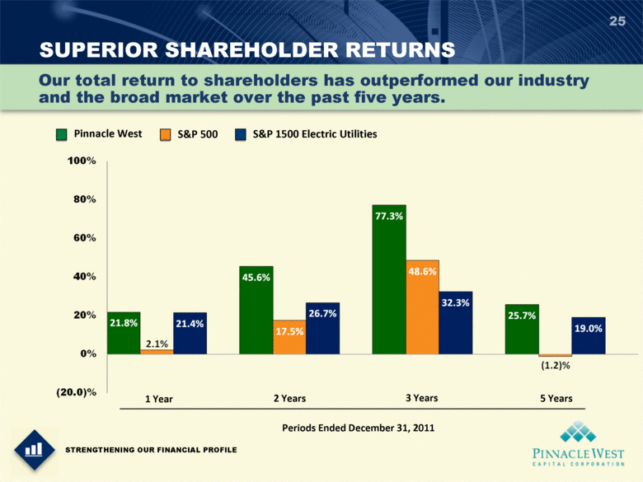 | SUPERIOR SHAREHOLDER RETURNS 25 Our total return to shareholders has outperformed our industry and the broad market over the past five years. STRENGTHENING OUR FINANCIAL PROFILE Pinnacle West S&P 500 S&P 1500 Electric Utilities 1 Year 2 Years 3 Years 5 Years Periods Ended December 31, 2011

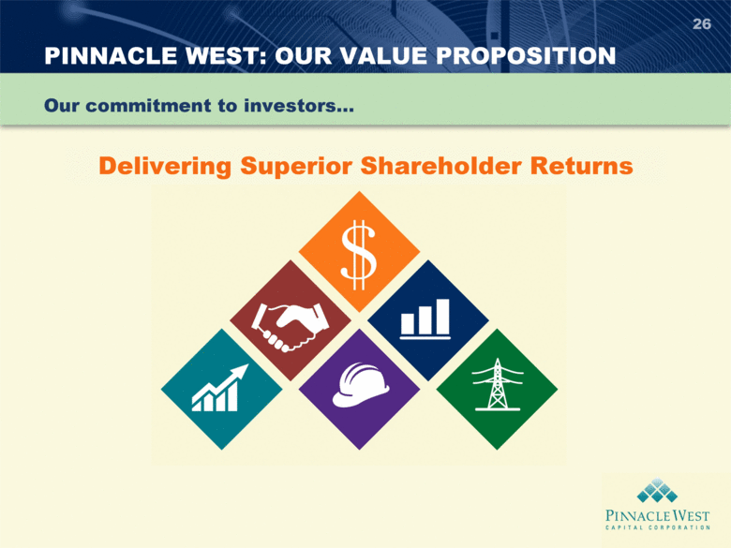 | PINNACLE WEST: OUR VALUE PROPOSITION 26 Our commitment to investors... Delivering Superior Shareholder Returns

APPENDIX

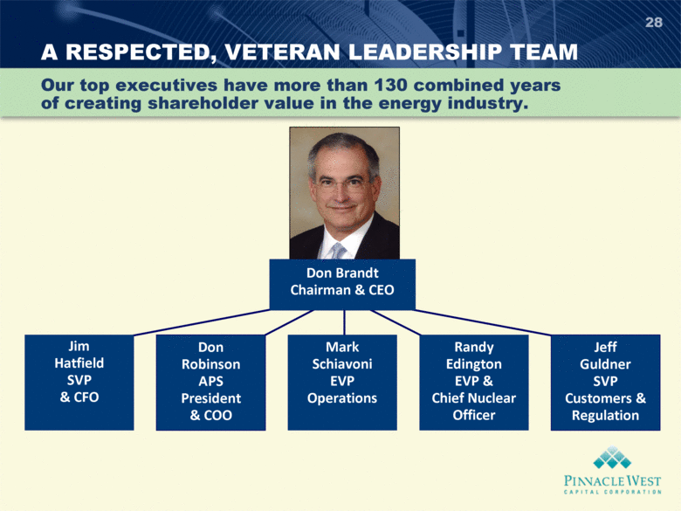 | A RESPECTED, VETERAN LEADERSHIP TEAM Jim Hatfield SVP & CFO 28 Our top executives have more than 130 combined years of creating shareholder value in the energy industry. Don Brandt Chairman & CEO Mark Schiavoni EVP Operations Jeff Guldner SVP Customers & Regulation Randy Edington EVP & Chief Nuclear Officer Don Robinson APS President & COO

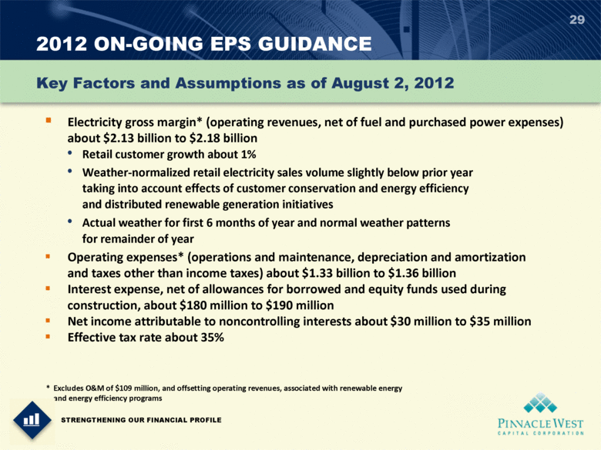 | 2012 ON-GOING EPS GUIDANCE 29 Electricity gross margin* (operating revenues, net of fuel and purchased power expenses) about $2.13 billion to $2.18 billion Retail customer growth about 1% Weather-normalized retail electricity sales volume slightly below prior year taking into account effects of customer conservation and energy efficiency and distributed renewable generation initiatives Actual weather for first 6 months of year and normal weather patterns for remainder of year Operating expenses* (operations and maintenance, depreciation and amortization and taxes other than income taxes) about $1.33 billion to $1.36 billion Interest expense, net of allowances for borrowed and equity funds used during construction, about $180 million to $190 million Net income attributable to noncontrolling interests about $30 million to $35 million Effective tax rate about 35% Key Factors and Assumptions as of August 2, 2012 * Excludes O&M of $109 million, and offsetting operating revenues, associated with renewable energy and energy efficiency programs STRENGTHENING OUR FINANCIAL PROFILE

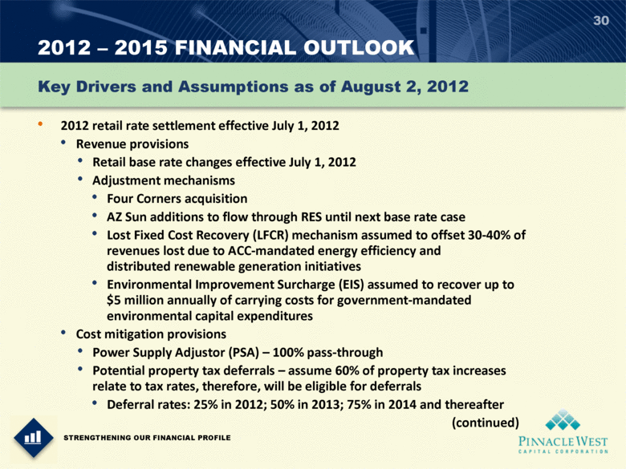 | 2012  2015 FINANCIAL OUTLOOK 30 2012 retail rate settlement effective July 1, 2012 Revenue provisions Retail base rate changes effective July 1, 2012 Adjustment mechanisms Four Corners acquisition AZ Sun additions to flow through RES until next base rate case Lost Fixed Cost Recovery (LFCR) mechanism assumed to offset 30-40% of revenues lost due to ACC-mandated energy efficiency and distributed renewable generation initiatives Environmental Improvement Surcharge (EIS) assumed to recover up to $5 million annually of carrying costs for government-mandated environmental capital expenditures Cost mitigation provisions Power Supply Adjustor (PSA)  100% pass-through Potential property tax deferrals  assume 60% of property tax increases relate to tax rates, therefore, will be eligible for deferrals Deferral rates: 25% in 2012; 50% in 2013; 75% in 2014 and thereafter (continued) Key Drivers and Assumptions as of August 2, 2012 STRENGTHENING OUR FINANCIAL PROFILE

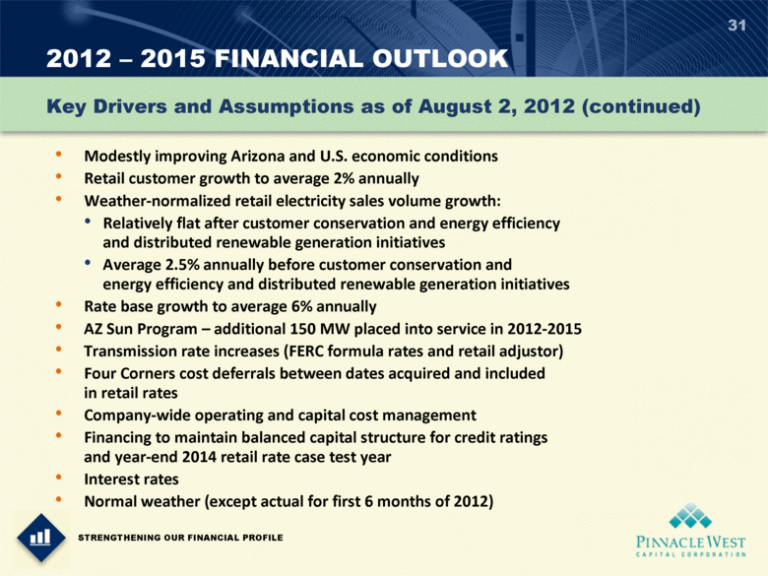 | 2012  2015 FINANCIAL OUTLOOK 31 Key Drivers and Assumptions as of August 2, 2012 (continued) Modestly improving Arizona and U.S. economic conditions Retail customer growth to average 2% annually Weather-normalized retail electricity sales volume growth: Relatively flat after customer conservation and energy efficiency and distributed renewable generation initiatives Average 2.5% annually before customer conservation and energy efficiency and distributed renewable generation initiatives Rate base growth to average 6% annually AZ Sun Program  additional 150 MW placed into service in 2012-2015 Transmission rate increases (FERC formula rates and retail adjustor) Four Corners cost deferrals between dates acquired and included in retail rates Company-wide operating and capital cost management Financing to maintain balanced capital structure for credit ratings and year-end 2014 retail rate case test year Interest rates Normal weather (except actual for first 6 months of 2012) STRENGTHENING OUR FINANCIAL PROFILE

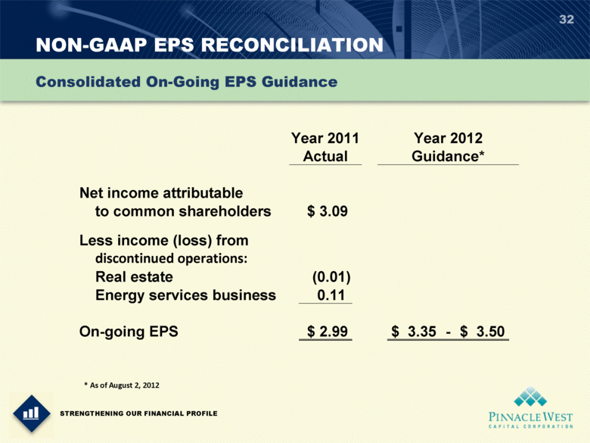 | NON-GAAP EPS RECONCILIATION 32 Consolidated On-Going EPS Guidance Year 2011 Year 2012 Actual Guidance* Net income attributable to common shareholders $ 3.09 Less income (loss) from discontinued operations: Real estate (0.01) Energy services business 0.11 On-going EPS $ 2.99 $ 3.35 - $ 3.50 * As of August 2, 2012 STRENGTHENING OUR FINANCIAL PROFILE

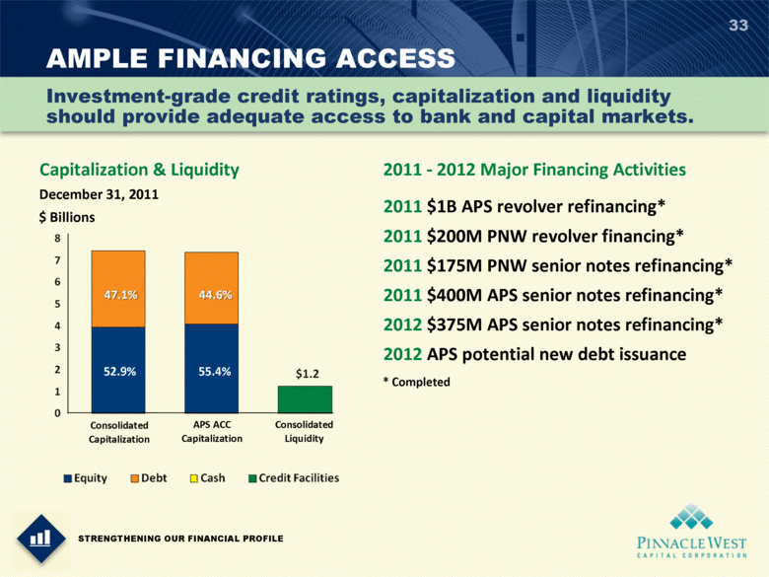 | AMPLE FINANCING ACCESS 33 Investment-grade credit ratings, capitalization and liquidity should provide adequate access to bank and capital markets. STRENGTHENING OUR FINANCIAL PROFILE Capitalization & Liquidity $ Billions Consolidated Capitalization APS ACC Capitalization Consolidated Liquidity December 31, 2011 52.9% 55.4% 2011 $1B APS revolver refinancing* 2011 $200M PNW revolver financing* 2011 $175M PNW senior notes refinancing* 2011 $400M APS senior notes refinancing* 2012 $375M APS senior notes refinancing* 2012 APS potential new debt issuance 2011 - 2012 Major Financing Activities * Completed

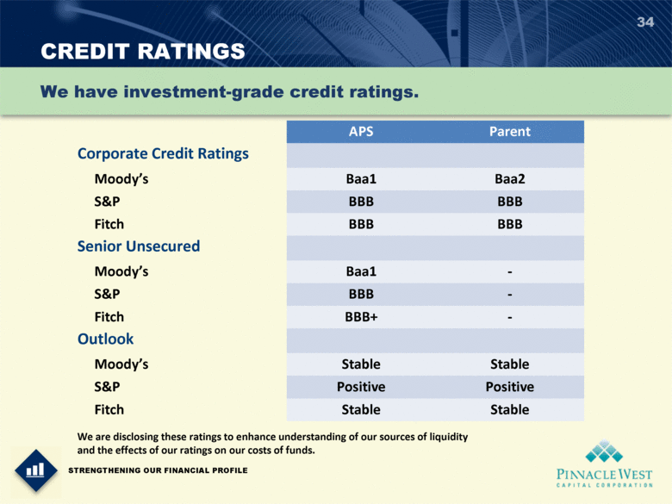 | CREDIT RATINGS 34 We have investment-grade credit ratings. STRENGTHENING OUR FINANCIAL PROFILE We are disclosing these ratings to enhance understanding of our sources of liquidity and the effects of our ratings on our costs of funds. APS Parent Corporate Credit Ratings Moodys Baa1 Baa2 S&P BBB BBB Fitch BBB BBB Senior Unsecured Moodys Baa1 - S&P BBB - Fitch BBB+ - Outlook Moodys Stable Stable S&P Positive Positive Fitch Stable Stable

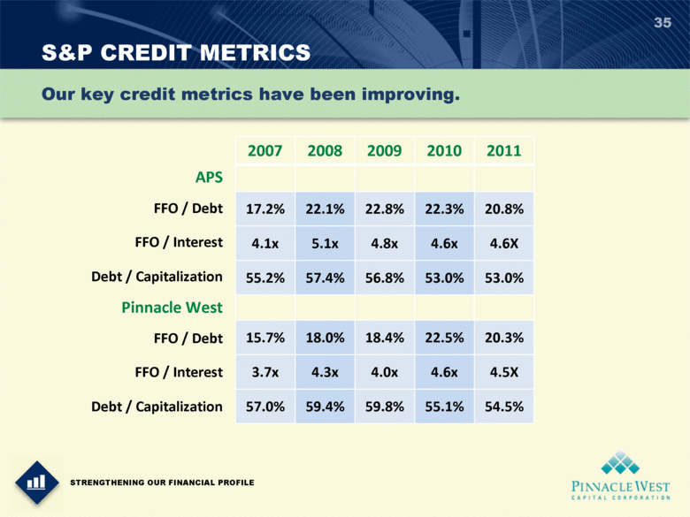 | S&P CREDIT METRICS 35 APS FFO / Debt FFO / Interest Debt / Capitalization Pinnacle West FFO / Debt FFO / Interest Debt / Capitalization Our key credit metrics have been improving. STRENGTHENING OUR FINANCIAL PROFILE 2007 2008 2009 2010 2011 17.2% 22.1% 22.8% 22.3% 20.8% 4.1x 5.1x 4.8x 4.6x 4.6X 55.2% 57.4% 56.8% 53.0% 53.0% 15.7% 18.0% 18.4% 22.5% 20.3% 3.7x 4.3x 4.0x 4.6x 4.5X 57.0% 59.4% 59.8% 55.1% 54.5%

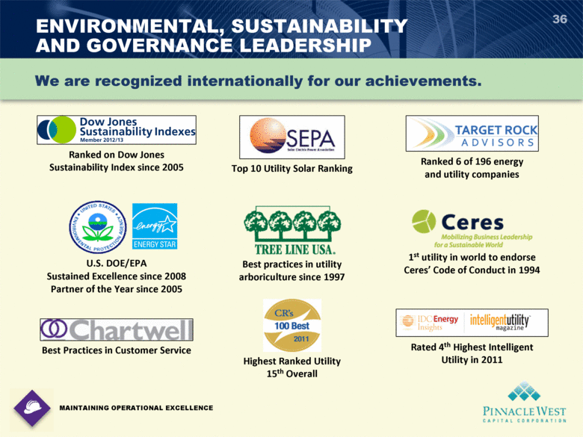 | ENVIRONMENTAL, SUSTAINABILITY AND GOVERNANCE LEADERSHIP 36 MAINTAINING OPERATIONAL EXCELLENCE We are recognized internationally for our achievements. Highest Ranked Utility 15th Overall Best practices in utility arboriculture since 1997 U.S. DOE/EPA Sustained Excellence since 2008 Partner of the Year since 2005 Ranked on Dow Jones Sustainability Index since 2005 1st utility in world to endorse Ceres Code of Conduct in 1994 Ranked 6 of 196 energy and utility companies Top 10 Utility Solar Ranking Best Practices in Customer Service Rated 4th Highest Intelligent Utility in 2011

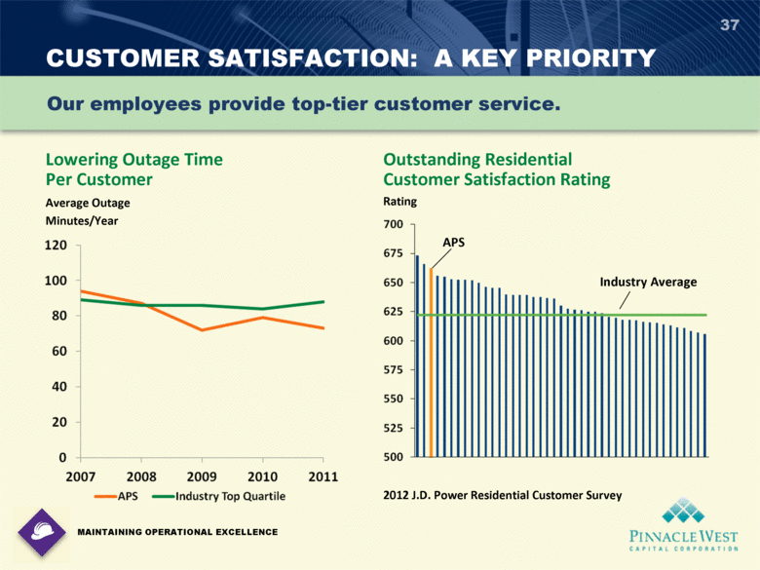 | CUSTOMER SATISFACTION: A KEY PRIORITY 37 Our employees provide top-tier customer service. MAINTAINING OPERATIONAL EXCELLENCE Lowering Outage Time Per Customer Average Outage Minutes/Year Outstanding Residential Customer Satisfaction Rating Rating 2012 J.D. Power Residential Customer Survey APS Industry Average APS Industry Top Quartile

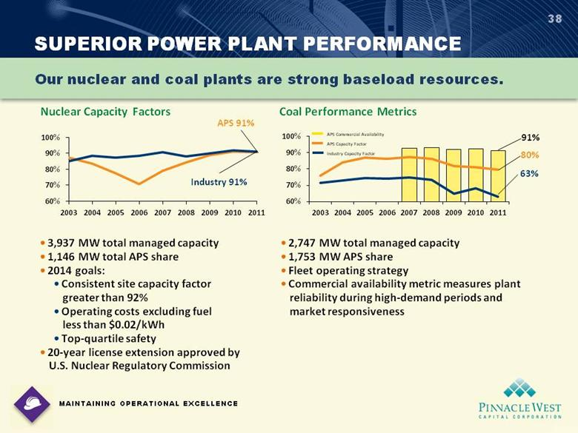 | Coal Performance Metrics Nuclear Capacity Factors SUPERIOR POWER PLANT PERFORMANCE 38 Our nuclear and coal plants are strong baseload resources. MAINTAINING OPERATIONAL EXCELLENCE APS Commercial Availability APS Capacity Factor Industry Capacity Factor Industry 91% APS 91% 63% 80% 91%  3,937 MW total managed capacity  1,146 MW total APS share  2014 goals:  Consistent site capacity factor greater than 92%  Operating costs excluding fuel less than $0.02/kWh  Top-quartile safety  20-year license extension approved by U.S. Nuclear Regulatory Commission  2,747 MW total managed capacity  1,753 MW APS share  Fleet operating strategy  Commercial availability metric measures plant reliability during high-demand periods and market responsiveness

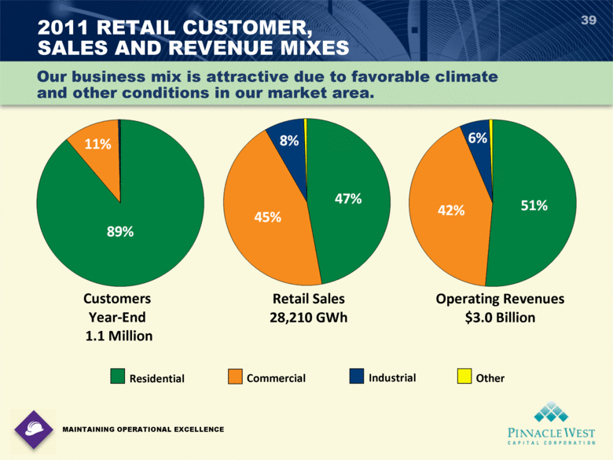 | 2011 RETAIL CUSTOMER, SALES AND REVENUE MIXES 39 Residential Commercial Industrial Other Customers Year-End 1.1 Million Retail Sales 28,210 GWh Operating Revenues $3.0 Billion 8% 45% 47% 11% 89% 6% 42% 51% Our business mix is attractive due to favorable climate and other conditions in our market area. MAINTAINING OPERATIONAL EXCELLENCE

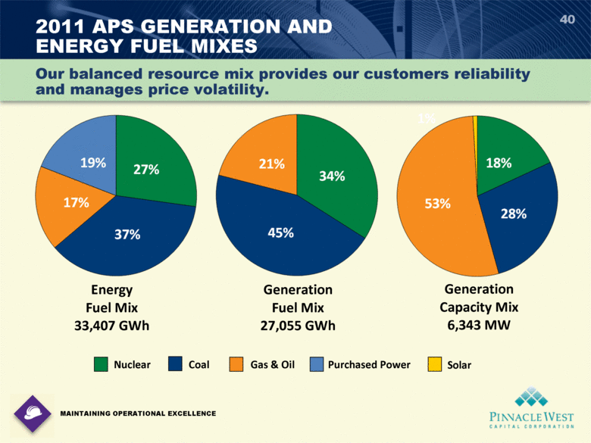 | 40 2011 APS GENERATION AND ENERGY FUEL MIXES Energy Fuel Mix 33,407 GWh Generation Fuel Mix 27,055 GWh Generation Capacity Mix 6,343 MW Nuclear Coal Gas & Oil Purchased Power Our balanced resource mix provides our customers reliability and manages price volatility. MAINTAINING OPERATIONAL EXCELLENCE 45% 34% 21% 37% 27% 17% 19% 53% 28% 18% Solar

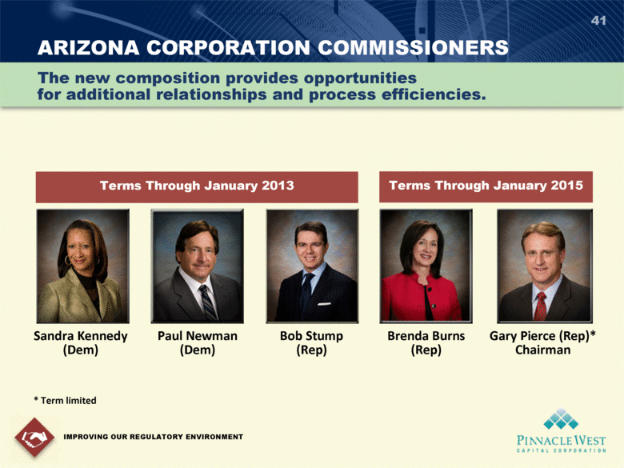 | ARIZONA CORPORATION COMMISSIONERS 41 IMPROVING OUR REGULATORY ENVIRONMENT Sandra Kennedy (Dem) Paul Newman (Dem) Bob Stump (Rep) Brenda Burns (Rep) Gary Pierce (Rep)* Chairman Terms Through January 2013 The new composition provides opportunities for additional relationships and process efficiencies. Terms Through January 2015 * Term limited

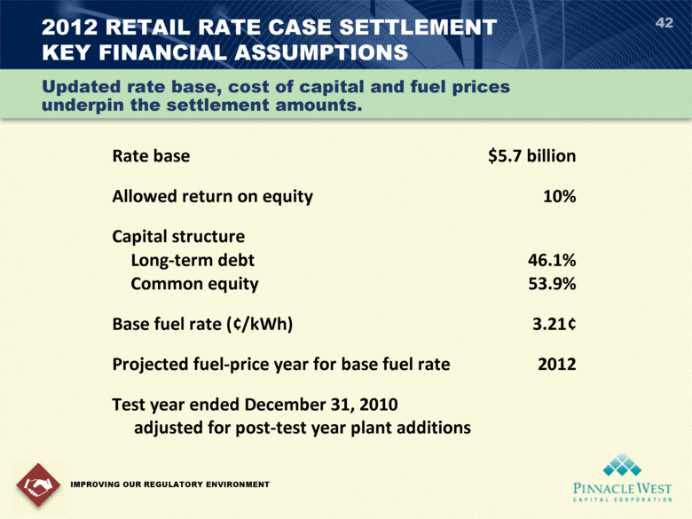 | 2012 RETAIL RATE CASE SETTLEMENT KEY FINANCIAL ASSUMPTIONS 42 IMPROVING OUR REGULATORY ENVIRONMENT Rate base $5.7 billion Allowed return on equity 10% Capital structure Long-term debt 46.1% Common equity 53.9% Base fuel rate (¢/kWh) 3.21¢ Projected fuel-price year for base fuel rate 2012 Test year ended December 31, 2010 adjusted for post-test year plant additions Updated rate base, cost of capital and fuel prices underpin the settlement amounts.

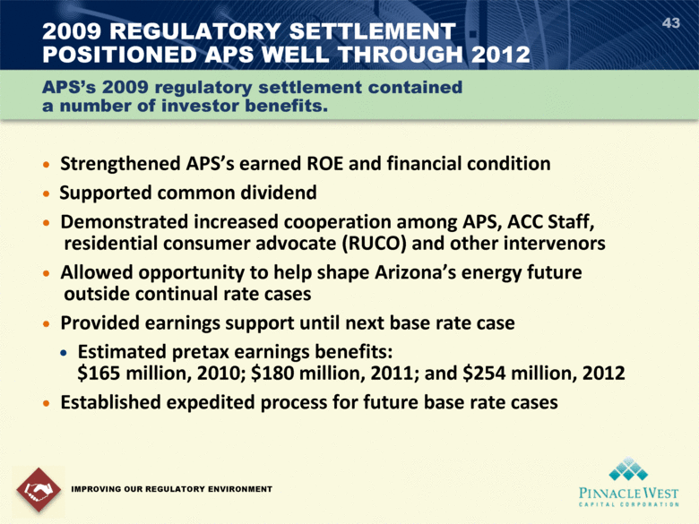 |  Strengthened APSs earned ROE and financial condition  Supported common dividend  Demonstrated increased cooperation among APS, ACC Staff, residential consumer advocate (RUCO) and other intervenors  Allowed opportunity to help shape Arizonas energy future outside continual rate cases  Provided earnings support until next base rate case  Estimated pretax earnings benefits: $165 million, 2010; $180 million, 2011; and $254 million, 2012  Established expedited process for future base rate cases 43 2009 REGULATORY SETTLEMENT POSITIONED APS WELL THROUGH 2012 IMPROVING OUR REGULATORY ENVIRONMENT APSs 2009 regulatory settlement contained a number of investor benefits.

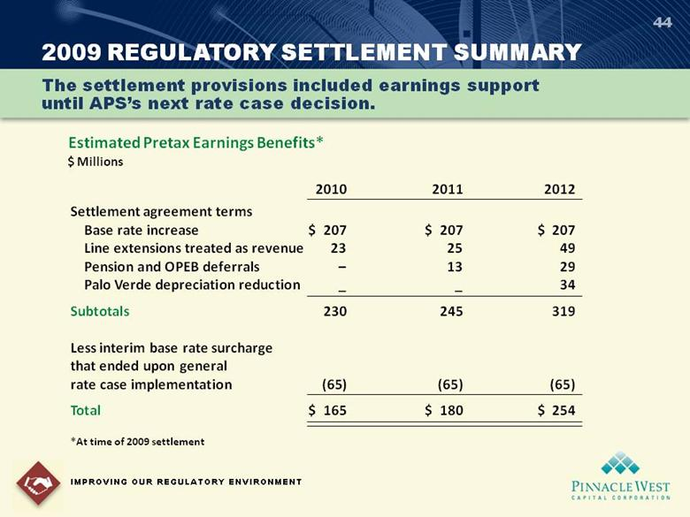 | 2009 REGULATORY SETTLEMENT SUMMARY 44 IMPROVING OUR REGULATORY ENVIRONMENT The settlement provisions included earnings support until APSs next rate case decision. Estimated Pretax Earnings Benefits* $ Millions 2010 2011 2012 Settlement agreement terms Base rate increase $ 207 $ 207 $ 207 Line extensions treated as revenue 23 25 49 Pension and OPEB deferrals  13 29 Palo Verde depreciation reduction _ _ 34 Subtotals 230 245 319 Less interim base rate surcharge that ended upon general rate case implementation (65) (65) (65) Total $ 165 $ 180 $ 254 *At time of 2009 settlement

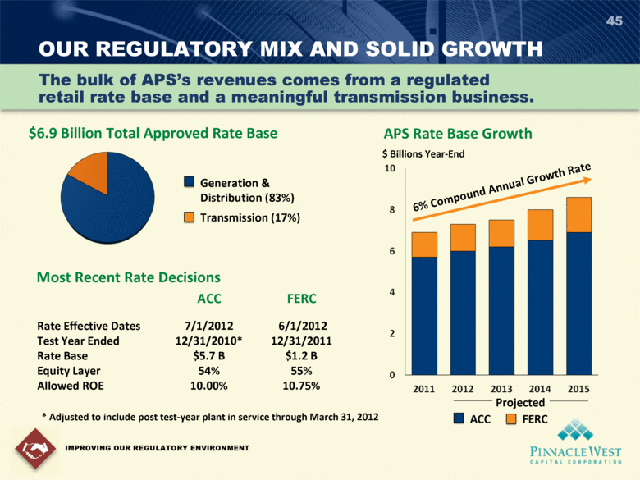 | OUR REGULATORY MIX AND SOLID GROWTH 45 $6.9 Billion Total Approved Rate Base Most Recent Rate Decisions ACC FERC Rate Effective Dates 7/1/2012 6/1/2012 Test Year Ended 12/31/2010* 12/31/2011 Rate Base $5.7 B $1.2 B Equity Layer 54% 55% Allowed ROE 10.00% 10.75% IMPROVING OUR REGULATORY ENVIRONMENT The bulk of APSs revenues comes from a regulated retail rate base and a meaningful transmission business. * Adjusted to include post test-year plant in service through March 31, 2012 $ Billions Year-End Projected APS Rate Base Growth 6% Compound Annual Growth Rate Generation & Distribution (83%) Transmission (17%) FERC ACC

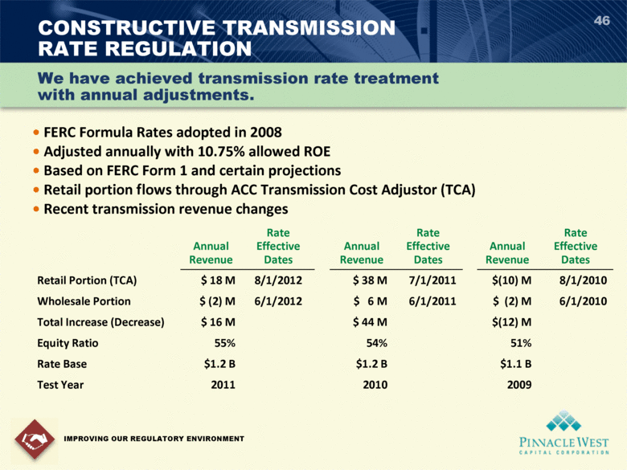 | 46  FERC Formula Rates adopted in 2008  Adjusted annually with 10.75% allowed ROE  Based on FERC Form 1 and certain projections  Retail portion flows through ACC Transmission Cost Adjustor (TCA)  Recent transmission revenue changes CONSTRUCTIVE TRANSMISSION RATE REGULATION Annual Revenue Rate Effective Dates Annual Revenue Rate Effective Dates Annual Revenue Rate Effective Dates Retail Portion (TCA) $ 18 M 8/1/2012 $ 38 M 7/1/2011 $(10) M 8/1/2010 Wholesale Portion $ (2) M 6/1/2012 $ 6 M 6/1/2011 $ (2) M 6/1/2010 Total Increase (Decrease) $ 16 M $ 44 M $(12) M Equity Ratio 55% 54% 51% Rate Base $1.2 B $1.2 B $1.1 B Test Year 2011 2010 2009 IMPROVING OUR REGULATORY ENVIRONMENT We have achieved transmission rate treatment with annual adjustments.

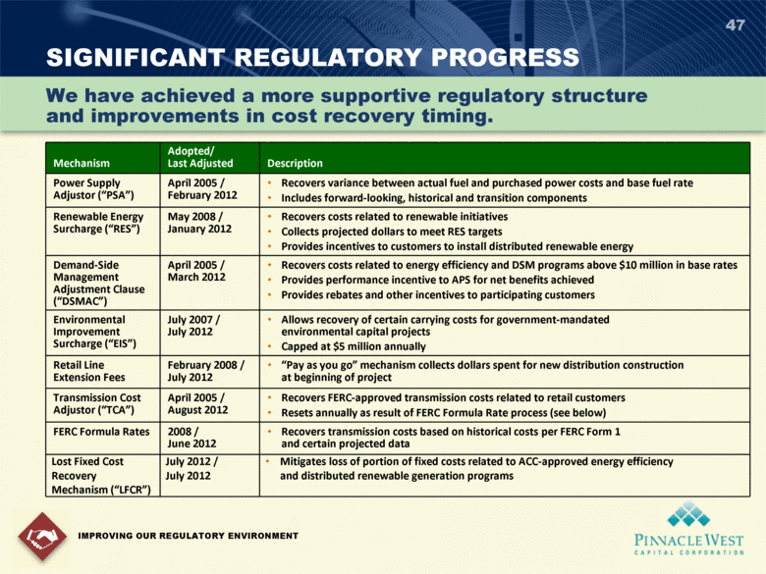 | 47 SIGNIFICANT REGULATORY PROGRESS IMPROVING OUR REGULATORY ENVIRONMENT We have achieved a more supportive regulatory structure and improvements in cost recovery timing. Mechanism Adopted/ Last Adjusted Description Power Supply Adjustor (PSA) April 2005 / February 2012 Recovers variance between actual fuel and purchased power costs and base fuel rate Includes forward-looking, historical and transition components Renewable Energy Surcharge (RES) May 2008 / January 2012 Recovers costs related to renewable initiatives Collects projected dollars to meet RES targets Provides incentives to customers to install distributed renewable energy Demand-Side Management Adjustment Clause (DSMAC) April 2005 / March 2012 Recovers costs related to energy efficiency and DSM programs above $10 million in base rates Provides performance incentive to APS for net benefits achieved Provides rebates and other incentives to participating customers Environmental Improvement Surcharge (EIS) July 2007 / July 2012 Allows recovery of certain carrying costs for government-mandated environmental capital projects Capped at $5 million annually Retail Line Extension Fees February 2008 / July 2012 Pay as you go mechanism collects dollars spent for new distribution construction at beginning of project Transmission Cost Adjustor (TCA) April 2005 / August 2012 Recovers FERC-approved transmission costs related to retail customers Resets annually as result of FERC Formula Rate process (see below) FERC Formula Rates 2008 / June 2012 Recovers transmission costs based on historical costs per FERC Form 1 and certain projected data Lost Fixed Cost Recovery Mechanism (LFCR) July 2012 / July 2012 Mitigates loss of portion of fixed costs related to ACC-approved energy efficiency and distributed renewable generation programs

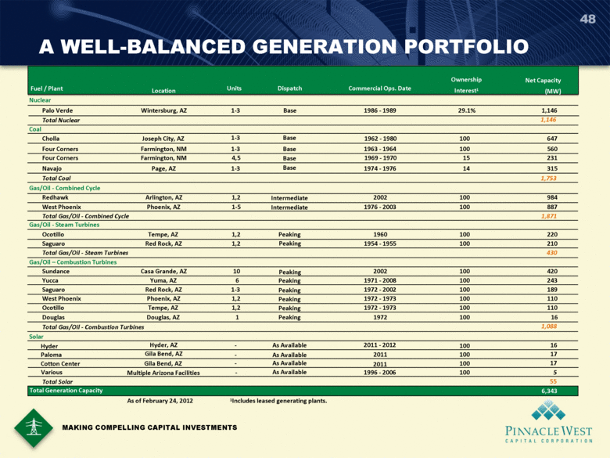 | A WELL-BALANCED GENERATION PORTFOLIO 48 Fuel / Plant Location Units Dispatch Commercial Ops. Date Ownership Interest1 Net Capacity (MW) Nuclear Palo Verde Wintersburg, AZ 1-3 Base 1986 - 1989 29.1% 1,146 Total Nuclear 1,146 Coal Cholla Joseph City, AZ 1-3 Base 1962 - 1980 100 647 Four Corners Farmington, NM 1-3 Base 1963 - 1964 100 560 Four Corners Farmington, NM 4,5 Base 1969 - 1970 15 231 Navajo Page, AZ 1-3 Base 1974 - 1976 14 315 Total Coal 1,753 Gas/Oil - Combined Cycle Redhawk Arlington, AZ 1,2 Intermediate 2002 100 984 West Phoenix Phoenix, AZ 1-5 Intermediate 1976 - 2003 100 887 Total Gas/Oil - Combined Cycle 1,871 Gas/Oil - Steam Turbines Ocotillo Tempe, AZ 1,2 Peaking 1960 100 220 Saguaro Red Rock, AZ 1,2 Peaking 1954 - 1955 100 210 Total Gas/Oil - Steam Turbines 430 Gas/Oil  Combustion Turbines Sundance Casa Grande, AZ 10 Peaking 2002 100 420 Yucca Yuma, AZ 6 Peaking 1971 - 2008 100 243 Saguaro Red Rock, AZ 1-3 Peaking 1972 - 2002 100 189 West Phoenix Phoenix, AZ 1,2 Peaking 1972 - 1973 100 110 Ocotillo Tempe, AZ 1,2 Peaking 1972 - 1973 100 110 Douglas Douglas, AZ 1 Peaking 1972 100 16 Total Gas/Oil - Combustion Turbines 1,088 Solar Total Solar Total Generation Capacity 6,343 As of February 24, 2012 1Includes leased generating plants. 5 Paloma Cotton Center Hyder Various Gila Bend, AZ Gila Bend, AZ Hyder, AZ Multiple Arizona Facilities - - - - As Available As Available As Available As Available 2011 2011 2011 - 2012 1996 - 2006 100 100 100 100 16 17 17 55 MAKING COMPELLING CAPITAL INVESTMENTS

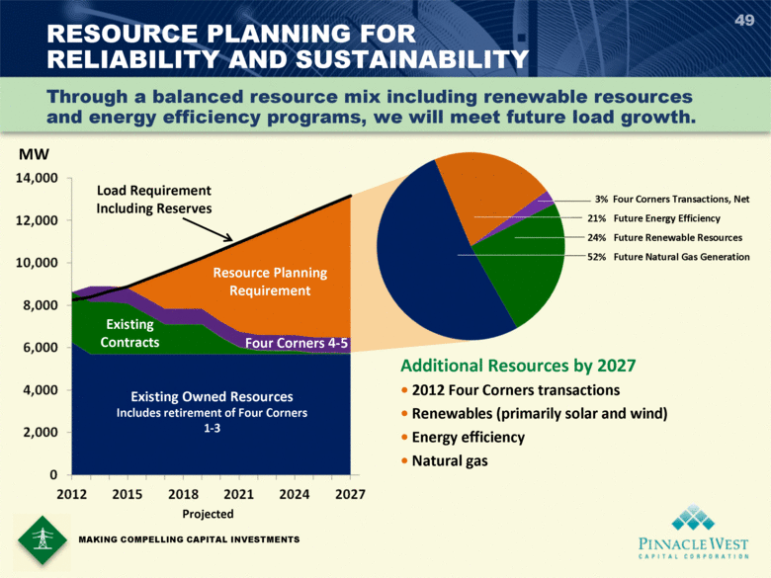 | RESOURCE PLANNING FOR RELIABILITY AND SUSTAINABILITY Existing Owned Resources Includes retirement of Four Corners 1-3 Existing Contracts Four Corners 4-5 Resource Planning Requirement Load Requirement Including Reserves 49 MAKING COMPELLING CAPITAL INVESTMENTS Through a balanced resource mix including renewable resources and energy efficiency programs, we will meet future load growth. Projected Additional Resources by 2027  2012 Four Corners transactions  Renewables (primarily solar and wind)  Energy efficiency  Natural gas 3% Four Corners Transactions, Net 21% Future Energy Efficiency 24% Future Renewable Resources 52% Future Natural Gas Generation MW 14,000 12,000 10,000 8,000 6,000 4,000 2,000 0 2012 2015 2018 2021 2024 2027

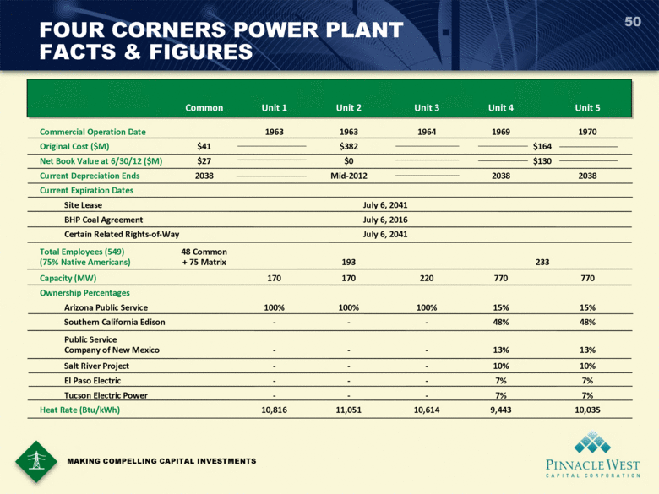 | 50 FOUR CORNERS POWER PLANT FACTS & FIGURES MAKING COMPELLING CAPITAL INVESTMENTS Common Unit 1 Unit 2 Unit 3 Unit 4 Unit 5 Commercial Operation Date 1963 1963 1964 1969 1970 Original Cost ($M) $41 $382 $164 Net Book Value at 6/30/12 ($M) $27 $0 $130 Current Depreciation Ends 2038 Mid-2012 2038 2038 Current Expiration Dates Site Lease July 6, 2041 BHP Coal Agreement July 6, 2016 Certain Related Rights-of-Way July 6, 2041 Total Employees (549) 48 Common (75% Native Americans) + 75 Matrix 193 233 Capacity (MW) 170 170 220 770 770 Ownership Percentages Arizona Public Service 100% 100% 100% 15% 15% Southern California Edison - - - 48% 48% Public Service Company of New Mexico - - - 13% 13% Salt River Project - - - 10% 10% El Paso Electric - - - 7% 7% Tucson Electric Power - - - 7% 7% Heat Rate (Btu/kWh) 10,816 11,051 10,614 9,443 10,035

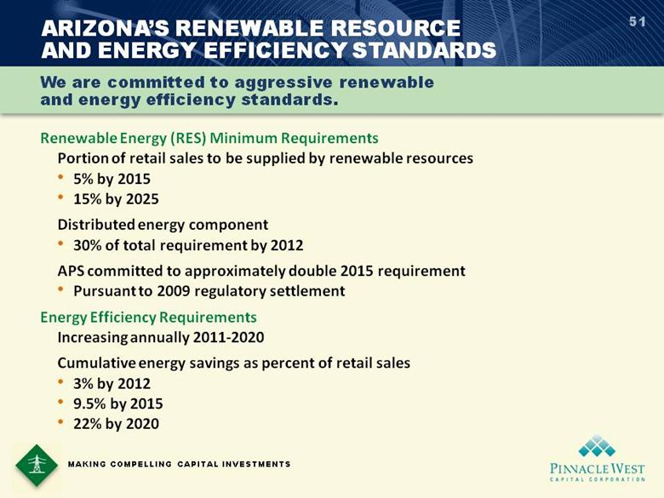 | 51 Renewable Energy (RES) Minimum Requirements Portion of retail sales to be supplied by renewable resources • 5% by 2015 • 15% by 2025 Distributed energy component • 30% of total requirement by 2012 APS committed to approximately double 2015 requirement • Pursuant to 2009 regulatory settlement Energy Efficiency Requirements Increasing annually 2011-2020 Cumulative energy savings as percent of retail sales • 3% by 2012 • 9.5% by 2015 • 22% by 2020 ARIZONAS RENEWABLE RESOURCE AND ENERGY EFFICIENCY STANDARDS We are committed to aggressive renewable and energy efficiency standards. MAKING COMPELLING CAPITAL INVESTMENTS

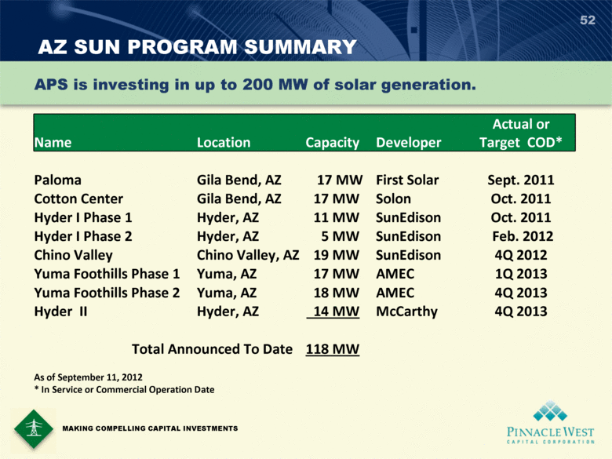 | AZ SUN PROGRAM SUMMARY 52 MAKING COMPELLING CAPITAL INVESTMENTS Name Location Capacity Developer Actual or Target COD* Paloma Gila Bend, AZ 17 MW First Solar Sept. 2011 Cotton Center Gila Bend, AZ 17 MW Solon Oct. 2011 Hyder I Phase 1 Hyder, AZ 11 MW SunEdison Oct. 2011 Hyder I Phase 2 Hyder, AZ 5 MW SunEdison Feb. 2012 Chino Valley Chino Valley, AZ 19 MW SunEdison 4Q 2012 Yuma Foothills Phase 1 Yuma, AZ 17 MW AMEC 1Q 2013 Yuma Foothills Phase 2 Yuma, AZ 18 MW AMEC 4Q 2013 Hyder II Hyder, AZ 14 MW McCarthy 4Q 2013 Total Announced To Date 118 MW As of September 11, 2012 * In Service or Commercial Operation Date APS is investing in up to 200 MW of solar generation.

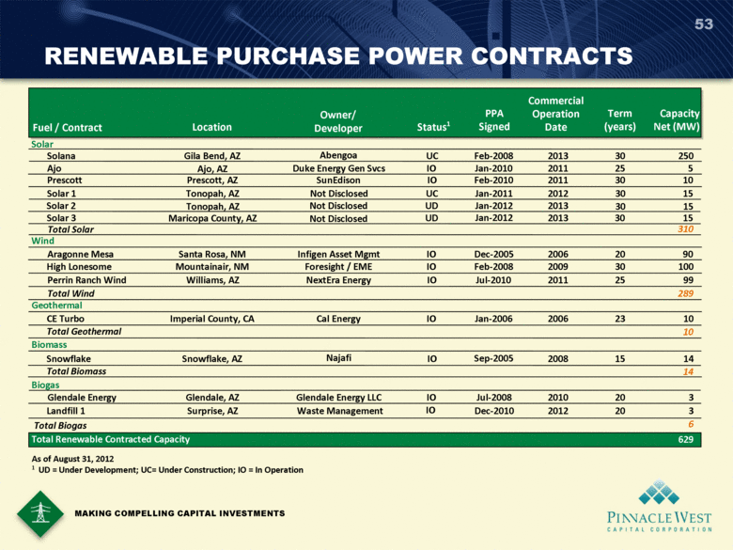 | RENEWABLE PURCHASE POWER CONTRACTS 53 MAKING COMPELLING CAPITAL INVESTMENTS Fuel / Contract Location Owner/ Developer Status 1 PPA Signed Commercial Operation Date Term (years) Capacity Net (MW) Solar Solana Gila Bend, AZ Abengoa UC Feb-2008 2013 30 250 Ajo Ajo, AZ Duke Energy Gen Svcs IO Jan-2010 2011 25 5 Prescott Prescott, AZ SunEdison IO Feb-2010 2011 30 10 Solar 1 Tonopah, AZ Not Disclosed UC Jan-2011 2012 30 15 Total Solar 310 Wind Aragonne Mesa Santa Rosa, NM Infigen Asset Mgmt IO Dec-2005 2006 20 90 High Lonesome Mountainair, NM Foresight / EME IO Feb-2008 2009 30 100 Perrin Ranch Wind Williams, AZ NextEra Energy IO Jul-2010 2011 25 99 Total Wind 289 Geothermal CE Turbo Imperial County, CA Cal Energy IO Jan-2006 2006 23 10 Total Geothermal 10 Biomass Snowflake Snowflake, AZ Najafi IO Sep-2005 2008 15 14 Total Biomass 14 Biogas Glendale Energy Glendale, AZ Glendale Energy LLC IO Jul-2008 2010 20 3 Landfill 1 Surprise, AZ Waste Management IO Dec-2010 2012 20 3 Total Biogas 6 Total Renewable Contracted Capacity 629 Solar 2 Solar 3 Tonopah, AZ Not Disclosed Jan-2012 2013 30 15 Maricopa County, AZ Not Disclosed Jan-2012 2013 30 15 UD UD As of August 31, 2012 1 UD = Under Development; UC= Under Construction; IO = In Operation

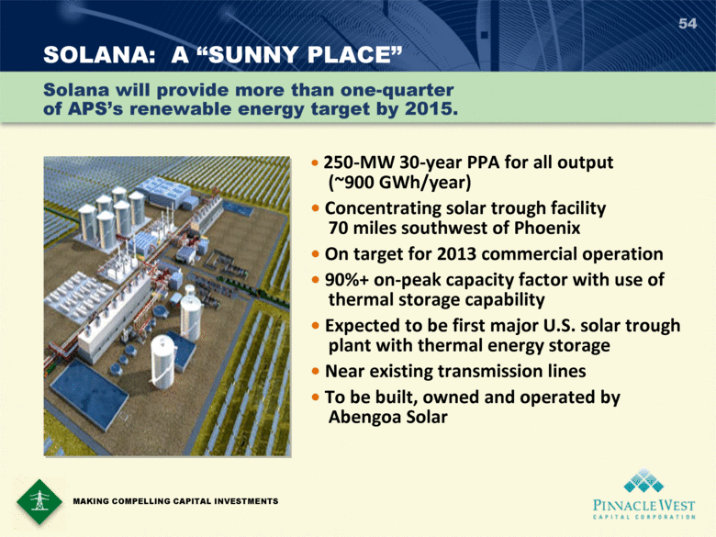 | SOLANA: A SUNNY PLACE 54  250-MW 30-year PPA for all output (~900 GWh/year)  Concentrating solar trough facility 70 miles southwest of Phoenix  On target for 2013 commercial operation  90%+ on-peak capacity factor with use of thermal storage capability  Expected to be first major U.S. solar trough plant with thermal energy storage  Near existing transmission lines  To be built, owned and operated by Abengoa Solar MAKING COMPELLING CAPITAL INVESTMENTS Solana will provide more than one-quarter of APSs renewable energy target by 2015.

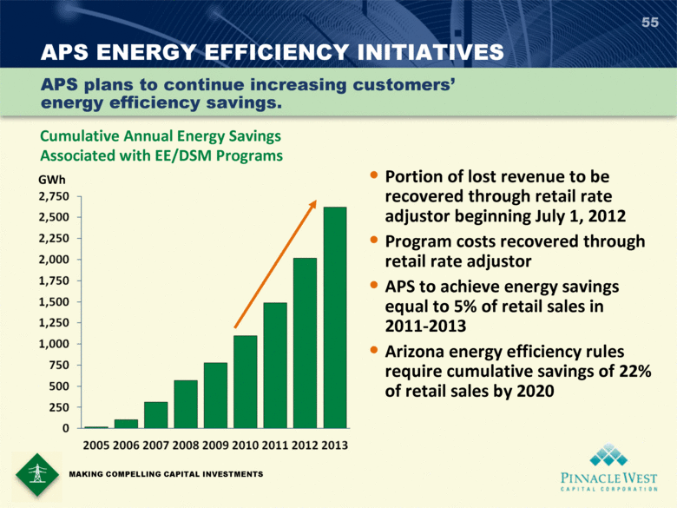 | 55 APS ENERGY EFFICIENCY INITIATIVES • Portion of lost revenue to be recovered through retail rate adjustor beginning July 1, 2012 • Program costs recovered through retail rate adjustor • APS to achieve energy savings equal to 5% of retail sales in 2011-2013 • Arizona energy efficiency rules require cumulative savings of 22% of retail sales by 2020 Cumulative Annual Energy Savings Associated with EE/DSM Programs APS plans to continue increasing customers energy efficiency savings. GWh MAKING COMPELLING CAPITAL INVESTMENTS

