UNITED STATES
SECURITIES AND EXCHANGE COMMISSION
Washington, D.C. 20549

FORM 8-K

CURRENT REPORT
Pursuant to Section 13 or 15(d) of the
Securities Exchange Act of 1934

Date of report (Date of earliest event reported): November 10, 2014

Commission File Number | Exact Name of Registrant as Specified in Charter; State of Incorporation;  Address and Telephone Number | IRS Employer  Identification Number
1-8962 | Pinnacle West Capital Corporation  (an Arizona corporation)  400 North Fifth Street, P.O. Box 53999  Phoenix, AZ 85072-3999  (602) 250-1000 | 86-0512431
1-4473 | Arizona Public Service Company  (an Arizona corporation)  400 North Fifth Street, P.O. Box 53999  Phoenix, AZ 85072-3999  (602) 250-1000 | 86-0011170

Check the appropriate box below if the Form 8-K filing is intended to simultaneously satisfy the filing obligation of the registrant under any of the following provisions:

☐ Written communications pursuant to Rule 425 under the Securities Act (17 CFR 230.425)

☐ Soliciting material pursuant to Rule 14a-12 under the Exchange Act (17 CFR 240.14a-12)

☐ Pre-commencement communications pursuant to Rule 14d-2(b) under the Exchange Act (17 CFR 240.14d-2(b))

☐ Pre-commencement communications pursuant to Rule 13e-4(c) under the Exchange Act (17 CFR 240.13e-4(c))

This combined Form 8-K is separately filed or furnished by Pinnacle West Capital Corporation and Arizona Public Service Company. Each registrant is filing or furnishing on its own behalf all of the information contained in this Form 8-K that relates to such registrant and, where required, its subsidiaries. Except as stated in the preceding sentence, neither registrant is filing or furnishing any information that does not relate to such registrant, and therefore makes no representation as to any such information.

Item 7.01 Regulation FD Disclosure.

Investor and Analyst Meetings

Pinnacle West Capital Corporation (“Pinnacle West”) will be participating in various meetings with securities analysts and investors on November 11 through November 13, 2014 and will be utilizing handouts during those meetings. Copies of the handouts are attached hereto as Exhibit 99.1.

Item 9.01 Financial Statements and Exhibits.

(d) Exhibits

Exhibit No. | Registrant(s) | Description
99.1 | Pinnacle West  Arizona Public  Service Company | Pinnacle West handouts for use at meetings on November 11 through November 13, 2014.

2

SIGNATURES

Pursuant to the requirements of the Securities Exchange Act of 1934, each registrant has duly caused this report to be signed on its behalf by the undersigned hereunto duly authorized.

 |  | PINNACLE WEST CAPITAL CORPORATION
 |  | (Registrant)
Dated: November 10, 2014 |  | By: /s/ James R. Hatfield
 |  | James R. Hatfield
 |  | Executive Vice President and
 |  | Chief Financial Officer
 |  | ARIZONA PUBLIC SERVICE COMPANY
 |  | (Registrant)
Dated: November 10, 2014 |  | By: /s/ James R. Hatfield
 |  | James R. Hatfield
 |  | Executive Vice President and
 |  | Chief Financial Officer

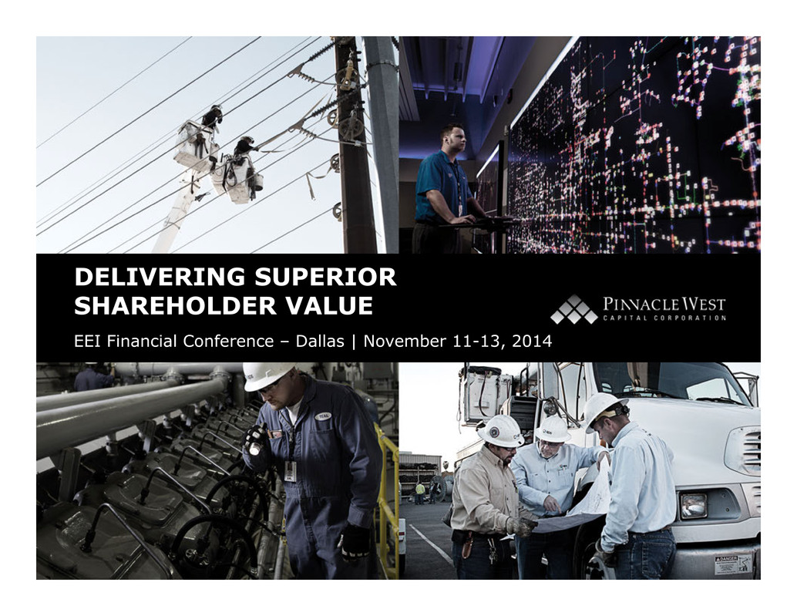
Delivering Superior Shareholder Value DELIVERING SUPERIOR SHAREHOLDER VALUE EEI Financial Conference – Dallas | November 11-13, 2014

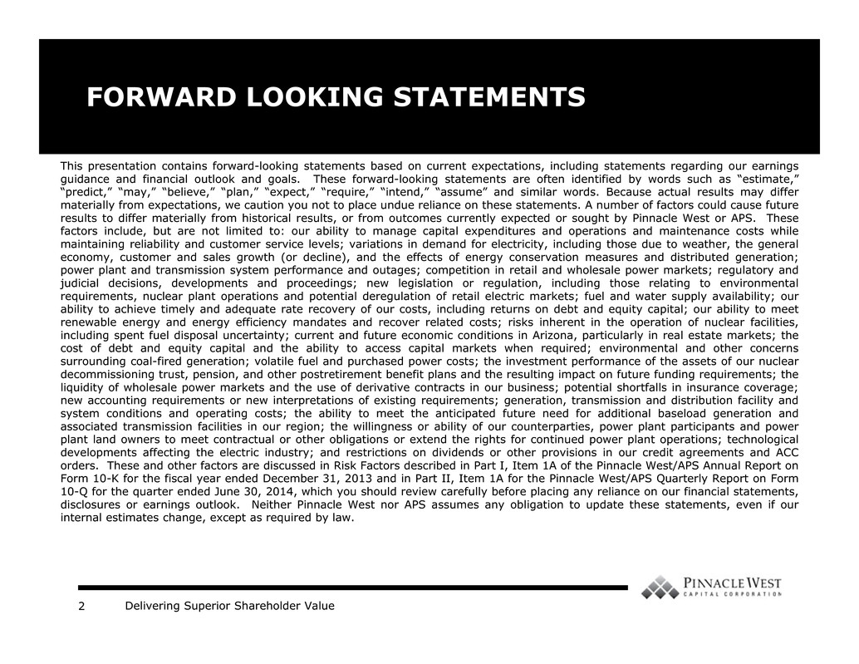
Delivering Superior Shareholder Value2 FORWARD LOOKING STATEMENTS This presentation contains forward-looking statements based on current expectations, including statements regarding our earnings guidance and financial outlook and goals. These forward-looking statements are often identified by words such as “estimate,” “predict,” “may,” “believe,” “plan,” “expect,” “require,” “intend,” “assume” and similar words. Because actual results may differ materially from expectations, we caution you not to place undue reliance on these statements. A number of factors could cause future results to differ materially from historical results, or from outcomes currently expected or sought by Pinnacle West or APS. These factors include, but are not limited to: our ability to manage capital expenditures and operations and maintenance costs while maintaining reliability and customer service levels; variations in demand for electricity, including those due to weather, the general economy, customer and sales growth (or decline), and the effects of energy conservation measures and distributed generation; power plant and transmission system performance and outages; competition in retail and wholesale power markets; regulatory and judicial decisions, developments and proceedings; new legislation or regulation, including those relating to environmental requirements, nuclear plant operations and potential deregulation of retail electric markets; fuel and water supply availability; our ability to achieve timely and adequate rate recovery of our costs, including returns on debt and equity capital; our ability to meet renewable energy and energy efficiency mandates and recover related costs; risks inherent in the operation of nuclear facilities, including spent fuel disposal uncertainty; current and future economic conditions in Arizona, particularly in real estate markets; the cost of debt and equity capital and the ability to access capital markets when required; environmental and other concerns surrounding coal-fired generation; volatile fuel and purchased power costs; the investment performance of the assets of our nuclear decommissioning trust, pension, and other postretirement benefit plans and the resulting impact on future funding requirements; the liquidity of wholesale power markets and the use of derivative contracts in our business; potential shortfalls in insurance coverage; new accounting requirements or new interpretations of existing requirements; generation, transmission and distribution facility and system conditions and operating costs; the ability to meet the anticipated future need for additional baseload generation and associated transmission facilities in our region; the willingness or ability of our counterparties, power plant participants and power plant land owners to meet contractual or other obligations or extend the rights for continued power plant operations; technological developments affecting the electric industry; and restrictions on dividends or other provisions in our credit agreements and ACC orders. These and other factors are discussed in Risk Factors described in Part I, Item 1A of the Pinnacle West/APS Annual Report on Form 10-K for the fiscal year ended December 31, 2013 and in Part II, Item 1A for the Pinnacle West/APS Quarterly Report on Form 10-Q for the quarter ended June 30, 2014, which you should review carefully before placing any reliance on our financial statements, disclosures or earnings outlook. Neither Pinnacle West nor APS assumes any obligation to update these statements, even if our internal estimates change, except as required by law.

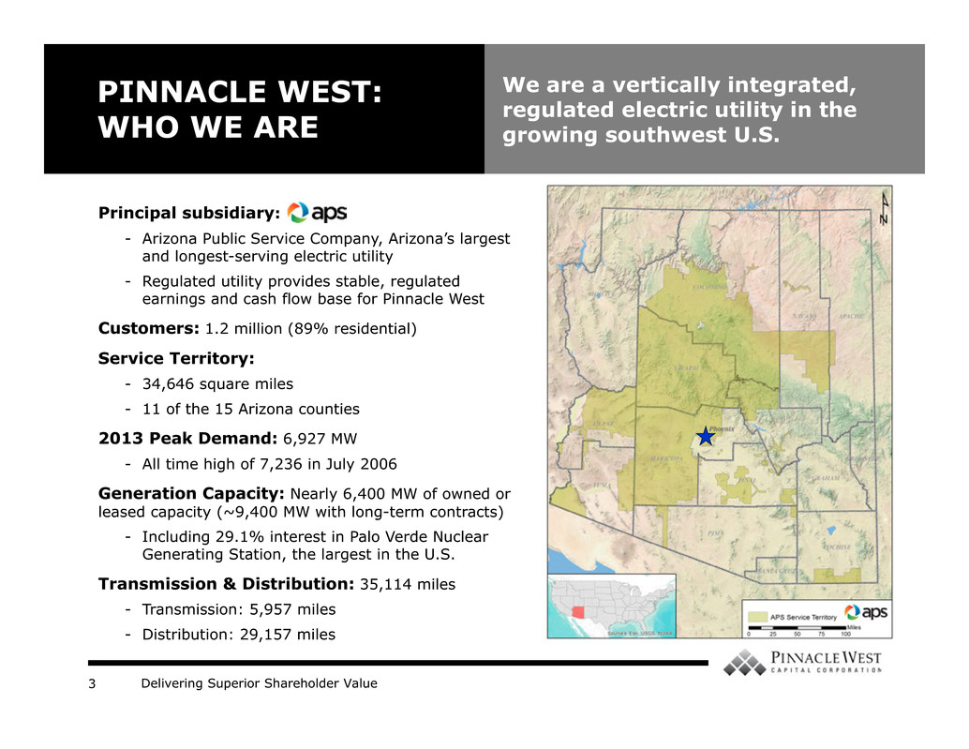
Delivering Superior Shareholder Value3 PINNACLE WEST: WHO WE ARE We are a vertically integrated, regulated electric utility in the growing southwest U.S. Principal subsidiary: - Arizona Public Service Company, Arizona’s largest and longest-serving electric utility - Regulated utility provides stable, regulated earnings and cash flow base for Pinnacle West Customers: 1.2 million (89% residential) Service Territory: - 34,646 square miles - 11 of the 15 Arizona counties 2013 Peak Demand: 6,927 MW - All time high of 7,236 in July 2006 Generation Capacity: Nearly 6,400 MW of owned or leased capacity (~9,400 MW with long-term contracts) - Including 29.1% interest in Palo Verde Nuclear Generating Station, the largest in the U.S. Transmission & Distribution: 35,114 miles - Transmission: 5,957 miles - Distribution: 29,157 miles

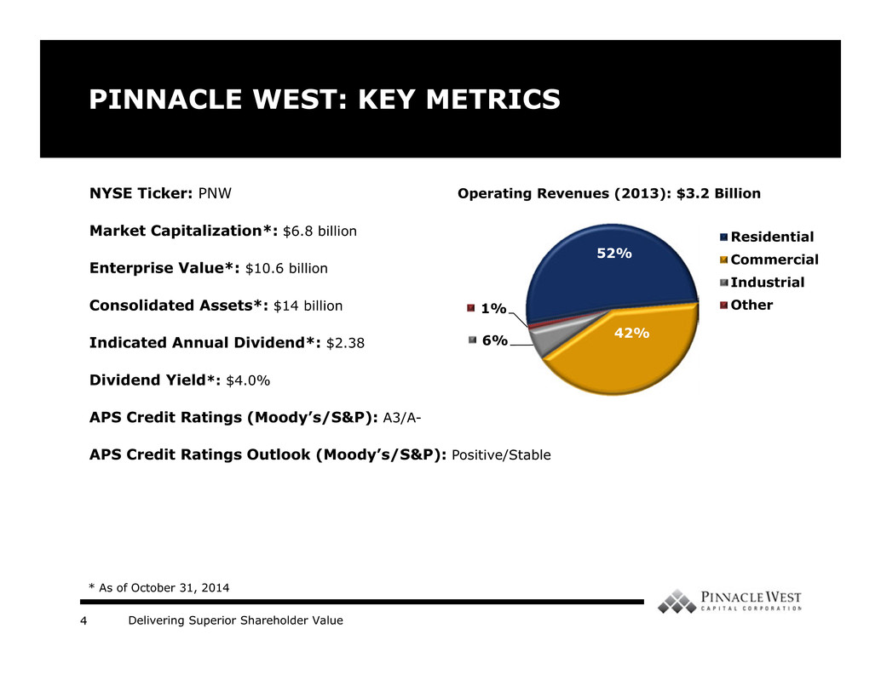
Delivering Superior Shareholder Value4 PINNACLE WEST: KEY METRICS NYSE Ticker: PNW Market Capitalization*: $6.8 billion Enterprise Value*: $10.6 billion Consolidated Assets*: $14 billion Indicated Annual Dividend*: $2.38 Dividend Yield*: $4.0% APS Credit Ratings (Moody’s/S&P): A3/A- APS Credit Ratings Outlook (Moody’s/S&P): Positive/Stable * As of October 31, 2014 52% 42%6% 1% Operating Revenues (2013): $3.2 Billion Residential Commercial Industrial Other

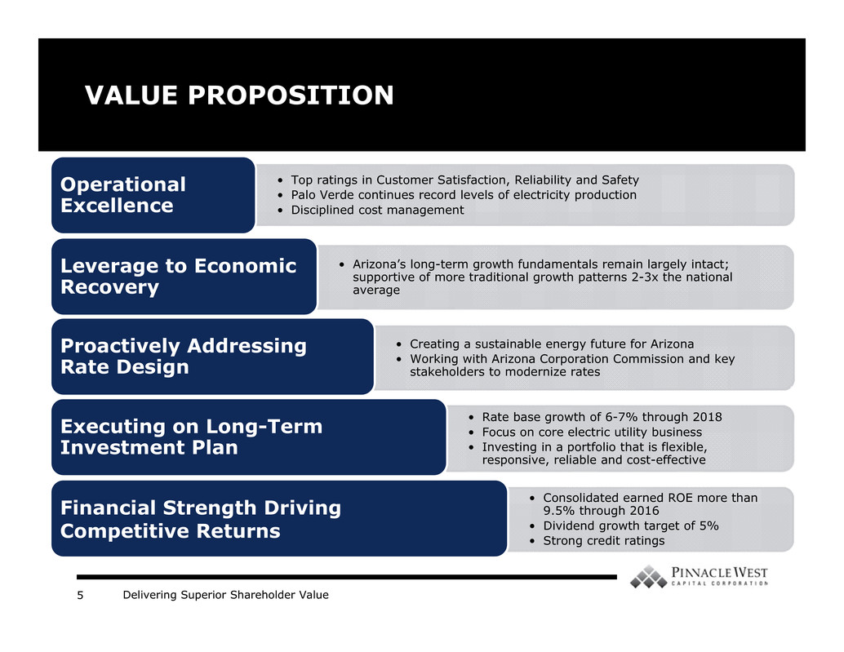
Delivering Superior Shareholder Value5 VALUE PROPOSITION • Top ratings in Customer Satisfaction, Reliability and Safety • Palo Verde continues record levels of electricity production • Disciplined cost management Operational Excellence • Arizona’s long-term growth fundamentals remain largely intact; supportive of more traditional growth patterns 2-3x the national average Leverage to Economic Recovery • Creating a sustainable energy future for Arizona • Working with Arizona Corporation Commission and key stakeholders to modernize rates Proactively Addressing Rate Design • Rate base growth of 6-7% through 2018 • Focus on core electric utility business • Investing in a portfolio that is flexible, responsive, reliable and cost-effective Executing on Long-Term Investment Plan • Consolidated earned ROE more than 9.5% through 2016 • Dividend growth target of 5% • Strong credit ratings Financial Strength Driving Competitive Returns

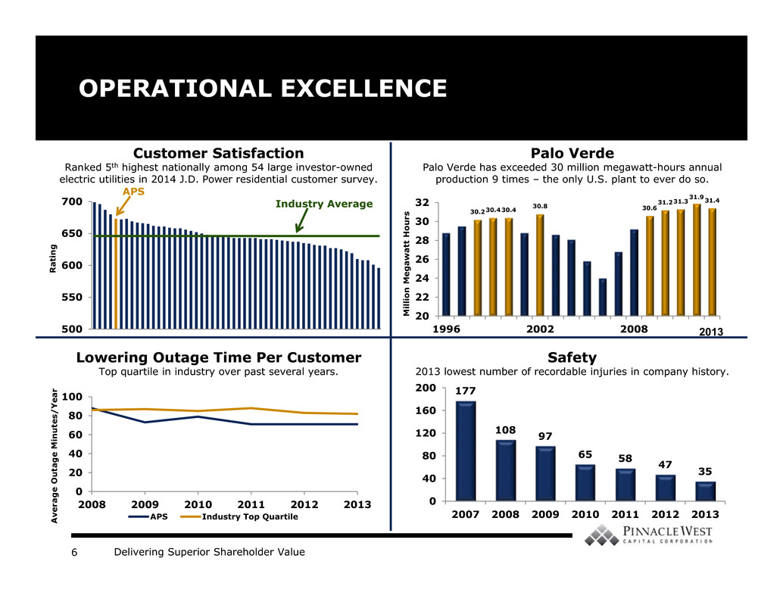
Delivering Superior Shareholder Value6 30.230.430.4 30.8 30.6 31.231.3 31.931.4 20 22 24 26 28 30 32 1996 2002 2008 OPERATIONAL EXCELLENCE 177 108 97 65 58 47 35 0 40 80 120 160 200 2007 2008 2009 2010 2011 2012 2013 Palo Verde Palo Verde has exceeded 30 million megawatt-hours annual production 9 times – the only U.S. plant to ever do so. Safety 2013 lowest number of recordable injuries in company history. 0 20 40 60 80 100 2008 2009 2010 2011 2012 2013 APS Industry Top Quartile Customer Satisfaction Ranked 5th highest nationally among 54 large investor-owned electric utilities in 2014 J.D. Power residential customer survey. Lowering Outage Time Per Customer Top quartile in industry over past several years. A v e r a g e O u t a g e M i n u t e s / Y e a r M i l l i o n M e g a w a t t H o u r s 500 550 600 650 700 R a t i n g Industry Average APS 2013

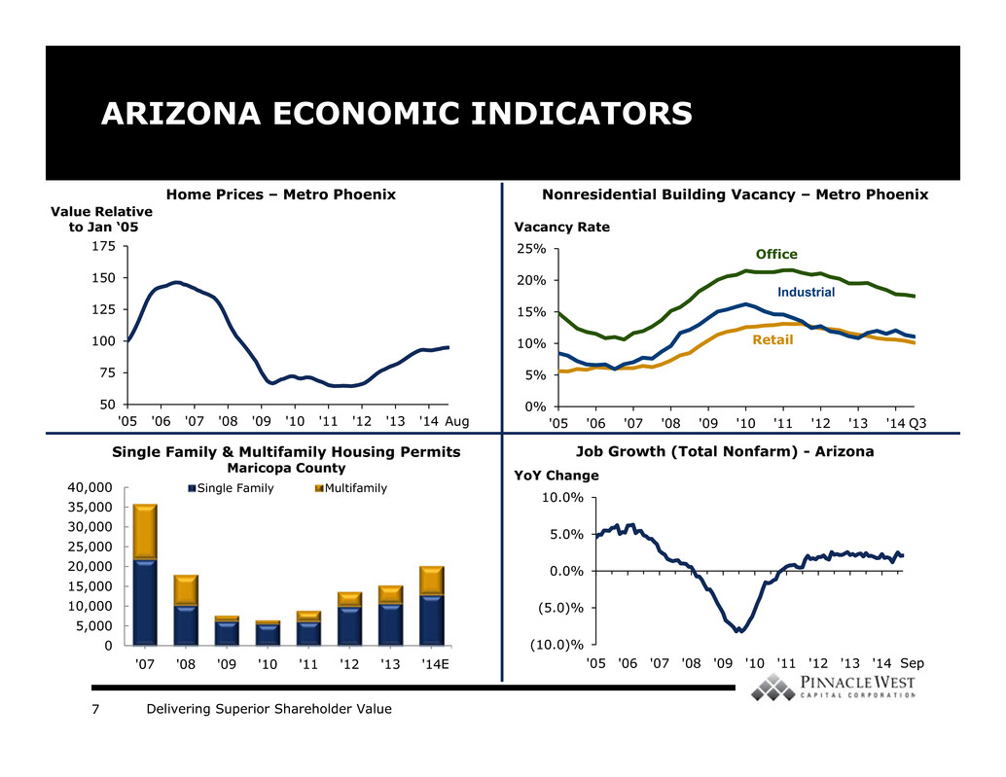
Delivering Superior Shareholder Value7 0% 5% 10% 15% 20% 25% '05 '06 '07 '08 '09 '10 '11 '12 '13 '14 Industrial ARIZONA ECONOMIC INDICATORS Nonresidential Building Vacancy – Metro Phoenix Single Family & Multifamily Housing Permits Maricopa County Home Prices – Metro Phoenix Value Relative to Jan ‘05 50 75 100 125 150 175 '05 '06 '07 '08 '09 '10 '11 '12 '13 '14 Vacancy Rate Office Retail Job Growth (Total Nonfarm) - Arizona (10.0)% (5.0)% 0.0% 5.0% 10.0% '05 '06 '07 '08 '09 '10 '11 '12 '13 '14 YoY Change E Q3Aug 0 5,000 10,000 15,000 20,000 25,000 30,000 35,000 40,000 '07 '08 '09 '10 '11 '12 '13 '14 Single Family Multifamily Sep

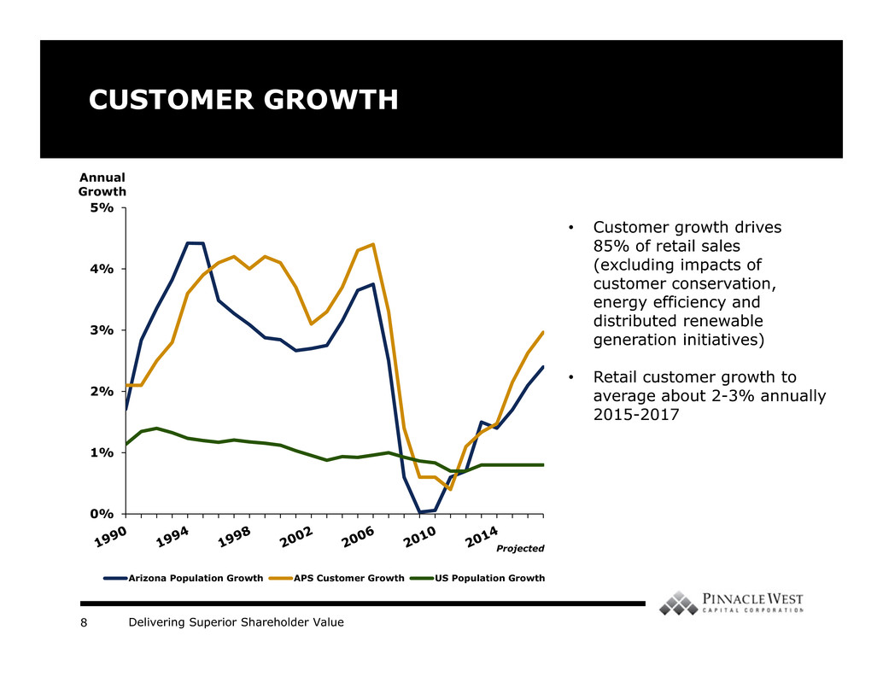
Delivering Superior Shareholder Value8 CUSTOMER GROWTH 0% 1% 2% 3% 4% 5% Arizona Population Growth APS Customer Growth US Population Growth Annual Growth • Customer growth drives 85% of retail sales (excluding impacts of customer conservation, energy efficiency and distributed renewable generation initiatives) • Retail customer growth to average about 2-3% annually 2015-2017 Projected

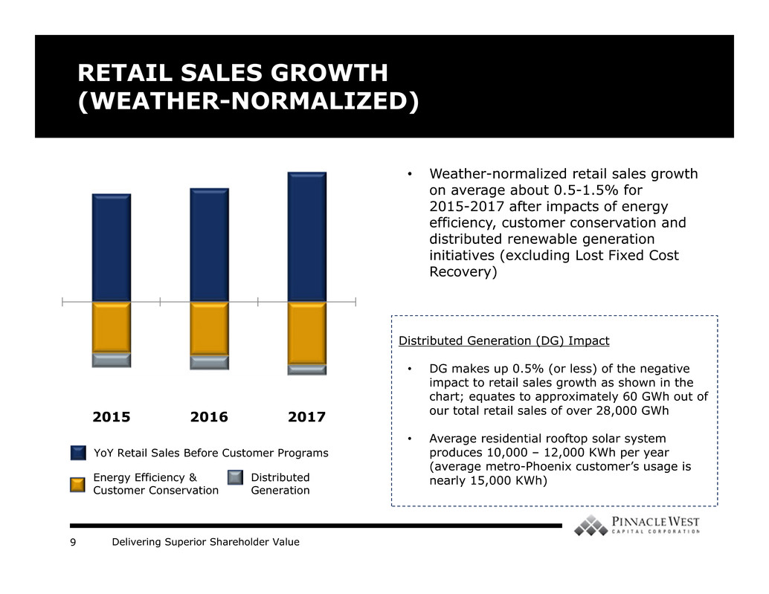
Delivering Superior Shareholder Value9 2015 2016 2017 RETAIL SALES GROWTH (WEATHER-NORMALIZED) YoY Retail Sales Before Customer Programs Energy Efficiency & Customer Conservation Distributed Generation • Weather-normalized retail sales growth on average about 0.5-1.5% for 2015-2017 after impacts of energy efficiency, customer conservation and distributed renewable generation initiatives (excluding Lost Fixed Cost Recovery) Distributed Generation (DG) Impact • DG makes up 0.5% (or less) of the negative impact to retail sales growth as shown in the chart; equates to approximately 60 GWh out of our total retail sales of over 28,000 GWh • Average residential rooftop solar system produces 10,000 – 12,000 KWh per year (average metro-Phoenix customer’s usage is nearly 15,000 KWh)

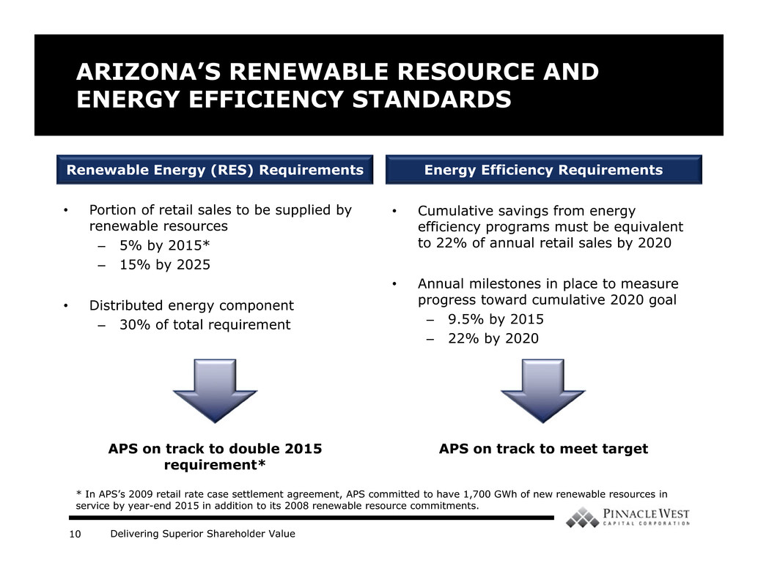
Delivering Superior Shareholder Value10 • Cumulative savings from energy efficiency programs must be equivalent to 22% of annual retail sales by 2020 • Annual milestones in place to measure progress toward cumulative 2020 goal – 9.5% by 2015 – 22% by 2020 ARIZONA’S RENEWABLE RESOURCE AND ENERGY EFFICIENCY STANDARDS • Portion of retail sales to be supplied by renewable resources – 5% by 2015* – 15% by 2025 • Distributed energy component – 30% of total requirement Energy Efficiency RequirementsRenewable Energy (RES) Requirements APS on track to double 2015 requirement* APS on track to meet target * In APS’s 2009 retail rate case settlement agreement, APS committed to have 1,700 GWh of new renewable resources in service by year-end 2015 in addition to its 2008 renewable resource commitments.

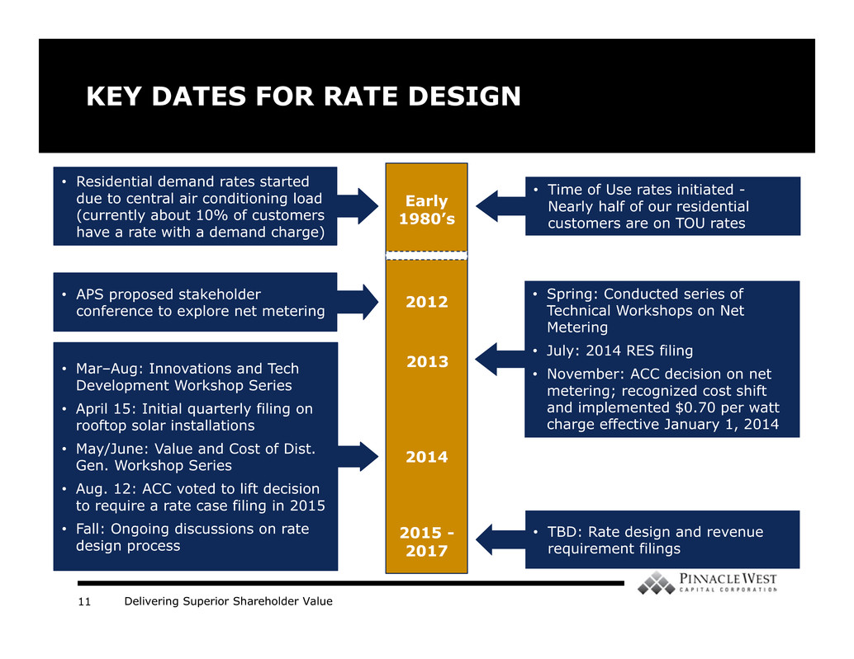
Delivering Superior Shareholder Value11 KEY DATES FOR RATE DESIGN 2012 2013 2014 2015 - 2017 • APS proposed stakeholder conference to explore net metering • Spring: Conducted series of Technical Workshops on Net Metering • July: 2014 RES filing • November: ACC decision on net metering; recognized cost shift and implemented $0.70 per watt charge effective January 1, 2014 • Mar–Aug: Innovations and Tech Development Workshop Series • April 15: Initial quarterly filing on rooftop solar installations • May/June: Value and Cost of Dist. Gen. Workshop Series • Aug. 12: ACC voted to lift decision to require a rate case filing in 2015 • Fall: Ongoing discussions on rate design process • Time of Use rates initiated - Nearly half of our residential customers are on TOU rates • Residential demand rates started due to central air conditioning load (currently about 10% of customers have a rate with a demand charge) Early 1980’s • TBD: Rate design and revenue requirement filings

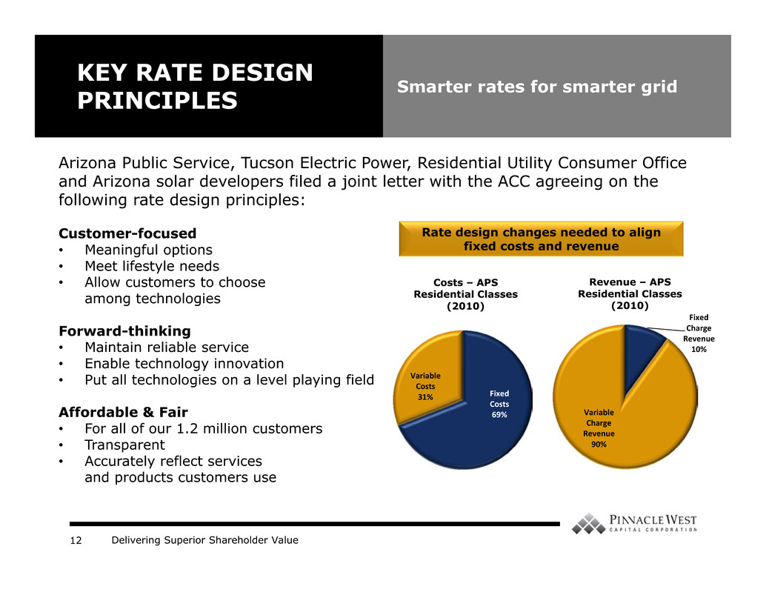
Delivering Superior Shareholder Value12 KEY RATE DESIGN PRINCIPLES Smarter rates for smarter grid Arizona Public Service, Tucson Electric Power, Residential Utility Consumer Office and Arizona solar developers filed a joint letter with the ACC agreeing on the following rate design principles: Customer-focused • Meaningful options • Meet lifestyle needs • Allow customers to choose among technologies Forward-thinking • Maintain reliable service • Enable technology innovation • Put all technologies on a level playing field Affordable & Fair • For all of our 1.2 million customers • Transparent • Accurately reflect services and products customers use Fixed Costs 69% Variable Costs 31% Costs – APS Residential Classes (2010) Fixed Charge Revenue 10% Variable Charge Revenue 90% Revenue – APS Residential Classes (2010) Rate design changes needed to align fixed costs and revenue

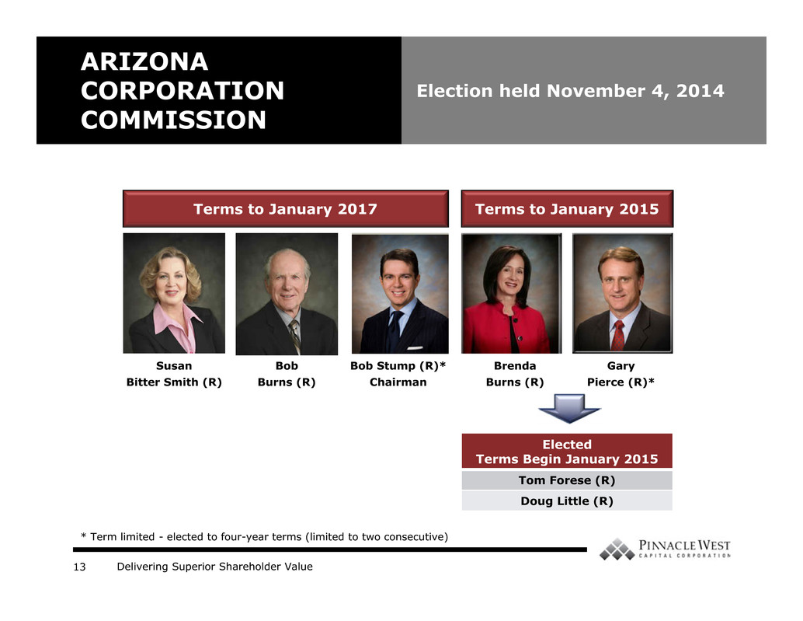
Delivering Superior Shareholder Value13 ARIZONA CORPORATION COMMISSION Election held November 4, 2014 Bob Stump (R)* Chairman Brenda Burns (R) Gary Pierce (R)* Terms to January 2015Terms to January 2017 Susan Bitter Smith (R) Bob Burns (R) * Term limited - elected to four-year terms (limited to two consecutive) Elected Terms Begin January 2015 Tom Forese (R) Doug Little (R)

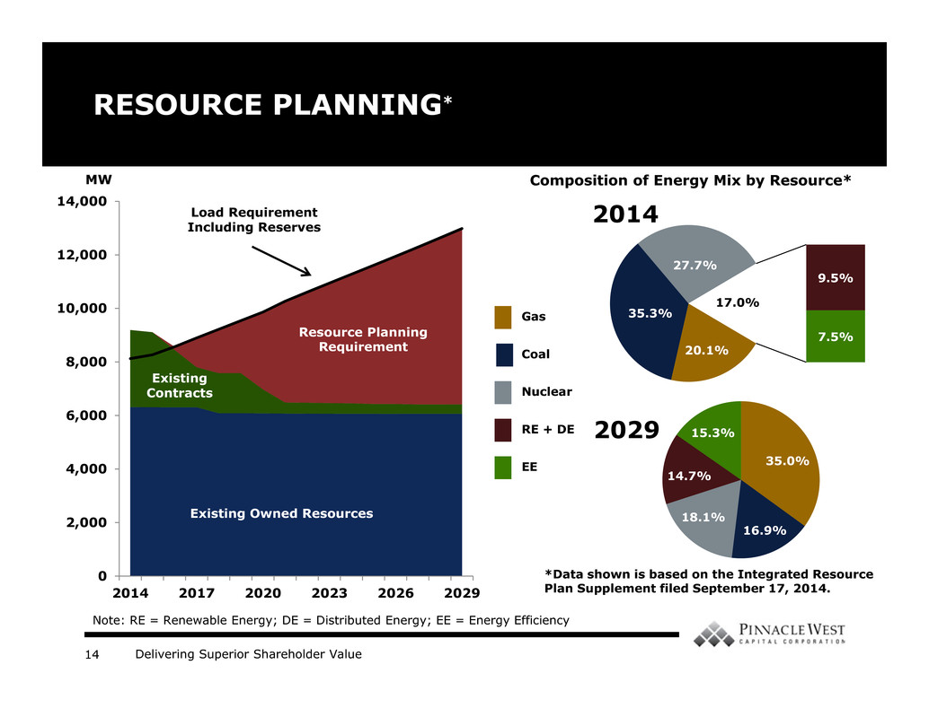
Delivering Superior Shareholder Value14 RESOURCE PLANNING* 0 2,000 4,000 6,000 8,000 10,000 12,000 14,000 2014 2017 2020 2023 2026 2029 Existing Owned Resources Existing Contracts Resource Planning Requirement Load Requirement Including Reserves MW 20.1% 35.3% 27.7% 9.5% 7.5% 17.0% 2014 Gas Coal Nuclear RE + DE EE Composition of Energy Mix by Resource* Note: RE = Renewable Energy; DE = Distributed Energy; EE = Energy Efficiency 35.0% 16.9% 18.1% 14.7% 15.3% *Data shown is based on the Integrated Resource Plan Supplement filed September 17, 2014. 2029

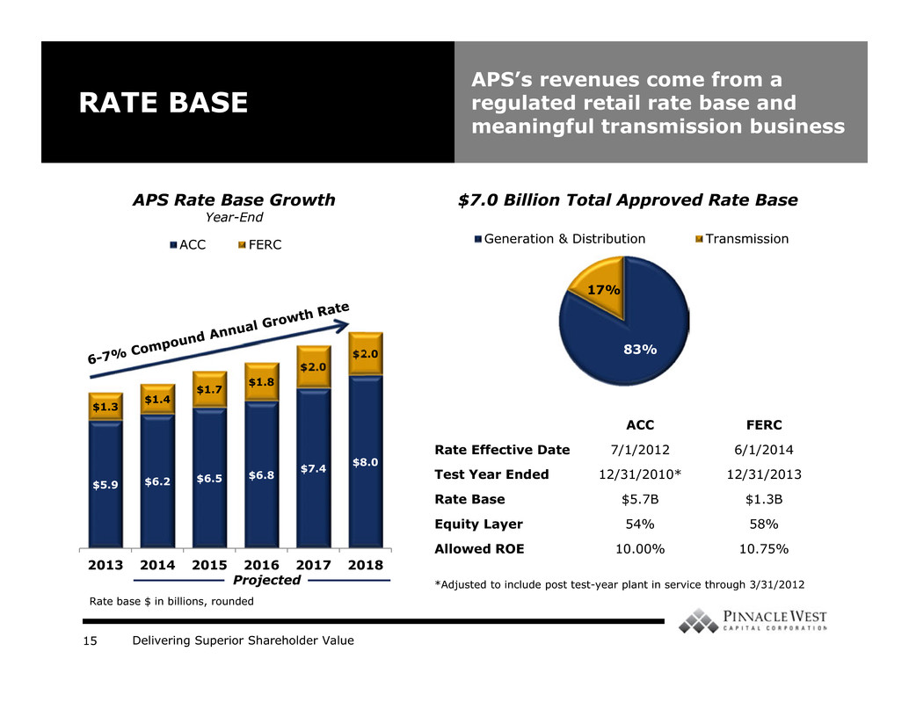
Delivering Superior Shareholder Value15 RATE BASE APS’s revenues come from a regulated retail rate base and meaningful transmission business $5.9 $6.2 $6.5 $6.8 $7.4 $8.0 $1.3 $1.4 $1.7 $1.8 $2.0 $2.0 2013 2014 2015 2016 2017 2018 APS Rate Base Growth Year-End ACC FERC $7.0 Billion Total Approved Rate Base Projected Most Recent Rate Decisions ACC FERC Rate Effective Date 7/1/2012 6/1/2014 Test Year Ended 12/31/2010* 12/31/2013 Rate Base $5.7B $1.3B Equity Layer 54% 58% Allowed ROE 10.00% 10.75% *Adjusted to include post test-year plant in service through 3/31/2012 83% 17% Generation & Distribution Transmission Rate base $ in billions, rounded

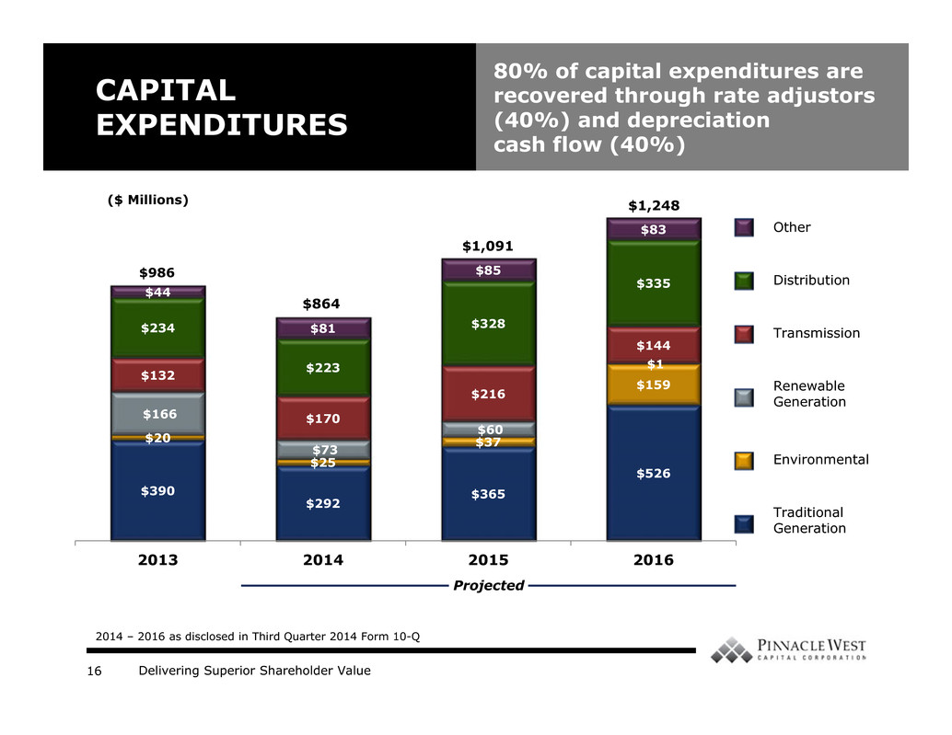
Delivering Superior Shareholder Value16 $390 $292 $365 $526 $20 $25 $37 $159 $166 $73 $60 $1 $132 $170 $216 $144 $234 $223 $328 $335 $44 $81 $85 $83 2013 2014 2015 2016 CAPITAL EXPENDITURES 80% of capital expenditures are recovered through rate adjustors (40%) and depreciation cash flow (40%) ($ Millions) $986 $864 $1,091 2014 – 2016 as disclosed in Third Quarter 2014 Form 10-Q Other Distribution Transmission Renewable Generation Environmental Traditional Generation Projected $1,248

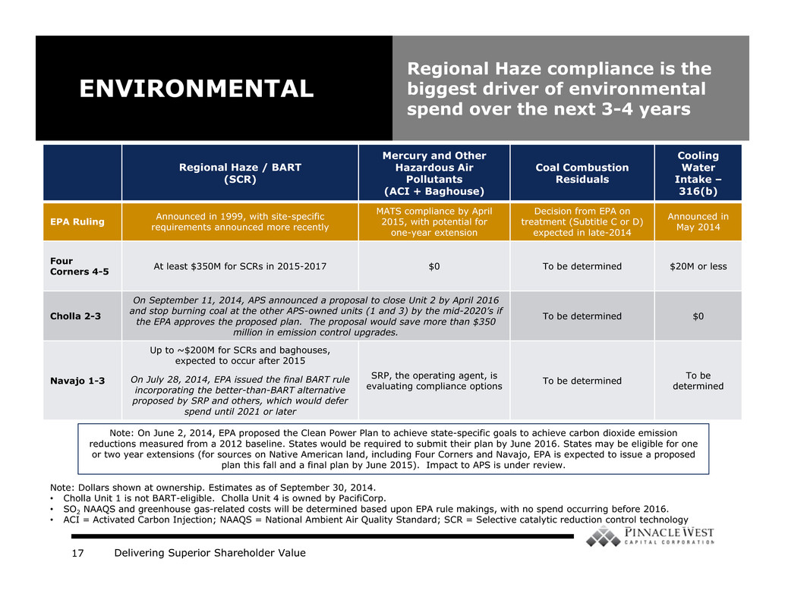
Delivering Superior Shareholder Value17 Regional Haze / BART (SCR) Mercury and Other Hazardous Air Pollutants (ACI + Baghouse) Coal Combustion Residuals Cooling Water Intake – 316(b) EPA Ruling Announced in 1999, with site-specific requirements announced more recently MATS compliance by April 2015, with potential for one-year extension Decision from EPA on treatment (Subtitle C or D) expected in late-2014 Announced in May 2014 Four Corners 4-5 At least $350M for SCRs in 2015-2017 $0 To be determined $20M or less Cholla 2-3 On September 11, 2014, APS announced a proposal to close Unit 2 by April 2016 and stop burning coal at the other APS-owned units (1 and 3) by the mid-2020’s if the EPA approves the proposed plan. The proposal would save more than $350 million in emission control upgrades. To be determined $0 Navajo 1-3 Up to ~$200M for SCRs and baghouses, expected to occur after 2015 On July 28, 2014, EPA issued the final BART rule incorporating the better-than-BART alternative proposed by SRP and others, which would defer spend until 2021 or later SRP, the operating agent, is evaluating compliance options To be determined To be determined Note: Dollars shown at ownership. Estimates as of September 30, 2014. • Cholla Unit 1 is not BART-eligible. Cholla Unit 4 is owned by PacifiCorp. • SO2 NAAQS and greenhouse gas-related costs will be determined based upon EPA rule makings, with no spend occurring before 2016. • ACI = Activated Carbon Injection; NAAQS = National Ambient Air Quality Standard; SCR = Selective catalytic reduction control technology ENVIRONMENTAL Regional Haze compliance is the biggest driver of environmental spend over the next 3-4 years Note: On June 2, 2014, EPA proposed the Clean Power Plan to achieve state-specific goals to achieve carbon dioxide emission reductions measured from a 2012 baseline. States would be required to submit their plan by June 2016. States may be eligible for one or two year extensions (for sources on Native American land, including Four Corners and Navajo, EPA is expected to issue a proposed plan this fall and a final plan by June 2015). Impact to APS is under review.

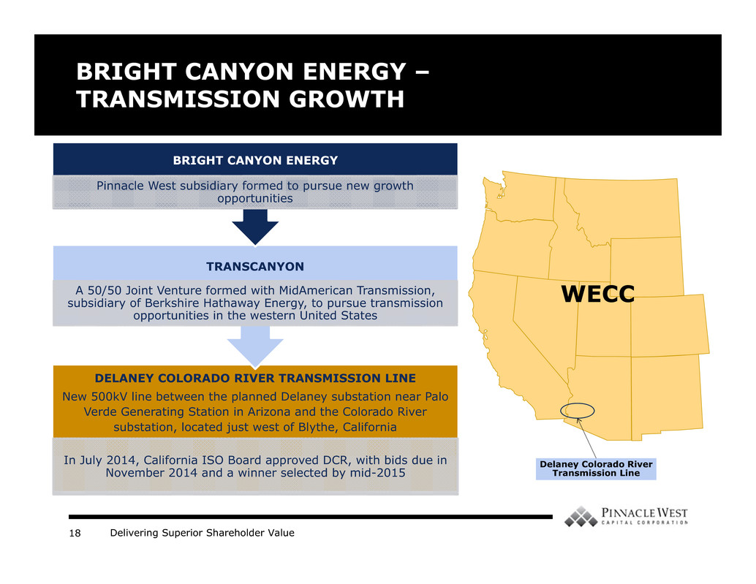
Delivering Superior Shareholder Value18 BRIGHT CANYON ENERGY – TRANSMISSION GROWTH DELANEY COLORADO RIVER TRANSMISSION LINE New 500kV line between the planned Delaney substation near Palo Verde Generating Station in Arizona and the Colorado River substation, located just west of Blythe, California In July 2014, California ISO Board approved DCR, with bids due in November 2014 and a winner selected by mid-2015 TRANSCANYON A 50/50 Joint Venture formed with MidAmerican Transmission, subsidiary of Berkshire Hathaway Energy, to pursue transmission opportunities in the western United States BRIGHT CANYON ENERGY Pinnacle West subsidiary formed to pursue new growth opportunities Delaney Colorado River Transmission Line WECC

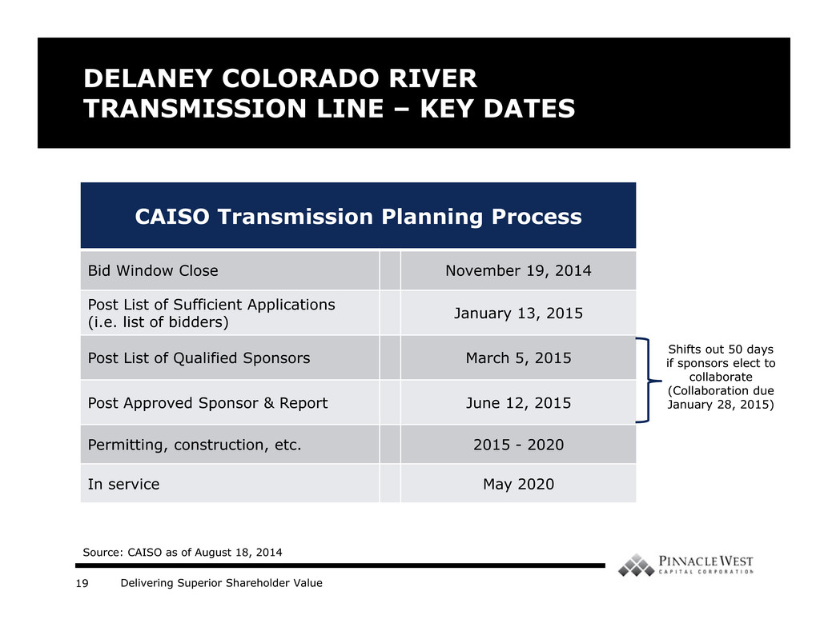
Delivering Superior Shareholder Value19 DELANEY COLORADO RIVER TRANSMISSION LINE – KEY DATES CAISO Transmission Planning Process Bid Window Close November 19, 2014 Post List of Sufficient Applications (i.e. list of bidders) January 13, 2015 Post List of Qualified Sponsors March 5, 2015 Post Approved Sponsor & Report June 12, 2015 Permitting, construction, etc. 2015 - 2020 In service May 2020 Shifts out 50 days if sponsors elect to collaborate (Collaboration due January 28, 2015) Source: CAISO as of August 18, 2014

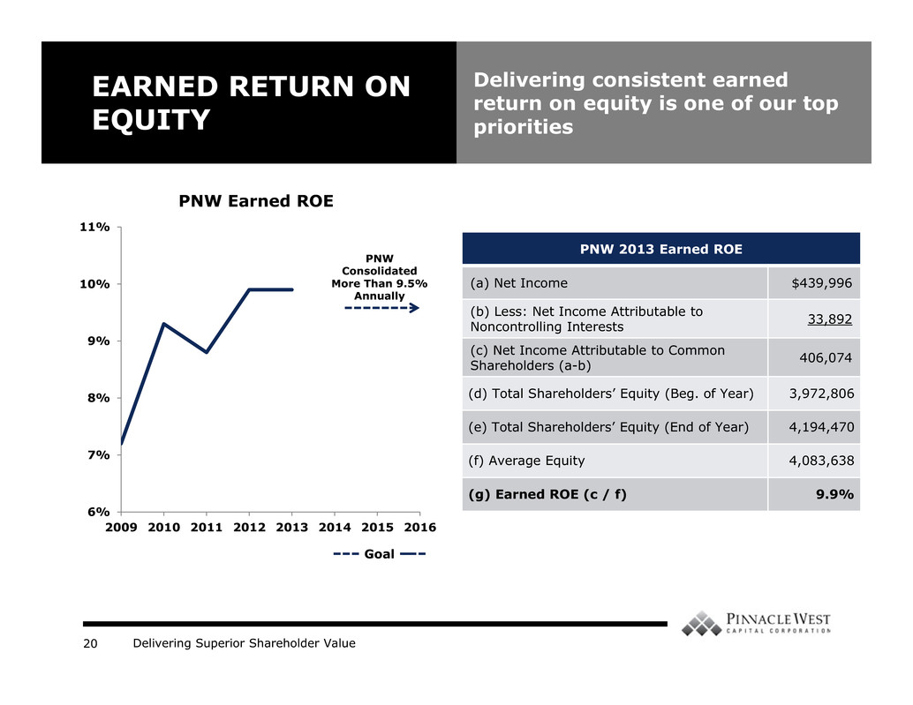
Delivering Superior Shareholder Value20 6% 7% 8% 9% 10% 11% 2009 2010 2011 2012 2013 2014 2015 2016 EARNED RETURN ON EQUITY PNW Earned ROE Goal Delivering consistent earned return on equity is one of our top priorities PNW Consolidated More Than 9.5% Annually PNW 2013 Earned ROE (a) Net Income $439,996 (b) Less: Net Income Attributable to Noncontrolling Interests 33,892 (c) Net Income Attributable to Common Shareholders (a-b) 406,074 (d) Total Shareholders’ Equity (Beg. of Year) 3,972,806 (e) Total Shareholders’ Equity (End of Year) 4,194,470 (f) Average Equity 4,083,638 (g) Earned ROE (c / f) 9.9%

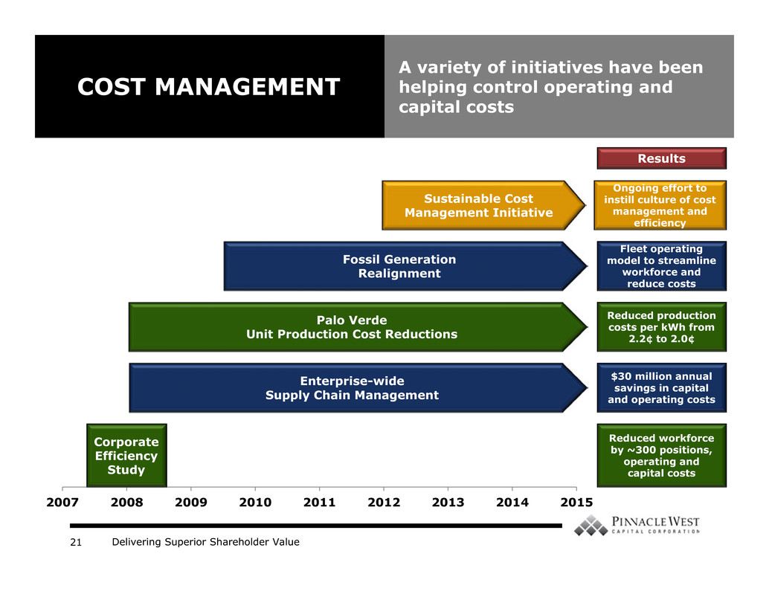
Delivering Superior Shareholder Value21 2007 2008 2009 2010 2011 2012 2013 2014 2015 COST MANAGEMENT A variety of initiatives have been helping control operating and capital costs Sustainable Cost Management Initiative Ongoing effort to instill culture of cost management and efficiency Fossil Generation Realignment Fleet operating model to streamline workforce and reduce costs Palo Verde Unit Production Cost Reductions Reduced production costs per kWh from 2.2¢ to 2.0¢ Enterprise-wide Supply Chain Management $30 million annual savings in capital and operating costs Corporate Efficiency Study Reduced workforce by ~300 positions, operating and capital costs Results

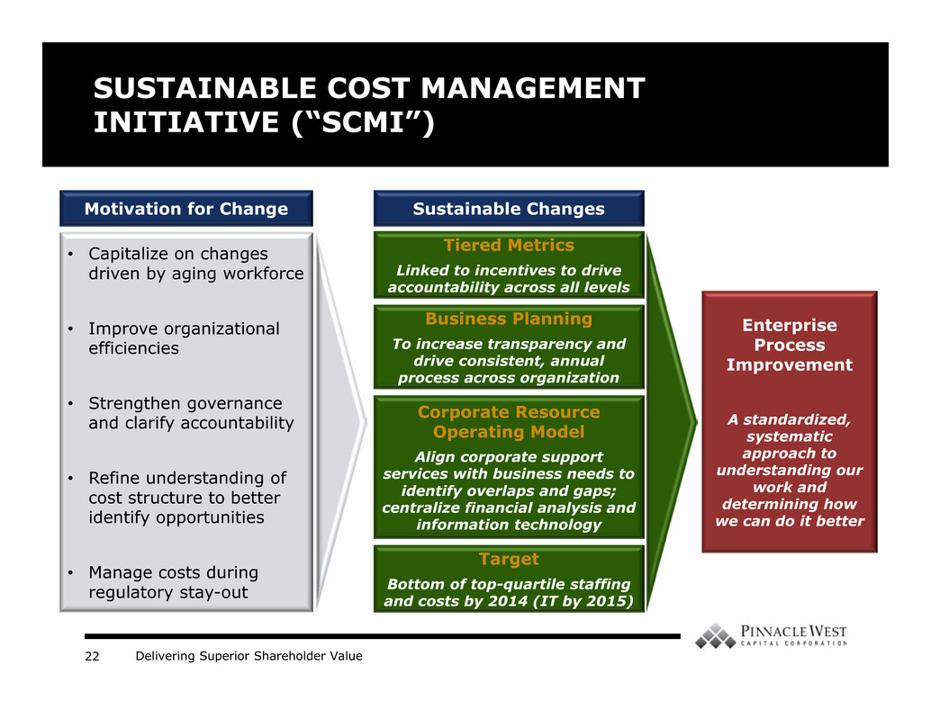
Delivering Superior Shareholder Value22 Motivation for Change SUSTAINABLE COST MANAGEMENT INITIATIVE (“SCMI”) • Capitalize on changes driven by aging workforce • Improve organizational efficiencies • Strengthen governance and clarify accountability • Refine understanding of cost structure to better identify opportunities • Manage costs during regulatory stay-out Sustainable Changes Tiered Metrics Linked to incentives to drive accountability across all levels Business Planning To increase transparency and drive consistent, annual process across organization Corporate Resource Operating Model Align corporate support services with business needs to identify overlaps and gaps; centralize financial analysis and information technology Target Bottom of top-quartile staffing and costs by 2014 (IT by 2015) Enterprise Process Improvement A standardized, systematic approach to understanding our work and determining how we can do it better

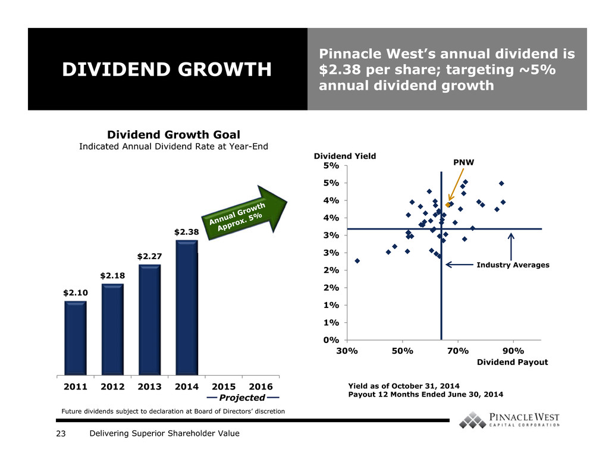
Delivering Superior Shareholder Value23 0% 1% 1% 2% 2% 3% 3% 4% 4% 5% 5% 30% 50% 70% 90% $2.10 $2.18 $2.27 $2.38 2011 2012 2013 2014 2015 2016 Dividend Growth Goal Indicated Annual Dividend Rate at Year-End DIVIDEND GROWTH Pinnacle West’s annual dividend is $2.38 per share; targeting ~5% annual dividend growth Projected Yield as of October 31, 2014 Payout 12 Months Ended June 30, 2014 Dividend Yield Dividend Payout PNW Industry Averages Future dividends subject to declaration at Board of Directors’ discretion

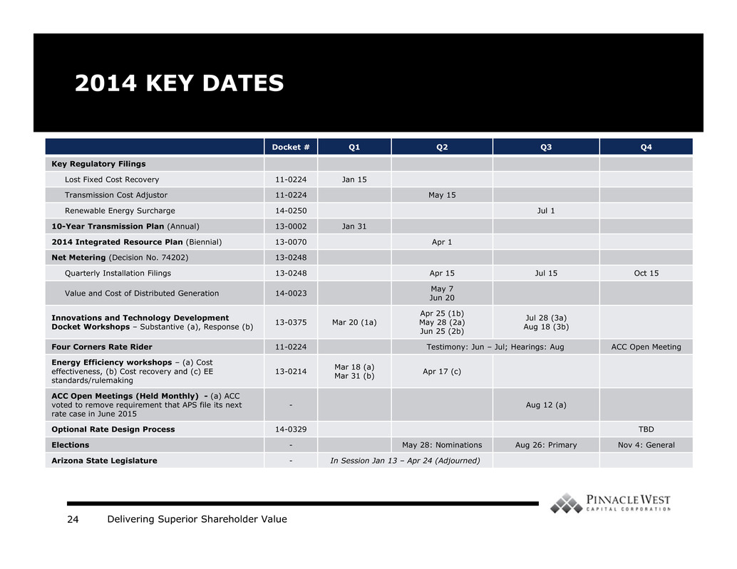
Delivering Superior Shareholder Value24 2014 KEY DATES Docket # Q1 Q2 Q3 Q4 Key Regulatory Filings Lost Fixed Cost Recovery 11-0224 Jan 15 Transmission Cost Adjustor 11-0224 May 15 Renewable Energy Surcharge 14-0250 Jul 1 10-Year Transmission Plan (Annual) 13-0002 Jan 31 2014 Integrated Resource Plan (Biennial) 13-0070 Apr 1 Net Metering (Decision No. 74202) 13-0248 Quarterly Installation Filings 13-0248 Apr 15 Jul 15 Oct 15 Value and Cost of Distributed Generation 14-0023 May 7Jun 20 Innovations and Technology Development Docket Workshops – Substantive (a), Response (b) 13-0375 Mar 20 (1a) Apr 25 (1b) May 28 (2a) Jun 25 (2b) Jul 28 (3a) Aug 18 (3b) Four Corners Rate Rider 11-0224 Testimony: Jun – Jul; Hearings: Aug ACC Open Meeting Energy Efficiency workshops – (a) Cost effectiveness, (b) Cost recovery and (c) EE standards/rulemaking 13-0214 Mar 18 (a)Mar 31 (b) Apr 17 (c) ACC Open Meetings (Held Monthly) - (a) ACC voted to remove requirement that APS file its next rate case in June 2015 - Aug 12 (a) Optional Rate Design Process 14-0329 TBD Elections - May 28: Nominations Aug 26: Primary Nov 4: General Arizona State Legislature - In Session Jan 13 – Apr 24 (Adjourned)

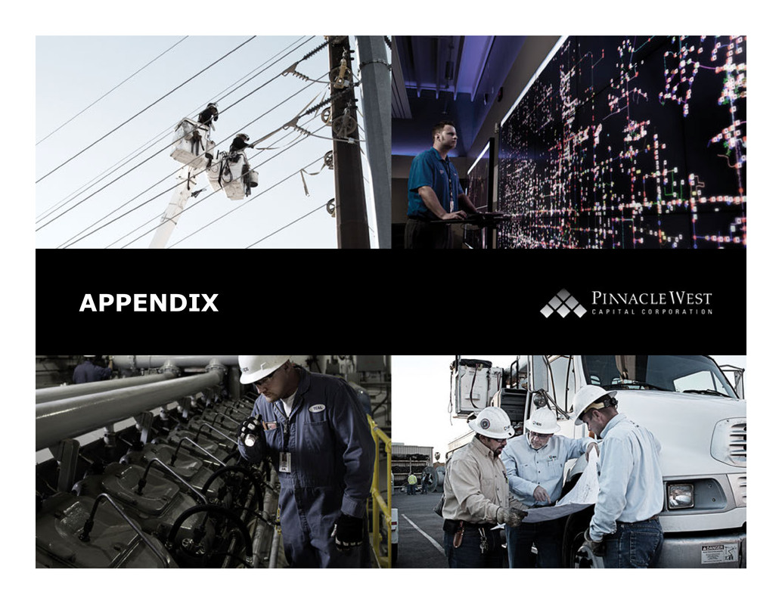
Delivering Superior Shareholder Value APPENDIX

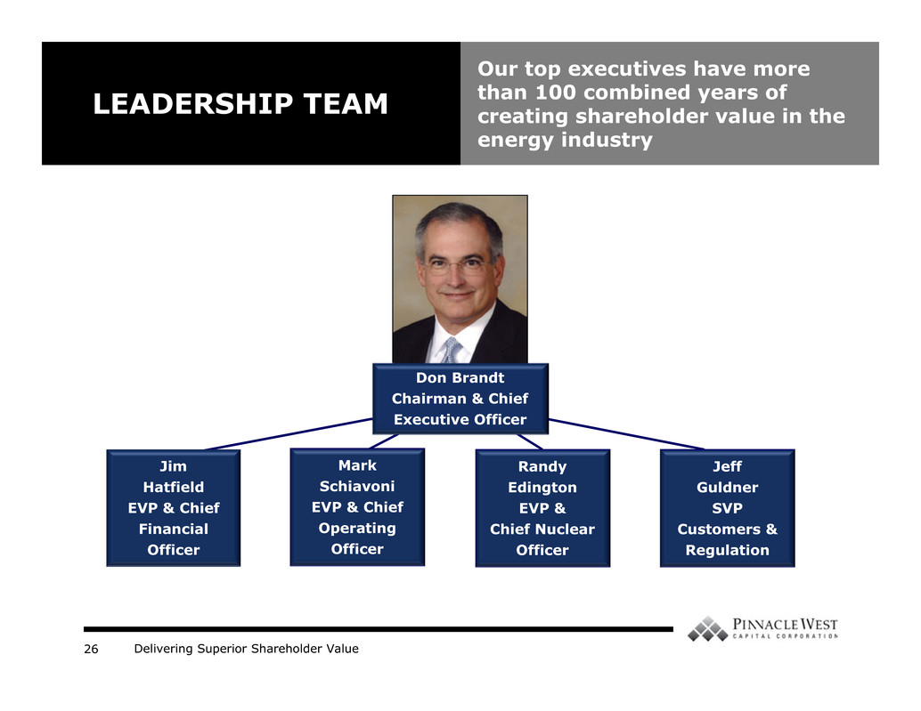
Delivering Superior Shareholder Value26 LEADERSHIP TEAM Our top executives have more than 100 combined years of creating shareholder value in the energy industry Don Brandt Chairman & Chief Executive Officer Mark Schiavoni EVP & Chief Operating Officer Jeff Guldner SVP Customers & Regulation Randy Edington EVP & Chief Nuclear Officer Jim Hatfield EVP & Chief Financial Officer

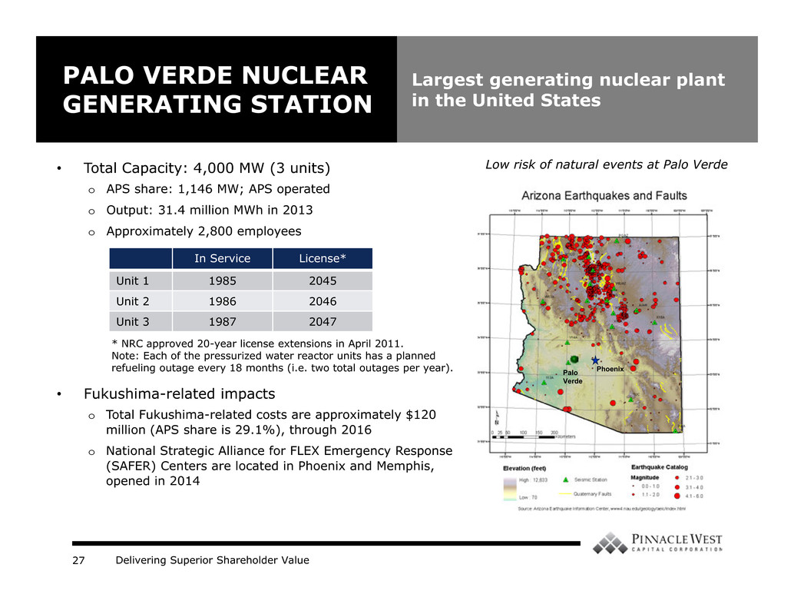
Delivering Superior Shareholder Value27 PALO VERDE NUCLEAR GENERATING STATION Largest generating nuclear plant in the United States • Total Capacity: 4,000 MW (3 units) o APS share: 1,146 MW; APS operated o Output: 31.4 million MWh in 2013 o Approximately 2,800 employees • Fukushima-related impacts o Total Fukushima-related costs are approximately $120 million (APS share is 29.1%), through 2016 o National Strategic Alliance for FLEX Emergency Response (SAFER) Centers are located in Phoenix and Memphis, opened in 2014 Palo Verde Phoenix Low risk of natural events at Palo Verde In Service License* Unit 1 1985 2045 Unit 2 1986 2046 Unit 3 1987 2047 * NRC approved 20-year license extensions in April 2011. Note: Each of the pressurized water reactor units has a planned refueling outage every 18 months (i.e. two total outages per year).

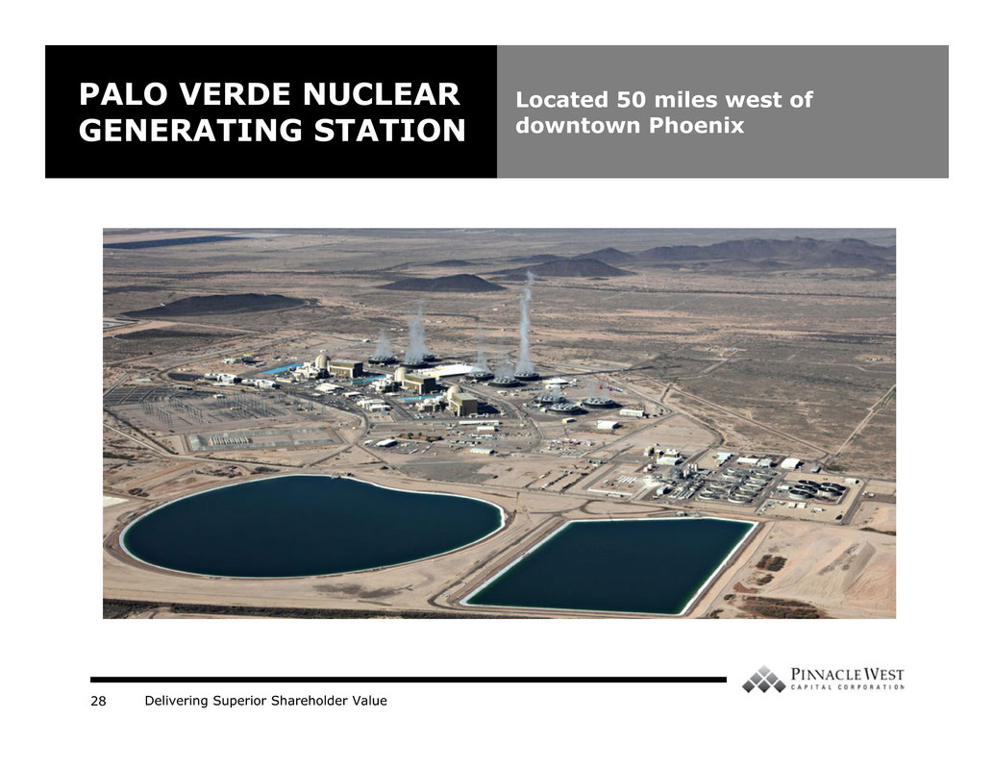
Delivering Superior Shareholder Value28 PALO VERDE NUCLEAR GENERATING STATION Located 50 miles west of downtown Phoenix

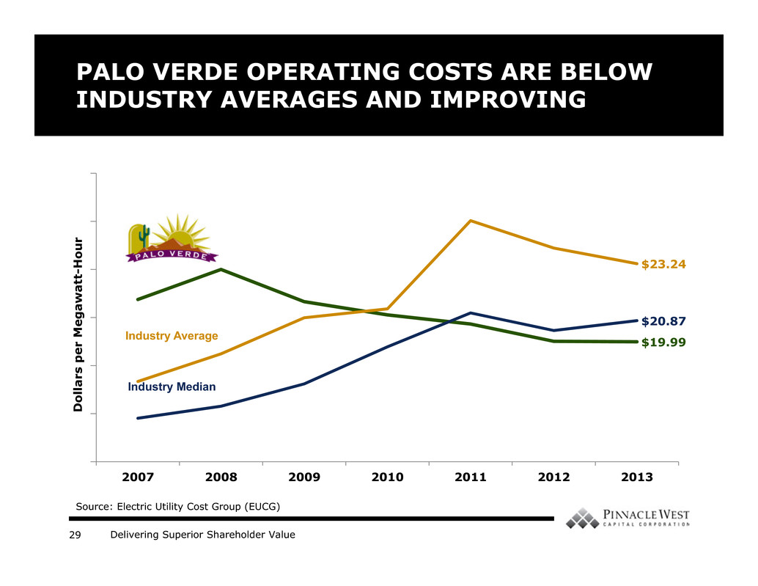
Delivering Superior Shareholder Value29 $19.99 $23.24 $20.87 2007 2008 2009 2010 2011 2012 2013 D o l l a r s p e r M e g a w a t t - H o u r PALO VERDE OPERATING COSTS ARE BELOW INDUSTRY AVERAGES AND IMPROVING Industry Average Industry Median Source: Electric Utility Cost Group (EUCG)

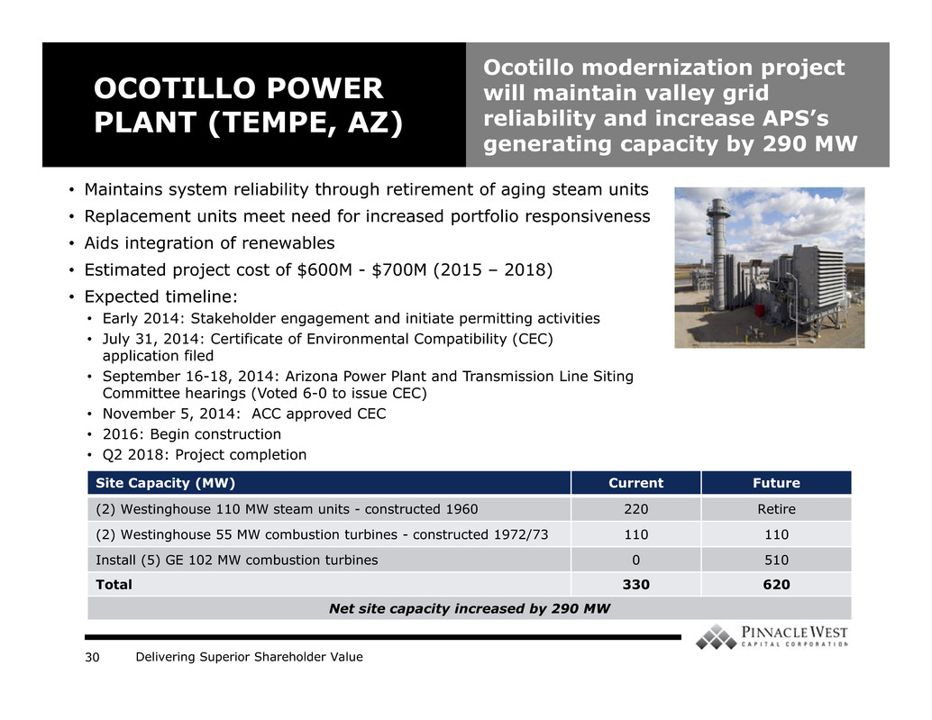
Delivering Superior Shareholder Value30 OCOTILLO POWER PLANT (TEMPE, AZ) Ocotillo modernization project will maintain valley grid reliability and increase APS’s generating capacity by 290 MW • Maintains system reliability through retirement of aging steam units • Replacement units meet need for increased portfolio responsiveness • Aids integration of renewables • Estimated project cost of $600M - $700M (2015 – 2018) • Expected timeline: • Early 2014: Stakeholder engagement and initiate permitting activities • July 31, 2014: Certificate of Environmental Compatibility (CEC) application filed • September 16-18, 2014: Arizona Power Plant and Transmission Line Siting Committee hearings (Voted 6-0 to issue CEC) • November 5, 2014: ACC approved CEC • 2016: Begin construction • Q2 2018: Project completion Site Capacity (MW) Current Future (2) Westinghouse 110 MW steam units - constructed 1960 220 Retire (2) Westinghouse 55 MW combustion turbines - constructed 1972/73 110 110 Install (5) GE 102 MW combustion turbines 0 510 Total 330 620 Net site capacity increased by 290 MW

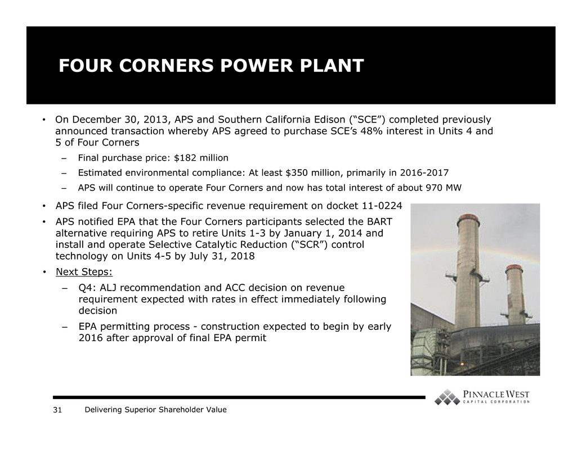
Delivering Superior Shareholder Value31 • On December 30, 2013, APS and Southern California Edison (“SCE”) completed previously announced transaction whereby APS agreed to purchase SCE’s 48% interest in Units 4 and 5 of Four Corners – Final purchase price: $182 million – Estimated environmental compliance: At least $350 million, primarily in 2016-2017 – APS will continue to operate Four Corners and now has total interest of about 970 MW FOUR CORNERS POWER PLANT • APS filed Four Corners-specific revenue requirement on docket 11-0224 • APS notified EPA that the Four Corners participants selected the BART alternative requiring APS to retire Units 1-3 by January 1, 2014 and install and operate Selective Catalytic Reduction (“SCR”) control technology on Units 4-5 by July 31, 2018 • Next Steps: – Q4: ALJ recommendation and ACC decision on revenue requirement expected with rates in effect immediately following decision – EPA permitting process - construction expected to begin by early 2016 after approval of final EPA permit

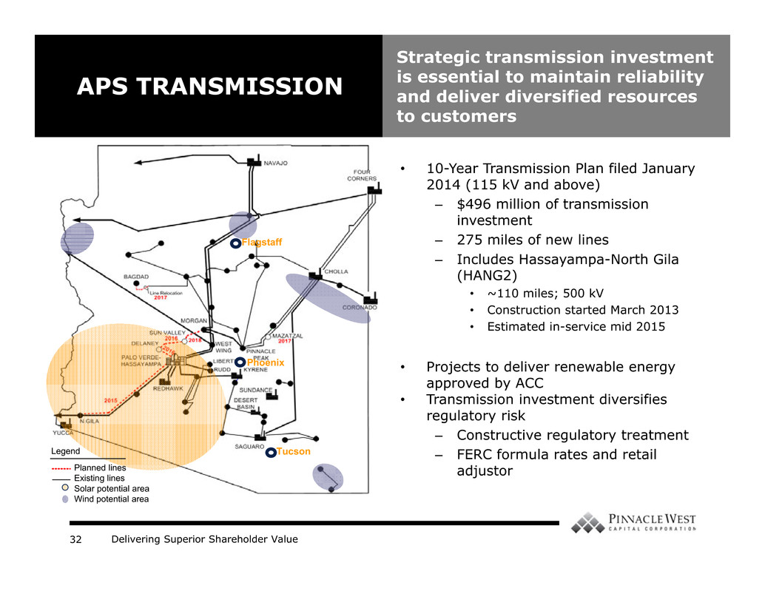
Delivering Superior Shareholder Value32 • 10-Year Transmission Plan filed January 2014 (115 kV and above) – $496 million of transmission investment – 275 miles of new lines – Includes Hassayampa-North Gila (HANG2) • ~110 miles; 500 kV • Construction started March 2013 • Estimated in-service mid 2015 • Projects to deliver renewable energy approved by ACC • Transmission investment diversifies regulatory risk – Constructive regulatory treatment – FERC formula rates and retail adjustor APS TRANSMISSION Strategic transmission investment is essential to maintain reliability and deliver diversified resources to customers Legend Planned lines Existing lines Solar potential area Wind potential area Phoenix Flagstaff Tucson

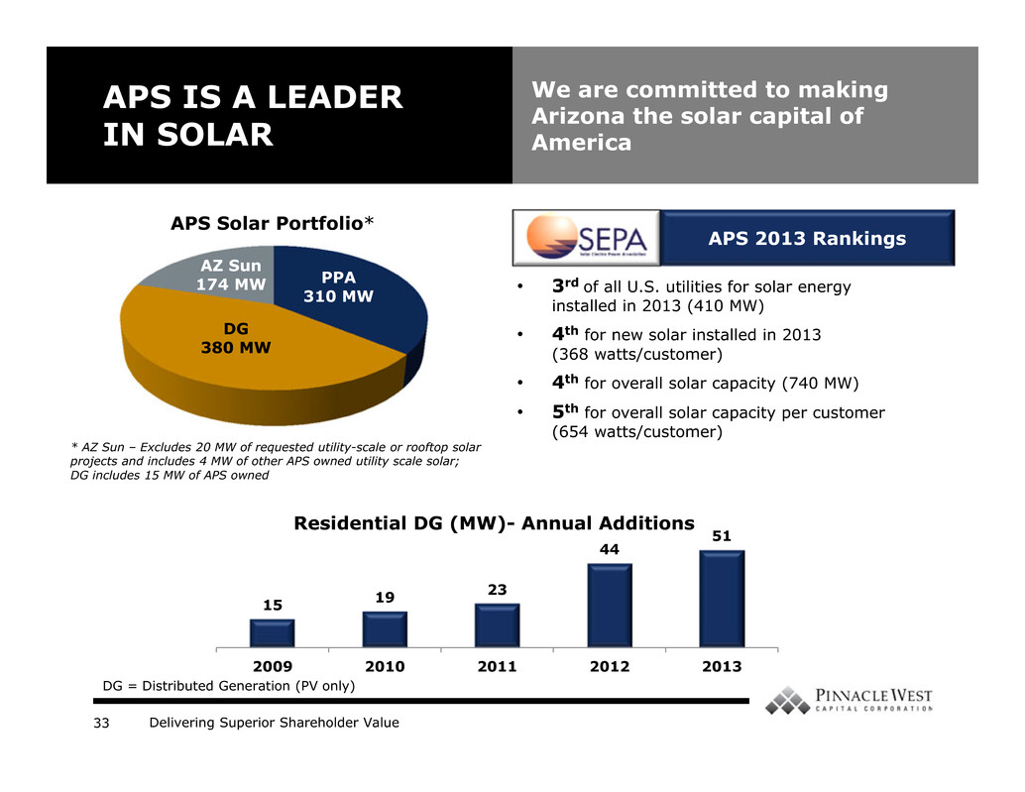
Delivering Superior Shareholder Value33 APS IS A LEADER IN SOLAR We are committed to making Arizona the solar capital of America • 3rd of all U.S. utilities for solar energy installed in 2013 (410 MW) • 4th for new solar installed in 2013 (368 watts/customer) • 4th for overall solar capacity (740 MW) • 5th for overall solar capacity per customer (654 watts/customer) DG 380 MW AZ Sun 174 MW APS Solar Portfolio* 15 19 23 44 51 2009 2010 2011 2012 2013 Residential DG (MW)- Annual Additions APS 2013 Rankings * AZ Sun – Excludes 20 MW of requested utility-scale or rooftop solar projects and includes 4 MW of other APS owned utility scale solar; DG includes 15 MW of APS owned DG = Distributed Generation (PV only) PPA 310 MW

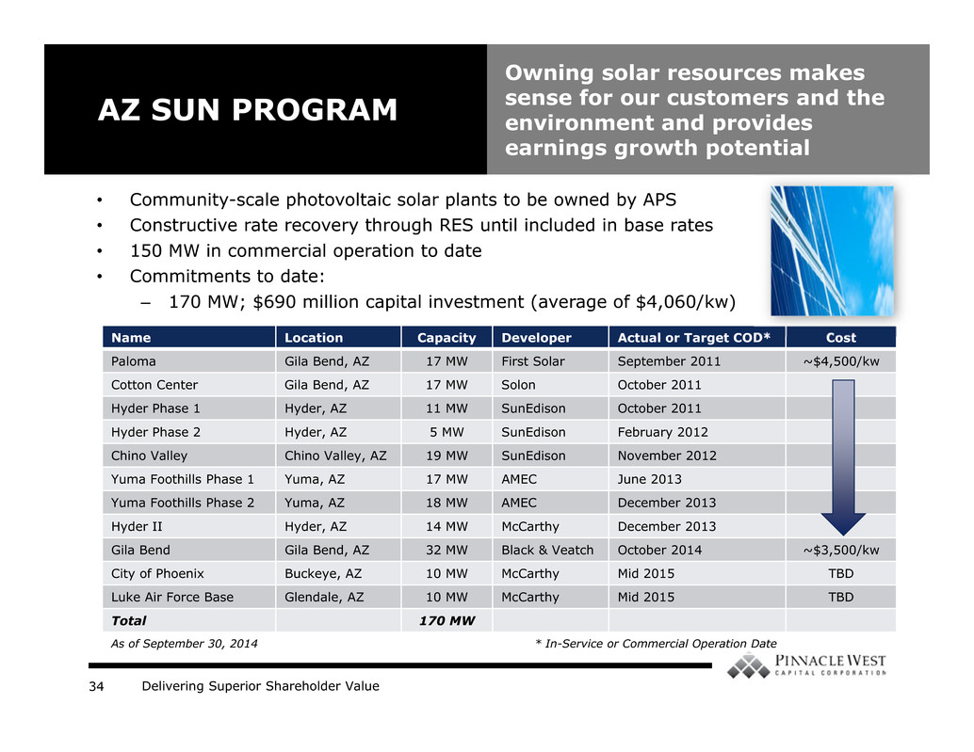
Delivering Superior Shareholder Value34 • Community-scale photovoltaic solar plants to be owned by APS • Constructive rate recovery through RES until included in base rates • 150 MW in commercial operation to date • Commitments to date: – 170 MW; $690 million capital investment (average of $4,060/kw) AZ SUN PROGRAM Owning solar resources makes sense for our customers and the environment and provides earnings growth potential Name Location Capacity Developer Actual or Target COD* Cost Paloma Gila Bend, AZ 17 MW First Solar September 2011 ~$4,500/kw Cotton Center Gila Bend, AZ 17 MW Solon October 2011 Hyder Phase 1 Hyder, AZ 11 MW SunEdison October 2011 Hyder Phase 2 Hyder, AZ 5 MW SunEdison February 2012 Chino Valley Chino Valley, AZ 19 MW SunEdison November 2012 Yuma Foothills Phase 1 Yuma, AZ 17 MW AMEC June 2013 Yuma Foothills Phase 2 Yuma, AZ 18 MW AMEC December 2013 Hyder II Hyder, AZ 14 MW McCarthy December 2013 Gila Bend Gila Bend, AZ 32 MW Black & Veatch October 2014 ~$3,500/kw City of Phoenix Buckeye, AZ 10 MW McCarthy Mid 2015 TBD Luke Air Force Base Glendale, AZ 10 MW McCarthy Mid 2015 TBD Total 170 MW As of September 30, 2014 * In-Service or Commercial Operation Date

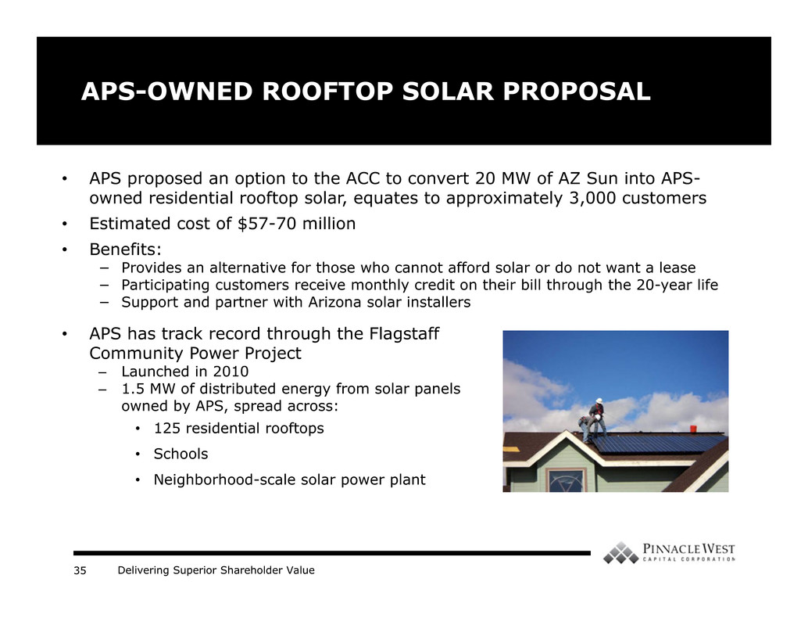
Delivering Superior Shareholder Value35 APS-OWNED ROOFTOP SOLAR PROPOSAL • APS proposed an option to the ACC to convert 20 MW of AZ Sun into APS- owned residential rooftop solar, equates to approximately 3,000 customers • Estimated cost of $57-70 million • Benefits: − Provides an alternative for those who cannot afford solar or do not want a lease − Participating customers receive monthly credit on their bill through the 20-year life − Support and partner with Arizona solar installers • TBD • APS has track record through the Flagstaff Community Power Project – Launched in 2010 – 1.5 MW of distributed energy from solar panels owned by APS, spread across: • 125 residential rooftops • Schools • Neighborhood-scale solar power plant

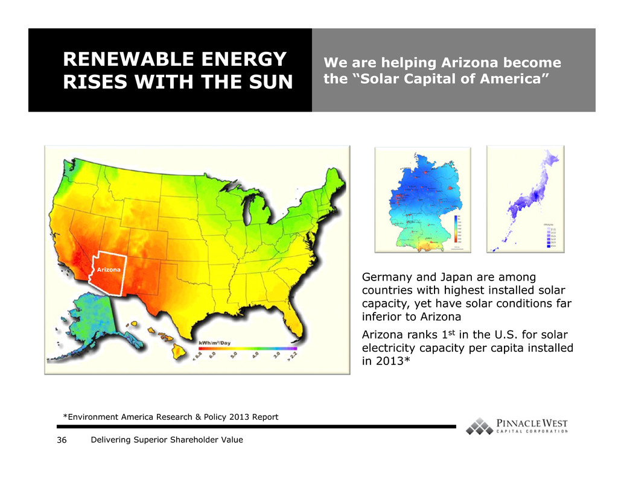
Delivering Superior Shareholder Value36 Germany and Japan are among countries with highest installed solar capacity, yet have solar conditions far inferior to Arizona Arizona ranks 1st in the U.S. for solar electricity capacity per capita installed in 2013* RENEWABLE ENERGY RISES WITH THE SUN We are helping Arizona become the “Solar Capital of America” Arizona *Environment America Research & Policy 2013 Report

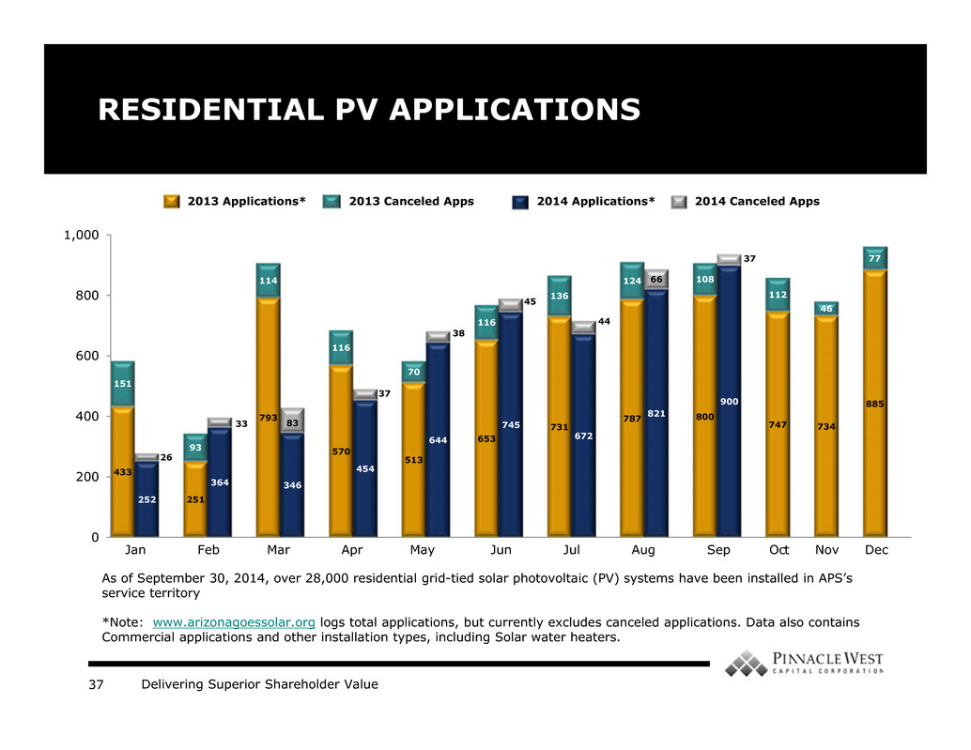
Delivering Superior Shareholder Value37 As of September 30, 2014, over 28,000 residential grid-tied solar photovoltaic (PV) systems have been installed in APS’s service territory *Note: www.arizonagoessolar.org logs total applications, but currently excludes canceled applications. Data also contains Commercial applications and other installation types, including Solar water heaters. 433 251 793 570 513 653 731 787 800 900 747 734 885 252 364 346 454 644 745 672 821 151 93 114 116 70 116 136 124 108 37 112 46 77 26 33 83 37 38 45 44 66 0 200 400 600 800 1,000 13-Jan 14-Jan 13-Feb2 14-Feb 13-Mar 14-Mar2 13-Apr2 14-Apr3 13-May2 14-May3 Column2 13-Jun2 14-Jun3 13-Jul2 14-Jul3 13-Aug2 14-Aug3 Column3 13-Sep2 14-Sep3 Column4 13-Oct2 14-Oct3 13-Nov2 14-Nov3 13-Dec2 14-Dec3 RESIDENTIAL PV APPLICATIONS 2013 Applications* 2014 Applications* 2014 Canceled Apps2013 Canceled Apps Jan Feb Mar Apr May Jun Jul Aug Sep Oct Nov Dec

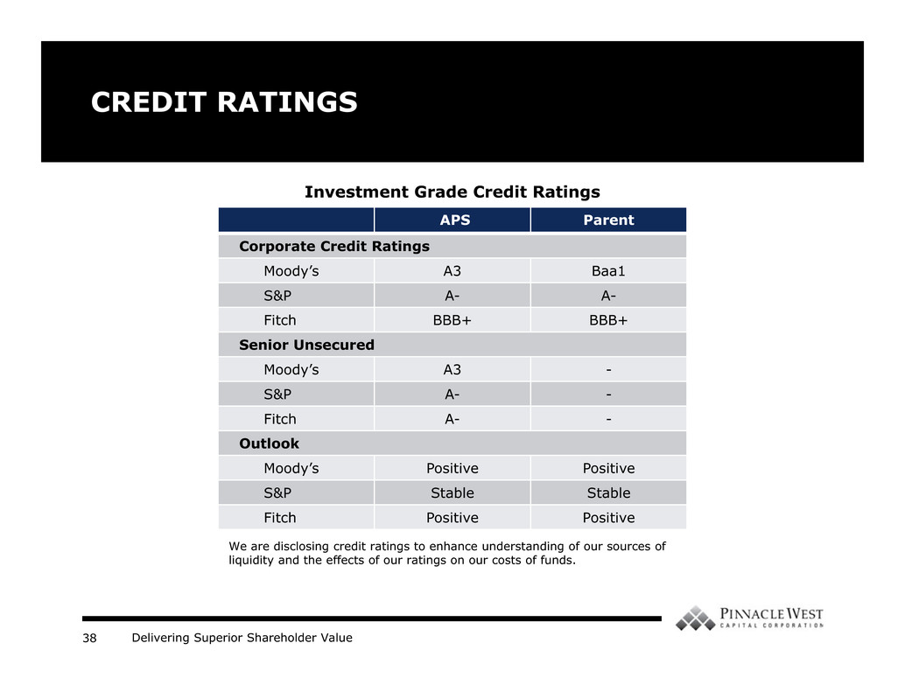
Delivering Superior Shareholder Value38 CREDIT RATINGS APS Parent Corporate Credit Ratings Moody’s A3 Baa1 S&P A- A- Fitch BBB+ BBB+ Senior Unsecured Moody’s A3 - S&P A- - Fitch A- - Outlook Moody’s Positive Positive S&P Stable Stable Fitch Positive Positive We are disclosing credit ratings to enhance understanding of our sources of liquidity and the effects of our ratings on our costs of funds. Investment Grade Credit Ratings

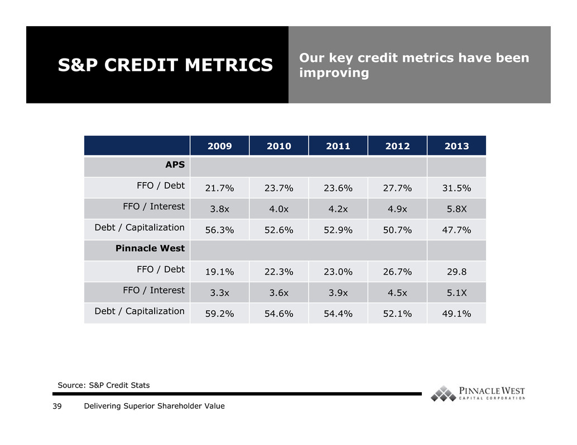
Delivering Superior Shareholder Value39 2009 2010 2011 2012 2013 APS FFO / Debt 21.7% 23.7% 23.6% 27.7% 31.5% FFO / Interest 3.8x 4.0x 4.2x 4.9x 5.8X Debt / Capitalization 56.3% 52.6% 52.9% 50.7% 47.7% Pinnacle West FFO / Debt 19.1% 22.3% 23.0% 26.7% 29.8 FFO / Interest 3.3x 3.6x 3.9x 4.5x 5.1X Debt / Capitalization 59.2% 54.6% 54.4% 52.1% 49.1% S&P CREDIT METRICS Our key credit metrics have been improving Source: S&P Credit Stats

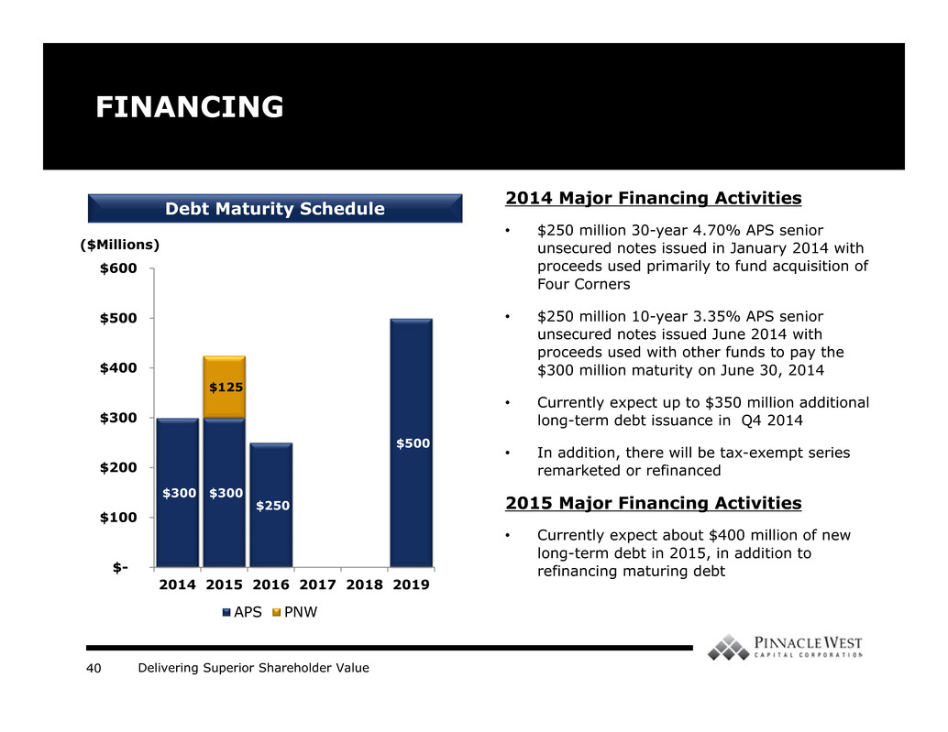
Delivering Superior Shareholder Value40 FINANCING $300 $300 $250 $500 $125 $- $100 $200 $300 $400 $500 $600 2014 2015 2016 2017 2018 2019 APS PNW ($Millions) Debt Maturity Schedule 2014 Major Financing Activities • $250 million 30-year 4.70% APS senior unsecured notes issued in January 2014 with proceeds used primarily to fund acquisition of Four Corners • $250 million 10-year 3.35% APS senior unsecured notes issued June 2014 with proceeds used with other funds to pay the $300 million maturity on June 30, 2014 • Currently expect up to $350 million additional long-term debt issuance in Q4 2014 • In addition, there will be tax-exempt series remarketed or refinanced 2015 Major Financing Activities • Currently expect about $400 million of new long-term debt in 2015, in addition to refinancing maturing debt

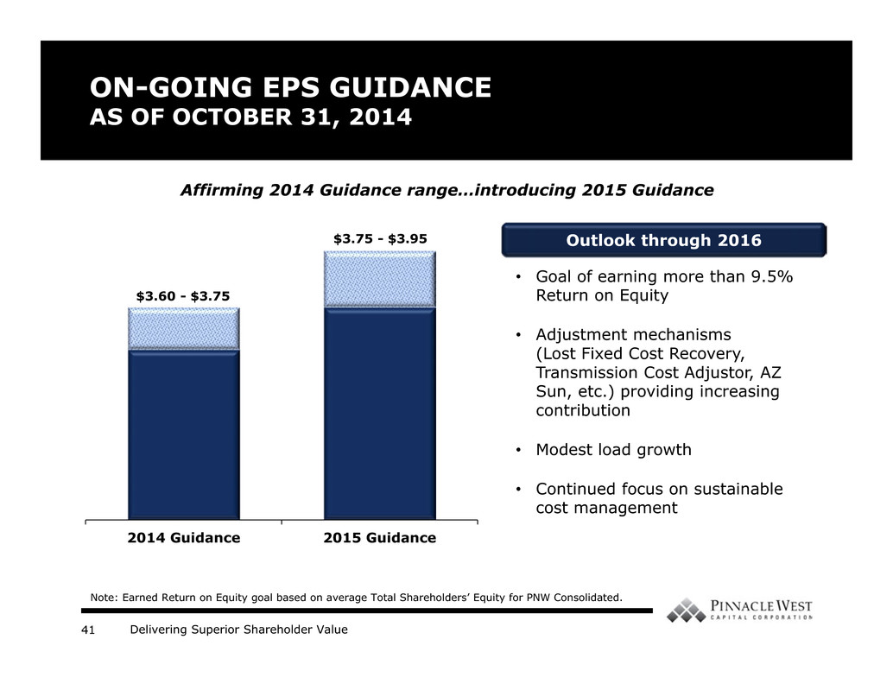
Delivering Superior Shareholder Value41 ON-GOING EPS GUIDANCE AS OF OCTOBER 31, 2014 2014 Guidance 2015 Guidance Note: Earned Return on Equity goal based on average Total Shareholders’ Equity for PNW Consolidated. Affirming 2014 Guidance range…introducing 2015 Guidance $3.60 - $3.75 $3.75 - $3.95 Outlook through 2016 • Goal of earning more than 9.5% Return on Equity • Adjustment mechanisms (Lost Fixed Cost Recovery, Transmission Cost Adjustor, AZ Sun, etc.) providing increasing contribution • Modest load growth • Continued focus on sustainable cost management

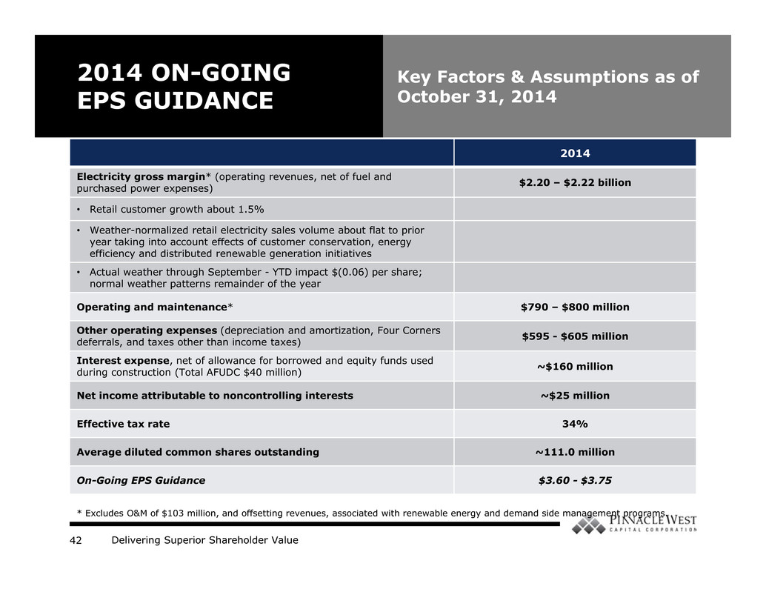
Delivering Superior Shareholder Value42 2014 ON-GOING EPS GUIDANCE Key Factors & Assumptions as of October 31, 2014 2014 Electricity gross margin* (operating revenues, net of fuel and purchased power expenses) $2.20 – $2.22 billion • Retail customer growth about 1.5% • Weather-normalized retail electricity sales volume about flat to prior year taking into account effects of customer conservation, energy efficiency and distributed renewable generation initiatives • Actual weather through September - YTD impact $(0.06) per share; normal weather patterns remainder of the year Operating and maintenance* $790 – $800 million Other operating expenses (depreciation and amortization, Four Corners deferrals, and taxes other than income taxes) $595 - $605 million Interest expense, net of allowance for borrowed and equity funds used during construction (Total AFUDC $40 million) ~$160 million Net income attributable to noncontrolling interests ~$25 million Effective tax rate 34% Average diluted common shares outstanding ~111.0 million On-Going EPS Guidance $3.60 - $3.75 * Excludes O&M of $103 million, and offsetting revenues, associated with renewable energy and demand side management programs.

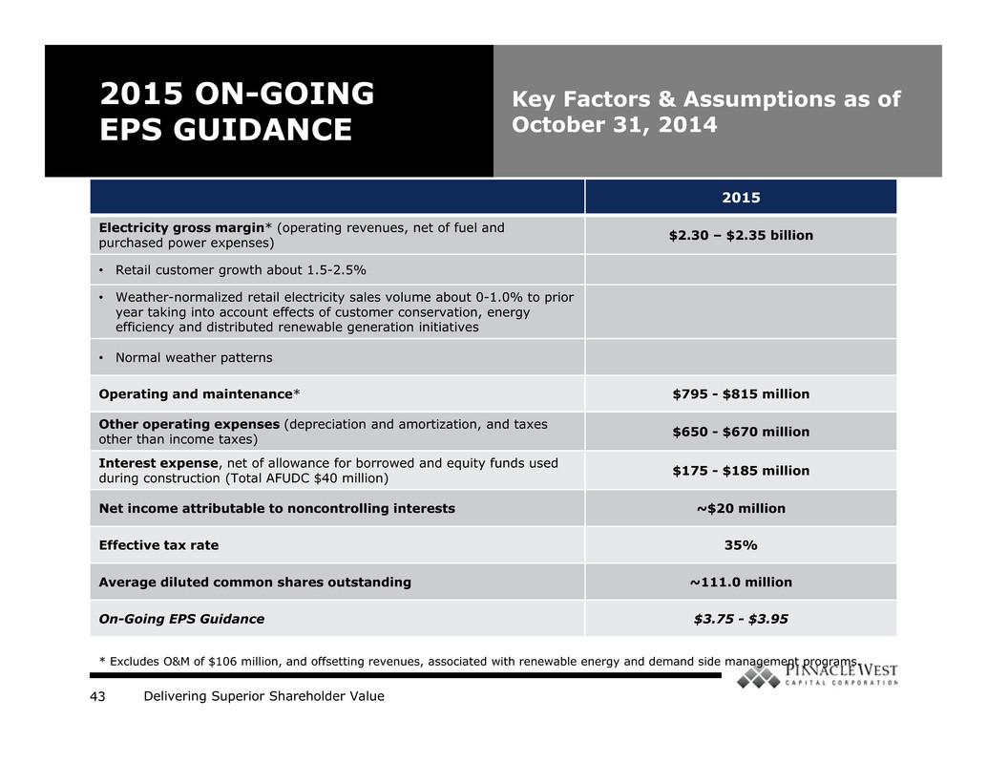
Delivering Superior Shareholder Value43 2015 ON-GOING EPS GUIDANCE Key Factors & Assumptions as of October 31, 2014 2015 Electricity gross margin* (operating revenues, net of fuel and purchased power expenses) $2.30 – $2.35 billion • Retail customer growth about 1.5-2.5% • Weather-normalized retail electricity sales volume about 0-1.0% to prior year taking into account effects of customer conservation, energy efficiency and distributed renewable generation initiatives • Normal weather patterns Operating and maintenance* $795 - $815 million Other operating expenses (depreciation and amortization, and taxes other than income taxes) $650 - $670 million Interest expense, net of allowance for borrowed and equity funds used during construction (Total AFUDC $40 million) $175 - $185 million Net income attributable to noncontrolling interests ~$20 million Effective tax rate 35% Average diluted common shares outstanding ~111.0 million On-Going EPS Guidance $3.75 - $3.95 * Excludes O&M of $106 million, and offsetting revenues, associated with renewable energy and demand side management programs.

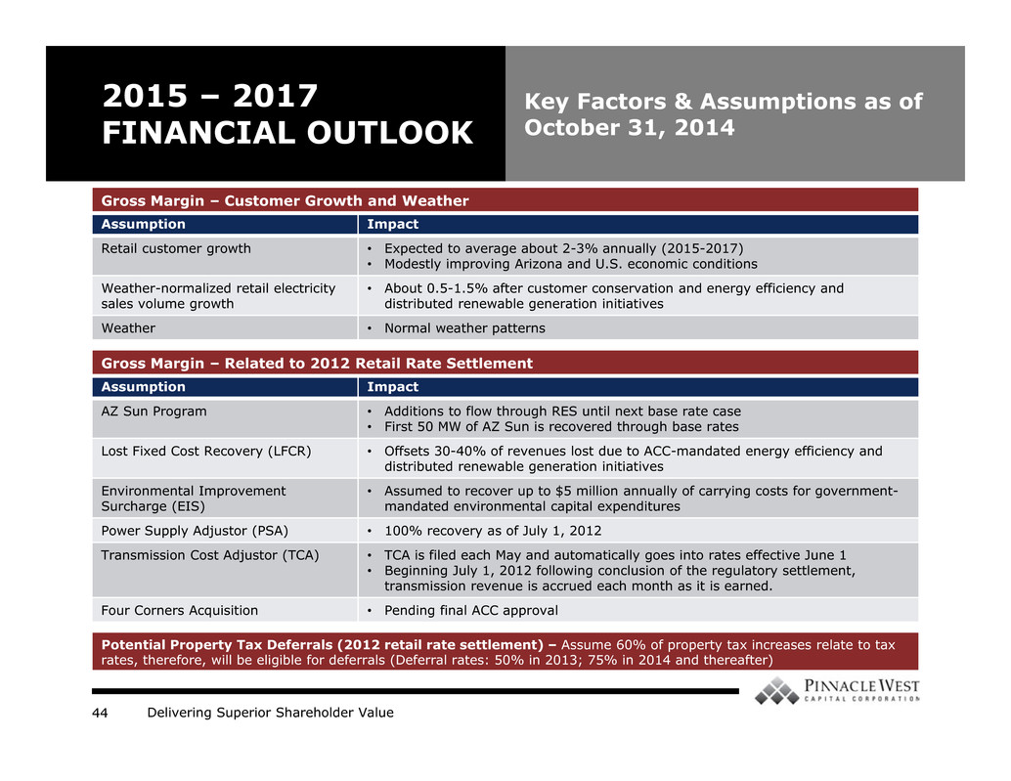
Delivering Superior Shareholder Value44 2015 – 2017 FINANCIAL OUTLOOK Key Factors & Assumptions as of October 31, 2014 Assumption Impact Retail customer growth • Expected to average about 2-3% annually (2015-2017) • Modestly improving Arizona and U.S. economic conditions Weather-normalized retail electricity sales volume growth • About 0.5-1.5% after customer conservation and energy efficiency and distributed renewable generation initiatives Weather • Normal weather patterns Assumption Impact AZ Sun Program • Additions to flow through RES until next base rate case • First 50 MW of AZ Sun is recovered through base rates Lost Fixed Cost Recovery (LFCR) • Offsets 30-40% of revenues lost due to ACC-mandated energy efficiency and distributed renewable generation initiatives Environmental Improvement Surcharge (EIS) • Assumed to recover up to $5 million annually of carrying costs for government- mandated environmental capital expenditures Power Supply Adjustor (PSA) • 100% recovery as of July 1, 2012 Transmission Cost Adjustor (TCA) • TCA is filed each May and automatically goes into rates effective June 1 • Beginning July 1, 2012 following conclusion of the regulatory settlement, transmission revenue is accrued each month as it is earned. Four Corners Acquisition • Pending final ACC approval Potential Property Tax Deferrals (2012 retail rate settlement) – Assume 60% of property tax increases relate to tax rates, therefore, will be eligible for deferrals (Deferral rates: 50% in 2013; 75% in 2014 and thereafter) Gross Margin – Customer Growth and Weather Gross Margin – Related to 2012 Retail Rate Settlement

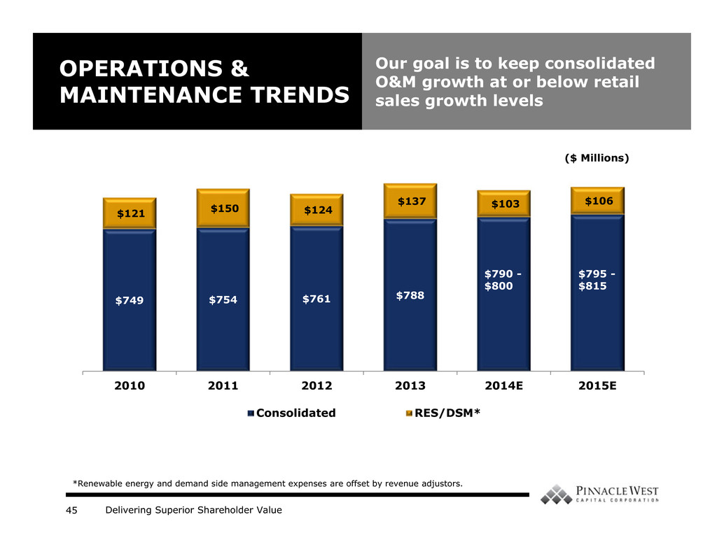
Delivering Superior Shareholder Value45 OPERATIONS & MAINTENANCE TRENDS Our goal is to keep consolidated O&M growth at or below retail sales growth levels $749 $754 $761 $788 $121 $150 $124 $137 $103 $106 2010 2011 2012 2013 2014E 2015E Consolidated RES/DSM* *Renewable energy and demand side management expenses are offset by revenue adjustors. $795 - $815 ($ Millions) $790 - $800

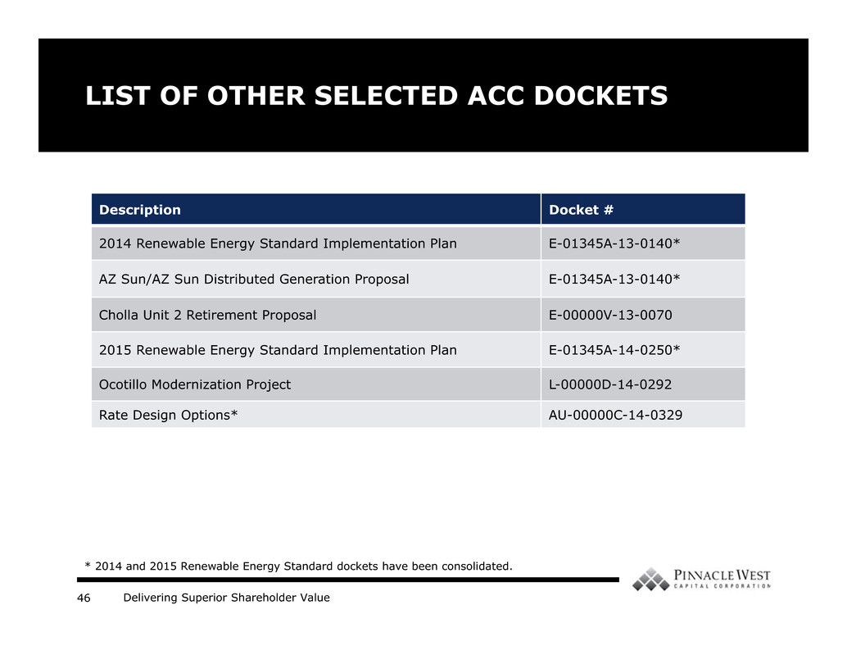
Delivering Superior Shareholder Value46 LIST OF OTHER SELECTED ACC DOCKETS Description Docket # 2014 Renewable Energy Standard Implementation Plan E-01345A-13-0140* AZ Sun/AZ Sun Distributed Generation Proposal E-01345A-13-0140* Cholla Unit 2 Retirement Proposal E-00000V-13-0070 2015 Renewable Energy Standard Implementation Plan E-01345A-14-0250* Ocotillo Modernization Project L-00000D-14-0292 Rate Design Options* AU-00000C-14-0329 * 2014 and 2015 Renewable Energy Standard dockets have been consolidated.

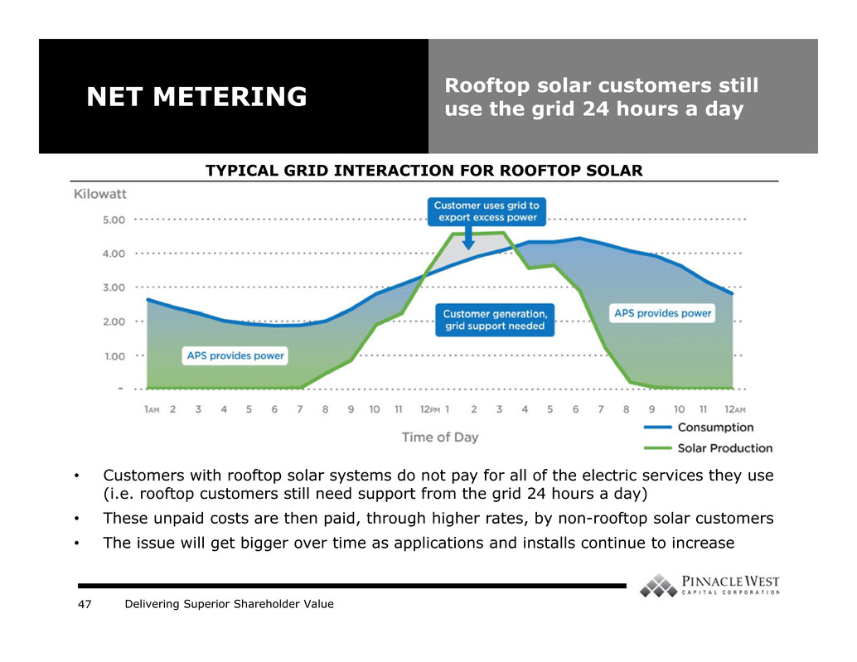
Delivering Superior Shareholder Value47 • Customers with rooftop solar systems do not pay for all of the electric services they use (i.e. rooftop customers still need support from the grid 24 hours a day) • These unpaid costs are then paid, through higher rates, by non-rooftop solar customers • The issue will get bigger over time as applications and installs continue to increase NET METERING Rooftop solar customers still use the grid 24 hours a day TYPICAL GRID INTERACTION FOR ROOFTOP SOLAR

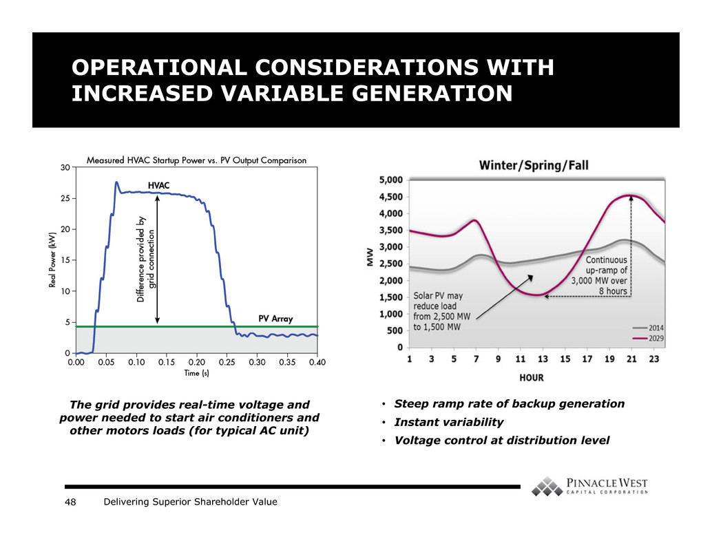
Delivering Superior Shareholder Value48 OPERATIONAL CONSIDERATIONS WITH INCREASED VARIABLE GENERATION The grid provides real-time voltage and power needed to start air conditioners and other motors loads (for typical AC unit) • Steep ramp rate of backup generation • Instant variability • Voltage control at distribution level

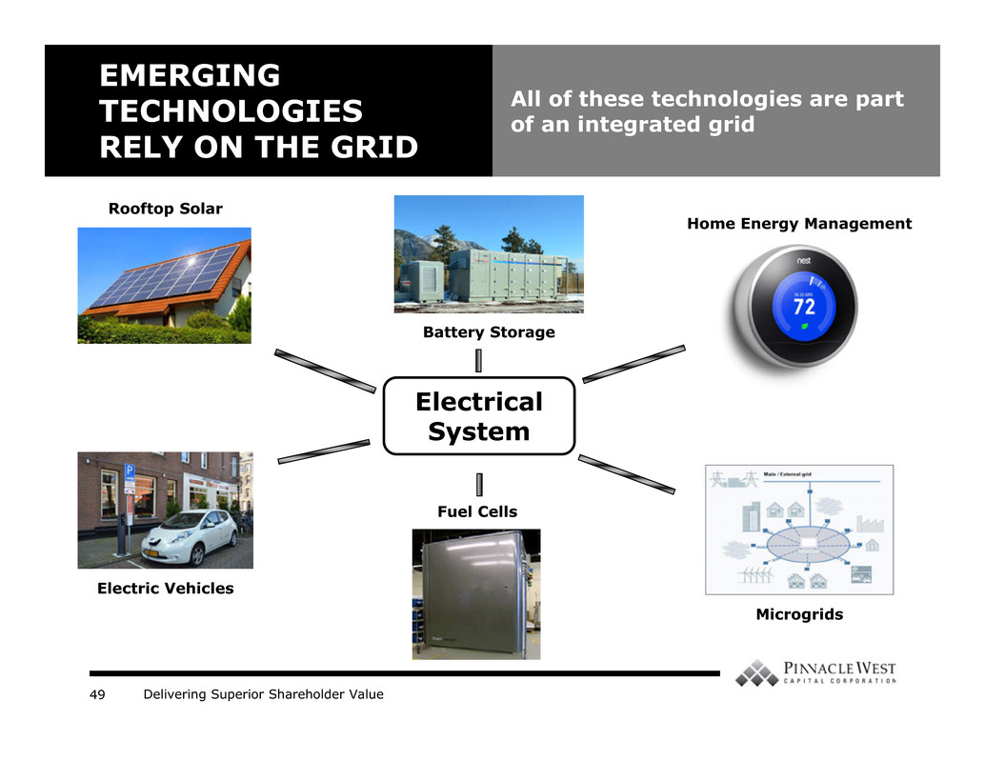
Delivering Superior Shareholder Value49 EMERGING TECHNOLOGIES RELY ON THE GRID All of these technologies are part of an integrated grid Electric Vehicles Battery Storage Fuel Cells Home Energy Management Microgrids Rooftop Solar Electrical System

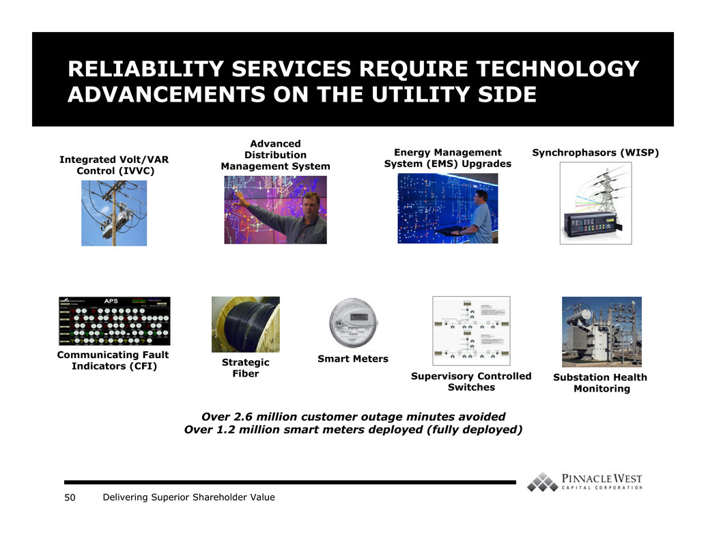
Delivering Superior Shareholder Value50 RELIABILITY SERVICES REQUIRE TECHNOLOGY ADVANCEMENTS ON THE UTILITY SIDE Substation Health Monitoring Integrated Volt/VAR Control (IVVC) Communicating Fault Indicators (CFI) Synchrophasors (WISP) Supervisory Controlled Switches Advanced Distribution Management System Smart Meters Energy Management System (EMS) Upgrades Strategic Fiber Over 2.6 million customer outage minutes avoided Over 1.2 million smart meters deployed (fully deployed)

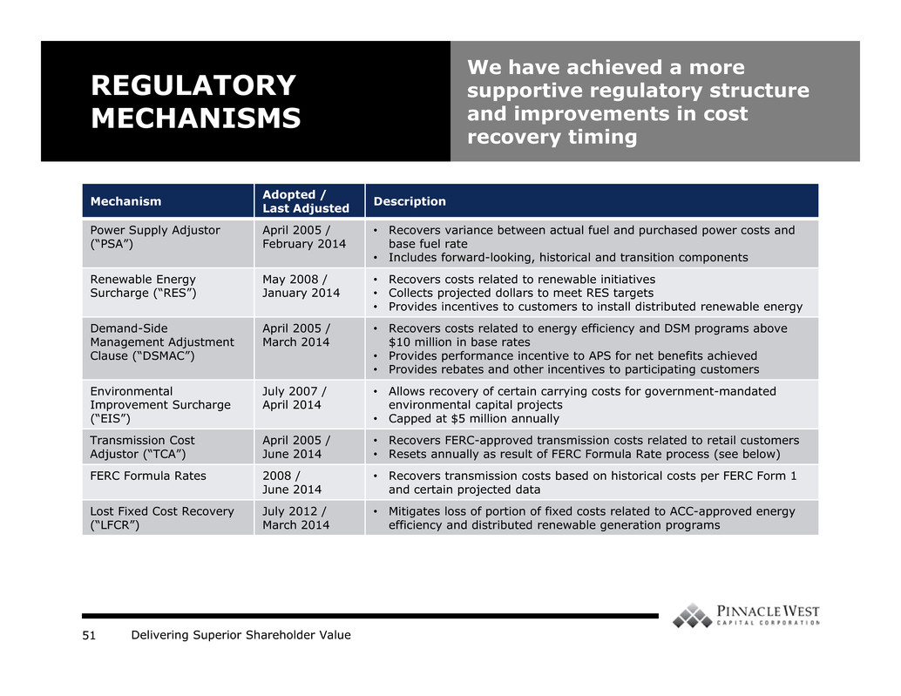
Delivering Superior Shareholder Value51 Mechanism Adopted / Last Adjusted Description Power Supply Adjustor (“PSA”) April 2005 / February 2014 • Recovers variance between actual fuel and purchased power costs and base fuel rate • Includes forward-looking, historical and transition components Renewable Energy Surcharge (“RES”) May 2008 / January 2014 • Recovers costs related to renewable initiatives • Collects projected dollars to meet RES targets • Provides incentives to customers to install distributed renewable energy Demand-Side Management Adjustment Clause (“DSMAC”) April 2005 / March 2014 • Recovers costs related to energy efficiency and DSM programs above $10 million in base rates • Provides performance incentive to APS for net benefits achieved • Provides rebates and other incentives to participating customers Environmental Improvement Surcharge (“EIS”) July 2007 / April 2014 • Allows recovery of certain carrying costs for government-mandated environmental capital projects • Capped at $5 million annually Transmission Cost Adjustor (“TCA”) April 2005 / June 2014 • Recovers FERC-approved transmission costs related to retail customers • Resets annually as result of FERC Formula Rate process (see below) FERC Formula Rates 2008 / June 2014 • Recovers transmission costs based on historical costs per FERC Form 1 and certain projected data Lost Fixed Cost Recovery (“LFCR”) July 2012 / March 2014 • Mitigates loss of portion of fixed costs related to ACC-approved energy efficiency and distributed renewable generation programs REGULATORY MECHANISMS We have achieved a more supportive regulatory structure and improvements in cost recovery timing

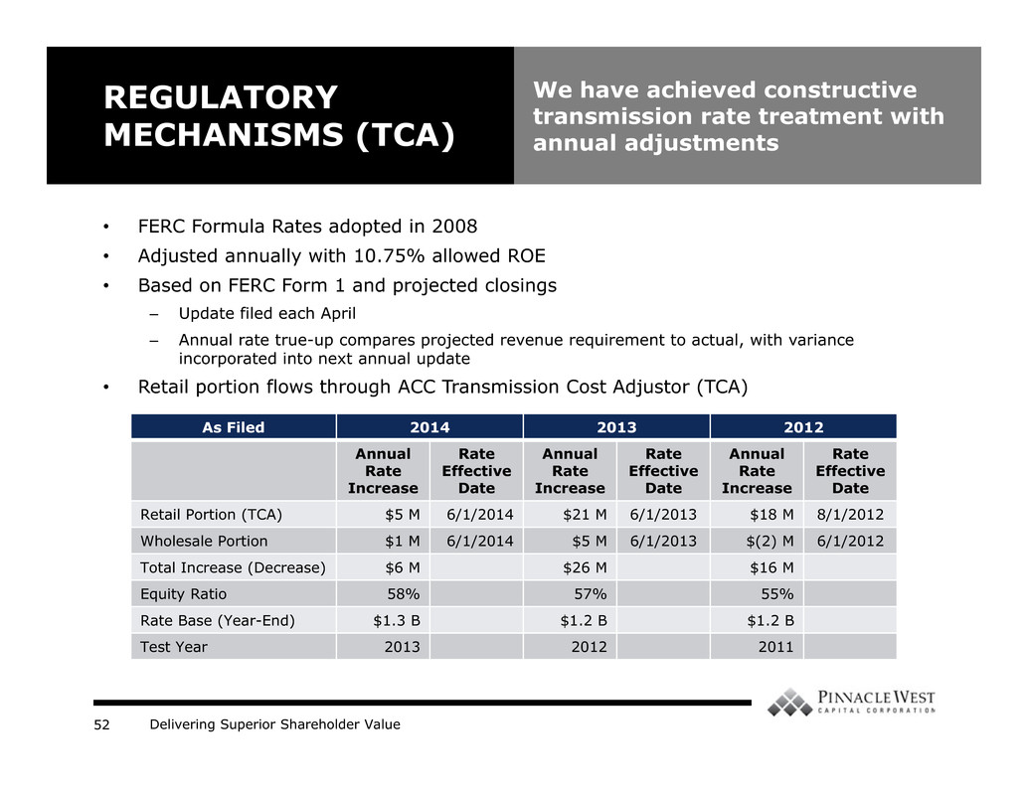
Delivering Superior Shareholder Value52 • FERC Formula Rates adopted in 2008 • Adjusted annually with 10.75% allowed ROE • Based on FERC Form 1 and projected closings – Update filed each April – Annual rate true-up compares projected revenue requirement to actual, with variance incorporated into next annual update • Retail portion flows through ACC Transmission Cost Adjustor (TCA) REGULATORY MECHANISMS (TCA) We have achieved constructive transmission rate treatment with annual adjustments As Filed 2014 2013 2012 Annual Rate Increase Rate Effective Date Annual Rate Increase Rate Effective Date Annual Rate Increase Rate Effective Date Retail Portion (TCA) $5 M 6/1/2014 $21 M 6/1/2013 $18 M 8/1/2012 Wholesale Portion $1 M 6/1/2014 $5 M 6/1/2013 $(2) M 6/1/2012 Total Increase (Decrease) $6 M $26 M $16 M Equity Ratio 58% 57% 55% Rate Base (Year-End) $1.3 B $1.2 B $1.2 B Test Year 2013 2012 2011

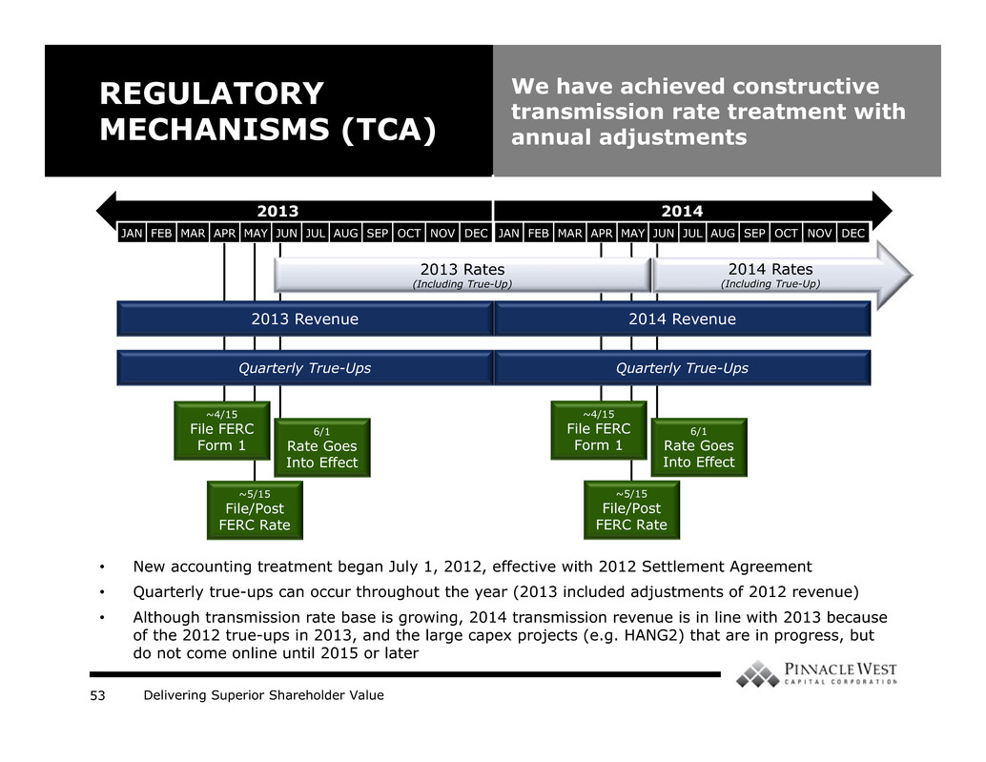
Delivering Superior Shareholder Value53 6/1 Rate Goes Into Effect REGULATORY MECHANISMS (TCA) We have achieved constructive transmission rate treatment with annual adjustments 2013 2014 JAN FEB MAR APR MAY JUN JUL AUG SEP OCT NOV DEC JAN FEB MAR APR MAY JUN JUL AUG SEP OCT NOV DEC 6/1 Rate Goes Into Effect ~5/15 File/Post FERC Rate ~4/15 File FERC Form 1 ~5/15 File/Post FERC Rate ~4/15 File FERC Form 1 • New accounting treatment began July 1, 2012, effective with 2012 Settlement Agreement • Quarterly true-ups can occur throughout the year (2013 included adjustments of 2012 revenue) • Although transmission rate base is growing, 2014 transmission revenue is in line with 2013 because of the 2012 true-ups in 2013, and the large capex projects (e.g. HANG2) that are in progress, but do not come online until 2015 or later 2013 Revenue 2013 Rates (Including True-Up) 2014 Rates (Including True-Up) 2014 Revenue Quarterly True-Ups Quarterly True-Ups

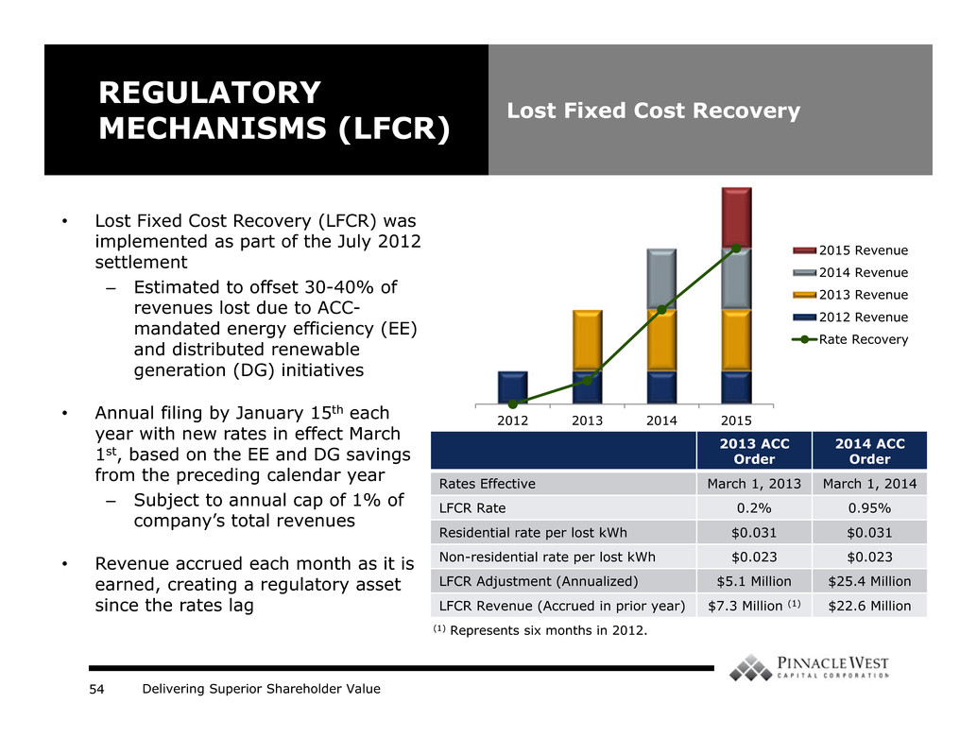
Delivering Superior Shareholder Value54 • Lost Fixed Cost Recovery (LFCR) was implemented as part of the July 2012 settlement – Estimated to offset 30-40% of revenues lost due to ACC- mandated energy efficiency (EE) and distributed renewable generation (DG) initiatives • Annual filing by January 15th each year with new rates in effect March 1st, based on the EE and DG savings from the preceding calendar year – Subject to annual cap of 1% of company’s total revenues • Revenue accrued each month as it is earned, creating a regulatory asset since the rates lag REGULATORY MECHANISMS (LFCR) Lost Fixed Cost Recovery 2013 ACC Order 2014 ACC Order Rates Effective March 1, 2013 March 1, 2014 LFCR Rate 0.2% 0.95% Residential rate per lost kWh $0.031 $0.031 Non-residential rate per lost kWh $0.023 $0.023 LFCR Adjustment (Annualized) $5.1 Million $25.4 Million LFCR Revenue (Accrued in prior year) $7.3 Million (1) $22.6 Million 2012 2013 2014 2015 2015 Revenue 2014 Revenue 2013 Revenue 2012 Revenue Rate Recovery (1) Represents six months in 2012.

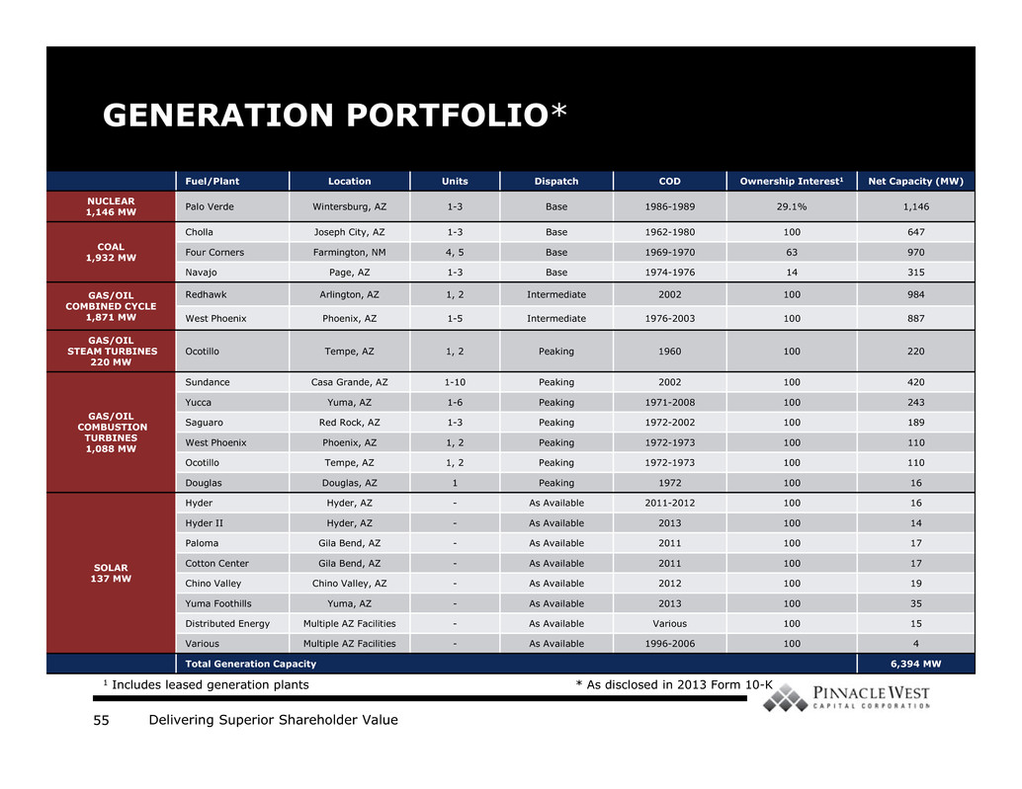
Delivering Superior Shareholder Value55 GENERATION PORTFOLIO* Fuel/Plant Location Units Dispatch COD Ownership Interest1 Net Capacity (MW) NUCLEAR 1,146 MW Palo Verde Wintersburg, AZ 1-3 Base 1986-1989 29.1% 1,146 COAL 1,932 MW Cholla Joseph City, AZ 1-3 Base 1962-1980 100 647 Four Corners Farmington, NM 4, 5 Base 1969-1970 63 970 Navajo Page, AZ 1-3 Base 1974-1976 14 315 GAS/OIL COMBINED CYCLE 1,871 MW Redhawk Arlington, AZ 1, 2 Intermediate 2002 100 984 West Phoenix Phoenix, AZ 1-5 Intermediate 1976-2003 100 887 GAS/OIL STEAM TURBINES 220 MW Ocotillo Tempe, AZ 1, 2 Peaking 1960 100 220 GAS/OIL COMBUSTION TURBINES 1,088 MW Sundance Casa Grande, AZ 1-10 Peaking 2002 100 420 Yucca Yuma, AZ 1-6 Peaking 1971-2008 100 243 Saguaro Red Rock, AZ 1-3 Peaking 1972-2002 100 189 West Phoenix Phoenix, AZ 1, 2 Peaking 1972-1973 100 110 Ocotillo Tempe, AZ 1, 2 Peaking 1972-1973 100 110 Douglas Douglas, AZ 1 Peaking 1972 100 16 SOLAR 137 MW Hyder Hyder, AZ - As Available 2011-2012 100 16 Hyder II Hyder, AZ - As Available 2013 100 14 Paloma Gila Bend, AZ - As Available 2011 100 17 Cotton Center Gila Bend, AZ - As Available 2011 100 17 Chino Valley Chino Valley, AZ - As Available 2012 100 19 Yuma Foothills Yuma, AZ - As Available 2013 100 35 Distributed Energy Multiple AZ Facilities - As Available Various 100 15 Various Multiple AZ Facilities - As Available 1996-2006 100 4 Total Generation Capacity 6,394 MW 1 Includes leased generation plants * As disclosed in 2013 Form 10-K

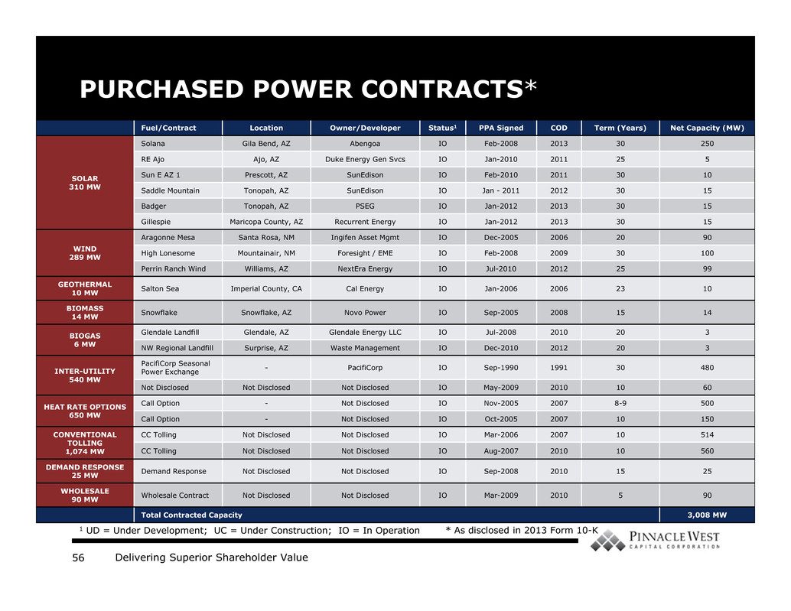
Delivering Superior Shareholder Value56 PURCHASED POWER CONTRACTS* Fuel/Contract Location Owner/Developer Status1 PPA Signed COD Term (Years) Net Capacity (MW) SOLAR 310 MW Solana Gila Bend, AZ Abengoa IO Feb-2008 2013 30 250 RE Ajo Ajo, AZ Duke Energy Gen Svcs IO Jan-2010 2011 25 5 Sun E AZ 1 Prescott, AZ SunEdison IO Feb-2010 2011 30 10 Saddle Mountain Tonopah, AZ SunEdison IO Jan - 2011 2012 30 15 Badger Tonopah, AZ PSEG IO Jan-2012 2013 30 15 Gillespie Maricopa County, AZ Recurrent Energy IO Jan-2012 2013 30 15 WIND 289 MW Aragonne Mesa Santa Rosa, NM Ingifen Asset Mgmt IO Dec-2005 2006 20 90 High Lonesome Mountainair, NM Foresight / EME IO Feb-2008 2009 30 100 Perrin Ranch Wind Williams, AZ NextEra Energy IO Jul-2010 2012 25 99 GEOTHERMAL 10 MW Salton Sea Imperial County, CA Cal Energy IO Jan-2006 2006 23 10 BIOMASS 14 MW Snowflake Snowflake, AZ Novo Power IO Sep-2005 2008 15 14 BIOGAS 6 MW Glendale Landfill Glendale, AZ Glendale Energy LLC IO Jul-2008 2010 20 3 NW Regional Landfill Surprise, AZ Waste Management IO Dec-2010 2012 20 3 INTER-UTILITY 540 MW PacifiCorp Seasonal Power Exchange - PacifiCorp IO Sep-1990 1991 30 480 Not Disclosed Not Disclosed Not Disclosed IO May-2009 2010 10 60 HEAT RATE OPTIONS 650 MW Call Option - Not Disclosed IO Nov-2005 2007 8-9 500 Call Option - Not Disclosed IO Oct-2005 2007 10 150 CONVENTIONAL TOLLING 1,074 MW CC Tolling Not Disclosed Not Disclosed IO Mar-2006 2007 10 514 CC Tolling Not Disclosed Not Disclosed IO Aug-2007 2010 10 560 DEMAND RESPONSE 25 MW Demand Response Not Disclosed Not Disclosed IO Sep-2008 2010 15 25 WHOLESALE 90 MW Wholesale Contract Not Disclosed Not Disclosed IO Mar-2009 2010 5 90 Total Contracted Capacity 3,008 MW 1 UD = Under Development; UC = Under Construction; IO = In Operation * As disclosed in 2013 Form 10-K

