SEC Form 4

FORM 4

Check this box if no longer subject to Section 16. Form 4 or Form 5 obligations may continue. See Instruction 1(b).

UNITED STATES SECURITIES AND EXCHANGE COMMISSION
Washington, D.C. 20549
 |  | OMB APPROVAL
STATEMENT OF CHANGES IN BENEFICIAL OWNERSHIP
 |  | OMB Number: | 3235-0287
 |  | Estimated average burden
Filed pursuant to Section 16(a) of the Securities Exchange Act of 1934 |  | hours per response: | 0.5
or Section 30(h) of the Investment Company Act of 1940
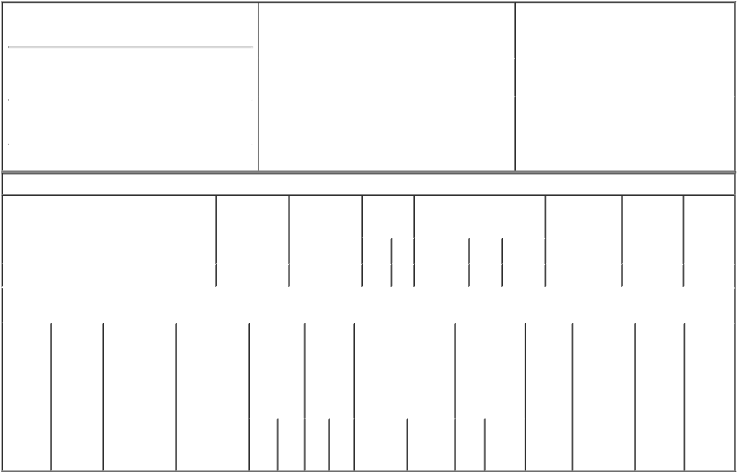

1. Name and Address of Reporting Person*
POST WILLIAM J

 | (Last) | (First) | (Middle)
 | 400 N. 5TH ST.
(Street)
 | PHOENIX | AZ | 85004
 | (City) | (State) | (Zip)

2. |  | Issuer Name and Ticker or Trading Symbol |  | 5. Relationship of Reporting Person(s) to Issuer
 | PINNACLE WEST CAPITAL CORP [ PNW ^{(Check all applicable)}
 | ] |  |  | X | Director |  | 10% Owner
 |  |  |  | X | Officer (give title | X | Other (specify
 |  |  |  |  | below) |  | below)
3. |  | Date of Earliest Transaction (Month/Day/Year)
 |  |  |  |  | Chief Executive Officer / Chairman
04/22/2005
4. |  | If Amendment, Date of Original Filed (Month/Day/Year) |  | 6. Individual or Joint/Group Filing (Check Applicable
04/26/2005 |  |  |  | Line)
 |  |  |  | X Form filed by One Reporting Person

Form filed by More than One Reporting
Person

Table I - Non-Derivative Securities Acquired, Disposed of, or Beneficially Owned

 | 1. Title of Security (Instr. 3) |  |  | 2. Transaction |  | 2A. Deemed |  | 3. |  | 4. Securities Acquired (A) or |  |  |  |  | 5. Amount of |  | 6. Ownership | 7. Nature
 |  |  |  | Date |  | Execution Date, |  |  | Transaction | Disposed Of (D) (Instr. 3, 4 and |  |  |  |  | Securities |  | Form: Direct | of Indirect
 |  |  |  | (Month/Day/Year) |  | if any |  |  | Code (Instr. | 5) |  |  |  |  | Beneficially |  | (D) or Indirect | Beneficial
 |  |  |  |  |  | (Month/Day/Year) |  | 8) |  |  |  |  |  |  | Owned Following |  | (I) (Instr. 4) | Ownership
 |  |  |  |  |  |  |  |  |  |  |  |  |  |  | Reported |  |  | (Instr. 4)
 |  |  |  |  |  |  |  |  | Code V | Amount | (A) or | Price |  |  | Transaction(s)
 |  |  |  |  |  |  |  |  |  |  | (D) |  |  |  | (Instr. 3 and 4)
 | Common Stock |  |  | 04/22/2005 |  |  |  |  | F | 6,379⁽¹⁾ | D | $42.58 |  |  | 111,262⁽²⁾ |  | D
 |  |  | Table II - Derivative Securities Acquired, Disposed of, or Beneficially Owned
 |  |  |  | (e.g., puts, calls, warrants, options, convertible securities)
 | 1. Title of | 2. | 3. Transaction | 3A. Deemed | 4. |  | 5. Number | 6. Date Exercisable and |  |  | 7. Title and |  |  | 8. Price of |  | 9. Number of | 10. | 11. Nature
 | Derivative | Conversion | Date | Execution Date, | Transaction |  | of | Expiration Date |  |  | Amount of |  |  | Derivative |  | derivative | Ownership | of Indirect
 | Security | or Exercise | (Month/Day/Year) | if any | Code (Instr. |  | Derivative | (Month/Day/Year) |  |  | Securities |  |  | Security |  | Securities | Form: | Beneficial
 | (Instr. 3) | Price of |  | (Month/Day/Year) | 8) |  | Securities |  |  |  | Underlying |  |  | (Instr. 5) |  | Beneficially | Direct (D) | Ownership
 |  | Derivative |  |  |  |  | Acquired |  |  |  | Derivative |  |  |  |  | Owned | or Indirect | (Instr. 4)
 |  | Security |  |  |  |  | (A) or |  |  |  | Security (Instr. 3 |  |  |  |  | Following | (I) (Instr. 4)
 |  |  |  |  |  |  | Disposed |  |  |  | and 4) |  |  |  |  | Reported
 |  |  |  |  |  |  | of (D) |  |  |  |  |  |  |  |  | Transaction(s)
 |  |  |  |  |  |  | (Instr. 3, 4 |  |  |  |  |  |  |  |  | (Instr. 4)
 |  |  |  |  |  |  | and 5)
 |  |  |  |  |  |  |  |  |  |  | Amount
 |  |  |  |  |  |  |  |  |  |  | or
 |  |  |  |  |  |  |  |  |  |  | Number
 |  |  |  |  |  |  |  | Date |  | Expiration | of
 |  |  |  |  | Code V |  | (A) (D) | Exercisable |  | Date | Title Shares

Explanation of Responses:

- The company inadvertently withheld fewer shares than were required to meet tax withholding obligations. Upon realization of this administrative oversight, the reporting person transferred the shares that were mistakenly granted to him back to the Company (with such transfer being effective as of April 22, 2005).

- This amended Form 4 filing shows the correct ownership of the reporting person as of April 22, 2005. This amount includes 48,000 "performance shares" reflected at the target level granted in 2003 and 2004. These shares are subject to the achievement of specified performance levels.

/s/ William J. Post |  | 10/28/2005
** Signature of Reporting Person |  | Date

Reminder: Report on a separate line for each class of securities beneficially owned directly or indirectly.

* If the form is filed by more than one reporting person, see Instruction 4 (b)(v).

- Intentional misstatements or omissions of facts constitute Federal Criminal Violations See 18 U.S.C. 1001 and 15 U.S.C. 78ff(a). Note: File three copies of this Form, one of which must be manually signed. If space is insufficient, see Instruction 6 for procedure.
Persons who respond to the collection of information contained in this form are not required to respond unless the form displays a currently valid OMB Number.

