SEC Form 4

FORM 4

Check this box if no longer subject to Section 16. Form 4 or Form 5 obligations may continue. See Instruction 1(b).

UNITED STATES SECURITIES AND EXCHANGE COMMISSION
Washington, D.C. 20549
 |  | OMB APPROVAL
STATEMENT OF CHANGES IN BENEFICIAL OWNERSHIP
 |  | OMB Number: | 3235-0287
 |  | Estimated average burden
Filed pursuant to Section 16(a) of the Securities Exchange Act of 1934 |  | hours per response: | 0.5
or Section 30(h) of the Investment Company Act of 1940
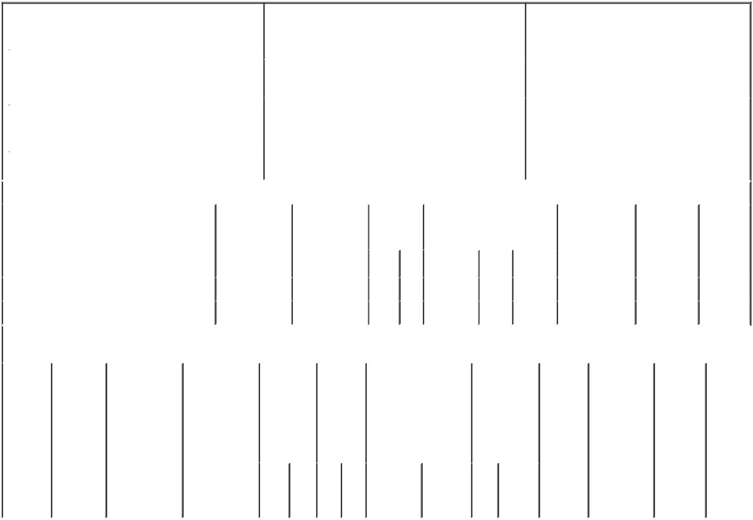

 | 1. Name and Address of Reporting Person* |  |  |  |  |  |  |  |  | 2. Issuer Name and Ticker or Trading Symbol |  |  |  |  |  |  |  |  | 5. Relationship of Reporting Person(s) to Issuer
 |  | Kelly Ann P |  |  |  |  |  |  |  | AMERICAN ELECTRIC POWER CO |  |  |  |  |  |  |  |  | (Check all applicable)
 |  |  |  |  |  |  |  |  |  |  |  |  |  |  |  |  |  |  |  |  |  | Director |  | 10% Owner
 |  |  |  |  |  |  |  |  |  | INC [ AEP ]
 |  |  |  |  |  |  |  |  |  |  |  |  |  |  |  |  |  |  |  |  | X | Officer (give title |  | Other (specify
 |  | (Last) |  | (First) |  | (Middle) |  |  |  |  |  |  |  |  |  |  |  |  |  |  |  | below) |  | below)
 |  |  |  |  |  |  |  |  |  | 3. Date of Earliest Transaction (Month/Day/Year)
 |  |  |  |  |  |  |  |  |  |  |  |  |  |  |  |  |  |  |  |  |  | Executive Vice President & CFO
 |  | 1 RIVERSIDE PLAZA |  |  |  |  | 02/20/2023
 |  |  |  |  |  |  |  |  |  | 4. If Amendment, Date of Original Filed (Month/Day/Year) |  |  |  |  |  |  |  |  | 6. Individual or Joint/Group Filing (Check Applicable
 | (Street) |  |  |  |  |  | 02/22/2023 |  |  |  |  |  |  |  |  |  |  |  | Line)
 |  | COLUMBUS OH |  |  |  | 43215 |  |  |  |  |  |  |  |  |  |  |  |  |  |  | X Form filed by One Reporting Person
 |  |  |  |  |  |  |  |  |  |  |  |  |  |  |  |  |  |  |  |  |  | Form filed by More than One Reporting
 |  | (City) |  | (State) |  | (Zip) |  |  |  |  |  |  |  |  |  |  |  |  |  |  |  | Person
 |  |  |  |  | Table I - Non-Derivative Securities Acquired, Disposed of, or Beneficially Owned
 | 1. Title of Security (Instr. 3) |  |  |  |  | 2. Transaction |  |  |  |  | 2A. Deemed |  | 3. | 4. Securities Acquired (A) or |  |  |  |  |  |  |  | 5. Amount of |  | 6. Ownership | 7. Nature
 |  |  |  |  |  | Date |  |  |  |  | Execution Date, |  | Transaction | Disposed Of (D) (Instr. 3, 4 and |  |  |  |  |  |  |  | Securities |  | Form: Direct | of Indirect
 |  |  |  |  |  | (Month/Day/Year) |  |  |  |  | if any |  | Code (Instr. | 5) |  |  |  |  |  |  |  | Beneficially |  | (D) or Indirect | Beneficial
 |  |  |  |  |  |  |  |  |  |  | (Month/Day/Year) |  | 8) |  |  |  |  |  |  |  |  | Owned Following |  | (I) (Instr. 4) | Ownership
 |  |  |  |  |  |  |  |  |  |  |  |  |  |  |  |  |  |  |  |  |  | Reported |  |  | (Instr. 4)
 |  |  |  |  |  |  |  |  |  |  |  |  | Code V | Amount | (A) or |  |  | Price |  |  |  | Transaction(s)
 |  |  |  |  |  |  |  |  |  |  |  |  |  |  | (D) |  |  |  |  |  |  | (Instr. 3 and 4)
 | Restricted Stock Units |  |  |  |  | 02/20/2023 |  |  |  |  |  |  | A | 4,599⁽¹⁾ | A |  |  | $0 |  |  |  |  | 5,735 | D
 | Restricted Stock Units |  |  |  |  | 02/21/2023 |  |  |  |  |  |  | F | 114⁽²⁾ | D |  |  | $90.85 |  |  |  | 5,621⁽³⁾ |  | D
 |  |  |  |  |  | Table II - Derivative Securities Acquired, Disposed of, or Beneficially Owned
 |  |  |  |  |  | (e.g., puts, calls, warrants, options, convertible securities)
 | 1. Title of |  | 2. |  | 3. Transaction | 3A. Deemed | 4. |  |  |  |  | 5. Number | 6. Date Exercisable and |  | 7. Title and |  |  |  |  |  | 8. Price of |  | 9. Number of 10. |  | 11. Nature
 | Derivative |  | Conversion |  | Date | Execution Date, |  |  | Transaction |  |  | of | Expiration Date |  | Amount of |  |  |  |  |  | Derivative |  | derivative | Ownership | of Indirect
 | Security |  | or Exercise |  | (Month/Day/Year) if any |  |  |  | Code (Instr. |  |  | Derivative | (Month/Day/Year) |  | Securities |  |  |  |  |  | Security |  | Securities | Form: | Beneficial
 | (Instr. 3) |  | Price of |  |  | (Month/Day/Year) | 8) |  |  |  |  | Securities |  |  | Underlying |  |  |  |  |  | (Instr. 5) |  | Beneficially | Direct (D) | Ownership
 |  |  | Derivative |  |  |  |  |  |  |  |  | Acquired |  |  | Derivative |  |  |  |  |  |  |  | Owned | or Indirect | (Instr. 4)
 |  |  | Security |  |  |  |  |  |  |  |  | (A) or |  |  | Security (Instr. |  |  |  |  |  |  |  | Following | (I) (Instr. 4)
 |  |  |  |  |  |  |  |  |  |  |  | Disposed |  |  | 3 and 4) |  |  |  |  |  |  |  | Reported
 |  |  |  |  |  |  |  |  |  |  |  | of (D) |  |  |  |  |  |  |  |  |  |  | Transaction(s)
 |  |  |  |  |  |  |  |  |  |  |  | (Instr. 3, 4 |  |  |  |  |  |  |  |  |  |  | (Instr. 4)
 |  |  |  |  |  |  |  |  |  |  |  | and 5)
 |  |  |  |  |  |  |  |  |  |  |  |  |  |  |  |  | Amount
 |  |  |  |  |  |  |  |  |  |  |  |  |  |  |  |  | or
 |  |  |  |  |  |  |  |  |  |  |  |  |  |  |  |  | Number
 |  |  |  |  |  |  |  |  |  |  |  |  | Date | Expiration |  |  | of
 |  |  |  |  |  |  |  |  | Code |  | V | (A) (D) | Exercisable | Date | Title |  | Shares

Explanation of Responses:

- Each restricted stock unit represents a contingent right to receive AEP common stock upon vesting. The restricted stock units vest in three equal installments on February 21, 2024, February 21, 2025 and February 21, 2026.

- A portion of the reporting person's restricted stock units (378, incorrectly listed on prior report as 896) granted on November 30, 2022 vested on February 21, 2023. Upon vesting, 114 (incorrectly listed on prior report as 269) restricted stock units were withheld to satisfy the reporting person's tax liability.

3. Amount incorrectly listed on prior report as 7,171.

Remarks:

/s/ David C. House, Attorney-

in-Fact for Ann P. Kelly

** Signature of Reporting Person

03/23/2023

Date

Reminder: Report on a separate line for each class of securities beneficially owned directly or indirectly.

* If the form is filed by more than one reporting person, see Instruction 4 (b)(v).

- Intentional misstatements or omissions of facts constitute Federal Criminal Violations See 18 U.S.C. 1001 and 15 U.S.C. 78ff(a). Note: File three copies of this Form, one of which must be manually signed. If space is insufficient, see Instruction 6 for procedure.

Persons who respond to the collection of information contained in this form are not required to respond unless the form displays a currently valid OMB Number.

