UNITED STATES
SECURITIES AND EXCHANGE COMMISSION
Washington, D.C. 20549

Form 6-K

REPORT OF FOREIGN PRIVATE ISSUER PURSUANT TO RULE 13a-16 OR 15d-16 UNDER THE
SECURITIES EXCHANGE ACT OF 1934

For the month June, 2012
Commission File Number

AGNICO-EAGLE MINES LIMITED
(Translation of registrants name into English)

145 King Street East, Suite 400, Toronto, Ontario M5C 2Y7
(Address of principal executive office)

Indicate by check mark whether the registrant files or will file annual reports under cover of Form 20-F or Form 40-F.
Form 20-F x Form 40-F o

Indicate by check mark if the registrant is submitting the Form 6-K in paper as permitted by Regulation S-T Rule 101 (b)( 1): o

Note: Regulation S-T Rule 101 (b)( 1) only permits the submission in paper of a Form 6-K if submitted solely to provide an attached annual report to security holders.

Indicate by check mark if the registrant is submitting the Form 6-K in paper as permitted by Regulation S-T Rule 101 (b)(7): o

Note: Regulation S-T Rule 101(b)(7) only permits the submission in paper of a Form 6-K if submitted to furnish a report or other document that the registrant foreign private issuer must furnish and make public under the laws of the jurisdiction in which the registrant is incorporated, domiciled or legally organized (the registrants home country), or under the rules of the home country exchange on which the registrants securities are traded, as long as the report or other document is not a press release, is not required to be and has not been distributed to the registrants security holders, and, if discussing a material event, has already been the subject of a Form 6-K submission or other Commission filing on EDGAR.

Indicate by check mark whether the registrant by furnishing the information contained in this Form is also thereby furnishing the information to the Commission pursuant to Rule 12g3-2(b) under the Securities Exchange Act of 1934. Yes o No x

If Yes is marked, indicate below the file number assigned to the registrant in connection with Rule 12g3-2(b): 82- .

EXHIBITS

Exhibit No. |  | Exhibit Description
99.1 |  | Press Release dated June 26, 2012 providing the Corporations exploration update.
99.2 |  | Press Release dated June 26, 2012 announcing the Corporations changes to its senior management team.

SIGNATURES

Pursuant to the requirements of the Securities Exchange Act of 1934, the registrant has duly caused this report to be signed on its behalf by the undersigned, thereunto duly authorized.

 | AGNICO-EAGLE MINES LIMITED
 | (Registrant)
Date: June 26, 2012 | By: | /s/ R. Gregory Laing
 |  | R. Gregory Laing
 |  | General Counsel, Sr. Vice President, Legal and Corporate Secretary

Exhibit 99.1

Stock Symbol: AEM (NYSE, TSX) | For further information:
 | Investor Relations (416) 947-1212

(All amounts expressed in U.S. dollars unless otherwise noted)

AGNICO-EAGLE PROVIDES EXPLORATION UPDATE;
ZONES EXTENDED AT SEVERAL DEPOSITS;
NEW DISCOVERY NEAR MELIADINES WESMEG DEPOSIT

TORONTO (June 26, 2012) - Agnico-Eagle Mines Limited (NYSE:AEM)(TSX:AEM) (Agnico-Eagle or the Company) is pleased to provide interim results from its 2012 exploration program. The 2012 program is primarily focused on drilling at Kittila (Finland), Meliadine (Canada) and Mascota/Bravo (Mexico), conversion of resources at La India (Mexico) and further exploration of the early-stage deposit at Tarachi (Mexico).

From January through May 2012, Agnico-Eagle spent approximately $43 million on exploration.

Highlights of the 2012 exploration program to date include:

• At Meliadine:
• Discovery of the new Normeg zone on the west end of the Wesmeg deposit
• Confirmation that the Pump deposit has two distinct branches
• Tiriganiaq bulk sample returned 13.5 grams per tonne (g/t) gold from 4,573 tonnes, confirming the grade estimate of reserves in the two largest zones, and increasing confidence in the model precision and accuracy of future reserves and resources estimates
• At Kittila:
• High-grade drill intercepts at Rimpi confirm the continuity of the zone at depth and to the north, yielding 6.6 g/t gold over 10.0 metres true width at 800 metres depth, and 10.7 g/t gold over 3.8 metres at 1,040 metres depth
• At La India:
• Infill drilling is confirming the expected grades and widths and increasing the confidence in the resource model developed by the previous owner
• At Pinos Altos:
• New Veta Flor zone discovered west of Creston Mascota pit includes 3.3 g/t gold and 41.7 g/t silver over 6.2 metres core length at 263 metres depth
• Better than expected grades near eastern side of Creston Mascota pit and possible expansion to south toward Bravo zone

These exploration results reinforce our opinion that we own several world-class gold deposits that we expect will continue to grow said Sean Boyd, President and CEO. We look forward to the completion of several feasibility and expansion studies in the medium

term that will reinforce that Agnico-Eagle remains a lower-risk gold growth company added Mr. Boyd.

Meliadine  Current Orebody Continues to Grow and New Zones Discovered

The 2012 exploration budget for the Meliadine project in Nunavut is $20.7 million for drilling on the known deposits, as well as a further $9.6 million for regional exploration. However, due to the exploration success to date in 2012 the Company expects that additional exploration funding will be provided to extend the Meliadine drilling program an extra two months into September 2012. This drilling will target the parts of the deposit that have the best potential in terms of grade and / or thickness. The company-wide exploration expenditures in 2012 are now anticipated to total approximately $115 million for the full year.

From January through May 2012, the drilling has focused on resource expansion, resource to reserve conversion, and investigating new areas of interest near Tiriganiaq, Wesmeg, Pump, the F Zone and Normeg. These zones, and the location of selected drill collars, are shown on the geology map below.

[Meliadine local geology map]

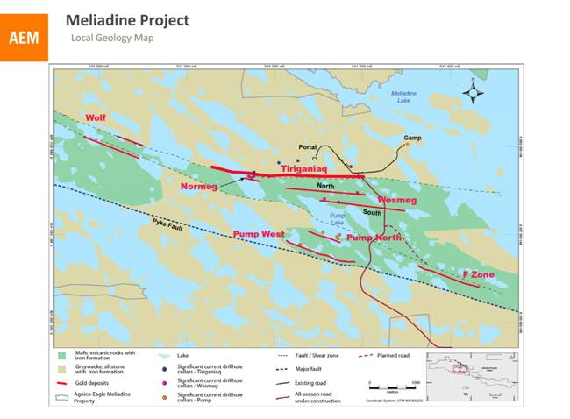

2

High-grade Intercepts at Tiriganiaq and Underground Bulk Sample Results

In the Tiriganiaq zone, drilling continues to focus on converting resources into reserves. The table below sets out the most significant drill results from the Tiriganiaq zone through May 2012. The hole collars are located on the Meliadine geology map, and the pierce points are shown on the Tiriganiaq longitudinal section.

Significant Tiriganiaq zone drill results

Drill Hole |  | Zone |  | From  (metres) |  | To  (metres) |  | Depth  below  surface  (metres) |  | Estimated  true width  (metres) |  | Gold  grade  (g/t)  (uncut) |  | Gold  grade  (g/t)  (cut)*
M11-1304 |  | 1000 & 1025 |  | 345.8 |  | 359.0 |  | 305 |  | 10.9 |  | 13.5 |  | 13.5
including |  | 1000 |  | 348.5 |  | 353.0 |  | 304 |  | 3.8 |  | 36.1 |  | 36.1
M11-1314 |  | 1100 |  | 324.7 |  | 329.0 |  | 266 |  | 4.3 |  | 21.7 |  | 14.4
M11-1364 |  | 1000, 1015 & 1025 |  | 427.0 |  | 438.0 |  | 402 |  | 9.6 |  | 7.7 |  | 7.7
including |  | 1000 & 1015 |  | 431.0 |  | 437.0 |  | 403 |  | 5.1 |  | 10.9 |  | 10.9
M11-1370 |  | 1087, 1100 & 1155 |  | 195.0 |  | 210.0 |  | 174 |  | 12.1 |  | 14.6 |  | 10.4
including |  | 1155 & 1100 |  | 195.0 |  | 201.0 |  | 170 |  | 5.0 |  | 29.1 |  | 18.6
M12-1504 |  | 1025 |  | 57.0 |  | 63.0 |  | 49 |  | 5.4 |  | 9.3 |  | 9.3
including |  | 1025 |  | 57.0 |  | 60.0 |  | 47 |  | 2.8 |  | 15.9 |  | 15.9

*Holes at Tiriganiaq deposit use a capping factor ranging from 15 to 120 g/t gold depending on the zone.

3

[Tiriganiaq Longitudinal Section]

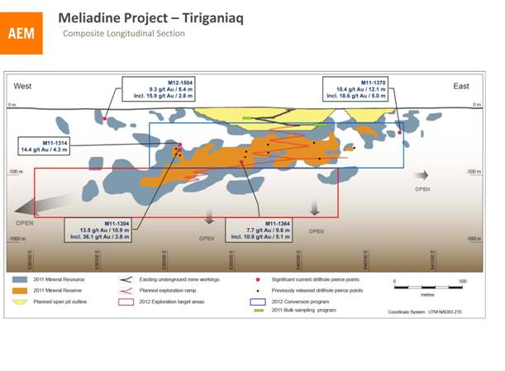
The drilling on Tiriganiaq has returned a number of intersections that confirmed or exceeded the current reserve grade (7.2 g/t of gold) over significant thicknesses, such as hole M11-1304 which yielded 13.5 g/t over 10.9 metres estimated true width at 305 metres depth. Other drilling has confirmed the east and west extensions to the mineralized zones, such as hole M11-1370 which yielded 10.4 g/t of gold over 12.1 metres at 174 metres depth on the east side of the resource envelope, and M12-1504 which yielded 15.9 g/t of gold over 2.8 metres at 47 metres depth on the west end.

Bulk Sample Confirms Assumptions

The Company processed approximately 4,600 tonnes of ore from an underground bulk sample from the Tiriganiaq orebody during 2011. The ore was extracted from lateral development in the Tiriganiaq deposit on two levels. The areas were sampled beforehand by diamond drilling on 15-metre spacings. Each development round was also sampled individually through the on-site sampling tower and the samples were shipped to an independent laboratory for assaying. The results of the program were compared with the December 31, 2011 reserve and resource estimate.

The program confirmed, within expected precision, the resource estimation model that has been developed for the two principal zones (Zones 1000 and 1100) at Tiriganiaq. In fact, the sampling results indicate approximately 6% more gold than was predicted by the block model for these areas. The following table sets out the undiluted results of the 2011 bulk sample.

4

Results of the Tiriganiaq 2011 bulk sample vs. the block model estimates

 |  | Block Model |  |  |  |  |  |  |  | Bulk Sample
Zone & Level |  | Drill  holes |  | Tonnes |  | Gold  grade  (g/t) |  | Gold (oz) |  | Tonnes |  | Gold  grade  (g/t) |  | Gold (oz)
1000 Zone |  | 20 |  | 2,391 |  | 9.4 |  | 720 |  | 2,158 |  | 10.0 |  | 691
1100 Zone |  | 13 |  | 2,555 |  | 14.0 |  | 1,149 |  | 2,415 |  | 16.7 |  | 1,298
Total |  | 33 |  | 4,946 |  | 11.8 |  | 1,869 |  | 4,573 |  | 13.5 |  | 1,989

The 2011 bulk sample program also confirmed the previous assessment of the Companys block model in terms of grade continuity, consistency and distribution, and the evaluation of related mining properties through geological mapping, underground chip-, channel- and muck-sampling, and geotechnical observations.

Wesmeg Zone Extended

Drilling in 2012 has continued to outline good grades and thicknesses at very shallow depths in the central portion of the Wesmeg deposit, such as hole M12-1405 which returned 7.7 g/t gold over 4.2 metres estimated true width at seven metres depth, M12-1412 which returned 6.2 g/t gold over 8.0 metres at 88 metres depth, and M12-1474 which returned 4.8 g/t gold over 8.9 metres at 26 metres depth. The successful drilling program is expected to result in a significant increase in indicated resources in the Wesmeg deposit for the year end calculation.

Significant recent Wesmeg drill results

Drill Hole |  | Zone |  | Program |  | From  (metres) |  | To  (metres) |  | Depth  below  surface  (metres) |  | Estimated  true  width  (metres) |  | Gold  grade  (g/t)  (uncut) |  | Gold  grade  (g/t)  (cut)*
M12-1405 |  | 490 |  | conversion |  | 9.7 |  | 14.0 |  | 7 |  | 4.2 |  | 9.7 |  | 7.7
and |  | 430 |  |  |  | 185.0 |  | 189.8 |  | 129 |  | 4.6 |  | 5.4 |  | 5.4
M12-1412 |  | 460 |  | conversion |  | 113.5 |  | 122.0 |  | 88 |  | 8.0 |  | 6.2 |  | 6.2
including |  |  |  |  |  | 119.0 |  | 122.0 |  | 90 |  | 2.9 |  | 10.8 |  | 10.8
M12-1474 |  | 710 |  | conversion |  | 30.4 |  | 40.0 |  | 26 |  | 8.9 |  | 4.8 |  | 4.8
including |  |  |  |  |  | 33.0 |  | 39.0 |  | 26 |  | 5.5 |  | 6.3 |  | 6.3

* Holes at Wesmeg deposit use a capping factor of 30.0 g/t gold.

5

[Wesmeg Composite Longitudinal Section]

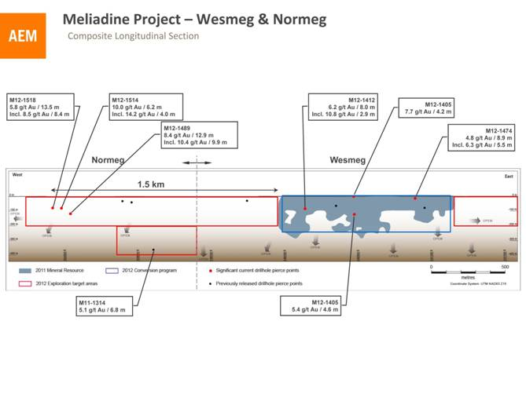

New Zone Discovered at Normeg

The Normeg zone was discovered in 2011 on the western end of the Wesmeg zones North Trend by drill hole M11-1314 which returned 5.1 g/t gold over 6.8 m at 380 metres depth (disclosed in the Companys February 15, 2012 news release).

Recent drill results from approximately 500 metres west of the discovery drill hole, include M12-1489 which returned 8.4 g/t gold over 12.9 m including 10.4 g/t over 9.9 m at 124 m depth, M12-1514 which returned 10.0 g/t gold over 6.2 m including 14.2 g/t over 4.0 m at 84 m depth, and M12-1518 which returned 5.8 g/t gold over 13.5 m including 8.5 g/t over 8.4 m at 78 m depth. These results suggest that Normeg likely has a strike length of approximately 500 metres to 700 metres and that it extends from surface to at least 380 metres depth.

This zone is an important target in the 2012 program, as it may improve the open pit and underground components of the Meliadine deposit with multiple parallel mineralized horizons. The objectives for the rest of the year will be to define and estimate the initial resources for the Normeg zone.

6

Drill Hole |  | Zone |  | Program |  | From  (metres) |  | To  (metres) |  | Depth  below  surface  (metres) |  | Estimated  true  width  (metres) |  | Gold  grade  (g/t)  (uncut) |  | Gold  grade  (g/t)  (cut)*
**M11-1314 |  | Normeg |  | exploration |  | 480.0 |  | 487.0 |  | 380 |  | 6.8 |  | 5.1 |  | 5.1
M12-1489 |  | Normeg |  | exploration |  | 144.0 |  | 158.0 |  | 122 |  | 12.9 |  | 23.1 |  | 8.4
including |  |  |  |  |  | 146.4 |  | 157.0 |  | 124 |  | 9.9 |  | 29.7 |  | 10.4
M12-1514 |  | Normeg |  | exploration |  | 104.0 |  | 110.5 |  | 83 |  | 6.2 |  | 43.6 |  | 10.0
including |  |  |  |  |  | 106.3 |  | 110.5 |  | 84 |  | 4.0 |  | 66.3 |  | 14.2
M12-1518 |  | Normeg |  | exploration |  | 94.5 |  | 110.1 |  | 81 |  | 13.5 |  | 5.8 |  | 5.8
including |  |  |  |  |  | 94.5 |  | 104.0 |  | 78 |  | 8.4 |  | 8.6 |  | 8.5

* Holes at Normeg deposit use a capping factor of 30.0 g/t gold.
** This intersection of hole M11-1314 was previously reported in the Companys exploration news release dated February 15, 2012.

Pump Zone Extended, Has Two Distinct Branches

Exploration drilling in 2012 has led to a better understanding of the Pump deposit and the previously known zones have been extended. It is now confirmed that these zones are composed of stacked structures that are separated into two distinct deposits named Pump West and the Pump North. The Pump North deposit is very prospective and will be a focus with the expectation of adding resources in the near future. Drill results show that the Pump deposits have strong grades and widths near surface and are open along strike and at depth. This suggests that these deposits may be amenable to extraction by open pit techniques.

Significant recent Pump zone drill results

Drill Hole |  | Branch |  | From  (metres) |  | To  (metres) |  | Depth below  surface  (metres) |  | Estimated  true width  (metres) |  | Gold  grade (g/t)  (uncut) |  | Gold  grade  (g/t)  (cut)*
M12-1392 |  | Pump West |  | 20.0 |  | 28.0 |  | 18 |  | 6.8 |  | 6.4 |  | 6.4
including |  |  |  | 24.0 |  | 28.0 |  | 19 |  | 3.4 |  | 11.0 |  | 11.0
M12-1410 |  | Pump North |  | 149.8 |  | 157.0 |  | 108 |  | 7.2 |  | 6.5 |  | 6.5
including |  |  |  | 149.8 |  | 154.1 |  | 107 |  | 4.3 |  | 9.1 |  | 9.1
and |  |  |  | 161.8 |  | 172.1 |  | 117 |  | 9.9 |  | 7.0 |  | 7.0
including |  |  |  | 164.7 |  | 171.4 |  | 119 |  | 6.4 |  | 9.2 |  | 9.2
M12-1437 |  | Pump North |  | 87.0 |  | 105.0 |  | 68 |  | 17.1 |  | 3.5 |  | 3.5
including |  |  |  | 90.0 |  | 95.0 |  | 66 |  | 4.8 |  | 7.1 |  | 7.1
M12-1449 |  | Pump North |  | 211.0 |  | 217.1 |  | 161 |  | 6.1 |  | 6.5 |  | 6.5
including |  |  |  | 213.0 |  | 217.1 |  | 162 |  | 4.1 |  | 9.0 |  | 9.0
M12-1458 |  | Pump North |  | 214.0 |  | 222.5 |  | 198 |  | 7.6 |  | 8.7 |  | 8.0
including |  |  |  | 216.5 |  | 220.5 |  | 198 |  | 3.3 |  | 15.0 |  | 13.4
M12-1593 |  | Pump North |  | 179.0 |  | 185.6 |  | 135 |  | 6.4 |  | 7.8 |  | 7.8

* Holes at Pump deposit use a capping factor of 35.0 g/t gold.

7

[Pump Longitudinal Section]

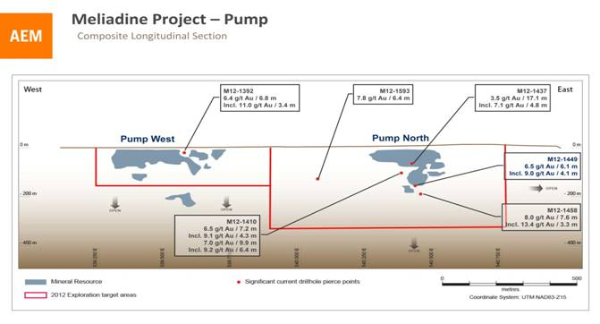

At Pump West, hole M12-1392 yielded 6.4 g/t gold over 6.8 metres estimated true width including 11.0 g/t gold over 3.4 metres at 19 metres depth. In Pump North, hole M12-1410 yielded 9.2 g/t gold over 6.4 metres at 119 metres depth, while M12-1458 yielded 8.0 g/t gold over 7.6 metres including 13.4 g/t gold over 3.3 metres at 198 metres depth. On the western side of Pump North, hole M12-1593 yielded 7.8 g/t gold over 6.4 metres at 135 metres depth. Additional investigation will be done between Pump West and Pump North to see if they are connected.

The Pump zones current inferred resources of approximately 775,000 tonnes at 5.3 g/t gold are expected to grow in the next Meliadine resources estimate for year end 2012 (currently anticipated to be released in February 2013).

Kittilas Rimpi and Roura Zones Expand Northward and at Depth

Three main deposits currently comprise the majority of the Kittila orebody, located in Finnish Lapland. The Suuri, Roura and Rimpi deposits have a strike length of almost four kilometres with reserves and resources to a depth of more than 1,000 metres.

8

Exploration to date in 2012 has confirmed grades and thicknesses at Suuri and expanded the known mineralization at the Rimpi and Roura deposits, both at depth and to the north, highlighting further exploration potential.

Construction of a ramp is underway which will facilitate the drilling of the Suuri and Roura deposits at depth (below 1,000 metres) and is expected to reach the Rimpi zone within the next two years. To the end of May 2012, the ramp had advanced 150 metres towards the Roura zone at 600 metres below surface. Approximately 600 metres of development is planned on this ramp in 2012. Drilling from the ramp is expected to begin in the second quarter of 2013 targeting infill drilling and the largely untested areas at depth below both Suuri and Roura.

Recent conversion drilling in the Suuri and Roura deposits has confirmed similar grades and thicknesses between 300 and 600 metres below surface as compared to prior drilling. For example, hole SCON-11-507 returned 7.2 g/t gold over 12.4 metres at 605 metres depth in the Suuri deposit. In Roura, hole ROU-11-004 intersected 12.2 g/t gold over 5.1 metres at 970 metres depth.

The table below sets out selected recent drill results from the mine site exploration. The pierce points of the intercepts are shown on the Kittila longitudinal section.

Significant recent Rimpi, Roura and Suuri zone exploration drill results

Drill Hole |  | Zone |  | From  (metres) |  | To  (metres) |  | Depth below  surface  (metres) |  | Estimated  true width  (metres) |  | Gold grade  (g/t)  (uncut)*
SCON-11-501 |  | Suuri |  | 209 |  | 215 |  | 560 |  | 6.0 |  | 6.90
SCON-11-506 |  |  |  | 167 |  | 176 |  | 510 |  | 8.7 |  | 5.70
SCON-11-507 |  | Suuri |  | 163 |  | 174 |  | 600 |  | 10.8 |  | 3.73
and |  |  |  | 193 |  | 206 |  | 605 |  | 12.4 |  | 7.22
SCON-11-510 |  | Suuri |  | 83 |  | 96 |  | 328 |  | 13.0 |  | 5.23
SCON-11-511 |  | Suuri |  | 56 |  | 60 |  | 347 |  | 3.9 |  | 6.61
SCON-11-518 |  | Suuri |  | 110 |  | 114 |  | 422 |  | 4.0 |  | 5.59
ROU-11-004 |  | Roura North |  | 1,094 |  | 1,103 |  | 969 |  | 5.1 |  | 12.15
RIE-11-010B |  | Rimpi Central |  | 980 |  | 992 |  | 794 |  | 10.0 |  | 6.59
and |  |  |  | 1,026 |  | 1,035 |  | 818 |  | 7.6 |  | 3.05
RIE-11-012 |  | Rimpi Central |  | 1,076 |  | 1,088 |  | 863 |  | 10.7 |  | 4.81
RIE-11-019 |  | Rimpi North |  | 1,163 |  | 1,169 |  | 1,022 |  | 3.8 |  | 7.58
and |  |  |  | 1,184 |  | 1,194 |  | 1,040 |  | 6.4 |  | 7.19
including |  |  |  | 1,188 |  | 1,194 |  | 1,041 |  | 3.8 |  | 10.74

*All grades are uncut at Kittila

9

[Kittila longitudinal section]

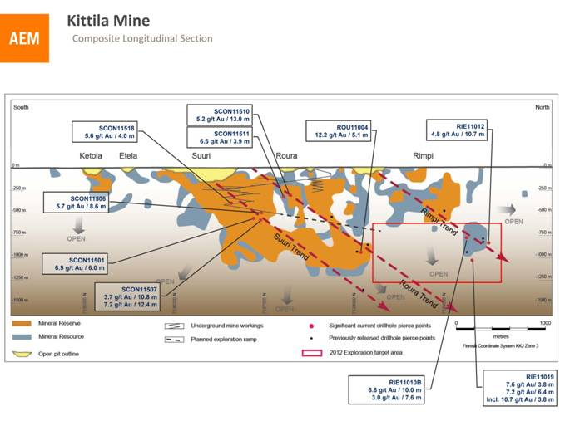

Rimpi Trend Extended at Depth by 150 metres

The Rimpi Trend continues to show strong potential, plunging from surface shallowly northward. Hole RIE-11-010B had five intercepts within the current resource envelope, with the best being 6.6 g/t gold over 10.0 metres true width at 800 metres depth. These appear to be the same lenses that were intersected by hole RIE-11-019 (10.7 g/t gold over 3.8 m at 1,040 metres depth). The RIE-11-019 intercept extends the Rimpi mineralization by approximately 150 metres below the deepest hole from previous drilling.

Additionally, hole RIE-11-012 intersected 4.8 g/t gold over 10.7 metres at approximately 865 metres depth, extending the mineralization roughly 50 metres northward. These higher grade, deep intercepts are expected to contribute to increased mineral resources in the next reserve and resource statement. It is possible that the Rimpi mineralization could have a significant impact on Kittilas future production profile via a longer term expansion, likely involving a shaft.

Mine-site exploration expenditures at Kittila in 2012 are estimated to total $13.5 million. Five drill rigs are currently operating, with a sixth expected to be added shortly. The drilling focus remains on Rimpi and on demonstrating continuity of the mineralization at different depths with the goal of significantly increasing the resources to the north.

10

Hanhimaa Gold Project Optioned West of Kittila

In May 2012, Agnico-Eagle signed a Letter of Intent with an Australian company, Dragon Mining Limited (Dragon), to earn an interest in its Hanhimaa gold project, just 10 kilometres west of the Kittila mine operations. The Company can earn up to a 70% interest in the project by spending approximately $12 million over six years.

The 360 square kilometre Hanhimaa property encompasses the north-south-trending Hanhimaa Shear Zone, which is parallel to the Kiistala Shear Zone that hosts the main deposits of the Kittila mine, as shown in the map below.

[Hanhimaa project location map]

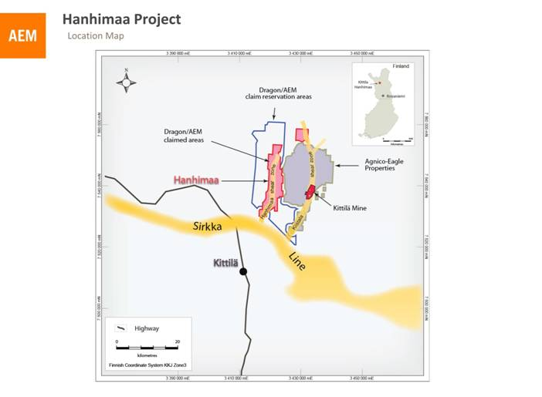

Dragon has completed 6,684 metres of diamond drilling on the Hanhimaa property, returning encouraging intercepts at the Kiimalaki prospect. Some of the best results reported from this prospect included 11.7 metres core length grading 4.48 g/t gold, 7.5 metres core length grading 5.88 g/t gold, and 5.0 metres core length grading 5.96 g/t gold.

Limited drilling at the Kellolaki prospect, approximately two kilometres to the north, has yielded intercepts of 8.0 metres core length grading 1.95 g/t gold, and 8.6 metres core

11

length grading 1.51 g/t gold. Gold occurrences have also been identified at the Kiimakuusikko prospect, approximately four kilometres south of Kiimalaki. (Source: Dragon press release dated May 25, 2012. Readers should note that this exploration information has not been verified by Agnico-Eagle for disclosure compliance with National Instrument 43-101).

Once the final agreement is completed, Agnico-Eagle will begin to compile and verify the previous work on the property and take over as project manager. Targets are ready for a new drill program, which will begin when the claim permits have been confirmed.

Mexico

La India Feasibility Underway and Exploration at Tarachi Zone

The La India project, located in Mexicos Sonora State approximately 60 kilometres northwest of Agnico-Eagles Pinos Altos mine, was acquired in November 2011.

La India is being evaluated for its potential development as a low cost, open pit, heap leach operation. The Company is working on a feasibility study, and is concurrently obtaining environmental permits, land rights, and engineering design for the project. Work on access road improvements, site clearing, water supply development, communications, detailed engineering, and camp infrastructure is currently underway with the objective of enhancing the project development schedule and facilitating exploration in the area.

The focus of the exploration program this year is infill and condemnation drilling at the La India deposit, as well as resource expansion of the Tarachi deposit, approximately 10 kilometres to the north.

12

[La India & Tarachi Project Map]

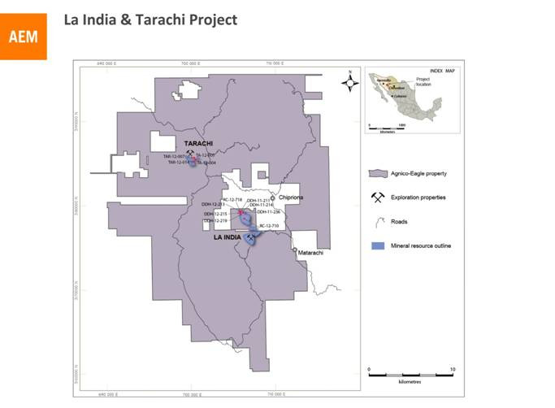

La India Infill Drilling Adding Confidence to Resource

The Companys recent infill drilling at La India has largely confirmed the grades and widths previously reported by the prior owner. Selected results of the 2012 program by Agnico-Eagle are set out in the following table.

Significant recent exploration drill results, North zone of La India deposit

Drill Hole |  | Zone |  | From  (metres) |  | To  (metres) |  | Depth  below  surface  (metres) |  | Estimated  true width  (metres) |  | Gold grade  (g/t) (uncut) |  | Gold  grade (g/t)  (cut)*
DDH-11-211 |  | North zone |  | 28.0 |  | 49.0 |  | 36 |  | 21.0 |  | 1.35 |  | 1.34
DDH-12-213 |  | North zone |  | 11.0 |  | 39.0 |  | 22 |  | 28.0 |  | 0.91 |  | 0.56
and |  |  |  | 67.0 |  | 76.0 |  | 68 |  | 9.0 |  | 2.71 |  | 2.71
DDH-12-214 |  | North zone |  | 0 |  | 26.0 |  | 11 |  | 26.0 |  | 0.90 |  | 0.74
DDH-12-215 |  | North zone |  | 1.0 |  | 10.0 |  | 4 |  | 9.0 |  | 1.00 |  | 1.00
and |  |  |  | 16.0 |  | 46.0 |  | 28 |  | 30.0 |  | 0.46 |  | 0.46
and |  |  |  | 54.0 |  | 71.0 |  | 55 |  | 17.0 |  | 1.36 |  | 1.36
DDH-12-219 |  | North zone |  | 99.0 |  | 120.0 |  | 81 |  | 21.0 |  | 0.70 |  | 0.70
and |  |  |  | 137.0 |  | 162.0 |  | 105 |  | 25.0 |  | 0.70 |  | 0.60
DDH-12-236 |  | North zone |  | 9.0 |  | 14.0 |  | 11 |  | 5.0 |  | 0.59 |  | 0.59
and |  |  |  | 32.0 |  | 47.2 |  | 34 |  | 15.2 |  | 1.76 |  | 1.76
and |  |  |  | 61.0 |  | 65.0 |  | 59 |  | 4.0 |  | 0.60 |  | 0.60
RC-12-710 |  | North zone |  | 10.7 |  | 32.0 |  | 15 |  | 21.3 |  | 1.11 |  | 0.71
RC-12-718 |  | North zone |  | 41.2 |  | 53.3 |  | 41 |  | 12.2 |  | 1.17 |  | 1.17
and |  |  |  | 54.9 |  | 77.7 |  | 64 |  | 22.9 |  | 0.60 |  | 0.60

13

* Holes at the la India deposit use a capping level ranging from 2 to 15 g/t gold

[La India Project Map]

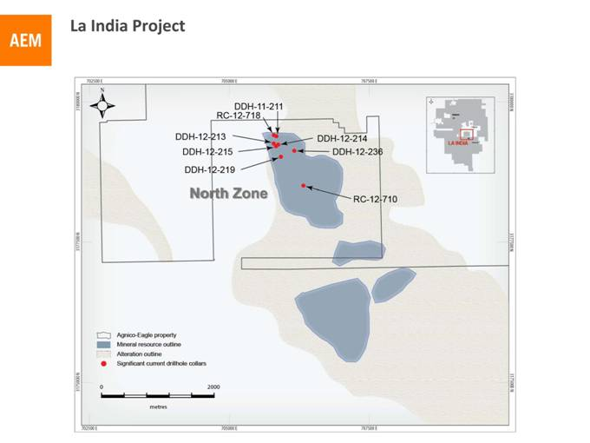

The drilling is expected to result in a new resource and reserve estimate that will accompany the La India feasibility study, scheduled for completion by the end of 2012. The Company plans to spend approximately $10.5 million on drilling at the La India property in 2012.

14

Tarachi  An Early-Stage But Promising Deposit

A 20,000-metre drill program is currently in progress on the Tarachi gold-bearing porphyry system. Two diamond drill rigs and one reverse circulation rig have already completed 11,000 metres in 40 holes. The drill results set out below have increased the known mineralization and are typical of the grades and thicknesses previously encountered at this recently discovered deposit. The main objective in 2012 is to drill between the three resource envelopes that made up Tarachis 2011 resources and link them together into one envelope, thereby increasing the overall size of the deposit.

Significant recent exploration drill results, Tarachi project

Drill Hole |  | Zone |  | From  (metres) |  | To  (metres) |  | Depth below  surface (metres) |  | Core length  (metres) |  | Gold grade  (g/t) (uncut)
TA-12-004 |  | Las Huejas |  | 63.0 |  | 100.0 |  | 67 |  | 37.0 |  | 1.10
including |  |  |  | 74.0 |  | 92.0 |  | 67 |  | 18.0 |  | 1.77
TA-12-005 |  | Las Huejas |  | 48.0 |  | 55.0 |  | 44 |  | 7.0 |  | 1.06
TAR-12-007 |  | Llano Grande |  | 15.2 |  | 44.2 |  | 33 |  | 29.0 |  | 0.68
TAR-12-014 |  | El Llano |  | 10.6 |  | 24.3 |  | 11 |  | 13.7 |  | 1.00
including |  |  |  | 13.7 |  | 19.8 |  | 11 |  | 6.1 |  | 1.82

Gold grades reported as uncut.

15

[Tarachi Project Map]

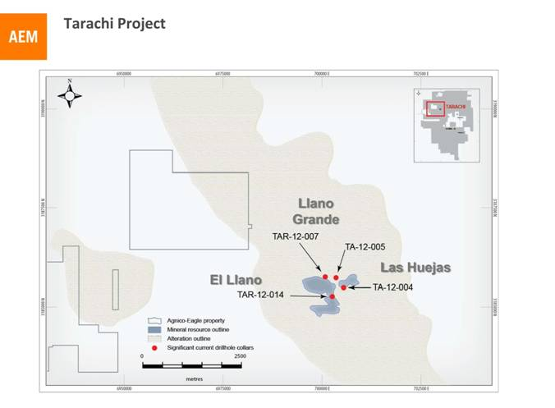

Among the best intercepts from Tarachi are hole TA-12-004 which grades 1.1 g/t gold over 37.0 metres core length at 67 metres depth including 1.8 g/t gold over 18.0 metres core length, and hole TAR-12-014 which grades 1.8 g/t gold over 6.1 metres core length at 11 metres depth.

Most of the 58,000-hectare property surrounding La India remains underexplored. While the La India and Tarachi deposits will be the main priorities in 2012, other parts of the property are being prospected and evaluated to determine the priority targets for future work.

The encouraging outlook for the La India project and the Tarachi exploration potential reinforce the growing importance of the Mexican operations as a key contributor to Agnico-Eagles operating and growth profile.

Creston Mascota Deposit Expanding

At Pinos Altos, the 2012 exploration program is budgeted at $5.8 million. Its main focus is on expanding the low-cost Creston Mascota satellite operation.

16

In 2011, conversion drilling increased the proven and probable gold reserves at Creston Mascota by approximately 75,000 ounces net of mining during the year (from 365,000 ounces to 440,000 ounces of gold), extending the Creston Mascota mine life by approximately two years to 2017.

Infill drilling in 2012 has found relatively higher grades on the eastern side of the pit outline. The Bravo deposit, which may be a southward extension of the Creston Mascota deposit, will be explored this year as well. Additionally, the recently discovered Veta Flor lens (approximately 500 metres west of Creston Mascota) could be an eastern branch of the nearby Cubiro deposit, displaced northward by faulting. All three deposits have the potential to supply ore to the Creston Mascota heap leach operation.

Recent infill drill results from the eastern side of Creston Mascota are set out in the table below and are located on the Creston Mascota longitudinal section.

17

[Creston Mascota Project Map]

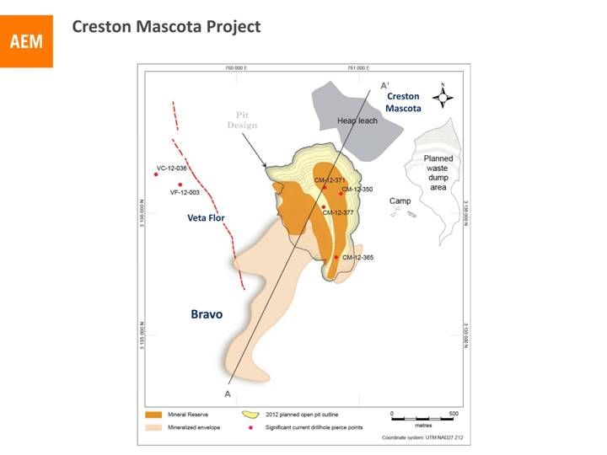

18

[Creston Mascota Longitudinal Section]

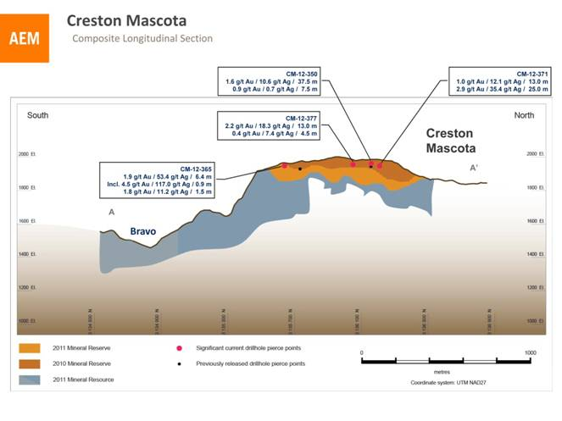

Significant recent Creston Mascota pit infill drilling results

Drill Hole |  | From  (metres) |  | To  (metres) |  | Depth  below  surface  (metres) |  | Estimated  true  width  (metres) |  | Gold grade  (g/t)  (uncut) |  | Gold  grade  (g/t)  (cut)* |  | Silver  grade (g/t)  (cut)*
CM-12-350 |  | 0.0 |  | 38.0 |  | 15 |  | 37.5 |  | 1.59 |  | 1.59 |  | 10.60
and |  | 69.5 |  | 77.0 |  | 55 |  | 7.5 |  | 0.86 |  | 0.86 |  | 0.70
CM-12-365 |  | 2.6 |  | 9.0 |  | 5 |  | 6.4 |  | 2.04 |  | 1.89 |  | 53.42
including |  | 3.2 |  | 4.1 |  | 3 |  | 0.9 |  | 4.52 |  | 4.52 |  | 117.00
and |  | 22.6 |  | 24.1 |  | 23 |  | 1.5 |  | 1.92 |  | 1.78 |  | 11.20
CM-12-371 |  | 45.5 |  | 59.1 |  | 52 |  | 13.0 |  | 1.16 |  | 1.04 |  | 12.13
and |  | 61.1 |  | 87.5 |  | 75 |  | 25.0 |  | 5.03 |  | 2.88 |  | 35.41
CM-12-377 |  | 14.0 |  | 29.0 |  | 23 |  | 13.0 |  | 2.16 |  | 2.16 |  | 18.27
and |  | 69.5 |  | 74.0 |  | 69 |  | 4.5 |  | 0.40 |  | 0.40 |  | 7.44

* Holes at the Creston Mascota deposit use a capping level ranging from 9 to 20 g/t gold and 88 to 210 g/t silver.

Infill drill holes such as CM-12-350, -365, -371 and -377 returned higher grade than was expected on the east side of the Creston Mascota deposit and are within the pit outline. Hole CM-12-350 intersected 37.5 metres estimated true width grading 1.6 g/t gold and 10.6

19

g/t silver at surface, while hole CM-12-365 intersected 1.9 g/t gold and 53.4 g/t silver over 6.4 metres estimated true width just below surface. Hole CM-12-371 intersected 25.0 metres grading 2.9 g/t gold and 35.4 g/t silver at 75 metres depth, and CM-12-377 intersected 2.2 g/t gold and 18.3 g/t silver over 13.0 metres, at 23 metres below surface.

Veta Flor is located in an extensive structural corridor subparallel to the Cubiro vein zone. The structural zone is characterized by breccias and stockworks of white and amethyst quartz. The table below sets out intersections in the Veta Flor zone in 2012.

Significant recent exploration drill results, Veta Flor zone, Pinos Altos property

Drill Hole |  | From  (metres) |  | To  (metres) |  | Depth below  surface  (metres) |  | Core  length  (metres) |  | Gold grade  (g/t) (uncut) |  | Gold  grade (g/t)  (cut)* |  | Silver  grade (g/t)  (uncut)
VC-12-036 |  | 422.0 |  | 429.0 |  | 354 |  | 7.0 |  | 2.06 |  | 2.06 |  | 15.6
VF-12-003 |  | 301.0 |  | 307.2 |  | 263 |  | 6.2 |  | 3.27 |  | 3.27 |  | 41.7
including |  | 305.2 |  | 307.2 |  | 265 |  | 2.0 |  | 7.43 |  | 7.43 |  | 93.5

*Holes at the Veta Flor zone use a capping level of 3.0 g/t gold.

To date, 2,500 metres of core drilling over six holes has tested the newly discovered structure for 600 metres along strike, with intercepts limited, so far, to levels of more than 250 metres below surface. The most encouraging intercept from Veta Flor is from hole VF-12-003 that yielded 3.3 g/t gold and 41.7 g/t silver over 6.2 metres at a depth of 263 metres.

Lapa exploration budget increased

The original 2012 exploration budget of $2.1 million for the Lapa mine, located in northwestern Quebec, has been increased by a further $2.8 million. The additional budget has been allocated to the exploration drift and infill drill program, with the goal of extending the mines life from 2015 by one or two years. The budget now includes 28,600 metres of exploration drilling plus 637 metres of development work on the exploration drift.

The focus of the mine-site exploration program this year is to complete the eastern and western exploration drifts on Level 101 (approximately 1,000 metres depth), which provide a platform for exploring the Lapa/Zulapa gold corridor. The program includes infill drilling to define several eastern resource blocks for future production. Encouraging results in 2010 and 2011, as shown in the table below and on the longitudinal section for the Lapa mine, led to the current more aggressive exploration program.

20

Significant Lapa drill results

Drill  Hole |  | Zone |  | Purpose |  | From  (metres) |  | To  (metres) |  | Depth  below  surface  (metres) |  | Estimated  true width  (metres) |  | Gold  grade  (g/t)  (uncut) |  | Gold  grade  (g/t)  (cut)*
LA10-98-19** |  | Contact |  | exploration |  | 405.5 |  | 416.1 |  | 1,365 |  | 2.8 |  | 12.6 |  | 12.6
LA10-101-39 |  | Zulapa |  | exploration |  | 360.2 |  | 370.3 |  | 1,335 |  | 4.9 |  | 14.8 |  | 14.8
LA11-98-46 |  | Contact |  | exploration |  | 296.2 |  | 299.5 |  | 1,035 |  | 2.8 |  | 27.6 |  | 27.6
LA11-101-54A |  | Contact |  | exploration |  | 574.4 |  | 577.6 |  | 1,282 |  | 2.8 |  | 9.3 |  | 9.3

* Holes at the Contact zone use a capping factor of 135.0 g/t gold, and at the Zulapa zone use a capping factor of 75 g/t gold.
** Hole LA10-98-19 previously reported in a Company news release dated April 28, 2011.

[Lapa longitudinal section]

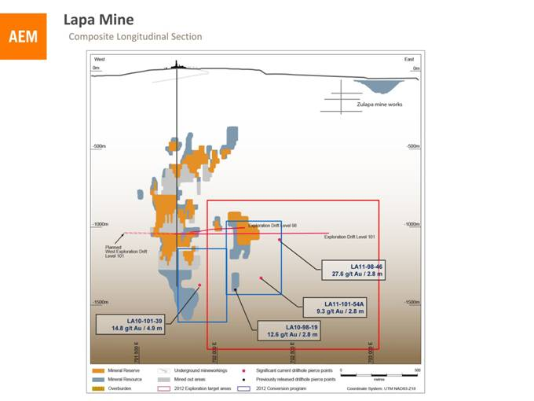

Hole LA10-98-19 in the Contact zone returned 12.6 g/t gold over an estimated true width of 2.8 metres at 1,365 metres depth (previously reported in a news release dated April 28, 2011), while hole LA10-101-39 in the Zulapa zone reported 14.8 g/t gold over 4.9 metres at 1,335 metres depth, approximately 130 metres south of the Contact zone. Farther to the

21

east in the Contact zone, hole LA11-98-46 intersected 2.8 metres grading 27.6 g/t gold at 1,035 metres depth, and hole LA11-101-54A returned 9.3 g/t gold over 2.8 metres at 1,282 metres depth.

A total of 11,524 metres of exploration drilling was done in the mine and surrounding area at a cost of approximately $1.0 million from January through May 2012. There has been 453 metres of exploration drift development in 2012 to the end of May at a cost of $1.21 million.

Goldex and La India Updates Expected in Third Quarter

The Company is planning to provide an update on its Goldex mine in northwestern Quebec in the third quarter of 2012. A significant amount of investigation, monitoring and remediation work has been completed since the October 2011 suspension of production.

Additionally, Agnico-Eagle plans to provide an update on the La India project in Mexico regarding the planning and permitting work that has been underway since the November 2011 acquisition of Grayd Resources Corporation.

About Agnico-Eagle

Agnico-Eagle is a long established, Canadian headquartered, gold producer with operations located in Canada, Finland and Mexico, and exploration and/or development activities in Canada, Finland, Mexico and the United States. The Company has full exposure to higher gold prices consistent with its policy of no forward gold sales and maintains a corporate strategy based on increasing shareholders exposure to gold, on a per share basis. It has declared a cash dividend for 30 consecutive years.

www.agnico-eagle.com

22

Detailed Mineral Reserve and Resource Data (as at December 31, 2011)

 |  |  |  |  |  |  |  |  |  |  |  | Au
 |  | Au |  | Ag |  | Cu |  | Zn |  | Pb |  | (000s |  | Tonnes
Category and Operation |  | (g/t) |  | (g/t) |  | (%) |  | (%) |  | (%) |  | oz.) |  | (000s)
Proven Mineral Reserve
Kittila (open pit) |  | 3.86 |  |  |  |  |  |  |  |  |  | 40 |  | 319
Kittila (underground) |  | 6.11 |  |  |  |  |  |  |  |  |  | 75 |  | 383
Kittila total proven |  | 5.09 |  |  |  |  |  |  |  |  |  | 115 |  | 702
Lapa (underground) |  | 6.45 |  |  |  |  |  |  |  |  |  | 217 |  | 1,044
LaRonde (underground) |  | 2.60 |  | 43.02 |  | 0.28 |  | 2.04 |  | 0.23 |  | 445 |  | 5,331
Meadowbank (open pit) |  | 1.49 |  |  |  |  |  |  |  |  |  | 92 |  | 1,931
Pinos Altos (open pit) |  | 0.80 |  | 13.82 |  |  |  |  |  |  |  | 22 |  | 848
Pinos Altos (underground) |  | 2.59 |  | 79.73 |  |  |  |  |  |  |  | 95 |  | 1,139
Pinos Altos total proven |  | 1.83 |  | 51.59 |  |  |  |  |  |  |  | 117 |  | 1,987
Meliadine (Open Pit) |  | 7.31 |  |  |  |  |  |  |  |  |  | 8 |  | 34
Subtotal Proven Mineral Reserve |  | 2.80 |  |  |  |  |  |  |  |  |  | 994 |  | 11,029
Probable Mineral Reserve
Bousquet (Open Pit) |  | 1.88 |  |  |  |  |  |  |  |  |  | 191 |  | 3,165
Kittila (open pit) |  | 5.66 |  |  |  |  |  |  |  |  |  | 146 |  | 802
Kittila (underground) |  | 4.63 |  |  |  |  |  |  |  |  |  | 4,916 |  | 33,060
Kittila total probable |  | 4.65 |  |  |  |  |  |  |  |  |  | 5,062 |  | 33,862
Lapa (underground) |  | 6.61 |  |  |  |  |  |  |  |  |  | 285 |  | 1,340
LaRonde (underground) |  | 4.74 |  | 22.41 |  | 0.27 |  | 0.77 |  | 0.05 |  | 4,255 |  | 27,901
Meadowbank (open pit) |  | 2.91 |  |  |  |  |  |  |  |  |  | 2,109 |  | 22,563
Meliadine (open pit) |  | 5.80 |  |  |  |  |  |  |  |  |  | 987 |  | 5,292
Meliadine (underground) |  | 8.20 |  |  |  |  |  |  |  |  |  | 1,882 |  | 7,142
Meliadine total probable |  | 7.18 |  |  |  |  |  |  |  |  |  | 2,869 |  | 12,434
Pinos Altos (open pit) |  | 1.68 |  | 37.51 |  |  |  |  |  |  |  | 1,059 |  | 19,599
Pinos Altos (underground) |  | 2.38 |  | 76.02 |  |  |  |  |  |  |  | 1,927 |  | 25,193
Pinos Altos total probable |  | 2.07 |  | 59.17 |  |  |  |  |  |  |  | 2,986 |  | 44,792
Subtotal Probable Mineral Reserve |  | 3.78 |  |  |  |  |  |  |  |  |  | 17,757 |  | 146,057
Total Proven and Probable Mineral Reserves |  | 3.71 |  |  |  |  |  |  |  |  |  | 18,750 |  | 157,086

23

 |  | Au |  | Ag |  | Cu |  | Zn |  | Pb |  | Tonnes
Category and Operation |  | (g/t) |  | (g/t) |  | (%) |  | (%) |  | (%) |  | (000s)
Measured Mineral Resource
Goldex (Underground) |  | 1.86 |  |  |  |  |  |  |  |  |  | 12,360
La India (Open Pit) |  | 1.06 |  |  |  |  |  |  |  |  |  | 3,730
Total Measured Mineral Resource |  | 1.67 |  |  |  |  |  |  |  |  |  | 16,090
Indicated Mineral Resource
Bousquet (open pit) |  | 1.76 |  |  |  |  |  |  |  |  |  | 8,101
Bousquet (underground) |  | 5.63 |  |  |  |  |  |  |  |  |  | 1,704
Bousquet total indicated |  | 2.44 |  |  |  |  |  |  |  |  |  | 9,805
Ellison (underground) |  | 5.68 |  |  |  |  |  |  |  |  |  | 415
Goldex (underground) |  | 1.72 |  |  |  |  |  |  |  |  |  | 24,448
Kittila (underground) |  | 2.46 |  |  |  |  |  |  |  |  |  | 12,978
Lapa (underground) |  | 4.08 |  |  |  |  |  |  |  |  |  | 1,964
LaRonde (underground) |  | 1.79 |  | 24.70 |  | 0.12 |  | 1.49 |  | 0.15 |  | 7,225
Meadowbank (open pit) |  | 1.99 |  |  |  |  |  |  |  |  |  | 14,872
Meadowbank (underground) |  | 4.85 |  |  |  |  |  |  |  |  |  | 2,341
Meadowbank total indicated |  | 2.38 |  |  |  |  |  |  |  |  |  | 17,213
Meliadine (open pit) |  | 3.14 |  |  |  |  |  |  |  |  |  | 6,049
Meliadine (underground) |  | 4.96 |  |  |  |  |  |  |  |  |  | 6,572
Meliadine total indicated |  | 4.09 |  |  |  |  |  |  |  |  |  | 12,621
Pinos Altos (open pit) |  | 0.95 |  | 12.25 |  |  |  |  |  |  |  | 9,574
Pinos Altos (underground) |  | 1.55 |  | 41.95 |  |  |  |  |  |  |  | 11,002
Pinos Altos total indicated |  | 1.27 |  | 28.13 |  |  |  |  |  |  |  | 20,576
Swanson (open pit) |  | 1.93 |  |  |  |  |  |  |  |  |  | 504
La India (open pit) |  | 0.85 |  |  |  |  |  |  |  |  |  | 23,040
Tarachi (open pit) |  | 0.57 |  |  |  |  |  |  |  |  |  | 21,456
La India/Tarachi total indicated |  | 0.72 |  |  |  |  |  |  |  |  |  | 44,496
Total Indicated Mineral Resource |  | 1.79 |  |  |  |  |  |  |  |  |  | 152,247
Total Measured & Indicated Mineral Resources |  | 1.78 |  |  |  |  |  |  |  |  |  | 168,336

 |  | Au |  | Ag |  | Cu |  | Zn |  | Pb |  | Tonnes
Category and Operation |  | (g/t) |  | (g/t) |  | (%) |  | (%) |  | (%) |  | (000s)
Inferred Mineral Resource
Bousquet (open pit) |  | 1.16 |  |  |  |  |  |  |  |  |  | 679
Bousquet (underground) |  | 4.54 |  |  |  |  |  |  |  |  |  | 3,888
Bousquet total inferred |  | 4.04 |  |  |  |  |  |  |  |  |  | 4,567
Ellison (underground) |  | 5.81 |  |  |  |  |  |  |  |  |  | 786
Goldex (underground) |  | 1.59 |  |  |  |  |  |  |  |  |  | 31,081
Kittila (open pit) |  | 3.87 |  |  |  |  |  |  |  |  |  | 276
Kittila (underground) |  | 4.58 |  |  |  |  |  |  |  |  |  | 7,677
Kittila total inferred |  | 4.55 |  |  |  |  |  |  |  |  |  | 7,953
Kuotko, Finland (open pit) |  | 3.24 |  |  |  |  |  |  |  |  |  | 1,116
Kylmäkangas, Finland (underground) |  | 4.07 |  |  |  |  |  |  |  |  |  | 1,924
Lapa (Open Pit Zulapa) |  | 2.79 |  |  |  |  |  |  |  |  |  | 496
Lapa (underground) |  | 9.09 |  |  |  |  |  |  |  |  |  | 223
Lapa total inferred |  | 4.74 |  |  |  |  |  |  |  |  |  | 719
LaRonde (underground) |  | 3.68 |  | 11.59 |  | 0.26 |  | 0.44 |  | 0.05 |  | 11,400
Meadowbank (open pit) |  | 3.03 |  |  |  |  |  |  |  |  |  | 1,532
Meadowbank (underground) |  | 4.36 |  |  |  |  |  |  |  |  |  | 2,213
Meadowbank total inferred |  | 3.81 |  |  |  |  |  |  |  |  |  | 3,745
Meliadine (open pit) |  | 3.53 |  |  |  |  |  |  |  |  |  | 4,857
Meliadine (underground) |  | 7.50 |  |  |  |  |  |  |  |  |  | 7,830
Meliadine total inferred |  | 5.98 |  |  |  |  |  |  |  |  |  | 12,687
Pinos Altos (open pit) |  | 0.88 |  | 18.47 |  |  |  |  |  |  |  | 20,159
Pinos Altos (underground) |  | 2.22 |  | 51.17 |  |  |  |  |  |  |  | 2,954
Pinos Altos total inferred |  | 1.05 |  | 22.65 |  |  |  |  |  |  |  | 23,113
La India (open pit) |  | 0.80 |  |  |  |  |  |  |  |  |  | 19,730
Tarachi (open pit) |  | 0.52 |  |  |  |  |  |  |  |  |  | 12,395
La India/Tarachi total inferred |  | 0.69 |  |  |  |  |  |  |  |  |  | 32,125
Total Inferred Resource |  | 2.30 |  |  |  |  |  |  |  |  |  | 131,216

24

Tonnage amounts and contained metal amounts presented in this table have been rounded to the nearest thousand. Reserves are not a sub-set of resources.

Forward-Looking Statements

The information in this news release has been prepared as at June 26, 2012. Certain statements contained in this press release constitute forward-looking statements within the meaning of the United States Private Securities Litigation Reform Act of 1995 and forward looking information under the provisions of Canadian provincial securities laws and are referred to herein as forward-looking statements. When used in this document, words such as anticipate, expect, estimate, forecast, planned, will, likely, schedule and similar expressions are intended to identify forward-looking statements.

Such statements include without limitation: the Companys forward-looking production guidance, including estimated ore grades, project timelines, drilling results, orebody configurations, metal production, life of mine, commencement of production estimates, the estimated timing of scoping and other studies, recovery rates, mill throughput, and projected exploration and capital expenditures, including costs and other estimates upon which such projections are based; the Companys goal to increase its mineral reserves and resources; and other statements and information regarding anticipated trends with respect to the Companys operations, exploration and the funding thereof. Such statements reflect the Companys views as at the date of this press release and are subject to certain risks, uncertainties and assumptions. Forward-looking statements are necessarily based upon a number of factors and assumptions that, while considered reasonable by Agnico-Eagle as of the date of such statements, are inherently subject to significant business, economic and competitive uncertainties and contingencies. The factors and assumptions of Agnico-Eagle contained in this news release, which may prove to be incorrect, include, but are not limited to, the assumptions set forth herein and in managements discussion and analysis and the Companys Annual Report on Form 20-F for the year ended December 31, 2011 (Form 20-F) as well as: that there are no significant disruptions affecting operations, whether due to labour disruptions, supply disruptions, damage to equipment, natural occurrences, equipment failures, accidents, political changes, title issues or otherwise; that permitting, production and expansion at each of Agnico-Eagles mines and growth projects proceeds on a basis consistent with current expectations, and that Agnico-Eagle does not change its plans relating to such projects; that the exchange rate between the Canadian dollar, European Union euro, Mexican peso and the United States dollar will be approximately consistent with current levels or as set out in this news release; that prices for gold, silver, zinc, copper and lead will be consistent with Agnico-Eagles expectations; that prices for key mining and construction supplies, including labour costs, remain consistent with Agnico-Eagles current expectations; that Agnico-Eagles current estimates of mineral reserves, mineral resources, mineral grades and metal recovery are accurate; that there are no material delays in the timing for completion of ongoing growth projects; that the Companys current plans to optimize production are successful; and that there are no material variations in the current tax and regulatory environment. Many factors, known and unknown, could cause the actual results to be materially different from those expressed or

25

implied by such forward-looking statements. Such risks include, but are not limited to: the volatility of prices of gold and other metals; uncertainty of mineral reserves, mineral resources, mineral grades and metal recovery estimates; uncertainty of future production, capital expenditures, and other costs; currency fluctuations; financing of additional capital requirements; cost of exploration and development programs; mining risks; risks associated with foreign operations; governmental and environmental regulation; the volatility of the Companys stock price; and risks associated with the Companys byproduct metal derivative strategies. For a more detailed discussion of such risks and other factors, see the Form 20-F, as well as the Companys other filings with the Canadian Securities Administrators and the U.S. Securities and Exchange Commission (the SEC). The Company does not intend, and does not assume any obligation, to update these forward-looking statements and information, except as required by law. Accordingly, readers are advised not to place undue reliance on forward-looking statements. Certain of the foregoing statements, primarily related to projects, are based on preliminary views of the Company with respect to, among other things, grade, tonnage, processing, recoveries, mining methods, capital costs, total cash costs, minesite costs, and location of surface infrastructure. Actual results and final decisions may be materially different from those currently anticipated.

Notes to Investors Regarding the Use of Resources

Cautionary Note to Investors Concerning Estimates of Measured and Indicated Resources

This news release uses the terms measured resources and indicated resources. We advise investors that while those terms are recognized and required by Canadian regulations, the SEC does not recognize them. Investors are cautioned not to assume that any part or all of mineral deposits in these categories will ever be converted into reserves.

Cautionary Note to Investors Concerning Estimates of Inferred Resources

This press release also uses the term inferred resources. We advise investors that while this term is recognized and required by Canadian regulations, the SEC does not recognize it. Inferred resources have a great amount of uncertainty as to their existence, and great uncertainty as to their economic and legal feasibility. It cannot be assumed that all or any part of an inferred mineral resource will ever be upgraded to a higher category. Under Canadian rules, estimates of inferred mineral resources may not form the basis of feasibility or pre-feasibility studies, except in rare cases. Investors are cautioned not to assume that part or all of an inferred resource exists, or is economically or legally mineable.

Scientific and Technical Data

Agnico-Eagle Mines Limited is reporting mineral resource and reserve estimates in accordance with the CIM guidelines for the estimation, classification and reporting of resources and reserves.

Cautionary Note To U.S. Investors - The SEC permits U.S. mining companies, in their filings with the SEC, to disclose only those mineral deposits that a company can

26

economically and legally extract or produce. Agnico-Eagle uses certain terms in this press release, such as measured, indicated, and inferred, and resources that the SEC guidelines strictly prohibit U.S. registered companies from including in their filings with the SEC. U.S. investors are urged to consider closely the disclosure in our Form 20-F, which may be obtained from us, or from the SECs website at: http://sec.gov/edgar.shtml. A final or bankable feasibility study is required to meet the requirements to designate reserves under Industry Guide 7.

Estimates for all properties were calculated using historic three-year average metals prices and foreign exchange rates in accordance with the SEC Industry Guide 7. Industry Guide 7 requires the use of prices that reflect current economic conditions at the time of reserve determination, which the Staff of the SEC has interpreted to mean historic three-year average prices. The assumptions used for the mineral reserves and resources estimates reported by the Company on February 15, 2012 were based on three-year average prices for the period ending December 31, 2011 of $1,255 per ounce gold, $23.00 per ounce silver, $0.91 per pound zinc, $3.25 per pound copper, $0.95 per pound lead and C$/US$, US$/Euro and MXP/US$ exchange rates of 1.05, 1.37 and 12.86, respectively.

The Canadian Securities Administrators National Instrument 43-101 (NI 43-101) requires mining companies to disclose reserves and resources using the subcategories of proven reserves, probable reserves, measured resources, indicated resources and inferred resources. Mineral resources that are not mineral reserves do not have demonstrated economic viability.

A mineral reserve is the economically mineable part of a measured or indicated mineral resource demonstrated by at least a preliminary feasibility study. This study must include adequate information on mining, processing, metallurgical, economic and other relevant factors that demonstrate, at the time of reporting, that economic extraction can be justified. A mineral reserve includes diluting materials and allows for losses that may occur when the material is mined. A proven mineral reserve is the economically mineable part of a measured mineral resource demonstrated by at least a preliminary feasibility study. A probable mineral reserve is the economically mineable part of an indicated and, in some circumstances, a measured mineral resource demonstrated by at least a preliminary feasibility study.

A mineral resource is a concentration or occurrence of natural, solid, inorganic material, or natural, solid fossilized organic material including base and precious metals in or on the Earths crust in such form and quantity and of such a grade or quality that it has reasonable prospects for economic extraction. The location, quantity, grade, geological characteristics and continuity of a mineral resource are known, estimated or interpreted from specific geological evidence and knowledge. A measured mineral resource is that part of a mineral resource for which quantity, grade or

27

quality, densities, shape and physical characteristics are so well established that they can be estimated with confidence sufficient to allow the appropriate application of technical and economic parameters, to support production planning and evaluation of the economic viability of the deposit. The estimate is based on detailed and reliable exploration, sampling and testing information gathered through appropriate techniques from locations such as outcrops, trenches, pits, workings and drill holes that are spaced closely enough to confirm both geological and grade continuity. An indicated mineral resource is that part of a mineral resource for which quantity, grade or quality, densities, shape and physical characteristics can be estimated with a level of confidence sufficient to allow the appropriate application of technical and economic parameters, to support mine planning and evaluation of the economic viability of the deposit. The estimate is based on detailed and reliable exploration and testing information gathered through appropriate techniques from locations such as outcrops, trenches, pits, workings and drill holes that are spaced closely enough for geological and grade continuity to be reasonably assumed. An inferred mineral resource is that part of a mineral resource for which quantity and grade or quality can be estimated on the basis of geological evidence and limited sampling and reasonably assumed, but not verified, geological and grade continuity. The estimate is based on limited information and sampling gathered through appropriate techniques from locations such as outcrops, trenches, pits, workings and drill holes. Mineral resources which are not mineral reserves do not have demonstrated economic viability.

Investors are cautioned not to assume that part or all of an inferred resource exists, or is economically or legally mineable.

A feasibility study is a comprehensive technical and economic study of the selected development option for a mineral project that includes appropriately detailed assessments of realistically assumed mining, processing, metallurgical, economic, marketing, legal, environmental, social and governmental considerations together with any other relevant operational factors and detailed financial analysis, that are necessary to demonstrate at the time of reporting that extraction is reasonably justified (economically mineable). The results of the study may reasonably serve as the basis for a final decision by a proponent or financial institution to proceed with, or finance, the development of the project. The confidence level of the study will be higher than that of a Pre-Feasibility Study.

The mineral reserves presented in this disclosure are separate from and not a portion of the mineral resources.

Property/Project name  and location |  | Qualified Person  responsible for the  current Mineral  Resource and  Reserve Estimate and  relationship to  Agnico-Eagle |  | Qualified Person  responsible for  Exploration and  relationship to  Agnico-Eagle |  | Date of most recent  Technical Report (NI  43-101) filed on  SEDAR
LaRonde, Bousquet & Ellison, Quebec, Canada |  | François Blanchet Ing., LaRonde Division Superintendent of geology |  | François Blanchet Ing., LaRonde Division Superintendent of geology |  | March 23, 2005
Kittila, Kuotko and Kylmakangas, Finland |  | Daniel Doucet, Ing., Corporate Director of Reserve Development |  | Daniel Doucet, Ing., Corporate Director of Reserve Development |  | March 4, 2010
Pinos Altos, La India, Mexico. Swanson, Quebec, Canada |  | Pinos Altos: Dyane Duquette, P.Geo., Superintendent of geology, Technical Services Group; La |  | Mine site: Dyane Duquette, P.Geo.; Regional: Manuel Padilla,Exploration Technical Manager |  | March 25, 2009

28

 |  | India project: Matthew D. Gray, C.P.G., independent consultant; Tarachi project: Gary Giroux, P.Eng., independent consultant |  | for Mexico
Meadowbank, Nunavut, Canada |  | Elzear Belzile, Ing., Independent Consultant |  | Mine site: Marc Ruel, P.Geo., Corporate Director of Mine Geology & Grade Control; Regional: Denis Vaillaincourt, P.Geo., Exploration manager for Eastern Canada |  | February 15, 2012
Goldex, Quebec, Canada |  | Richard Genest, Ing., Goldex Division Superintendent of geology |  | Richard Genest, Ing., Goldex Division Superintendent of geology |  | October 19, 2011
Lapa, Quebec, Canada |  | Normand Bédard, P.Geo., Lapa Division Superintendent of geology |  | Richard Dubuc, P.Geo., Lapa Division Superintendent of geology |  | June 8, 2006
Meliadine, Nunavut, Canada |  | Dyane Duquette, P.Geo., Superintendent of geology, Technical Services Group |  | Denis Vaillancourt, P.Geo., Exploration manager for eastern Canada |  | March 8, 2011

The effective date for all of the Companys mineral resource and reserve estimates in this press release is December 31, 2011. Additional information about each of the mineral projects that is required by NI 43-101, sections 3.2 and 3.3 and paragraphs 3.4 (a), (c) and (d) can be found in the Technical Reports referred to above, which may be found at www.sedar.com. Other important operating information can be found in the Companys Form 20-F and its news release dated February 15, 2012.

The contents of this press release have been prepared under the supervision of, and reviewed by, Alain Blackburn P.Eng., Senior Vice-President Exploration and a Qualified Person for the purposes of NI 43-101. The contents of the Detailed Mineral Reserve and Resource Data table have been prepared under the supervision of, and reviewed by, Marc Legault P.Eng., Senior Vice-President Project Evaluations and a Qualified Person for the purposes of NI 43-101.

29

Appendix: Selected Drill Results, La India Property

Property |  | Target |  | Drill hole |  | East* |  | North* |  | Elevation |  | Azimuth |  | Dip (degrees)
La India |  | La India |  | DDH-11-211 |  | 705845 |  | 3179380 |  | 1605 |  | 90 |  | -65
La India |  | La India |  | DDH-12-213 |  | 705800 |  | 3179250 |  | 1573 |  | 90 |  | -70
La India |  | La India |  | DDH-12-214 |  | 705880 |  | 3179230 |  | 1596 |  | 90 |  | -65
La India |  | La India |  | DDH-12-215 |  | 705838 |  | 3179200 |  | 1580 |  | 90 |  | -65
La India |  | La India |  | DDH-12-219 |  | 705927 |  | 3179011 |  | 1600 |  | 90 |  | -55
La India |  | La India |  | DDH-12-236 |  | 706166 |  | 3179120 |  | 1672 |  | 90 |  | -70
La India |  | La India |  | RC-12-710 |  | 706328 |  | 3178498 |  | 1640 |  | 90 |  | -65
La India |  | La India |  | RC-12-718 |  | 705800 |  | 3179400 |  | 1591 |  | 90 |  | -75
La India |  | Tarachi |  | TA-12-004 |  | 700549 |  | 3185489 |  | 1380 |  | 349 |  | -55
La India |  | Tarachi |  | TA-12-005 |  | 700357 |  | 3185736 |  | 1461 |  | 15 |  | -60
La India |  | Tarachi |  | TAR-12-007 |  | 700085 |  | 3185757 |  | 1358 |  | 195 |  | -45
La India |  | Tarachi |  | TAR-12-014 |  | 700259 |  | 3185261 |  | 1405 |  | 44 |  | -69

* Drill hole collars on UTM Coordinate System UTM NAD27

Appendix: Selected Veta Flor Drill Results, Pinos Altos Property

Property |  | Target |  | Drill  hole |  | East* |  | North* |  | Elevation |  | Azimuth |  | Dip  (degrees)
Pinos Altos |  | Veta Flor |  | VC-12-036 |  | 759344.280 |  | 3136317.809 |  | 1563.905 |  | 40 |  | -58
Pinos Altos |  | Veta Flor |  | VF-12-003 |  | 759537.784 |  | 3136235.671 |  | 1648.456 |  | 46 |  | -65

* Drill hole collars on UTM Coordinate System UTM NAD27 Z12

30

Exhibit 99.2

Stock Symbol: |  | AEM (NYSE and TSX) |  | For further information:
 |  |  |  | Investor Relations
 |  |  |  | (416) 947-1212

Agnico-Eagle Announces Senior Management Change

Toronto; (June 26, 2012)  Agnico-Eagle Mines Limited (NYSE:AEM)(TSX:AEM) (Agnico-Eagle or the Company) announced today that Ammar Al-Joundi, Senior Vice-President, Finance and Chief Financial Officer, is leaving the Company, effective July 9, 2012, to assume a similar position with another resource company.

We want to thank Ammar for his contributions, guidance and friendship during his time with Agnico-Eagle and we wish him success in his new position, said Agnico-Eagles President and CEO Sean Boyd. Agnico-Eagle will take the necessary time to identify the best possible candidate to fill this position.

About Agnico-Eagle

Agnico-Eagle is a long established, Canadian headquartered, gold producer with operations located in Canada, Finland and Mexico, and exploration and/or development activities in Canada, Finland, Mexico and the United States. The Company has full exposure to higher gold prices consistent with its policy of no forward gold sales and maintains a corporate strategy based on increasing shareholders exposure to gold, on a per share basis. It has declared a cash dividend for 30 consecutive years. www.agnico-eagle.com

1

