**UNITED STATES**

**SECURITIES AND EXCHANGE COMMISSION**

**Washington, D.C. 20549**

**Form 6-K**

**REPORT OF FOREIGN PRIVATE ISSUER PURSUANT TO RULE 13a-16 OR 15d-16 UNDER THE  
SECURITIES EXCHANGE ACT OF 1934**

**For the month of September, 2010.**

**Commission File Number**

**AGNICO-EAGLE MINES LIMITED**

(Translation of registrants name into English)

**145 King Street East, Suite 400, Toronto, Ontario M5C 2Y7**

(Address of principal executive office)

Indicate by check mark whether the registrant files or will file annual reports under cover of Form 20-F or Form 40-F.  
Form 20-F x  Form 40-F o

Indicate by check mark if the registrant is submitting the Form 6-K in paper as permitted by Regulation S-T Rule 101 (b)( 1): o

**Note:** Regulation S-T Rule 101 (b)( 1) only permits the submission in paper of a Form 6-K if submitted solely to provide an attached annual report to security holders.

Indicate by check mark if the registrant is submitting the Form 6-K in paper as permitted by Regulation S-T Rule 101 (b)(7): o

**Note:** Regulation S-T Rule 101(b)(7) only permits the submission in paper of a Form 6-K if submitted to furnish a report or other document that the registrant foreign private issuer must furnish and make public under the laws of the jurisdiction in which the registrant is incorporated, domiciled or legally organized (the registrants home country), or under the rules of the home country exchange on which the registrants securities are traded, as long as the report or other document is not a press release, is not required to be and has not been distributed to the registrants security holders, and, if discussing a material event, has already been the subject of a Form 6-K submission or other Commission filing on EDGAR.

Indicate by check mark whether the registrant by furnishing the information contained in this Form is also thereby furnishing the information to the Commission pursuant to Rule 12g3-2(b) under the Securities Exchange Act of 1934. Yes o  No x

If Yes is marked, indicate below the file number assigned to the registrant in connection with Rule 12g3-2(b): 82-                 .

**EXHIBITS**

|  |  |  |
| --- | --- | --- |
| **Exhibit No.** |  | **Exhibit Description** |
| 1 |  | Press Release dated September 8, 2010 providing exploration update on 2010 activities. |

**SIGNATURES**

Pursuant to the requirements of the Securities Exchange Act of 1934, the registrant has duly caused this report to be signed on its behalf by the undersigned, thereunto duly authorized.

|  |  |  |  |
| --- | --- | --- | --- |
|  | AGNICO-EAGLE MINES LIMITED | |  |
|  | (Registrant) | |  |
|  |  |  | |
|  |  |  | |
| Date: September 9, 2010 | By: | /s/ R. Gregory Laing | |
|  |  | R. Gregory Laing | |
|  |  | General Counsel, Sr. Vice President, Legal | |
|  |  | and Corporate Secretary | |
|  |  |  |  |

2

**Exhibit 1**



|  |  |  |
| --- | --- | --- |
| **Stock Symbol: AEM (NYSE, TSX)** |  | **For further information:** |
|  |  | **Investor Relations (416) 947-1212** |

**(All amounts expressed in U.S. dollars unless otherwise noted)**

**AGNICO-EAGLE PROVIDES EXPLORATION UPDATE ON 2010 ACTIVITIES:**

**MINERALIZATION EXTENDED AT DEPTH AT KITTILA;**

**NEW ZONE FOUND AT PINOS ALTOS;**

**AGGRESSIVE PROGRAM UNDERWAY AT MELIADINE**

Toronto (September 8, 2010) - **Agnico-Eagle Mines Limited** (Agnico-Eagle or the Company) is pleased to provide an update on its 2010 exploration program.  During the course of 2010, the Companys programs have resulted in expansions of several mineralized zones at the Companys operations, most significantly at Kittila and Pinos Altos.

Additionally, due to the acquisition of the Meliadine property on July 6, 2010 and the acceleration of exploration at other properties, and the positive results overall, the companys exploration budget for 2010 has been increased by more than 45% to $110 million.  This is double of what was spent in 2009, with $25 million having been spent to the end of July.

**Highlights of the 2010 exploration program to date include:**

·                  At Kittila:

·                  Deep mineralization at the Suuri and Roura zones has been extended northward, increasing the strike length by approximately 30% at 900 metres below surface.  Deposit remains open on strike and at depth

·                  Hole ROU-09-002, containing one of the thickest drill intersections to date on the property, indicates the potential for underground mining in a previously untested area

·                  Rimpi zone mineralization deepened by 100 metres to almost 700 metres below surface as gold continues to be encountered along strike to the north

·                  At Pinos Altos:

·                  Cubiro vein continues to yield quality gold intercepts. Mineralization now extends to 230 metres below surface.  May result in a stand-alone mining operation.

·                  Step-out drilling discovered the new Cubiro West vein zone approximately 200 metres away

·                  At Meliadine:

·                  $130-million budget approved, including 200-kilometre drill program, bulk sample, permitting and proposed all-season road construction over next 2.5 years

·                  High grade drill results continue to suggest growth and conversion potential of the five million ounce resource over the next several years

·                  Early drilling results suggest possible combination of open pit and underground scenarios at F zone

·                  Feasibility study expected to be completed in 2013.

With six operating mines driving record operating and financial results, the focus for Agnico-Eagle turns to continued production growth through optimization and expansion of these mines.  At the same time, we have begun an aggressive exploration program at all of our new mines and our newly acquired Meliadine project, as we feel the exploration potential is excellent and these deposits are still relatively under-explored said Sean Boyd, Vice-Chairman and CEO. Recent exploration results, particularly at Kittila, Pinos Altos, Goldex and Meliadine, have confirmed our understanding of the potential to continue to grow our reserve and resource base through exploration.  With the largest drilling program in our history now underway, we look forward to getting a better understanding of the ultimate size of our deposits and incorporating these results into our ongoing expansion studies added Mr. Boyd.

**Kittila  Mineralization Continues to Be Discovered at Depth and to the North**

The overall reserve and resource envelopes of the Kittila property have grown consistently since Agnico-Eagle acquired the property in 2005, transforming it into the largest gold deposit in Scandinavia.  The current mineralized zones remain wide open for further expansion and warrant further exploration along strike and at depth.

Prompted by the large increase in Kittila reserves and resources at the end of 2009, Agnico-Eagle is actively studying the possibility of increasing the capacity of the mine above its 3,000 tonne per day design rate.  The main exploration objectives in 2010 are to drill the Suuri North and Central Roura zones to convert and expand the gold resources between 600 and 1,100 metres below surface.  The 2010 drill results will be incorporated in a feasibility study which is currently investigating scenarios for increasing the mining rate and plant throughput.  The study is now scheduled for completion in the second half of 2011.

Including shallower exploration drilling in the Rimpi, Ketola and Etela zones, and conversion drilling at Suuri South, overall drilling through the end of July has totalled 58,570 metres out of approximately 80,000 metres expected for the full year.

**Roura Exploration Drilling Returns One of Thickest Gold Intersections to Date**

Drilling is ongoing below the Roura zones.  This drilling is largely intended to convert resource to reserve, but also to extend the resource envelope to the north from its current limit at 650 metres down to a depth of 1,100 metres or more.  Selected holes and intersections are presented in the following tables and linked sections.

**Selected Roura Drill Results**

|  |  |  |  |  |  |  |  |  |  |  |  |  |  |
| --- | --- | --- | --- | --- | --- | --- | --- | --- | --- | --- | --- | --- | --- |
| **Drill Hole** |  | **Lens** |  | **Purpose** |  | **From (metres)** |  | **To (metres)** |  | **Estimated True Width (metres)** |  | **Gold (g/t) (Uncut)** |  |
| ROU-09-001D |  | Roura C |  | conversion |  | 714.0 |  | 721.0 |  | 5.4 |  | 6.49 |  |
| ROU-09-002 |  | Roura N |  | exploration |  | 880.0 |  | 891.0 |  | 4.0 |  | 5.92 |  |
| and |  | Roura N |  | exploration |  | 913.0 |  | 1027.9 |  | 30.0 |  | 6.00 |  |
| ROU-10-004B |  | Roura C |  | conversion |  | 1026.0 |  | 1045.0 |  | 8.0 |  | 10.70 |  |
| and |  | Roura C |  | conversion |  | 1140.0 |  | 1148.0 |  | 3.6 |  | 5.02 |  |
| ROU-10-007 |  | Roura C |  | conversion |  | 871.0 |  | 886.0 |  | 6.1 |  | 9.61 |  |
| ROU-10-010B |  | Roura C |  | conversion |  | 996.0 |  | 1012.0 |  | 9.1 |  | 5.84 |  |
| ROU-10-014 |  | Roura C |  | conversion |  | 998.0 |  | 1006.0 |  | 3.8 |  | 5.17 |  |
| and |  | Roura C |  | conversion |  | 1116.3 |  | 1126.4 |  | 5.1 |  | 4.73 |  |

2

Hole ROU-09-002 has returned one of the most significant intersections at depth, to date, on the property with 6.00 grams per tonne (g/t) over an estimated true width of 30.0 metres.  This intersection is approximately 920 metres below surface and approximately 300 metres north of the current resource envelope.  This represents an increase of the known strike length at this depth by approximately 30% to the north.

Kittila Mine Longitudinal Section

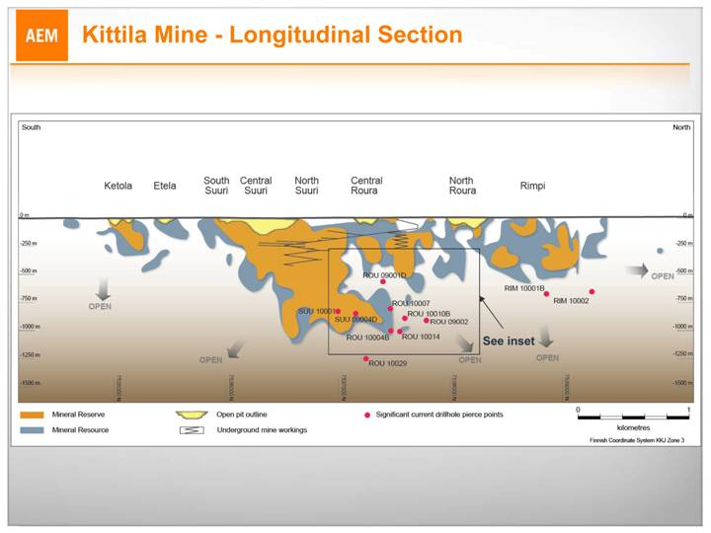

3

Kittila Mine Longitudinal Section Inset

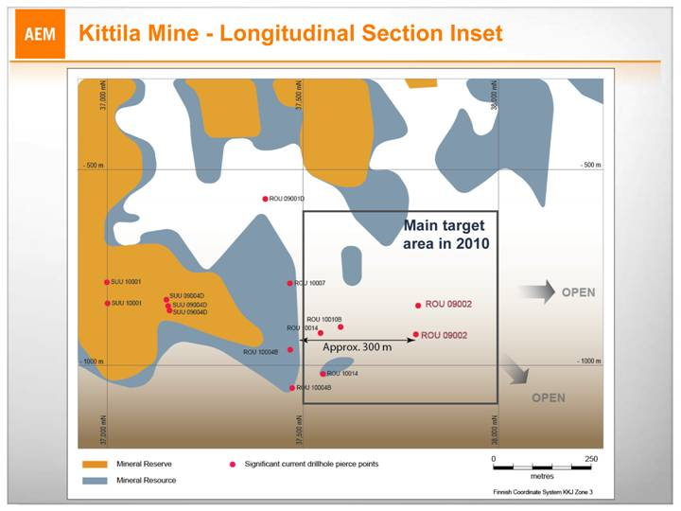

Additionally, at 850 metres depth and approximately 40 metres to the west, the same hole yielded another intercept of 5.92 g/t gold over 4.0 metres.  This wide two-part intersection is similar to previous results on the property where significant zones of gold mineralization are marked by wide zones comprised of multiple parallel lenses.

There were also other significant gold-bearing intercepts outside of the current resource envelope.  Hole ROU-09-001D intersected gold mineralization at almost 600 metres depth in an area previously thought to be barren.  Holes ROU-10010B and 014 have pushed the known extent of the deep mineralization in the Roura area northward more than 100 metres towards the previously mentioned Rou-09-002 drill intersections.

Through the remainder of 2010 and into 2011, this important 500 metre by 500 metre target area will continue to be tested.  For reference, the adjacent roughly 500 metre by 500 metre area to the south contained (in the 2009 year-end estimate) 0.9 million ounces of probable reserves (5.8 million tonnes at 5.0 g/t gold), 0.3 million ounces of indicated resource (4.2 million tonnes at 2.3 g/t gold) and 0.4 million ounces of inferred resources (2.9 million tonnes at 3.9 g/t gold).

A budget supplement of $4.5 million has been approved to confirm the continuity of mineralization around the hole ROU-09-002 intercepts between 600 and 1,100 metres depth.

**Deep Exploration Program Underway**

At the end of June, a deep exploration drill program began below the 1,300-metre depth in the Suuri and Roura zones.  The purpose of this program is to test the favourable Kittila mine horizon on a wide spacing below the current level of exploration in order to assess an exploration shaft option in the expansion study described previously.

While the first drill hole of the program, ROU-10-029, is still in progress, preliminary results are positive, with typical, albeit narrow intervals of arsenopyrite mineralization (generally

4

associated with gold) evident between 1,310 metres and 1,320 metres below surface.  Assays are pending.

Beginning in early to mid-2011, the Company expects to be able to perform exploration drilling from the underground ramp for the first time.  This is expected to facilitate deeper drilling and also to speed up the exploration program as the holes will be significantly shorter.

**Suuri Infill and Resource Conversion Drilling Continues to be Successful**

Conversion drilling in sectors of indicated and inferred resource within the current Suuri North zone was also successful below 600 metres depth.  Drill hole SUU-10-001 intersected 6.25 g/t gold over 17.3 metres at the edge of the current reserves in a sector where the average thickness is about 4.5 metres.  Another positive result in the Suuri area was a 10.6 metre intersection grading 9.91 g/t gold (hole SUU-09-004D), which extends a lens comprising the deep Suuri zone at least 30 metres to the north, at approximately 800 metres depth.  This is an area where there were no resources previously reported.

|  |  |  |  |  |  |  |  |  |  |  |  |  |  |
| --- | --- | --- | --- | --- | --- | --- | --- | --- | --- | --- | --- | --- | --- |
| **Drill Hole** |  | **Lens** |  | **Purpose** |  | **From (metres)** |  | **To (metres)** |  | **Estimated True Width (metres)** |  | **Gold (g/t) (Uncut)** |  |
| SUU-09-004D |  | Suuri N |  | conversion |  | 982.0 |  | 997.0 |  | 10.6 |  | 9.91 |  |
| and |  | Suuri N |  | conversion |  | 1009.0 |  | 1018.0 |  | 6.5 |  | 7.39 |  |
| and |  | Suuri N |  | conversion |  | 1026.0 |  | 1031.0 |  | 3.6 |  | 4.55 |  |
| SUU-10-001 |  | Suuri N |  | conversion |  | 877.0 |  | 915.0 |  | 17.3 |  | 6.25 |  |
| and |  | Suuri N |  | conversion |  | 950.0 |  | 965.0 |  | 7.2 |  | 5.24 |  |

Conversion and infill drilling will continue during 2010 in the Suuri zones.

**Selected Rimpi Drill Results**

The Rimpi zone is the most northerly zone, to date, within the Kittila mining lease area.  While it currently only contains approximately 5% of the gold reserves, it is a growing zone that has only recently become a focus.

Geophysics and follow-up exploration drilling has suggested significant resource potential at relatively shallow depths beneath the currently known resource and reserve envelope and also downplunge to the north (below previous shallow drilling that indicated the zone was cut-off).

|  |  |  |  |  |  |  |  |  |  |  |  |  |  |
| --- | --- | --- | --- | --- | --- | --- | --- | --- | --- | --- | --- | --- | --- |
| **Drill Hole** |  | **Lens** |  | **Purpose** |  | **From (metres)** |  | **To (metres)** |  | **Estimated True Width (metres)** |  | **Gold (g/t) (Uncut)** |  |
| RIM-10-001B |  | Rimpi S |  | exploration |  | 800.5 |  | 802.0 |  | 1.0 |  | 9.01 |  |
| RIM-10-002 |  | Rimpi C |  | exploration |  | 730.0 |  | 743.0 |  | 13.0 |  | 2.82 |  |

These two drill holes intercepted gold mineralization below the current Rimpi resource envelope along strike to the north of the main Suuri and Roura zones.  These holes were drilled to test geophysical anomalies downplunge of Rimpi which were found in 2009.  These holes intercepted mineralized lenses almost 700 metres below surface, strongly

5

indicating that Rimpi extends at least another 100 metres northward and further at depth.  This would be consistent with the plunge and trend of the adjacent Suuri and Roura zones.  Preparations are underway to pursue exploration in this area, near the northern limit of the Kittila mining lease, in the upcoming winter drilling season.

**Pinos Altos  New Parallel Zone Extends Cubiro Deposit to West**

A $10.8-million exploration program is planned for 2010 on the 11,000 hectare Pinos Altos property in Chihuahua State, Mexico.  This program is divided between converting and extending resources in the areas of the Santo Nino and Oberon de Weber mines and the Creston Mascota satellite mine development, and also exploring several potential new satellite operations such as the Sinter deposit and the new Cubiro zones, which already have initial gold resources.  The existence of multiple satellite zones on the overall Pinos Altos property continues to confirm the significant exploration potential that originally attracted Agnico-Eagle to this area.

**Main Cubiro Zone Continues to Fill-In**

In the regional exploration program, the Cubiro area at the northwest end of the Pinos Altos property has shown the most exciting exploration results, to date, in 2010.

Pinos Altos Property Geology Map

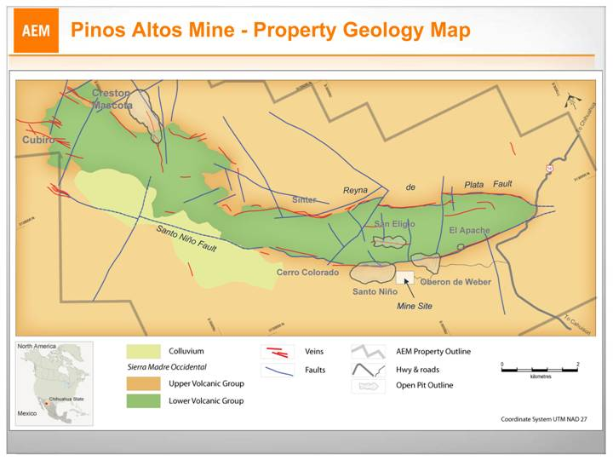

The Company has completed 34 drill holes (11,952 metres) at Cubiro in 2010, following up 49 drill holes (11,856 metres) in 2009.  Significant recent results from this area are shown in the table below.  The drill hole pierce points can be seen on the composite longitudinal section for the Cubiro and Cubiro West vein zones.

6

Cubiro Deposit Composite Longitudinal Section

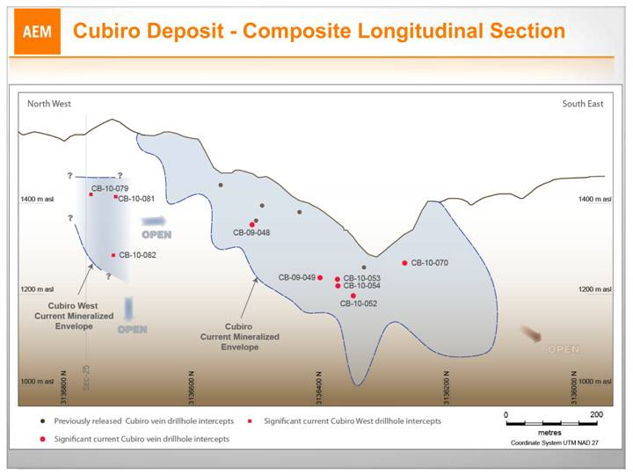

**Significant recent Cubiro vein area drill-hole intercepts**

|  |  |  |  |  |  |  |  |  |  |  |  |  |  |  |  |
| --- | --- | --- | --- | --- | --- | --- | --- | --- | --- | --- | --- | --- | --- | --- | --- |
| **Drill Hole** |  | **Location** |  | **Purpose** |  | **From (metres)** |  | **To (metres)** |  | **Estimated True Width (metres)** |  | **Gold (g/t) (Uncut)** |  | **Silver (g/t)** |  |
| CB-09-048 |  | Cubiro vein |  | exploration |  | 211.5 |  | 247.9 |  | 27.6 |  | 2.35 |  | 19.6 |  |
| CB-09-049 |  | Cubiro vein |  | exploration |  | 281.3 |  | 306.0 |  | 15.2 |  | 3.83 |  | 25.9 |  |
| including |  | Cubiro vein |  | exploration |  | 289.8 |  | 296.3 |  | 4.0 |  | 7.95 |  | 51.2 |  |
| CB-10-052 |  | Cubiro vein |  | exploration |  | 120.0 |  | 129.9 |  | 8.8 |  | 4.18 |  | 14.6 |  |
| CB-10-053 |  | Cubiro vein |  | exploration |  | 103.7 |  | 131.0 |  | 7.1 |  | 2.61 |  | 24.1 |  |
| CB-10-054 |  | Cubiro vein |  | exploration |  | 110.0 |  | 134.3 |  | 3.6 |  | 3.90 |  | 15.2 |  |
| CB-10-070 |  | Cubiro vein |  | exploration |  | 38.8 |  | 46.7 |  | 5.1 |  | 3.57 |  | 10.4 |  |

*These assay results are preliminary, pending routine check analyses*

Intersections from new drill holes such as CB-09-049 and -052 have confirmed that the grade is consistent in the main Cubiro gold-silver vein zone and that the thicknesses may allow for a bulk mining situation.

7

**New Gold Discovery at Cubiro West**

The newly discovered Cubiro West vein zone is roughly parallel to the Cubiro vein, but is located approximately 200 metres to the southwest.  This new zone dips steeply to the southwest, while the original Cubiro vein discovery dips steeply to the northeast.

Cubiro West Cross Section 25

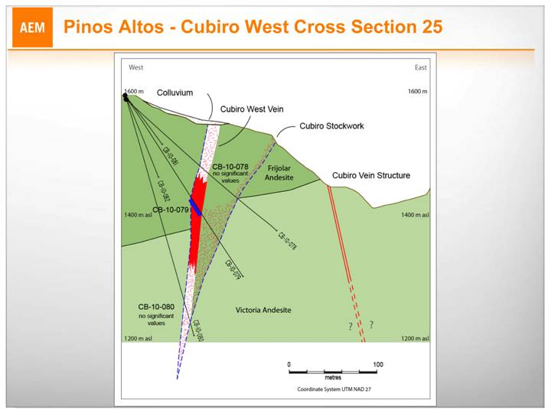

This new zone was discovered during step-out drilling from the main vein.  The best results to date are from drill hole CB-10-082 that intersected an estimated true thickness of 10.3 metres grading 4.26 g/t gold, and CB-10-079, which yielded 18.2 metres grading 3.47 g/t gold closely followed by 7.7 metres grading 2.36 g/t gold.  Drilling is underway with one portable rig, and a second drill rig will soon be added to determine the extensions of the mineralization.

|  |  |  |  |  |  |  |  |  |  |  |  |  |  |  |  |
| --- | --- | --- | --- | --- | --- | --- | --- | --- | --- | --- | --- | --- | --- | --- | --- |
| **Drill Hole** |  | **Location** |  | **Purpose** |  | **From (metres)** |  | **To (metres)** |  | **Estimated True Width (metres)** |  | **Gold (g/t) (Uncut)** |  | **Silver (g/t)** |  |
| CB-10-079 |  | Cubiro West vein |  | exploration |  | 200.0 |  | 228.5 |  | 18.2 |  | 3.47 |  | 23.5 |  |
| And |  | Cubiro West vein |  | exploration |  | 237.5 |  | 249.5 |  | 7.7 |  | 2.36 |  | 6.4 |  |
| And |  | Cubiro West vein |  | exploration |  | 267.4 |  | 270.7 |  | 2.1 |  | 2.81 |  | 12.6 |  |
| CB-10-081 |  | Cubiro West vein |  | exploration |  | 236.1 |  | 246.0 |  | 6.6 |  | 2.21 |  | 13.3 |  |
| including |  | Cubiro West vein |  | exploration |  | 237.1 |  | 243.3 |  | 4.1 |  | 8.34 |  | 26.5 |  |
| CB-10-082 |  | Cubiro West vein |  | exploration |  | 320.5 |  | 339.0 |  | 10.3 |  | 4.26 |  | 5.0 |  |
| including |  | Cubiro West vein |  | exploration |  | 320.5 |  | 328.5 |  | 4.5 |  | 9.07 |  | 9.3 |  |

*These assay results are preliminary, pending routine check analyses.*

It is anticipated that Cubiro and Cubiro West could eventually be mined as a satellite deposit of Pinos Altos.  A study contemplating the mining method and processing preference is expected to begin in 2011.  These discoveries also suggest the possibility of finding other en-echelon vein zones in this region.

8

**Meliadine  Major Program Preparing for Feasibility Work**

On July 6, 2010, Agnico-Eagle acquired the Meliadine advanced gold project, located approximately 25 kilometres from Rankin Inlet in Nunavut, Canada.  Details of the acquisition and the Meliadine mineral resources are contained in Company news releases dated July 6 and July 28, 2010.

The goal of the current exploration program is to bring the project through to the completion of a feasibility study in 2013.  A $130 million budget over the next two and a half years was approved in July 2010, including 200 kilometres of exploration and infill drilling, an underground bulk sample, construction of a permanent road and a permanent, all-season camp.  The six-month road construction period will begin when permits are received, which is expected in the second half of 2011.  The Company expects to proceed with permitting, while completing the feasibility study.

Meliadine Project Geology Map

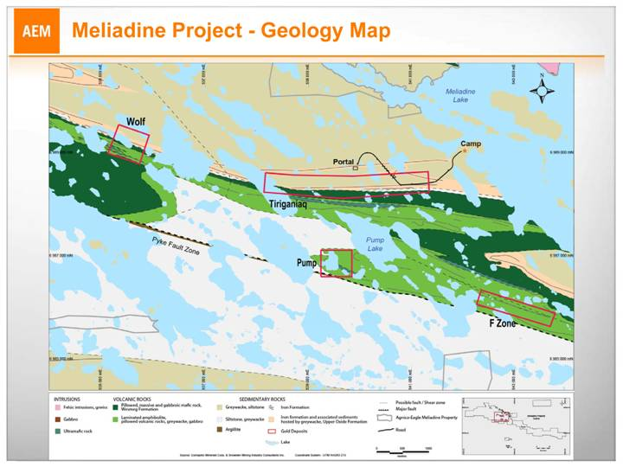

9

The $26 million budget for the remainder of 2010 involves approximately 25,000 metres of drilling, as well as mobilizing equipment for the extension of two underground sublevels which represent the bulk sample program.  A new trailer camp that is able to accommodate 100 people has been purchased for Meliadine and is expected to arrive in Rankin Inlet during the next few months.  Diamond drilling this year began in March, and through the end of July totalled approximately 20,000 metres.  The drilling program included 47 geotechnical drill holes and 44 conversion drill holes at each of Tiriganiaq and F zone.

**High Grade Tiriganiaq Zone Continues to Grow**

The main Tiriganiaq zone at Meliadine contains a series of sub-parallel gold zones.  The deposit is characterized by the occurrence of coarse visible gold and numerous anomalously high gold grades being returned in diamond drilling results over the past several years. This characteristic makes sampling and local grade estimation very challenging and will be one of the objects of the current work program.

As shown in the following linked longitudinal and cross sections, the deposit is open on strike and at depth.

Tiriganiaq Longitudinal Section

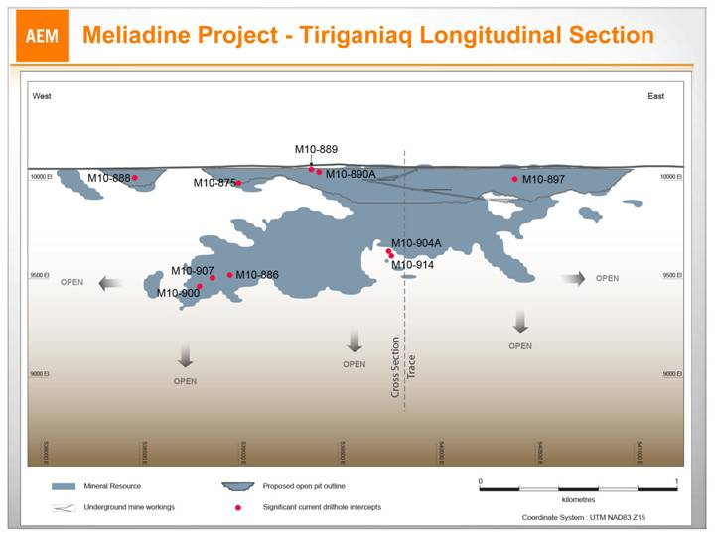

10

Tiriganiaq Zone Cross Section

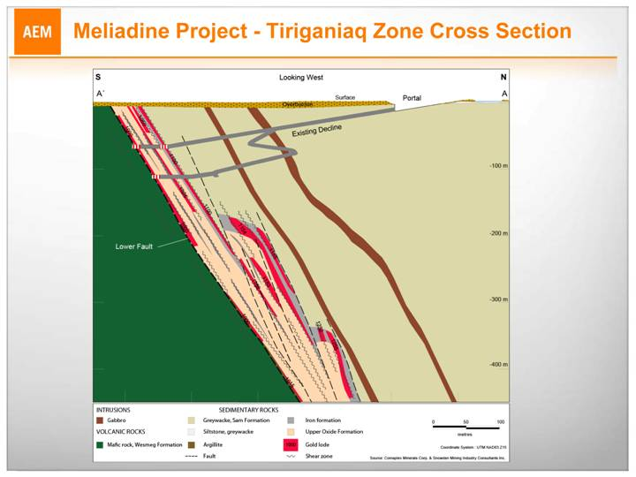

**Significant Tiriganiaq 2010 drill results**

|  |  |  |  |  |  |  |  |  |  |  |  |  |  |  |  |
| --- | --- | --- | --- | --- | --- | --- | --- | --- | --- | --- | --- | --- | --- | --- | --- |
| **Drill Hole** |  | **Zone** |  | **Lode** |  | **Purpose** |  | **From (metres)** |  | **To (metres)** |  | **Estimated True Width (metres)** |  | **Gold (g/t) (Uncut)** |  |
| M-10-875 |  | Tiriganiaq |  | 1100 |  | conversion |  | 92.7 |  | 98.4 |  | 5.4 |  | 4.50 |  |
| M-10-886 |  | Tiriganiaq |  |  |  | conversion |  | 551.0 |  | 558.5 |  | 6.5 |  | 4.29 |  |
| M-10-888 |  | Tiriganiaq |  | 1000 |  | conversion |  | 68.6 |  | 73.4 |  | 4.6 |  | 11.09 |  |
| M-10-889 |  | Tiriganiaq |  | 1000 |  | conversion |  | 28.5 |  | 36.6 |  | 7.8 |  | 24.90 |  |
| M-10-890A |  | Tiriganiaq |  | 1050/1025/1000 |  | conversion |  | 29.3 |  | 50.4 |  | 20.4 |  | 7.89 |  |
| M-10-897 |  | Tiriganiaq |  | 1075 |  | conversion |  | 16.8 |  | 23.0 |  | 5.9 |  | 5.92 |  |
| M-10-900 |  | Tiriganiaq |  | 1015 |  | conversion |  | 630.4 |  | 648.6 |  | 16.8 |  | 7.01 |  |
| M-10-904A |  | Tiriganiaq |  | 1153 |  | conversion |  | 429.4 |  | 437.1 |  | 6.5 |  | 12.14 |  |
| M-10-907 |  | Tiriganiaq |  | 1153 |  | conversion |  | 541.7 |  | 548.9 |  | 5.5 |  | 5.30 |  |
| M-10-914 |  | Tiriganiaq |  | 1100 |  | conversion |  | 464.5 |  | 467.7 |  | 3.0 |  | 7.77 |  |

Infill drilling at Tiriganiaq returned high grade results from outside the current resource envelope in shallow depths.  Examples of these intercepts are drill hole M-10-889 that yielded 24.9 g/t gold over 7.8 metres, M-10-890A that yielded 7.9 g/t gold over 20.4 metres, as well as M-10-875.  These three holes show the potential to extend the mineralization to the west and increase the size of the planned Tiriganiaq open pit.

There were also high-grade intercepts at depth, such as drill holes M-10-886, 904A, -907, -914 and drill hole M10-900, which returned 7.0 g/t gold over 17 metres at about 570 metres below surface.

11

**Early Results from Nearby F Zone**

Early results from the F zone drilling suggest that there is considerable potential outside the current resource envelope.  The F zone may have both open pit and underground mining potential as well.  Drill holes M-10-910, -911, -912 and -913 returned high grades at shallow depths, while holes M-10-901, -915 and -917 showed strong grade and width as deep as 125 metres below surface.  The exploration program is still underway.

Meliadine F Zone Longitudinal Section

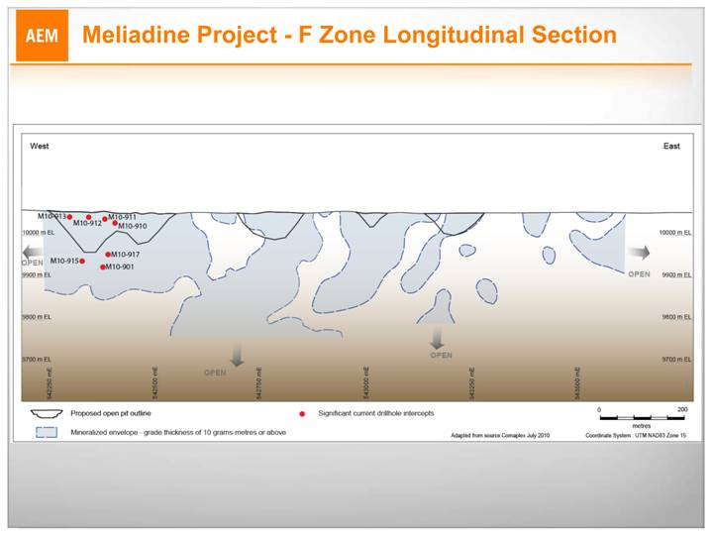

|  |  |  |  |  |  |  |  |  |  |  |  |  |  |
| --- | --- | --- | --- | --- | --- | --- | --- | --- | --- | --- | --- | --- | --- |
| **Drill Hole** |  | **Zone** |  | **Purpose** |  | **From (metres)** |  | **To (metres)** |  | **Estimated True Width (metres)** |  | **Gold (g/t) (Uncut)** |  |
| M-10-901* |  | F zone |  | conversion |  | 164.6 |  | 176.4 |  | 11.4 |  | 6.62 |  |
| And |  | F zone |  | conversion |  | 189.2 |  | 194.4 |  | 5.0 |  | 4.80 |  |
| And |  | F zone |  | conversion |  | 200.4 |  | 204.2 |  | 3.7 |  | 6.97 |  |
| M-10-910* |  | F zone |  | conversion |  | 22.4 |  | 26.4 |  | 3.7 |  | 8.24 |  |
| And |  | F zone |  | conversion |  | 57.0 |  | 60.0 |  | 2.8 |  | 4.61 |  |
| M-10-911* |  | F zone |  | conversion |  | 9.2 |  | 18.0 |  | 8.2 |  | 6.32 |  |
| And |  | F zone |  | conversion |  | 35.0 |  | 38.8 |  | 3.6 |  | 6.44 |  |
| M-10-912* |  | F zone |  | conversion |  | 17.2 |  | 39.4 |  | 21.8 |  | 4.58 |  |
| M-10-913* |  | F zone |  | conversion |  | 12.7 |  | 15.6 |  | 2.8 |  | 11.44 |  |
| M-10-915* |  | F zone |  | conversion |  | 152.5 |  | 158.8 |  | 6.2 |  | 4.12 |  |
| M-10-917* |  | F zone |  | conversion |  | 138.0 |  | 149.2 |  | 11.0 |  | 4.2 |  |

*\* Preliminary results from F zone pending routine check assays.*

These, and future results, will be considered in the eventual feasibility study at Meliadine.

12

**Abitibi Update  Goldex and Lapa Begin Deep Underground Programs**

**Deeper Drilling at Goldex Yields Intriguingly Familiar Mineralization**

The objectives of the 2010 diamond drill program at the Goldex mine were to convert the inferred resources to reserves in the E zone (the eastern extremity of the GEZ zone, which is currently being mined), to explore the eastern and western extensions of the GEZ zone as well as at depth (the D zone), and to investigate the potential above the M zone.  Through the end of July, 18,835 metres had been drilled of the planned 28,206 metre Goldex program for 2010.

The E zone is undergoing conversion drilling on a 30-metre grid pattern to determine if the current mine workings could extend eastward.  It is expected that 3,000 metres of underground diamond drilling will be done from the level 84 exploration drift before the end of 2010, as well as 4,000 metres from surface to verify the gold potential above the E zone.

Three drill rigs are working to define and extend resources in the deeper D zone.  This zone is located approximately 150 metres below the mine workings of the GEZ zone, and was originally discovered in the mid-1990s.  The most recent results are shown in the table below, and the drill hole pierce points are shown on the Goldex longitudinal section.

The long intercepts being returned, such as 161 metres of core length grading 2.0 g/t gold in drill hole 84-051, are reminiscent of those from the GEZ zone above (1.6 million ounce gold reserve).  Because the geometry of D zone is not yet fully defined, true widths could not be estimated.

Goldex Longitudinal Section

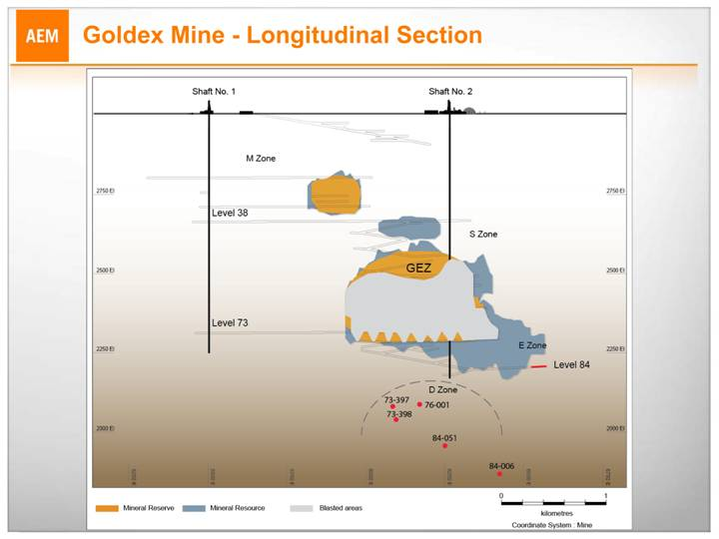

**Significant Goldex 2010 drill results**

|  |  |  |  |  |  |  |  |  |  |  |  |  |  |  |  |
| --- | --- | --- | --- | --- | --- | --- | --- | --- | --- | --- | --- | --- | --- | --- | --- |
| **Drill Hole** |  | **Zone** |  | **Purpose** |  | **Depth (metres)** |  | **From (metres)** |  | **To (metres)** |  | **Core length* (metres)** |  | **Gold (g/t) (Uncut)** |  |
| 73-397 |  | D zone |  | exploration |  | 641.0 |  | 430.5 |  | 559.5 |  | 129.0 |  | 1.28 |  |
| 73-398 |  | D zone |  | exploration |  | 621.0 |  | 436.5 |  | 589.5 |  | 153.0 |  | 1.10 |  |
| 76-001 |  | D zone |  | exploration |  | 534.0 |  | 334.5 |  | 429.0 |  | 94.5 |  | 2.02 |  |
| 84-006 |  | D zone |  | exploration |  | 556.5 |  | 412.5 |  | 423.0 |  | 10.5 |  | 1.48 |  |
| 84-051 |  | D zone |  | exploration |  | 504.0 |  | 325.5 |  | 486.0 |  | 160.5 |  | 2.04 |  |

\**Cannot determine true width yet, as the geometry of the D zone not yet understood.*

This zone remains open in all directions and at depth.  Further drilling is scheduled for 2010 and a mining study is expected to be initiated in 2011.

13

**Acquires 51% of Adventure Golds Dubuisson Property Near Goldex**

In July 2010, the Company signed an agreement with Adventure Gold Inc. acquiring a 51% interest in the 745 hectare Dubuisson property, immediately west of the Goldex mine property.  The Dubuisson property straddles the Cadillac - Larder Lake fault and includes a known gold deposit.

Dubuisson Property Location

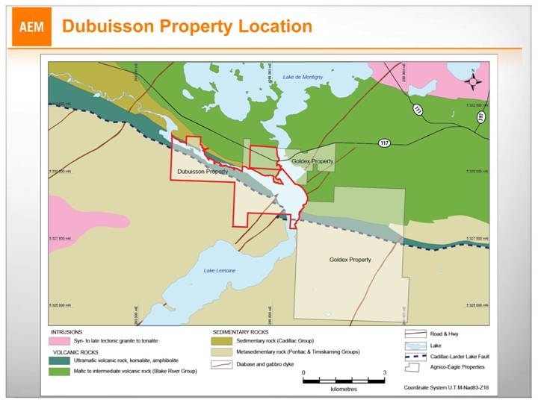

The gold system locally exceeds 20 metres in thickness and can be traced for more than 800 metres along strike.  This new property holds promise for ore potential in close proximity to the Goldex property.

14

**Lapa Underground Exploration Underway**

There are two exploration programs underway at the Lapa mine, using deep exploration drifts to expand and convert mineralization to the east of the current mine workings.  The two exploration drifts can be seen in the Lapa longitudinal section and plan map.

Lapa Longitudinal Section



15

Lapa Exploration Drifts

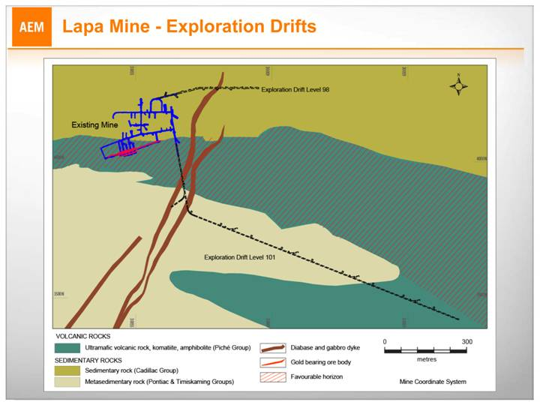

A three-year, $2.8-million project commenced earlier in 2010, driving a 970-metre-long tracked drift, approximately 1,010 metres below surface, to the east-southeast, following the southern contact of the Cadillac - Larder Lake fault zone.  This fault zone is the major structural control for gold deposits in the district.  This drift will provide an underground drill platform to test a favourable volcanic unit for mineralization.

A smaller, recently approved, exploration project involves driving a 385-metre-long trackless drift, approximately 980 metres below surface, to the east into the footwall beneath the Cadillac - Larder Lake fault to convert an existing resource.  The drift will allow for 9,400 metres of conversion and exploration drilling, which should all be accomplished in 2011.

16

**Regional Exploration**

**Ellison Pilot Hole Intersects Westwood Zone**

Agnico-Eagle is conducting a deep drilling program on its Ellison property, immediately west of the Companys LaRonde and Bousquet properties, to determine if IAMGOLD Corporations Westwood gold zone crosses onto Ellison at depth.

Abitibi Regional Geology Map

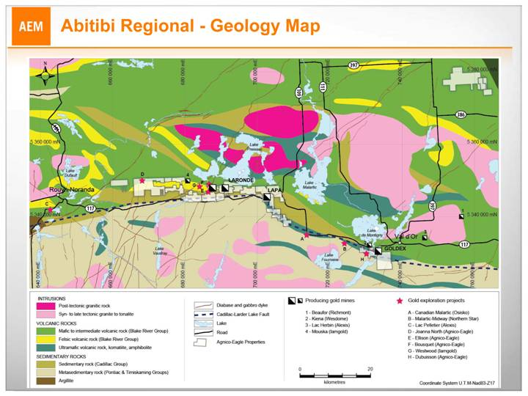

A 3,255-metre-long pilot drill hole was completed in early July 2010 at a vertical depth of 2,680 metres below surface.  Hole 114-10-16G, one of the deepest drill holes ever drilled in Quebec, returned more than 70 metres of mineralized core length (3,128 to 3,195 metres), confirming that both the Westwood zone and a new zone are present on the Ellison property.

The first, a LaRonde-style mineralized interval, returned 0.35 g/t gold and 0.34% copper over five metres.  The second mineralized interval is believed to represent the Westwood zone and returned 1.20 g/t gold over 10.5 metres, including 2.90 g/t gold over 3.0 metres. There are plans for two branch holes to be wedged out from the pilot hole to further investigate the mineralization.

17

**Exploration Underway at Dieppe**

North of Agnico-Eagles Quebec mines, the Company has initiated an exploration program on its 100%-owned Dieppe Township property, located 145 kilometres north of Rouyn-Noranda, Quebec, and immediately west of the operating Casa Berardi gold mine.  The property covers more than ten kilometres along the Casa Berardi Gold Trend.  No exploration work had taken place on the Dieppe Township property since the late 1980s, and a large portion of it had only been tested down to approximately 100 metres below surface.

Dieppe Township Property Location

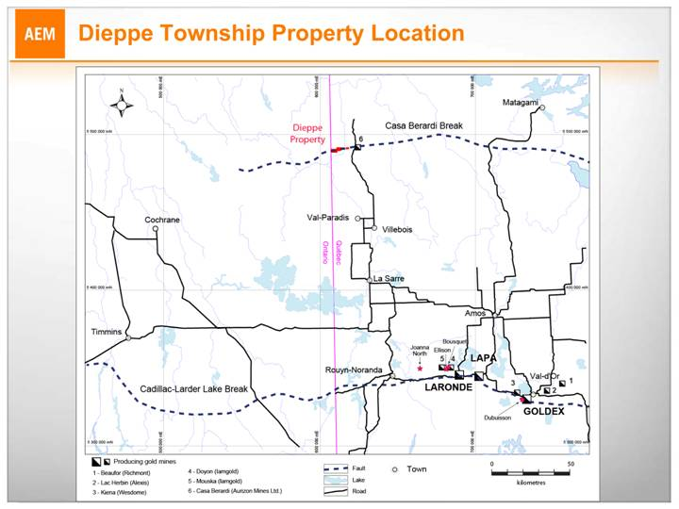

As part of the 2010 exploration program, fifteen drill holes were completed to date on the Dieppe Township property.  Most of them intersected the Casa Berardi Gold Trend and some have returned notable results.  The most promising results were from drill hole 157-10-10, which returned 2.90 g/t gold over 8.0 metres, including 5.10 g/t gold over 3.7 metres at a vertical depth of 150 metres.  Underneath this interval, drill hole 157-10-13 returned 1.00 g/t gold over 10.5 metres including 1.90 g/t gold over 4.5 metres at about 220 metres

18

vertical depth.  Closer to surface (30 metres vertical depth), another interval returned 26.80 g/t gold over 1.5 metres in a second structure with visible gold.  The 2011 winter drilling program is expected to follow up on these results.

**About Agnico-Eagle**

Agnico-Eagle is a long established Canadian gold producer with operations located in Canada, Finland and Mexico and exploration and development activities in Canada, Finland, Mexico and the United States.  Agnico-Eagles LaRonde mine is Canadas largest operating gold mine in terms of reserves.  The Company has full exposure to higher gold prices consistent with its policy of no forward gold sales.  It has declared a cash dividend for 28 consecutive years.  Agnico-Eagles registered office is located at 145 King Street East, Suite 400, Toronto, Ontario M5C 2Y7.

**Appendix: Selected Drill Results, Ellison and Dieppe Township Properties**

|  |  |  |  |  |  |  |  |  |  |  |  |  |  |  |  |  |  |  |  |
| --- | --- | --- | --- | --- | --- | --- | --- | --- | --- | --- | --- | --- | --- | --- | --- | --- | --- | --- | --- |
| **Property** |  | **Drill hole** |  | **East\*** |  | **North\*** |  | **Azimuth** |  | **Dip (degrees)** |  | **From (metres)** |  | **To (metres)** |  | **Core length (metres)** |  | **Gold (g/t) (Uncut)** |  |
| **Dieppe** |  | 157-10-10 |  | 608,110 |  | 5,488,879 |  | 335 |  | -62 |  | 226.0 |  | 234.0 |  | 8.0 |  | 2.90 |  |
|  |  | including |  |  |  |  |  |  |  |  |  | 228.3 |  | 232.0 |  | 3.7 |  | 5.10 |  |
| **Dieppe** |  | 157-10-13 |  | 608,094 |  | 5,488,758 |  | 5000 |  | -70.1 |  | 46.5 |  | 48.0 |  | 1.5 |  | 26.80 |  |
|  |  | and |  |  |  |  |  |  |  |  |  | 351.0 |  | 361.5 |  | 10.5 |  | 1.00 |  |
|  |  | including |  |  |  |  |  |  |  |  |  | 352.5 |  | 357.0 |  | 4.5 |  | 1.90 |  |
| **Ellison** |  | 114-09-16G |  | 685,994 |  | 5,345,495 |  | 347.1 |  | -86.9 |  | 3132.0 |  | 3137.0 |  | 5.0 |  | 0.35 |  |
|  |  | and |  |  |  |  |  |  |  |  |  | 3177.5 |  | 3188.0 |  | 10.5 |  | 1.20 |  |
|  |  | including |  |  |  |  |  |  |  |  |  | 3180.0 |  | 3183.0 |  | 3.0 |  | 2.90 |  |

*\* Drill hole collars on UTM Coordinate System NAD 83 Zone 17*

19

**Detailed Mineral Reserve and Resource Data (as at December 31, 2009) Including Meliadine Resources (as at January 2010)**

|  |  |  |  |  |  |  |  |  |  |  |  |  |  |  |  |
| --- | --- | --- | --- | --- | --- | --- | --- | --- | --- | --- | --- | --- | --- | --- | --- |
|  |  | **Au** |  | **Ag** |  | **Cu** |  | **Zn** |  | **Pb** |  | **Au** |  | **Tonnes** |  |
| **Category and Operation** |  | **(g/t)** |  | **(g/t)** |  | **(%)** |  | **(%)** |  | **(%)** |  | **(000s oz.)** |  | **(000s)** |  |
| *Proven Mineral Reserve* |  |  |  |  |  |  |  |  |  |  |  |  |  |  |  |
| Goldex (underground) |  | 2.02 |  |  |  |  |  |  |  |  |  | 339 |  | 5,217 |  |
| Kittila (open pit) |  | 3.71 |  |  |  |  |  |  |  |  |  | 30 |  | 255 |  |
| Kittila (underground) |  | 3.81 |  |  |  |  |  |  |  |  |  | 0 |  | 1 |  |
| **Kittila total proven** |  | **3.71** |  |  |  |  |  |  |  |  |  | **31** |  | **257** |  |
| Lapa (underground) |  | 8.33 |  |  |  |  |  |  |  |  |  | 240 |  | 897 |  |
| LaRonde (underground) |  | 2.34 |  | 61.95 |  | 0.26 |  | 3.31 |  | 0.39 |  | 358 |  | 4,755 |  |
| Meadowbank (open pit) |  | 4.57 |  |  |  |  |  |  |  |  |  | 88 |  | 600 |  |
| Pinos Altos (open pit) |  | 1.51 |  | 26.35 |  |  |  |  |  |  |  | 43 |  | 880 |  |
| *Subtotal Proven Mineral Reserve* |  | 2.71 |  |  |  |  |  |  |  |  |  | 1,098 |  | 12,605 |  |
|  |  |  |  |  |  |  |  |  |  |  |  |  |  |  |  |
| *Probable Mineral Reserve* |  |  |  |  |  |  |  |  |  |  |  |  |  |  |  |
| Goldex (underground) |  | 2.06 |  |  |  |  |  |  |  |  |  | 1,291 |  | 19,524 |  |
| Kittila (open pit) |  | 5.05 |  |  |  |  |  |  |  |  |  | 496 |  | 3,053 |  |
| Kittila (underground) |  | 4.80 |  |  |  |  |  |  |  |  |  | 3,499 |  | 22,651 |  |
| **Kittila total probable** |  | **4.83** |  |  |  |  |  |  |  |  |  | **3,994** |  | **25,704** |  |
| Lapa (underground) |  | 8.09 |  |  |  |  |  |  |  |  |  | 603 |  | 2,319 |  |
| LaRonde (underground) |  | 4.72 |  | 27.89 |  | 0.29 |  | 1.16 |  | 0.09 |  | 4,492 |  | 29,625 |  |
| Meadowbank (open pit) |  | 3.51 |  |  |  |  |  |  |  |  |  | 3,567 |  | 31,600 |  |
| Pinos Altos (open pit) |  | 2.05 |  | 49.30 |  |  |  |  |  |  |  | 1,195 |  | 18,101 |  |
| Pinos Altos (underground) |  | 2.92 |  | 86.87 |  |  |  |  |  |  |  | 2,158 |  | 22,979 |  |
| **Pinos Altos total probable** |  | **2.54** |  | **70.31** |  |  |  |  |  |  |  | **3,353** |  | **41,080** |  |
| *Subtotal Probable Mineral Reserve* |  | *3.59* |  |  |  |  |  |  |  |  |  | *17,300* |  | *149,852* |  |
| **Total Proven and Probable Mineral Reserves** |  | **3.52** |  |  |  |  |  |  |  |  |  | **18,398** |  | **162,458** |  |

|  |  |  |  |  |  |  |  |  |  |  |  |  |  |
| --- | --- | --- | --- | --- | --- | --- | --- | --- | --- | --- | --- | --- | --- |
|  |  | **Au** |  | **Ag** |  | **Cu** |  | **Zn** |  | **Pb** |  | **Tonnes** |  |
| **Category and Operation** |  | **(g/t)** |  | **(g/t)** |  | **(%)** |  | **(%)** |  | **(%)** |  | **(000s)** |  |
| *Measured Mineral Resource* |  |  |  |  |  |  |  |  |  |  |  |  |  |
| Meliadine (open pit) |  | 8.4 |  |  |  |  |  |  |  |  |  | 180 |  |
| Meliadine (underground) |  | 14.0 |  |  |  |  |  |  |  |  |  | 115 |  |
| **Total Measured Resource** |  | **10.6** |  |  |  |  |  |  |  |  |  | **295** |  |

|  |  |  |  |  |  |  |  |  |  |  |  |  |  |
| --- | --- | --- | --- | --- | --- | --- | --- | --- | --- | --- | --- | --- | --- |
|  |  | **Au** |  | **Ag** |  | **Cu** |  | **Zn** |  | **Pb** |  | **Tonnes** |  |
| **Category and Operation** |  | **(g/t)** |  | **(g/t)** |  | **(%)** |  | **(%)** |  | **(%)** |  | **(000s)** |  |
| *Indicated Mineral Resource* |  |  |  |  |  |  |  |  |  |  |  |  |  |
| Bousquet (underground) |  | 5.63 |  |  |  |  |  |  |  |  |  | 1,704 |  |
| Ellison (underground) |  | 5.68 |  |  |  |  |  |  |  |  |  | 415 |  |
| Goldex (underground) |  | 1.79 |  |  |  |  |  |  |  |  |  | 220 |  |
| Kittila (underground) |  | 2.19 |  |  |  |  |  |  |  |  |  | 20,550 |  |
| Lapa (underground) |  | 4.63 |  |  |  |  |  |  |  |  |  | 1,672 |  |
| LaRonde (underground) |  | 1.85 |  | 24.94 |  | 0.13 |  | 1.52 |  | 0.15 |  | 6,482 |  |
| Meadowbank (open pit) |  | 2.34 |  |  |  |  |  |  |  |  |  | 40,981 |  |
| Meadowbank (underground) |  | 5.23 |  |  |  |  |  |  |  |  |  | 1,388 |  |
| **Meadowbank total indicated** |  | **2.43** |  |  |  |  |  |  |  |  |  | **42,369** |  |
| Meliadine (open pit) |  | 5.4 |  |  |  |  |  |  |  |  |  | 5,917 |  |
| Meliadine (underground) |  | 10.0 |  |  |  |  |  |  |  |  |  | 6,735 |  |
| **Meliadine total indicated** |  | **7.9** |  |  |  |  |  |  |  |  |  | **12,652** |  |
| Pinos Altos (open pit) |  | 0.67 |  | 8.30 |  |  |  |  |  |  |  | 6,990 |  |
| Pinos Altos (underground) |  | 1.11 |  | 41.78 |  |  |  |  |  |  |  | 8,679 |  |
| **Pinos Altos total indicated** |  | **0.91** |  | **26.84** |  |  |  |  |  |  |  | **15,668** |  |
| Swanson (open pit) |  | 1.93 |  |  |  |  |  |  |  |  |  | 504 |  |
| **Total Indicated Resource** |  | **2.88** |  |  |  |  |  |  |  |  |  | **102,236** |  |

20

|  |  |  |  |  |  |  |  |  |  |  |  |  |  |
| --- | --- | --- | --- | --- | --- | --- | --- | --- | --- | --- | --- | --- | --- |
|  |  | **Au** |  | **Ag** |  | **Cu** |  | **Zn** |  | **Pb** |  | **Tonnes** |  |
| **Category and Operation** |  | **(g/t)** |  | **(g/t)** |  | **(%)** |  | **(%)** |  | **(%)** |  | **(000s)** |  |
| *Inferred Mineral Resource* |  |  |  |  |  |  |  |  |  |  |  |  |  |
| Bousquet (underground) |  | 7.45 |  |  |  |  |  |  |  |  |  | 1,667 |  |
| Ellison (underground) |  | 5.81 |  |  |  |  |  |  |  |  |  | 786 |  |
| Goldex (underground) |  | 2.37 |  |  |  |  |  |  |  |  |  | 10,540 |  |
| Kittila (underground) |  | 3.42 |  |  |  |  |  |  |  |  |  | 5,350 |  |
| Kylmäkangas, Finland (underground) |  | 4.07 |  |  |  |  |  |  |  |  |  | 1,924 |  |
| Lapa (underground) |  | 7.90 |  |  |  |  |  |  |  |  |  | 393 |  |
| LaRonde (underground) |  | 3.93 |  | 11.34 |  | 0.27 |  | 0.43 |  | 0.04 |  | 10,942 |  |
| Meadowbank (open pit) |  | 2.54 |  |  |  |  |  |  |  |  |  | 9,166 |  |
| Meadowbank (underground) |  | 6.12 |  |  |  |  |  |  |  |  |  | 16 |  |
| **Meadowbank total inferred** |  | **2.54** |  |  |  |  |  |  |  |  |  | **9,182** |  |
| Meliadine (open pit) |  | 4.0 |  |  |  |  |  |  |  |  |  | 3,397 |  |
| Meliadine (underground) |  | 8.1 |  |  |  |  |  |  |  |  |  | 4,991 |  |
| **Meliadine total inferred** |  | **6.4** |  |  |  |  |  |  |  |  |  | **8,388** |  |
| Pinos Altos (open pit) |  | 1.02 |  | 15.33 |  |  |  |  |  |  |  | 11,655 |  |
| Pinos Altos (underground) |  | 2.42 |  | 43.41 |  |  |  |  |  |  |  | 4,018 |  |
| **Pinos Altos total inferred** |  | **1.38** |  | **22.53** |  |  |  |  |  |  |  | **15,673** |  |
| **Total Inferred Resource** |  | **3.29** |  |  |  |  |  |  |  |  |  | **64,845** |  |

Tonnage amounts and contained metal amounts presented in this table have been rounded to the nearest thousand. Reserves are not a sub-set of resources.

**Forward-Looking Statements**

The information in this news release has been prepared as at September 8, 2010. Certain statements contained in this press release constitute forward-looking statements within the meaning of the United States Private Securities Litigation Reform Act of 1995 and forward looking information under the provisions of Canadian provincial securities laws and are referred to herein as forward-looking statements. When used in this document, words such as anticipate, expect, estimate, forecast, planned, will, likely, schedule and similar expressions are intended to identify forward-looking statements.

Such statements include without limitation: the Companys forward-looking production guidance, including estimated ore grades, project timelines, drilling results, orebody configurations, metal production, life of mine horizons, commencement of production estimates, the estimated timing of scoping studies, recovery rates, mill throughput, and

21

projected exploration and capital expenditures, including costs and other estimates upon which such projections are based; the Companys goal to increase its mineral reserves and resources; and other statements and information regarding anticipated trends with respect to the Companys operations, exploration and the funding thereof. Such statements reflect the Companys views as at the date of this press release and are subject to certain risks, uncertainties and assumptions. Forward-looking statements are necessarily based upon a number of factors and assumptions that, while considered reasonable by Agnico-Eagle as of the date of such statements, are inherently subject to significant business, economic and competitive uncertainties and contingencies. The factors and assumptions of Agnico-Eagle contained in this news release, which may prove to be incorrect, include, but are not limited to, the assumptions set forth herein and in managements discussion and analysis and the Companys Annual Report on Form 20-F for the year ended December 31, 2009 (Form 20-F) as well as: that there are no significant disruptions affecting operations, whether due to labour disruptions, supply disruptions, damage to equipment, natural occurrences, political changes, title issues or otherwise; that permitting, production and expansion at each of Agnico-Eagles mines and growth projects proceeds on a basis consistent with current expectations, and that Agnico-Eagle does not change its plans relating to such projects; that the exchange rate between the Canadian dollar, European Union euro, Mexican peso and the United  States dollar will be approximately consistent with current levels or as set out in this news release; that prices for gold, silver, zinc, copper and lead will be consistent with Agnico-Eagles expectations; that prices for key mining and construction supplies, including labour costs, remain consistent with Agnico-Eagles current expectations; that Agnico-Eagles current estimates of mineral reserves, mineral resources, mineral grades and metal recovery are accurate; that there are no material delays in the timing for completion of ongoing growth projects; that the Companys current plans to optimize production are successful; and that there are no material variations in the current tax and regulatory environment.  Many factors, known and unknown, could cause the actual results to be materially different from those expressed or implied by such forward-looking statements. Such risks include, but are not limited to: the volatility of prices of gold and other metals; uncertainty of mineral reserves, mineral resources, mineral grades and metal recovery estimates; uncertainty of future production, capital expenditures, and other costs; currency fluctuations; financing of additional capital requirements; cost of exploration and development programs; mining risks; risks associated with foreign operations; governmental and environmental regulation; the volatility of the Companys stock price; and risks associated with the Companys byproduct metal derivative strategies. For a more detailed discussion of such risks and other factors, see the Form 20-F, as well as the Companys other filings with the Canadian Securities Administrators and the U.S. Securities and Exchange Commission (the SEC). The Company does not intend, and does not assume any obligation, to update these forward-looking statements and information, except as required by law. Accordingly, readers are advised not to place undue reliance on forward-looking statements. Certain of the foregoing statements, primarily related to projects, are based on preliminary views of the Company with respect to, among other things, grade, tonnage, processing, recoveries, mining methods, capital costs, total cash costs, minesite costs, and location of surface infrastructure.  Actual results and final decisions may be materially different from those currently anticipated.

22

**Notes to Investors Regarding the Use of Resources**

**Cautionary Note to Investors Concerning Estimates of Measured and Indicated Resources**

This news release uses the terms measured resources and indicated resources. We advise investors that while those terms are recognized and required by Canadian regulations, the SEC does not recognize them. **Investors are cautioned not to assume that any part or all of mineral deposits in these categories will ever be converted into reserves**.

**Cautionary Note to Investors Concerning Estimates of Inferred Resources**

This press release also uses the term inferred resources. We advise investors that while this term is recognized and required by Canadian regulations, the SEC does not recognize it. Inferred resources have a great amount of uncertainty as to their existence, and great uncertainty as to their economic and legal feasibility. It cannot be assumed that all or any part of an inferred mineral resource will ever be upgraded to a higher category. Under Canadian rules, estimates of inferred mineral resources may not form the basis of feasibility or pre-feasibility studies, except in rare cases. **Investors are cautioned not to assume that part or all of an inferred resource exists, or is economically or legally mineable.**

**Scientific and Technical Data**

Agnico-Eagle Mines Limited is reporting mineral resource and reserve estimates in accordance with the CIM guidelines for the estimation, classification and reporting of resources and reserves.

**Cautionary Note To U.S. Investors** **-** The SEC permits U.S. mining companies, in their filings with the SEC, to disclose only those mineral deposits that a company can economically and legally extract or produce. Agnico-Eagle uses certain terms in this press release, such as measured, indicated, and inferred, and resources that the SEC guidelines strictly prohibit U.S. registered companies from including in their filings with the SEC. U.S. investors are urged to consider closely the disclosure in our Form 20-F, which may be obtained from us, or from the SECs website at: http://sec.gov/edgar.shtml.  A final or bankable feasibility study is required to meet the requirements to designate reserves under Industry Guide 7.  Estimates for all properties other than Meliadine were calculated using historic three-year average metals prices and foreign exchange rates in accordance with the SEC Industry Guide 7.  Industry Guide 7 requires the use of prices that reflect current economic conditions at the time of reserve determination, which the Staff of the SEC has interpreted to mean historic three-year average prices.  The assumptions used for the mineral reserves and resources estimates reported by the Company on February 17, 2010 were based on three-year average prices for the period ending December 31, 2009 of $848 per ounce gold, $14.35 per ounce silver, $1.03 per pound zinc, $2.91 per pound copper, $0.97 per pound lead and C$/US$, US$/Euro and MXP/US$ exchange rates of 1.09, 1.41 and 11.85, respectively.

23

The Meliadine mineral resource estimates used various cutoff gold grades. The cutoff grade for most of Meliadines open pit resources is 2.5 g/t gold, and 5.5 g/t gold for the underground resources. Higher cutoff gold grades were chosen for the Discovery deposit (3.0 g/t for open pit and 6.0 g/t for underground) to compensate for greater transportation costs to the proposed mill site near the Tiriganiaq deposit. Please consult the February 2010 technical report, which is available on SEDAR.com under Comaplex Minerals Corp., for further details about the Meliadine mineral resources.

The Canadian Securities Administrators National Instrument 43-101 (NI 43-101) requires mining companies to disclose reserves and resources using the subcategories of proven reserves, probable reserves, measured resources, indicated resources and inferred resources. Mineral resources that are not mineral reserves do not have demonstrated economic viability.

A mineral reserve is the economically mineable part of a measured or indicated resource demonstrated by at least a preliminary feasibility study. This study must include adequate information on mining, processing, metallurgical, economic and other relevant factors that demonstrate, at the time of reporting, that economic extraction can be justified. A mineral reserve includes diluting materials and allows for losses that may occur when the material is mined. A proven mineral reserve is the economically mineable part of a measured resource for which quantity, grade or quality, densities, shape and physical characteristics are so well established that they can be estimated with confidence sufficient to allow the appropriate application of technical and economic parameters, to support production planning and evaluation of the economic viability of the deposit. A probable mineral reserve is the economically mineable part of an indicated mineral resource for which quantity, grade or quality, densities, shape and physical characteristics can be estimated with a level of confidence sufficient to allow the appropriate application of technical and economic parameters, to support mine planning and evaluation of the economic viability of the deposit.

A mineral resource is a concentration or occurrence of natural, solid, inorganic or fossilized organic material in or on the Earths crust in such form and quantity and of such a grade or quality that it has reasonable prospects for economic extraction. The location, quantity, grade, geological characteristics and continuity of a mineral resource are known, estimated or interpreted from specific geological evidence and knowledge. A measured mineral resource is that part of a mineral resource for which quantity, grade or quality, densities, shape and physical characteristics can be estimated with a level of confidence sufficient to allow the appropriate application of technical and economic parameters, to support mine planning and evaluation of the economic viability of the deposit. The estimate is based on detailed and reliable exploration, sampling and testing information gathered through appropriate techniques from locations such as outcrops, trenches, pits, workings and drill holes that are spaced closely enough to confirm both geological and grade continuity. An indicated mineral resource is that part of a mineral resource for which quantity, grade or quality, densities, shape and physical characteristics can be estimated with a level of confidence sufficient to allow the appropriate application of technical and economic parameters, to support mine planning and evaluation of the economic viability of the deposit. The estimate is based on detailed and reliable exploration and testing information gathered through appropriate techniques from locations such as outcrops, trenches, pits,

24

workings and drill holes that are spaced closely enough for geological and grade continuity to be reasonably assumed. An inferred mineral resource is that part of a mineral resource for which quantity and grade or quality can be estimated on the basis of geological evidence and limited sampling and reasonably assumed, but not verified, geological and grade continuity. The estimate is based on limited information and sampling gathered through appropriate techniques from locations such as outcrops, trenches, pits, workings and drill holes. Mineral resources which are not mineral reserves do not have demonstrated economic viability.

**Investors are cautioned not to assume that part or all of an inferred resource exists, or is economically or legally mineable.**

A feasibility study is a comprehensive study of a mineral deposit in which all geological, engineering, legal, operating, economic, social, environmental and other relevant factors are considered in sufficient detail that it could reasonably serve as the basis for a final decision by a financial institution to finance the development of the deposit for mineral production.

The mineral reserves presented in this disclosure are separate from and not a portion of the mineral resources.

|  |  |  |  |  |  |  |  |
| --- | --- | --- | --- | --- | --- | --- | --- |
| **Property/Project name and location** |  | **Qualified Person responsible for the current Mineral Resource and Reserve Estimate and relationship to Agnico-Eagle** |  | **Qualified Person responsible for Exploration and relationship to Agnico-Eagle** |  | **Date of most recent Technical Report (NI 43-101) filed on SEDAR** |  |
| LaRonde, Bousquet & Ellison, Quebec, Canada |  | François Blanchet Ing., LaRonde Division Superintendent of geology |  |  |  | March 23, 2005 |  |
| Kittila and Kylmakangas, Finland |  | Daniel Doucet, Ing., Corporate Director of Geology |  | Marc Legault P.Eng., VP Project Development |  | March 4, 2010 |  |
| Pinos Altos, Chihuahua, Mexico. Swanson, Quebec, Canada |  | Dyane Duquette, P.Geo., Principal geologist, Abitibi Technical Services Group |  | Mine site: Dyane Duquette, P.Geo.; Regional: Roger Doucet, P.Geo., Exploration manager for Mexico |  | March 25, 2009 |  |
| Meadowbank, Nunavut, Canada |  | Open Pit:  Bruno Perron Ing., Meadowbank Superintendent of geology  Underground:  Dyane Duquette, P.Geo., Principal geologist, Abitibi Technical Services Group |  | Mine site: Bruno Perron Ing., Meadowbank Division Superintendent of geology; Regional: Guy Gosselin Ing., Exploration manager for Canada |  | December 15, 2008 |  |

25

|  |  |  |  |  |  |  |  |
| --- | --- | --- | --- | --- | --- | --- | --- |
| Goldex, Quebec, Canada |  | Richard Genest, Ing., Goldex Division Superintendent of geology |  |  |  | October 27, 2005 |  |
| Lapa, Quebec, Canada |  | Normand Bédard, P.Geo., Lapa Division Superintendent of geology |  |  |  | June 8, 2006 |  |
| Meliadine, Nunavut, Canada |  | Pamela De Mark, P.Geo., Senior Consultant; George Gilchrist, Consultant; both with Snowden Mining Industry Consultants, Vancouver, BC. |  | Guy Gosselin Ing., Exploration manager for Canada |  | February 26, 2010 |  |

The effective date for all of the Companys mineral resource and reserve estimates in this press release is December 31, 2009, except for Meliadine, for which the effective date is January, 2010. No independent verification of the data has been published. Additional information about each of the mineral projects that is required by NI 43-101, sections 3.2 and 3.3 and paragraphs 3.4 (a), (c) and (d) can be found in the Technical Reports referred to above, which may be found at www.sedar.com. Other important operating information can be found in the Companys Form 20-F and its news release dated December 16, 2009.

The contents of this press release have been prepared under the supervision of, and reviewed by, Marc Legault P.Eng., Vice-President Project Development and a Qualified Person for the purposes of NI 43-101.

26