**SECURITIES AND EXCHANGE COMMISSION**

**Washington, DC 20549**

**FORM 6-K**

**REPORT OF FOREIGN PRIVATE ISSUER**

**PURSUANT TO RULE 13a-16 OR 15d-16 OF**

**THE SECURITIES EXCHANGE ACT OF 1934**

For the month of April 2006

**Agnico-Eagle Mines Limited**

(Translation of registrants name into English)

**145 King Street East, Suite 500, Toronto, Ontario  M5C 2Y7**

(Address of Principal Executive Offices)

Indicate by check mark whether the Registrant files or will file annual reports under cover of Form 20-F or   
Form 40-F

|  |  |  |
| --- | --- | --- |
| Form 20-F    x |  | Form 40-F    ☐ |

Indicate by check mark if the registrant is submitting the Form 6-K in paper as permitted by Regulation S-T  
Rule 101(b)(1): ______

Indicate by check mark if the registrant is submitting the Form 6-K in paper as permitted by Regulation S-T  
Rule 101(b)(7): ______

Indicate by check mark whether the registrant by furnishing the information contained in this form is also thereby furnishing the information to the Commission pursuant to Rule 12g3-2(b) under the Securities  
Exchange Act of 1934

|  |  |  |
| --- | --- | --- |
| Yes     ☐ |  | No     x |

(If Yes is marked, indicate below the file number assigned to the Registrant in connection with  
Rule 12g3-2(b): 82-______)

**EXHIBITS**

|  |  |  |
| --- | --- | --- |
| **Exhibit No.** |  | **Exhibit Description** |
| 1. |  | Annual Report to the Shareholders for the Fiscal Year Ended December 31, 2005 |

**SIGNATURE**

Pursuant to the requirements of the Securities Exchange Act of 1934, the registrant has duly caused this report to be signed on its behalf by the undersigned, thereunto duly authorized.

|  |  |  |  |
| --- | --- | --- | --- |
|  |  | **AGNICO-EAGLE MINES LIMITED** | |
|  |  |  | |
|  |  |  | |
| Date: April 6, 2006 |  | By: | /s/ R. Gregory Laing |
|  |  | Name: | R. Gregory  Laing |
|  |  | Title: | General Counsel, Vice President Legal and Corporate Secretary |

**AGNICO-EAGLE MINES LIMITED**

**ANNUAL REPORT 2005**

***The*** **NEW SYMBOL *for*** **GOLD**

**AGNICO-EAGLE MINES LIMITED**

*Annual Report 2005*

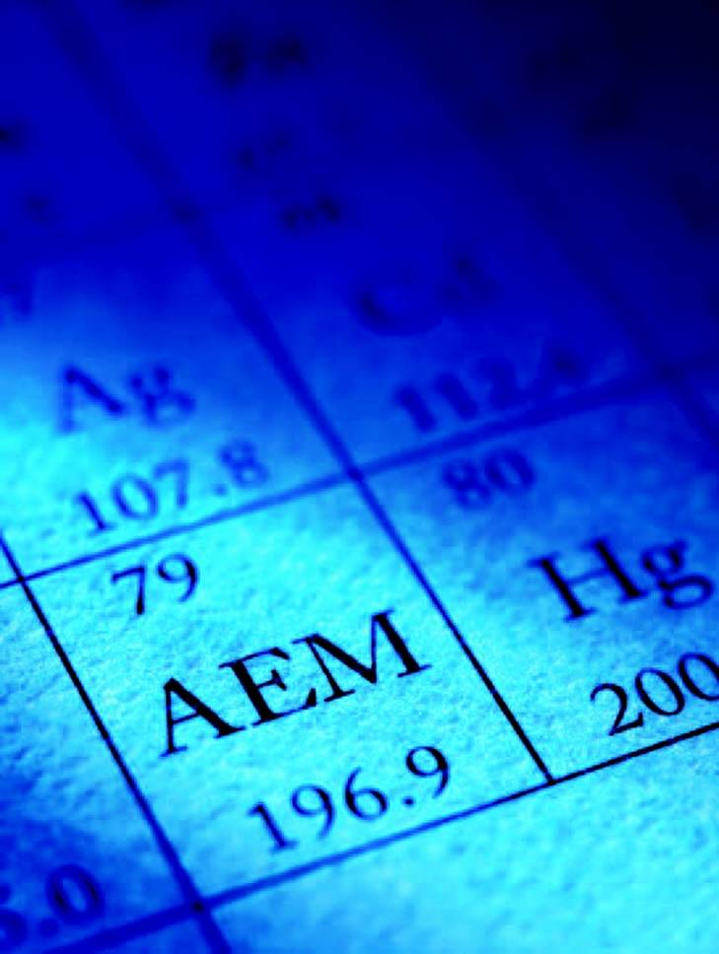

**2005 OVERVIEW**

Since its formation in 1972, Agnico-Eagle has produced more than 3.9 million ounces of gold. In the past five years, annual gold production at our flagship LaRonde mine has averaged approximately 250,000 ounces, and the mine is one of the lowest total cash cost producers in the industry. In 2005, we built on our strengths, maintaining solid operating performance while increasing gold reserves by 32%, beginning construction of our next gold mines, and accelerating our international expansion in Finland and Mexico.

|  |  |  |
| --- | --- | --- |
| **CASH PROVIDED BY OPERATING ACTIVITIES** |  | **GOLD RESERVES** |
| *(US$ millions)* |  | *( millions of ounces)* |
|  |  |  |
|  |  |  |

**HIGHLIGHTS**

|  |  |  |  |  |  |  |  |  |  |  |
| --- | --- | --- | --- | --- | --- | --- | --- | --- | --- | --- |
|  |  | **2005** | |  | **2004** | |  | **2003** | |  |
| **OPERATING** |  | 2.7 | |  | 2.7 | |  | 2.2 | |  |
| Ore production (millions of tonnes) |  | 241,807 | |  | 271,567 | |  | 236,653 | |  |
| Gold production (ounces) |  | $ | 43 |  | $ | 56 |  | $ | 269 |  |
| Total cash cost per ounce |  | $ | 449 |  | $ | 418 |  | $ | 368 |  |
| Average realized gold price |  | 10.4 | |  | 7.9 | |  | 7.9 | |  |
| Proven and probable gold reserves (millions of ounces) |  |  | |  |  | |  |  | |  |
|  |  |  | |  |  | |  |  | |  |
| **FINANCIAL** (millions except per share amounts) |  |  | |  |  | |  |  | |  |
| Revenue |  | $ | 241.3 |  | $ | 188.0 |  | $ | 126.8 |  |
| Net income |  | 37.0 | |  | 47.9 | |  | (19.5 | | ) |
| Net income per share |  | 0.42 | |  | 0.56 | |  | (0.23 | | ) |
| Cash provided by operating activities |  | 83.0 | |  | 49.5 | |  | 4.3 | |  |
| Dividends per share |  | $ | 0.03 |  | $ | 0.03 |  | $ | 0.03 |  |

*All dollar amounts are in US$ unless otherwise indicated.*

*All units of measurement are in metric unless otherwise noted.*

*Total cash cost per ounce is a non-GAAP measure. A reconciliation is included in the attached Form 20-F.*

*This document uses the terms measured resources, indicated resources and inferred resources. The U.S. Securities and Exchange Commission does not recognize them. A more detailed discussion is included in the attached Form 20-F.*

**AEM**

***The New Symbol for Gold***



On November 2, 2005, Agnico-Eagle adopted the symbol **AEM** for trading on the Toronto Stock Exchange, matching its New York Stock Exchange symbol. It is our hope and our belief that investors and analysts looking for growth and long-term value will soon recognize that AEM is the new symbol for gold.

**OUR FOUNDATION IS THE LARGEST GOLD DEPOSIT IN CANADA,** based on reserves, and before the decade is over we expect to have two more mines operating in the same gold-rich area. We also expect to establish mines outside of Canada. Within the next three years, our goal is to add significantly to our gold reserves, triple our gold production, and continue to **BUILD VALUE FOR OUR SHAREHOLDERS.**



*Agnico-Eagle Mines Limited*

**FELLOW SHAREHOLDERS:**

This is a very exciting time in Agnico-Eagles history. After more than three decades of building the company, and our reputation as an experienced mine developer and low-cost gold producer, Agnico-Eagle is poised to grow at an unprecedented rate.

Heres why investors interested in gold would do well to consider AEM  the new symbol for growth, value and gold:

Large growth pipeline

Agnico-Eagle enjoys an unparalleled reserve position among intermediate-sized gold companies. In 2005, gold reserves grew 32% to a record 10.4 million ounces. By 2009, our five growth projects are projected to triple our gold production.

International diversification

Agnico-Eagle now has large property positions in Canada, Mexico, Finland and the United States. All properties are in areas of low political risk with long-term mining camp potential, and several have near-term production prospects.

Quality business

Strong earnings and cash flows, low-cost production, a solid balance sheet, a stable and experienced mining team, and a disciplined approach to exploration deliver value no matter what the price of gold.

Agnico-Eagle participates 100% in rising gold prices

We have never sold away the upside price potential of our future gold production and have no intention of doing so in the future.

**RECORD OPERATING AND FINANCIAL PERFORMANCE**

In 2005, we demonstrated once again the underlying strength of our company, setting several operating and financial records. For the second consecutive year, our flagship LaRonde mine processed an average of approximately 7,300 tonnes of ore a day.

Total cash costs at LaRonde were at a record low level of $43 per ounce of gold compared to $56 in 2004. In an industry where the standard is approximately $250 per ounce, low-cost production provides our shareholders with valuable protection against any future decline in product prices.

This impressive result in 2005 can largely be attributed to high production volumes and significantly higher prices for our byproduct metals of silver, zinc and copper. To capitalize on soaring zinc prices, and in keeping with our goal of maximizing the value of the LaRonde orebody, we increased zinc tonnage 5% over budget. While this decision contributed to lower gold production  241,807 ounces versus 271,567 ounces a year earlier  it also helped drive record annual revenues and operating cash flows.

In 2005, revenues from mining operations increased to $241 million, compared to $188 million a year earlier. Earnings totaled $37.0 million versus $47.9 million in 2004. The difference is largely attributable to a loss on zinc derivative financial instruments and increased exploration expenses in 2005. The exploration helped drive our gold reserves up to a record 10.4 million ounces. Cash provided by operating activities increased to a record $83.0 million from $49.5 million in 2004.

In addition, Im extremely proud to report that Agnico-Eagle paid an annual dividend to shareholders for the 26th consecutive year. Very few gold companies can match our track record.

**OUR MANDATE IS VALUE-ADDED GROWTH**

Thanks to the strong cash flows consistently generated at LaRonde, the mandate for 2005 and beyond is growth. Our goal is to create value for shareholders by using our broad range of technical skills to build a low-cost, multi-mine platform in mining-friendly regions around the world. This past year, we took giant steps towards achieving this goal.

Construction is well advanced at our Goldex property. Shaft sinking and underground definition drilling has begun at the Lapa project. Mine start-up is possible at both of these projects in 2008, adding close to 300,000 ounces of low-cost gold production to our annual totals and confirming the Abitibi region of northwestern Quebec as one of the worlds most prolific gold mining camps.

We made a successful $130-million bid for the remaining shares of Riddarhyttan Resources AB. This acquisition includes 100% ownership of the Suurikuusikko gold deposit in Finland. The deposit hosts probable gold reserves of 2.3 million ounces. Pending the results of a final feasibility study, gold production at Suurikuusikko could commence as early as 2008.

*2005 Annual Report*

2

Sean Boyd

*Vice-Chairman and Chief Executive Officer*



We remain **CONFIDENT IN THE PRICE OF GOLD,** and are excited by what it could mean by way of increasing returns for shareholders. We have built this company to be the gold stock of choice  offering significant leverage to rising metals prices and **STEADFASTLY MAINTAINING A POLICY OF NO FORWARD GOLD SALES.** For investors looking for quality growth and exposure to gold, this is the prime time to consider AEM.

Early in 2005, we signed an option agreement to purchase 100% of the Pinos Altos property in northern Mexico. Under this agreement, we conducted a drilling program that doubled the gold and silver resources on the property, prompting us to exercise our option to acquire the property in February of this year. Through the remainder of 2006, we intend to continue the aggressive drilling campaign to gather the data necessary for a feasibility study.

LaRonde II, the deeper extension of the current LaRonde operation, holds our most substantial reserves, with gold grades significantly higher than those of LaRonde. Having completed a feasibility study in 2005, we are awaiting the results of a third-party review. LaRonde II could be approved for construction in 2006, with initial production within five years.

Collectively, these five growth projects have the potential to triple Agnico-Eagles gold production and add significantly to our large gold reserve base by 2009.

**THE YEAR AHEAD**

Our team has remained focused on building our business in a disciplined and systematic manner. As a result, Agnico-Eagle has a very solid foundation built on financial strength, superior technical skills, large and expanding gold reserves, and growing low-cost gold production. Although we have built a strong platform for growth, we will actively identify and assess promising new opportunities. And, as we diversify our gold production base into new regions of the world, we will continue to be strong contributors to the communities in which we operate and look forward to the new partnerships that will be formed.

Despite the challenges of operating a large, complex gold deposit, we are projecting 2006 LaRonde production levels to be similar to last years results. Likewise, LaRonde is expected to maintain its leading, low-cost position and generate significant cash flow to help fund our growth plans.

Our exploration budget in 2006 is expected to be the largest in the companys history. The focus will be on the Suurikuusikko and Pinos Altos properties.

In closing, I would like to welcome our newest board member, Mr. Pertti Voutilainen. Mr. Voutilainen is a mining industry veteran who was most recently the Chairman of the Board of Riddarhyttan. He will be an invaluable resource as we advance our growth projects.

I would also like to extend a heartfelt thanks to Agnico-Eagle employees for their dedication and hard work. We value their contributions to our success and recognize their importance to our growth plans. I am especially pleased that the companys expansion will provide our people with opportunities to enhance their skill sets and gain international experience.

|  |  |
| --- | --- |
| Sincerely, | |
|  | |
|  |  |
|  | |
| Sean Boyd | |
| *Vice-Chairman and Chief Executive Officer* | |

February 22, 2006

3

**AEM**

*in* **PRODUCTION**

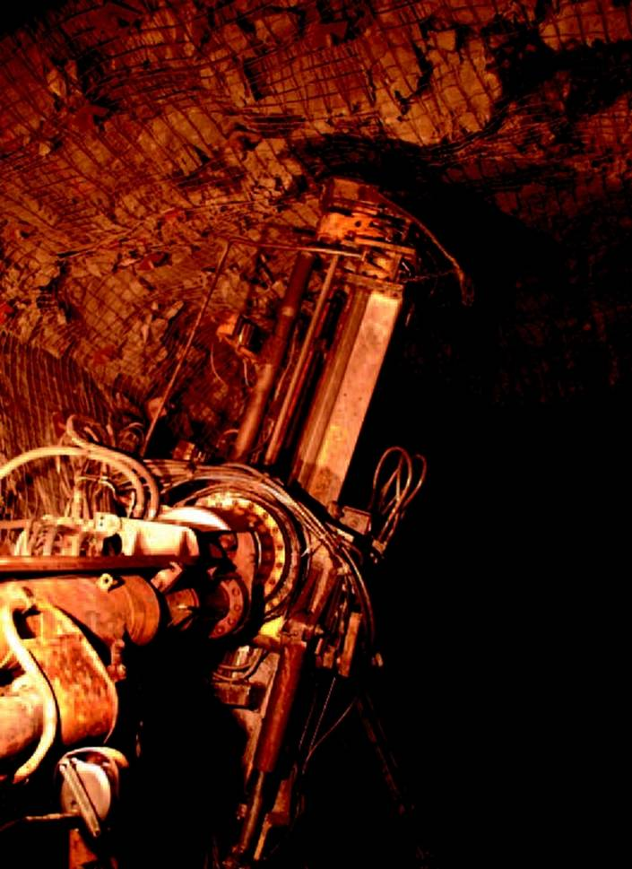

**AVERAGING**

7,300

*tonnes per day of ore production*

4

**LaRONDE OPERATIONS**

In 2005, Agnico-Eagles LaRonde mine processed approximately 7,300 tonnes of ore per day, **SUSTAINING THE PERFORMANCE LEVEL** achieved in 2004. The mine produced at **RECORD LOW TOTAL CASH COSTS** of $43 per ounce of gold. This accomplishment is a tribute to our skilled and highly motivated mining team which, for two years in a row, has operated the mine at impressive production rates and has further established LaRonde as **THE ENGINE OF AGNICO-EAGLES GROWTH AND PROSPERITY**.

|  |  |  |
| --- | --- | --- |
| **ORE PRODUCTION** |  | **TOTAL CASH COST PER OUNCE** |
| *(million tonnes)* |  | *(US$)* |
|  |  |  |
|  |  |  |

Our flagship LaRonde mine is located in the Cadillac-Bousquet region of the Abitibi Greenstone Belt in northwestern Quebec, approximately 650 kilometres northwest of Montreal. The mine extracts gold from the largest gold deposit in Canada in terms of reserves. Since 1988, LaRonde has produced more than 2.9 million ounces of gold.

At LaRonde, we have demonstrated our ability to operate a quality business. We have overcome the operating challenges of mining at more than 2,200 metres underground. Gold reserves have been progressively replaced or expanded. We have maintained an exceptionally low cost base - total cash costs of $43 per ounce in 2005 rank among the lowest in the gold industry. And we have consistently attracted and retained top-quality employees.

**SOLID OPERATING PERFORMANCE**

LaRonde continued its solid operating performance in 2005. Ore production of 2.7 million tonnes, or a daily average of approximately 7,300 tonnes, was essentially unchanged from the record 2004 level of approximately 7,400 tonnes per day.

Payable gold production for the year was 241,807 ounces, compared to 271,567 ounces in 2004. The mine also produced 4.8 million ounces of silver, 76,545 tonnes of zinc and 7,378 tonnes of copper. The lower gold production in 2005 was mainly due to the extra zinc ore processed, and lower ore recovery in the stopes of the lower mine. Ore recovery was expected to be 95%, but has now consistently been closer to 90%. Each of these factors has been incorporated into our 2006 production guidance.

5

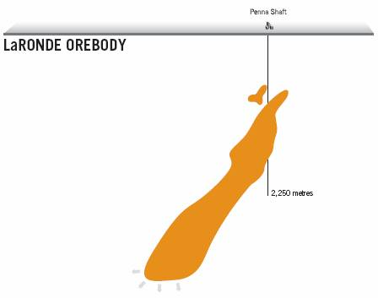

The LaRonde mines low costs are a result of **CONSISTENTLY HIGH PRODUCTION VOLUMES,** byproduct revenue and a skilled workforce dedicated to cost-efficient mining operations. Daily ore production has averaged approximately 7,300 tonnes since the beginning of 2004, when steady state production was achieved, following the mills final expansion. The mines **STRONG EARNINGS AND CASH FLOWS** are helping fund Agnico-Eagles international expansion.

**LOWER UNIT COSTS**

Total cash costs were reduced yet again, largely because of the strong prices for byproduct metals realized in 2005. Total cash costs declined from $56 per ounce of gold in 2004 to an average of just $43 in 2005. In the fourth quarter, total cash costs were a record low minus $22 per ounce of gold. Meanwhile, the realized price of gold for the year was $449 per ounce, up from $418 per ounce in 2004.

**RESERVES**

At the end of 2005, proven and probable gold reserves at LaRonde and LaRonde II rose to 5.3 million ounces, compared to 5.1 million ounces in 2004. As a result of ongoing infill drilling, resource ounces were moved to the reserve category. Also included in the LaRonde and LaRonde II orebodies are significant byproduct reserves of 54 million ounces of silver, 813 million kilograms of zinc and 124 million kilograms of copper.

Canadas largest gold deposit has reserves sufficient to give it a mine life of approximately 20 years.

6

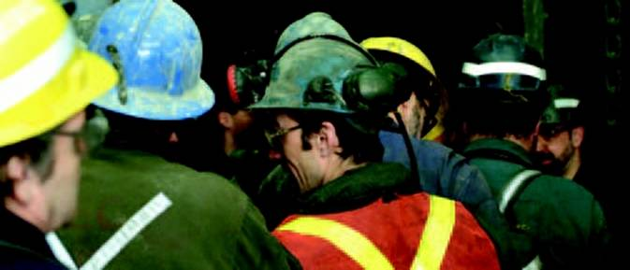

*Shift change at the LaRonde mine.*

*More than*

600

*employees at the LaRonde mine are the foundation of the companys success*

**SKILLED AND COMMITTED WORKFORCE**

More than 600 experienced and highly skilled people work at the LaRonde mine and are the foundation for Agnico-Eagles success. This applies equally to the miner extracting ore thousands of metres underground and to the employees on the surface.

Many employees have been with the company since production began at LaRonde almost 20 years ago. Their dedication and experience, as well as the technical expertise they have developed in mining the deep and complex ores at LaRonde, are significant advantages as we expand.

Our growth projects are well matched to the valuable technical skills of our personnel. This enables us to operate efficiently and cost-effectively, while we also see these projects as opportunities for our employees to expand their careers. The success of our approach is reflected in the fact that we are an industry leader in recruiting and retaining talented people.

7

**AEM**

*under*

**CONSTRUCTION**

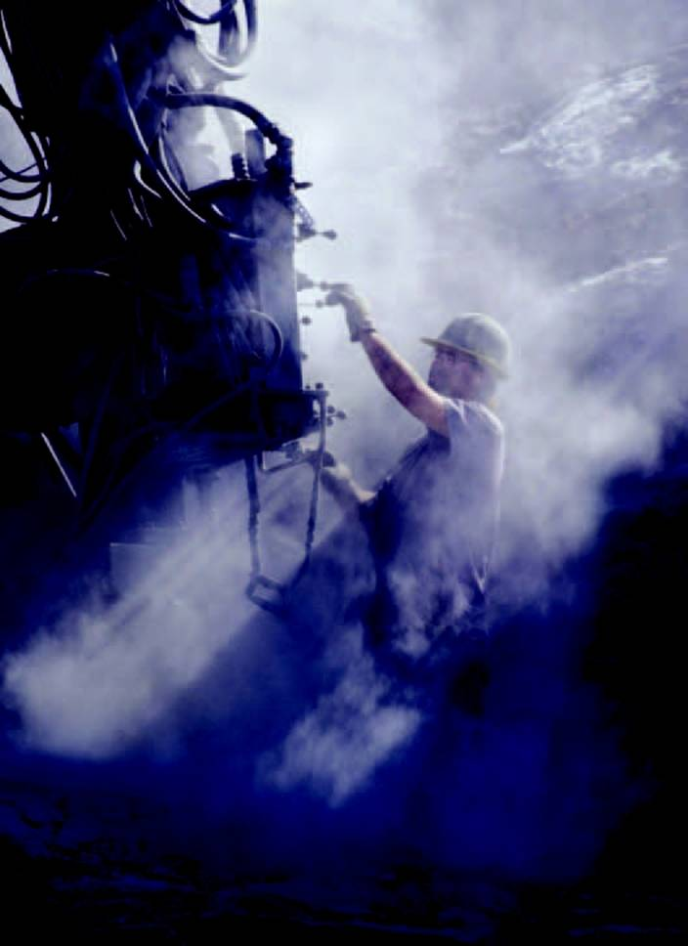

**ANNUAL GOLD PRODUCTION AT GOLDEX   
IS PROJECTED TO AVERAGE**

170,000

*ounces over a 10-year mine life*

8

**GOLDEX**

Construction of **AGNICO-EAGLES NEXT GOLD MINE** is well under way. The Goldex mine, located 50 kilometres east of the LaRonde mine, represents an important first step in our strategy of building value by expanding our low-cost production base. Gold production at Goldex is expected to begin in 2008. Thanks to the technical simplicity of the operation and its proximity to LaRonde, minesite **COSTS PER TONNE ARE PROJECTED TO BE APPROXIMATELY ONE-THIRD** those of the LaRonde mine.

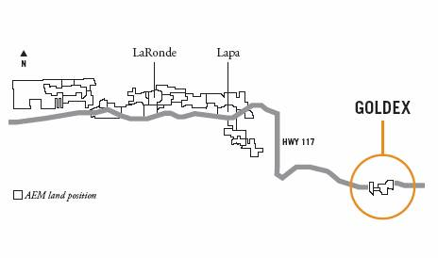

The Goldex property is located in the Abitibi region of northwestern Quebec, about 50 kilometres east of the LaRonde mine. It will be the first new gold mine in the Val dOr region in the last 25 years.

Our 100%-owned Goldex property is one in a long chain of properties that Agnico-Eagle owns in the gold-rich Abitibi Greenstone Belt of Quebec.

Proven and probable reserves at Goldex currently total 21.4 million tonnes with a grade of 2.4 grams per tonne, or 1.6 million ounces of gold. The deposit is open for potential future exploration and development at depth.

While Agnico-Eagle has explored this property for some 30 years, our decision to begin construction of the Goldex mine was based on our success in bulk mining at LaRonde, and encouraging results from a recent drilling and bulk sampling program. The program returned grades nearly 10% higher than the reserve grade, increasing confidence in the mines potential to deliver value.

In addition, project economics have improved significantly over the past several years. As a result of synergies with the LaRonde mine and in-house technical expertise honed over our many years in the region, Goldex enjoys numerous advantages that did not previously exist including a high processing rate, a new mining method and final processing at LaRonde. The base case projects an after-tax internal rate of return of 15%, based on a conservative $400 per ounce gold price. Capital costs are estimated at $135 million.

Underground development and construction are well advanced, with access from existing infrastructure. Plant construction and production shaft sinking are scheduled to begin in 2006.

9

**AEM**

*in the*

**PIPELINE**



**SUURIKUUSIKKO HOLDS**

2.3

*million ounces of probable gold reserves*

10

**SUURIKUUSIKKO**

Suurikuusikko, a **GROWING GOLD DEPOSIT IN NORTHERN FINLAND,** has the potential to become one of the largest gold mines in Europe. Agnico-Eagles acquisition of Suurikuusikko represents one of our most significant ventures outside Canada. Our rationale was simple: Suurikuusikko will help us create value by building a **LARGER, MORE DIVERSIFIED GOLD PRODUCTION BASE** which leverages Agnico-Eagles technical skills. Production at Suurikuusikko could begin as early as 2008.

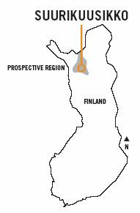

Suurikuusikko boasts excellent nearby infrastructure, including a paved road extending to within a few kilometres of the property.

The Suurikuusikko project is located some 900 kilometres north of Helsinki, Finland, on a 8,500-hectare property. Geology in the region is similar to that of the Cadillac-Bousquet belt in which the LaRonde mine operates.

We first became actively involved in the project in 2004, through our equity position and representation on the Board of Directors of Riddarhyttan. Buoyed by the results of an extensive exploration program, we made a successful $130-million bid for the remaining shares of Riddarhyttan in 2005.

Numerous drills are operating on the property aimed at testing the deposit at depth and converting gold resources to reserves.

As of year-end, probable reserves are 2.3 million ounces of gold, from 13.8 million tonnes grading 5.3 grams per tonne. The measured and indicated resource contains 1.9 million tonnes grading 4.2 grams per tonne, or 252,000 ounces of gold. The inferred resource contains 6.7 million tonnes grading 4.3 grams per tonne, or 934,000 ounces of gold.

As the exploration program continues, we are particularly encouraged by the potential along strike  while the known strike length of mineralization is 15 kilometres, only 5 kilometres have been drilled to date.

Construction of a mine at Suurikuusikko could begin in late 2006, pending completion of a final feasibility study. The study envisages open-pit and underground mining, and a 3,000 tonne per day processing facility. Capital expenditures are estimated to be approximately $170 million.

11

**LAPA**

At Lapa, we are in the first phase of development for another new gold mine in Quebec. The property holds **1.2 MILLION OUNCES OF GOLD RESERVES** with upside potential. Like Goldex, the Lapa project is located in LaRondes backyard. This enables us to **UTILIZE SOME OF THE SAME INFRASTRUCTURE**  including the LaRonde mill  and benefit from the technical expertise of the LaRonde mining team. Within a few years, we aim to have several mining camps like the one in the Abitibi region operating on long-life gold deposits in mining-friendly regions around the world.

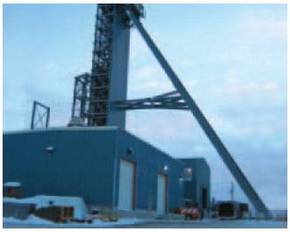

*Construction of the Lapa headframe, now completed.*

*The five-metre diameter, concrete-lined shaft is expected to reach its first phase depth of*

825

*metres by mid-2006*

The high-grade Lapa deposit was discovered by Agnico-Eagle in 2002, as part of an aggressive exploration program. The Lapa project is located just 10 kilometres east of LaRonde near Cadillac, Quebec, and is accessible by provincial highway.

The Lapa deposit contains 4.1 million tonnes of probable gold reserves, grading 8.9 grams per tonne, or 1.2 million ounces. In addition, it contains indicated mineral resources of 754,000 tonnes grading 5.5 grams per tonne, or 133,000 ounces of gold and inferred mineral resources of 1.7 million tonnes grading 7.7 grams per tonne, or 423,000 ounces of gold. Lapa has further ore potential at depth and to the east.

In 2004, the surface infrastructure  including the former LaRonde #1 shaft headframe  was installed at Lapa. We are currently conducting a $30-million underground development, definition drilling and metallurgical program which includes sinking the new mine shaft to a depth of 825 metres. Ongoing results from this critical assessment will be incorporated into a 2006 study contemplating the second phase of development.

Agnico-Eagle is considering accelerating the development program which could bring Lapa into production by mid-2008, at a further capital cost of $80 million, approximately six months earlier than previously scheduled. This second phase would extend the shaft to its ultimate depth of 1,370 metres.

The mine plan is based on processing 1,350 tonnes of ore per day. Annual gold production is expected to average 125,000 ounces at an estimated total cash cost of approximately $200 per ounce over a 10-year mine life.

12

**PINOS ALTOS**

Pinos Altos is a promising property in the Occidental Range of the prolific Sierra Madre gold and silver region of northern Mexico. In March 2006, Agnico-Eagle purchased this property after an extensive drilling campaign returned several **HIGH-GRADE PRECIOUS METALS VALUES** accessible by an open-pit and underground mine. Like Suurikuusikko, this acquisition is consistent with our strategy of building our gold production base through projects well matched to our technical skills and in **REGIONS WITH LOW POLITICAL RISK,** long-term mining camp potential and excellent nearby infrastructure.

*Pinos Altos has an indicated mineral resource of*

1.6

*million ounces of gold and 41 million ounces of silver*

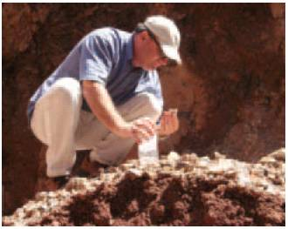

*Alain Blackburn, VP, Exploration, examines Pinos Altos mineralization.*

Following a three-year examination of opportunities in the Sierra Madre gold and silver camp, Agnico-Eagle finalized an exploration and option agreement with Industrias Peñoles S.A. de C.V. in 2005, giving us the right to purchase the Pinos Altos project upon completion of a $2.8 million drilling campaign. With its rich geology, low operating costs, political stability and mining friendly regulatory structure, Mexico is seen as a promising place for Agnico-Eagle to grow.

The large Pinos Altos property, located 225 kilometres west of Chihuahua City, the capital of Mexicos Chihuahua state, is directly accessible by paved highway and close to a major electric power terminus, which is under construction.

The 2005 drilling campaign confirmed an indicated resource of 12.5 million tonnes, grading 3.9 grams of gold per tonne and 102 grams per tonne of silver, containing approximately 1.6 million ounces of gold and 41 million ounces of silver. The property has inferred resources of 3.2 million tonnes, grading 5.2 grams per tonne of gold and 111 grams per tonne of silver, containing approximately 0.5 million ounces of gold and 11.6 million ounces of silver.

In addition, the drilling program validated the open-pit potential of the site and indicated mineralization outside of the current resource outline. These encouraging results prompted us to exercise our option to purchase the property for $32.5 million in cash, 1,869,350 in common shares of Agnico-Eagle and an additional $6.5 million worth of shares (priced near the closing date).

In 2006, we intend to continue our aggressive drilling campaign to gather the data necessary for a bankable feasibility study.

Preliminary analysis contemplates a 3,000 tonne per day operation with the open pit and underground mines each supplying   
1,500 tonnes. Capital cost estimates to bring the project into production are estimated at approximately $150 million.

13

**LaRONDE II**

Even as Agnico-Eagle expands abroad, our foundation remains in northwestern Quebec and **WE CONTINUE TO EXPLORE AND DEVELOP OUR ABITIBI REGION PROPERTIES.** LaRonde II, the deeper extension of the current LaRonde operation, holds the companys most substantial reserves. Drilling results indicate **GOLD GRADES ALMOST DOUBLE THOSE OF LARONDE.** Not only does LaRonde II boast tremendous precious metals values, it can be brought into production cost-effectively and could extend the mine life of LaRonde significantly.

*LaRonde II holds Agnico-Eagles most substantial reserves with more than 19 million tonnes of ore containing almost*

3.7

*million ounces of gold*

The LaRonde II project covers a large extension zone, at depth, of the gold-copper and zinc-silver mineralization that occurs on the LaRonde property but is not accessible by the current Penna Shaft.

Drilling and mine planning work continued throughout 2005. Drilling was focused on transferring deeper resources to reserves and exploring the limits of the deeper mineralization both at LaRonde II and along the main mineralized trend. As of year-end, probable reserves are 3.7 million ounces of gold, from 19.2 million tonnes grading almost 6.0 grams per tonne.

A third-party review of the bankable feasibility study will be delivered in the second quarter of 2006. If approved for construction, production could commence within five years, enabling the LaRonde mill to continue operating at capacity for a longer period.

The mine plan contemplates a production rate of 4,500 to 5,400 tonnes per day, with potential gold production of more than 300,000 ounces per year, over an 11-year mine life, or more.

14

**AEM**

*in*

**RESERVE**

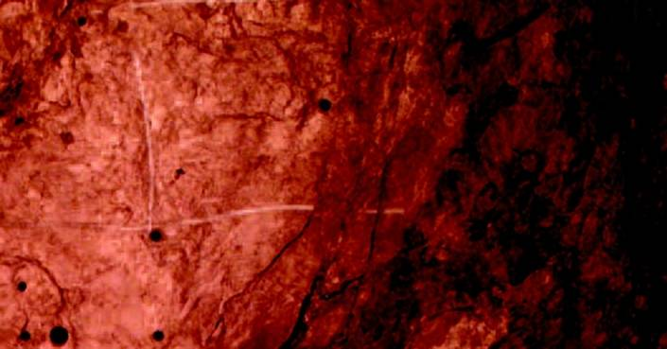

At the end of 2005, Agnico-Eagles proven and probable gold reserves reached an **ALL-TIME HIGH OF 10.4 MILLION OUNCES,** a 32% increase over the previous year.

Since production began at the LaRonde mine, Agnico-Eagle has consistently replaced or expanded its gold reserves. At the LaRonde property proven and probable reserves have grown from under one million ounces of gold in 1988 to 5.3 million ounces at year-end 2005.

Likewise, continued drilling at the neighbouring Lapa and Goldex properties has proved up important new reserves over the past few years. Most significantly, LaRonde II has added more than 19 million tonnes of ore containing almost 3.7 million ounces of gold in proven and probable reserves since 2003.

The significant increase in Agnico-Eagles reserves position in 2005 is primarily a result of the partial conversion of Suurikuusikko resources to reserves. Over the next two years, we plan to convert a large portion of the Pinos Altos resources to reserves, in addition to continued reserve conversion at Suurikuusikko, Lapa and at the LaRonde property.

With exploration continuing at all five growth projects, our goal is to increase the companys current gold reserves to 14 million or possibly 15 million ounces by 2008.

**GOLD RESERVES**

***(millions of ounces)***

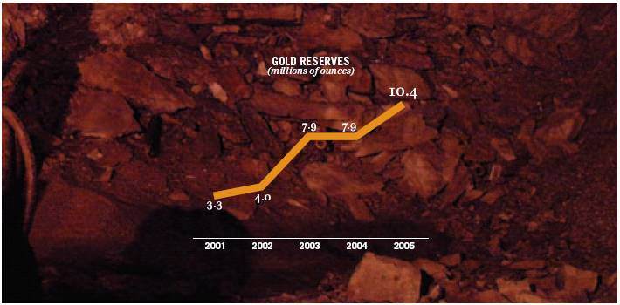

15

**BOARD OF DIRECTORS**

|  |  |  |  |  |
| --- | --- | --- | --- | --- |
|  | James D. Nasso, Chairman of the Board (1) (3) *(Director since 1986) Mr. Nasso is the retired founder and President of  Unilac Limited, a manufacturer of infant formula,  a position he held for the past 35 years. He is a  graduate of St. Francis Xavier University*  *(B.Comm.).* |  |  | Mel Leiderman, C.A., TEP (1) (3)  *(Director since 2003)*  *Mr. Leiderman is the managing partner of the Toronto accounting firm Lipton, Wiseman, Altbaum & Partners and is a graduate of the University of Windsor (B.A.).* |
|  |  |  |  |  |
|  | Leanne M. Baker (1) (2)  *(Director since 2003)*  *Dr. Baker is a consultant to companies in the mining and financial services industries. Previously, she was employed by Salomon Smith Barney where she was one of the top-ranked U.S. mining analysts. Dr. Baker is a graduate of the Colorado School of Mines (M.S. and Ph.D. in mineral economics).* |  |  | Eberhard Scherkus, P.Eng.  *(Director since 2005)*  *Mr. Scherkus is President and Chief Operating Officer of Agnico-Eagle Mines Limited and has been with the company for more than 20 years.*  *He was appointed COO in 1998 and as President in 2005. Prior to that, Mr. Scherkus held various senior management positions, most recently as Executive Vice-President and COO, and was manager of the companys LaRonde Division. Mr. Scherkus is a graduate of McGill University (B.Sc.).* |
|  |  |  |  |  |
|  | Douglas R. Beaumont, P.Eng. (2) (3)  *(Director since 1997)*  *Mr. Beaumont, now retired, is a former Senior Vice-President, Process Technology with SNC Lavalin. Prior to that, he was Executive Vice-President of Kilborn Engineering & Construction. Mr. Beaumont is a graduate of Queens University (B.Sc).* |  |  | Howard Stockford, P.Eng. (2)  *(Director since 2005)*  *Mr. Stockford, now retired, is a former Executive Vice-President of Aur Resources Inc., and has sat on several mining company boards. He has been involved in the mining business for more than 40 years. He is a graduate of the Royal School of Mines, Imperial College, London University.* |
|  |  |  |  |  |
|  | Sean Boyd, C.A. *(Director since 1998)* *Mr. Boyd is Vice-Chairman and CEO of Agnico-Eagle Mines Limited and has been with the company since 1985. He was appointed as CEO in 1998 and became Vice-Chairman in 2005. Prior to that, Mr. Boyd held various senior management positions in the company, most recently as President and CEO. Mr. Boyd is a graduate of the University of Toronto (B.Comm.). He is on the Board of Directors of several mineral exploration companies.* |  |  | Pertti Voutilainen (1)  *(Director since 2005)*  *Mr. Voutilainen is a mining industry veteran, most recently the Chairman of the Board of Riddarhyttan Resources AB. Previously, Mr. Voutilainen was Chairman of the Board and CEO for Kansallis Banking Group and President after its merger with Union Bank of Finland. He was also the CEO of Outokumpu Corp., Finlands largest mining and metals company.* |
|  |  |  |  |  |
|  | Bernard Kraft, C.A. (1) (2) (3)  *(Director since 1992)*  *Mr. Kraft is a senior partner of Kraft, Berger, Grill, Schwartz, Cohen & March, Chartered Accountants, and a principal in Kraft Yabrov Valuations Inc. Mr. Kraft is a member of the Canadian Institute of Chartered Business Valuators, the Association of Certified Fraud Examiners and the American Society of Appraisers.* |  |  |  |
|  |  |  |  |  |

(1) *Audit Committee*

(2) *Compensation Committee*

(3) *Corporate Governance*

16

**CORPORATE GOVERNANCE**

Agnico-Eagles Board of Directors and company management believe that sound and effective corporate governance contributes to **IMPROVED PERFORMANCE AND ENHANCED SHAREHOLDER VALUE.** Our governance practices reflect the structure and processes that we believe are necessary **TO ACHIEVE THESE OBJECTIVES** in the context of our business. As governance standards change, and our business evolves, these practices are assessed and modified as needed.

The Board of Directors is ultimately responsible for supervising the management of the business and affairs of the company and, in doing so, is required to act in the best interest of the company. The Board generally discharges its responsibilities either directly or through the three committees outlined below.

The Corporate Governance Committee advises and makes recommendations to the Board on corporate governance matters, the effectiveness of the Board and its committees, the contributions of individual directors, and the identification and selection of director nominees. This Committee is composed entirely of outside directors who are unrelated to, and independent from, the company.

The Audit Committee assists the Board in its oversight responsibilities with respect to, among other things, the integrity of the companys financial statements, compliance with legal and regulatory requirements, external auditor qualifications and independence, and performance of the companys internal and external audit functions.

The Compensation Committee advises and makes recommendations to the Board on company strategy, policies and programs for compensating and developing senior management and directors.

The charter for each of these committees is posted on our corporate website for easy access by shareholders and the general public.

**DIRECTOR INDEPENDENCE**

The Board of Directors consists of nine directors. All but two of the directors are independent of management and free from any interest or business that could materially interfere with their ability to act in the companys best interest.

**CODE OF ETHICS**

Agnico-Eagle has adopted a Code of Business Conduct and Ethics that is applicable to all directors, officers and employees. The Code embodies the commitment of Agnico-Eagle and its subsidiaries to conduct their business in accordance with all applicable laws, rules and regulations, and the highest ethical standards. The Code is posted on our corporate website.

In conjunction with the Code, Agnico-Eagle has established a toll-free compliance hotline to allow for anonymous reporting of any suspected Code violations, including concerns regarding accounting, internal accounting controls, or other auditing matters.

17

**ENVIRONMENT, HEALTH AND SAFETY**

Throughout our many years at LaRonde, Agnico-Eagles actions have been guided by a **COMMITMENT TO THE HEALTH AND WELL-BEING OF EMPLOYEES AND THE NATURAL ENVIRONMENT,** and a concern for the vitality of the communities in which we live and work. The result is a distinctive corporate culture, and a set of operating practices and policies designed to meet the needs of the present **WITHOUT COMPROMISING THE ABILITY OF FUTURE GENERATIONS TO MEET THEIR OWN NEEDS**. As the company expands, we intend to apply these same practices and policies to our new operations in Canada and internationally.

Agnico-Eagle subscribes to the principle of sustainable development in mining. While mining cannot occur without an impact on the surrounding natural environment and community, we focus on limiting our environmental footprint while creating shareholder and societal value.

**SAFETY**

Agnico-Eagle places the highest priority on the safety of our employees and independent contractors. We take great pride in our proactive safety programs that prepare people for any situation.

In 2005, we maintained the high standard of health and safety performance that has earned us a reputation for being one of the safest mines in Quebec. The LaRonde mine has now completed more than 14 consecutive months without a single lost-time injury.

The 24 volunteers who make up our first-rate mine rescue team embody the idea that our people are always watching out for one another  and for people in other mines as well. In 2005, the team won the prestigious annual Quebec mine rescue competition.

**ENVIRONMENT**

Agnico-Eagle employees strive to conduct all mining operations using environmental best practices, and to meet or exceed every environmental regulation that governs the companys exploration, mining and milling activities.

In 2005, we continued to optimize the new water treatment plant at the LaRonde mine. This high-tech biological treatment facility represents the final stage in a series of treatments designed to ensure that water released back into the environment meets all applicable provincial and federal water quality standards. Because the new plant utilizes a unique and state of the art technology, optimization has involved extensive analysis and testing. While the plant is being optimized, a number of alternative water treatment technologies have been evaluated and factored into the companys water management plans.

Through the year, we also developed a new approach to tailings dike construction that uses the waste rock generated by the mining operation. In addition to its environmental benefits, this approach is simpler and more cost-effective than traditional construction methods.

Environmental awareness presentations are delivered to all employees, so that they understand the companys environmental policy and the role they are expected to play in achieving good environmental stewardship.

Beyond its operations, Agnico-Eagle supports the Prospectors and Developers Association of Canadas Environmental   
Excellence in Exploration (E3), which aims to encourage the highest levels of environmental care and social engagement during mineral exploration. Through the application of E3 standards at our exploration properties, Agnico-Eagle teams take measures to minimize the environmental impacts of their work.

18

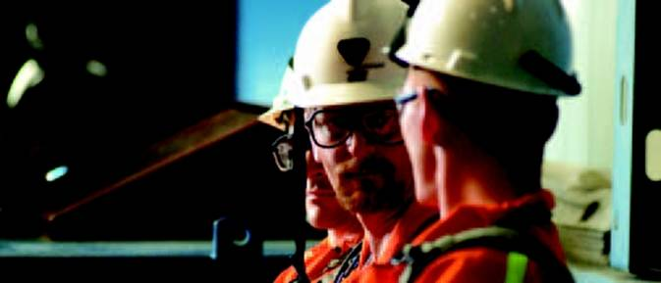

*Some members of Agnico-Eagles mine rescue team*

*The 2005 Quebec mine rescue competition was won by the*

24

*volunteer members of the LaRonde rescue team*

**ENVIRONMENTAL POLICY**

It is the policy of Agnico-Eagle to protect the environment, public health and safety, and natural resources by conducting operations in an environmentally sound manner while pursuing continuous improvement in our environmental performance. To achieve these goals, we are committed to:

                  Assessing the potential environmental impacts of all new undertakings with the objective of minimizing them

                  Designing and operating our facilities to ensure that effective controls are in place to minimize the risks to health, safety and the environment

                  Maintaining emergency response plans to minimize the impacts of unforeseen events

                  Directing professional environmental staff to plan and direct environmental compliance programs and to assist in training and education activities

                  Ensuring that environmental factors are considered in the purchase of equipment and materials

                  Ensuring that contractors operate according to our environmental policy and procedures

                  Complying with all applicable environmental laws and regulations

                  Communicating with employees, the public, government agencies and other stakeholders on activities involving the environment, health and safety

                  Regularly verifying environmental performance and implementing any required corrective action

                  Minimizing the generation of hazardous and non-hazardous waste and ensuring proper disposal of all wastes

                  Implementing measures to conserve natural resources such as energy and water

                  Rehabilitating sites in accordance with regulatory criteria and established timeframes

19

**MD&A AT-A-GLANCE**

*This MD&A At-a-Glance highlights some of the more significant and informative items that appear in the Managements Discussion and Analysis. For a complete summary of Agnico-Eagles strategies, business environment, performance, risk and other material information, please refer to the full MD&A in the Form 20-F which follows.*

**2005 HIGHLIGHTS**

Gold production of **241,807 OUNCES**  Record proven and probable gold reserves of **10.4 MILLION OUNCES**Record low full-year and fourth-quarter **TOTAL CASH COSTS PER OUNCE OF $43** and **MINUS $22** respectively **** **EARNINGS OF** **$37 MILLION**, or $0.42 per share, and record cash provided by operating activities of **$83 MILLION**  Acquisition of the **SUURIKUUSIKKO** property in Finland  Start of construction of a gold mine at the **GOLDEX** property in northwestern Quebec, and shaft sinking at the neighbouring **LAPA** property

**GOLD PM FIX**

*(US$/Oz) (Source: LBMA)*

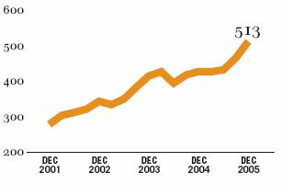

|  |  |  |  |  |  |
| --- | --- | --- | --- | --- | --- |
| **PRODUCTION** |  | **2006** |  | **2005** |  |
| **OUTLOOK** |  | **Estimate** |  | **Actual** |  |
|  |  |  |  |  |  |
| Gold *(ounces)* |  | 250,000 |  | 241,807 |  |
|  |  |  |  |  |  |
| Silver *(000s of ounces)* |  | 5,700 |  | 4,831 |  |
|  |  |  |  |  |  |
| Zinc *(000s of tonnes)* |  | 72.5 |  | 76.5 |  |
|  |  |  |  |  |  |
| Copper *(000s of tonnes)* |  | 9.0 |  | 7.4 |  |

**KEY PERFORMANCE DRIVERS**

|  |  |  |  |
| --- | --- | --- | --- |
| **Driver** |  | **2005 Performance** | |
|  |  |  | |
| Spot price of gold |  |  | Gold prices reached 25-year highs during the year; near-term peak at $575 per ounce in mid-February 2006 |
|  |  |  |  |
| Spot prices of silver, zinc and copper |  |  | Silver prices rose throughout the year, breaking $9 per ounce in December and $10 per ounce in March 2006 |
|  |  |  | Copper and zinc prices continued to strengthen throughout the year with current prices near all time highs |
|  |  |  |  |
| C$/US$ exchange rate |  |  | Company benefited from its currency hedges which, combined with the natural hedge of higher byproduct prices, helped control costs at LaRonde |
|  |  |  |  |
| Production volumes |  |  | Ore production of 2.7 million tonnes, or a daily average of 7,300 tonnes, was only slightly lower than the record 2004 level |
|  |  |  | Gold production decreased to 241,807 ounces, down 11% from 2004, primarily due to lower than expected ore recovery in several stopes, and the mining of additional, lower grade zinc mineralization in the hangingwall which is economic at current prices |
|  |  |  |  |
| Production costs |  |  | Total cash costs per ounce of gold decreased to $43 from $56 in 2004 and $269 in 2003, primarily as a result of higher byproduct revenue and strong ore production |

20

**SHAREHOLDER INFORMATION**

**OFFICERS**

Sean Boyd

*Vice-Chairman and Chief Executive Officer*

Eberhard Scherkus

*President and Chief Operating Officer*

David Garofalo

*Vice-President, Finance and Chief Financial Officer*

Donald G. Allan

*Vice-President, Corporate Development*

Alain Blackburn

*Vice-President, Exploration*

R. Gregory Laing

*General Counsel, Vice-President, Legal and Corporate Secretary*

Jean Robitaille

*Vice-President, Metallurgy and Marketing*

**Forward-Looking Statement**

The information in this annual report has been prepared as at March 14, 2006. Certain statements contained in this annual report constitute forward-looking statements within the meaning of the United States Private Securities Litigation Reform Act of 1995. When used in this document, the words anticipate, expect, estimate, forecast, planned and similar expressions are intended to identify forward-looking statements.

Such statements include, without limitation: estimates of future mineral production and sales; estimates of future production costs, cash costs, minesite costs and other expenses; estimates of future capital expenditures and other cash needs; statements as to the projected development of certain ore deposits, including estimates of exploration, development and other capital costs, and estimates of the timing of such development or decisions with respect to such development; estimates of reserves and resources, and statements regarding anticipated future exploration and feasibility study results; the anticipated timing of events with respect to the companys minesites, and the anticipated timing of events with respect to the companys acquisition of the Pinos Altos property; and other statements regarding anticipated trends with respect to the companys capital resources and results of operations. Such statements reflect the companys views as at the date this press release was prepared and are subject to certain risks, uncertainties and assumptions. Many factors, known and unknown, could cause the actual results to be materially different from those expressed or implied by such forward-looking statements. Such risks include, but are not limited to: the companys dependence upon its LaRonde mine for all of its current gold production; uncertainty of mineral reserve, mineral resource, mineral grade and mineral recovery estimates; uncertainty of future production, capital expenditures, and other costs; gold and other metals price volatility; currency fluctuations; mining risks; and governmental and environmental regulation. For a more detailed discussion of such risks and other factors, see companys Annual Information Form and Annual Report on Form 20-F for the year ended December 31, 2005, as well as the companys other filings with the Canadian Securities Administrators and the U.S. Securities and Exchange Commission. The company does not intend, and does not assume any obligation, to update these forward-looking statements.

Certain of the foregoing statements, primarily related to projects, are based on preliminary views of the company with respect to, among other things, grade, tonnage, processing, mining methods, capital costs, and location of surface infrastructure and actual results and final decisions may be quite different from those currently anticipated.

**CORPORATE HEAD OFFICE**

Agnico-Eagle Mines Limited

145 King Street East, Suite 500

Toronto, ON

Canada M5C 2Y7

Phone: (416) 947-1212

**WEBSITE**

www.agnico-eagle.com

**AUDITORS**

Ernst & Young LLP

*Chartered Accountants*

**SOLICITORS**

Davies Ward Philips & Vineberg LLP (Canada)

Brown Rudnick Berlack Israels LLP (U.S.A.)

**LISTINGS**

The New York Stock Exchange and the

Toronto Stock Exchange;

*Stock Symbol:* AEM

**TRANSFER AGENT**

Computershare Trust Company of Canada

**INVESTOR RELATIONS**

David L. Smith

*Director, Investor Relations*

(416) 947-1212

**ANNUAL MEETING OF SHAREHOLDERS**

Le Royal Meridien King Edward Hotel

37 King Street East

Toronto, ON, Canada

May 12, 2006

10:30 am



The cover and pages 1 to 20 of this report are printed on Mohawk Options, True White, Smooth, and contains 30% postconsumer waste fibre. It is manufactured with non-polluting, wind-generated energy.

Concept and Design: **THE WORKS www.worksdesign.com** Printing: **Merrill Corporation Canada**

Why

Invest

in **AEM**?

Over the past several years, the gold sector has produced strong returns for investors, with industry analysts calling for continued gains in the gold price. Among its industry peers, Agnico-Eagle stands out because of its growth pipeline, large and growing gold reserves, low-cost operations, international diversification and experienced mining team.

1.

Were rapidly growing with a **LARGE PIPELINE** of high-potential   
projects and a plan to triple gold production by 2009.

2.

Agnico-Eagles **GROWING GOLD RESERVES** are currently at

10.4 million ounces, with a goal of exceeding 14 million ounces by 2008.

3.

Our **LOW-COST LaRONDE MINE** helps fund growth

and protects shareholders from low product prices.

4.

The company is **INTERNATIONALLY** diversified   
within mining-friendly countries.

5.

Agnico-Eagles **EXPERIENCED MINING TEAM** is well-suited

to extracting value from our project pipeline.

*For more detail, visit*

**WWW.AGNICO-EAGLE.COM**

Agnico-Eagle Mines Limited

145 KING STREET EAST, SUITE 500  
TORONTO, ON M5C 2Y7 CANADA   
TEL: (416) 947-1212

FAX: (416) 367-4681